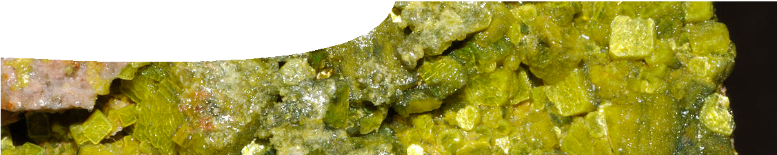
teacher guide
Nuclear reactions 4:
Decay chains

Components

 | NAME DESCRIPTION AUDIENCE
 | Decay chains  teachers guide | This guide provides a framework for student use of the  Decay chain explorer. | teachers
 | Decay chain explorer  learning object | This learning object contains three interactive activities. In the first activity students build decay chains of radioactive isotopes from their decay modes. The second looks at complete decay chains. The third investigates two uranium- lead decay series in detail. | students
 | Investigating decay chains  worksheet | This student worksheet provides a framework for use of the three interactive activities in Decay chain explorer. | students

Purpose
To Explore and Explain radioactive decay.

Activity summary
Outcomes
Students:
- explain nuclear decay;
- explain nuclear decay rate and half-life for different radioisotopes;
- explain radioactive decay series using a range of radioisotopes;
- describe the relationship between parent and daughter isotopes; and
- understand that simulations are a legitimate alternative to actual laboratory experiences.

ACTIVITY POSSIBLE STRATEGY
Students explore and use the interactive learning object, Decay chain explorer, to complete a three-part worksheet. | individually, in pairs or as whole class activity
The completed worksheets are discussed. | teacher-led discussion

Technical requirements
The learning object requires Adobe Flash Player version 8 or later (this is a free download from www.adobe.com).
The teachers guide and worksheet require Adobe Reader (version 5 or later), which is a free download from www.adobe.com. The worksheets is also available in Microsoft Word format.

Decay chain explorer
Decay chain explorer is a learning object that investigates natural and artificial decay chains formed by radioactive elements. The learning object includes three separate activities:
- Decay chain builder
- Decay chain explorer
- Uranium decay explorer
Once open, students can select Next or Back to navigate between activities.

Activity 1: Decay chain builder
Using a segment of the periodic table, students are challenged to identify and build a decay chain.
Individual columns in the table have the same number of protons. This means that each column contains isotopes of a particular element.
Shaded cells indicate radioactive isotopes and unshaded cells contain stable isotopes. Although there are many other isotopes, only those important to the activity are included in the table.
During building, students are prompted to draw a line that connects a parent isotope with its daughter product. The relationship between parent and daughter depends on the decay mode. Decay modes are illustrated in Figures 2 and 3.
To build a decay chain students are prompted by information and feedback in two information windows. When a cell is highlighted, the bottom-right window offers information on the selected isotope: element symbol; element name; mass; number of protons; principal decay mode; and half-life.
The top-left window provides feedback on whether the student’s selection of daughter isotope is correct. If a student makes three incorrect attempts they are given the correct answer.
The sequence stops when the decay chain reaches a stable isotope.

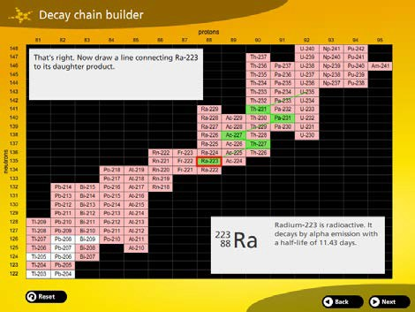
Figure 1: Decay chain explorer

Figure 2: Decay modes
Increasing number of protons
Increasing number of neutrons
electron capture and β+ decay
parent
β- decay
α decay

mode description change in protons and neutrons
α decay | A particle consisting of two protons and two neutrons is emitted from the nucleus. | -2p, -2n
β- decay | A neutron is converted into a proton and an electron. The electron is ejected from the nucleus. | +1p, -1n
β+ decay | A proton is converted into a neutron and a positron. The positron is ejected from the nucleus. | -1p, +1n
electron capture | An electron is absorbed by the nucleus, and combined with a proton to make a neutron. | -1p, +1n
Figure 3: Decay modes

Activity 2: Decay chain explorer
This activity has a similar interface to activity one. Using a segment of the periodic table, students are shown a complete decay chain when they select an isotope.
This activity is useful for quick comparison of different isotopes.
Along with single decay chains, this explorer also identifies branching decay chains. An example of this is found in the plutonium-239 decay chain, where actinium-227 and bismuth-211 have two daughter products produced by different decay schemes.
The thickness of the decay path line represents the proportion of the isotope taking any given path.

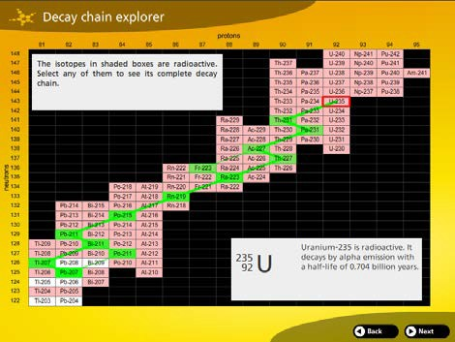

Figure 4: Decay chain from U235

Activity three – Uranium decay explorer
This activity investigates the decay of uranium-235 and uranium-238. Each simulation begins with one billion atoms of the parent isotope. As time passes the graph displays the amount of parent isotope being converted to daughter product. Uranium isotopes have very long half-lives so this simulation runs at high speed (one billion years pass every 10 seconds).
Students have two ways to view the decay — on an arithmetic scale or on a logarithmic scale.
The arithmetic scale displays the decay as a ratio of the parent isotope to final daughter product. Intermediate daughter products are not displayed in this graphing mode, because in this timescale they only have a fleeting existence. This display allows students to easily identify when half of the parent isotope has decayed.
The logarithmic scale displays the parent isotope, the stable daughter product, and some intermediate daughter products. Using the Pause button students can record atom counts for each daughter product.
However, in this graphing mode it is less obvious when half of the parent isotope atoms have decayed. During the simulation the abundance of intermediate isotopes remain fairly constant because they are in dynamic equilibrium. Radiogenic production of each radioactive daughter isotope is balanced by its decay. This is one reason why the ratio used for mineral dating is the stable lead daughter isotope to the parent uranium isotope.

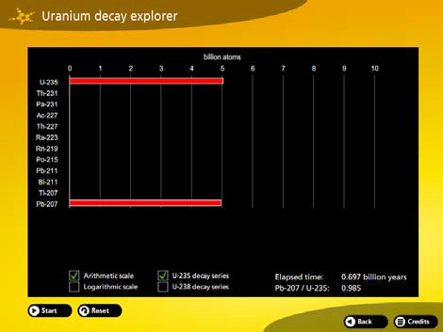
Figure 5: U235 decay products after 0.7 billion years

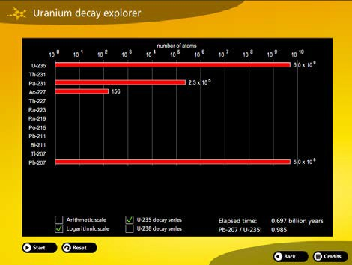
Figure 6: U235 decay, logarithmic scale

Associated SPICE resources
Nuclear reactions 4: Decay chains may be used in conjunction with related SPICE resources to address the broader topic of nuclear physics.

DESCRIPTION LEARNING PURPOSE
Nuclear reactions
This learning pathway shows how a number of SPICE resources can be combined to teach the topic of ionising radiation and nuclear reactions.
Nuclear reactions 1: Mines to medicine  Students express their opinions on a moral issue after viewing a film of demonstrators at a uranium mine and after a medical physicist explains why nuclear medicine is so important to diagnostic and therapeutic procedures. | Engage
Nuclear reactions 2: Nuclear radiation  Students investigate types and properties of radiation with particular attention to penetrative characteristics. | Explore 1
Nuclear reactions 3: Nuclear decay  Students manipulate variables in an interactive simulation to investigate connections between decay and half-life. An alternative procedure using dice is provided. | Explore 2
Nuclear reactions 4: Decay chains  In three separate interactive simulations, students experience modelling as an alternative way of exploring nuclear decay and half-life. | Explore 3
Nuclear reactions 5: Fission and fusion  Worked examples explain how to calculate mass defect and binding energy for fission and fusion reactions. The experimental ITER fusion reactor is also discussed. | Explain
Nuclear reactions 6: Nuclear medicine  Students explore applications of radioisotopes in medicine. | Elaborate 1
Nuclear reactions 7: Radioisotopes in research  Fact sheets illustrate the use of radioisotopes in research being undertaken at The University of Western Australia. | Elaborate 2

Acknowledgements
Developed by the Centre for Learning Technology, UWA. Production team: Brett Boughton (Willetton Senior High School), Alan Cadby, Fred Deshon, Bob Fitzpatrick, Jenny Gull, Trevor Hutchison, Paul Ricketts, Gary Thomas and Michael Wheatley.
banner image: ‘Autunite, a secondary uranium mineral’ by Parent Géry. CC-BY-SA-3.0. en.wikipedia.org/wiki/ File:Autunite_1(France).jpg

SPICE resources and copyright
All SPICE resources are available from the Centre for Learning Technology at The University of Western Australia (“UWA”). Selected SPICE resources are available through the websites of Australian State and Territory Education Authorities.
Copyright of SPICE Resources belongs to The University of Western Australia unless otherwise indicated.
Teachers and students at Australian and New Zealand schools are granted permission to reproduce, edit, recompile and include in derivative works the resources subject to conditions detailed at spice. wa.edu.au/usage.
All questions involving copyright and use should be directed to SPICE at UWA.
Web: spice.wa.edu.au Email: spice@uwa.edu.au Phone: (08) 6488 3917
Centre for Learning Technology (M016) The University of Western Australia
35 Stirling Highway
Crawley WA 6009

