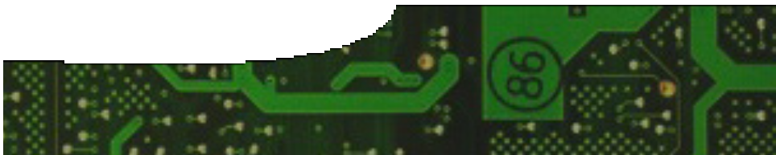
teacher guide

Electrical circuits 3:
Current electricity

Components

 | NAME | DESCRIPTION | AUDIENCE
 | Current electricity  teacher guide | This guide suggests alternative ways that students can experiment with simple circuits. | teachers
 | Models and misconceptions  background sheet | Eight models that teachers may use to help explain concepts in electricity are described. A list of common misconceptions about electricity, held by students, is included. | teachers
 | Simple circuits  worksheet | Students explore simple circuits by completing open-ended and structured experiments to explore current, resistance and potential difference. | students

Purpose
To Explore concepts of current, resistance and potential difference.

Activity summary
Outcomes
Students:
- construct simple circuits from components following circuit diagrams or verbal instructions;
- draw circuit diagrams to represent simple electrical setups;
- explore relationships between current size and position current is measured in a circuit;
- use ammeters and multimeters to measure current and resistance; and
- investigate the total resistance when resistors are connected in series and in parallel.

ACTIVITY | POSSIBLE STRATEGY
Students explore simple circuits either using procedures described in this guide, or in the worksheet, Simple circuits.  Simple circuits can be connected using standard laboratory components: power pack, lamps, meters, switches, cells and wires. Resistances can be measured using multimeters. | small groups or individuals

Teacher notes
Procedures may be open-ended with students experimenting with different combinations of components to develop confidence in using equipment. If a more structured approach is required then teachers may direct groups to connect components so a specific outcome is achieved. For example an instruction may be: ‘Produce a circuit
in which two lamps can be switched on and off independently.’
These experiments are written up in many different laboratory manuals in a more structured way.
Teachers may prefer to use these sources instead of the more open-ended approach.

Circuit diagrams may be drawn to represent circuits students construct.
A structured worksheet is included for teachers who prefer to approach the concepts more traditionally.
A large quantity of components is required if students work in small groups to construct a wide variety of circuits. If power packs are used as power sources, 12 V lamps will eliminate accidental ‘blowing’ of bulbs.
Commercially designed kits of components, which may be available in some schools, assist distribution of equipment to students.

Technical requirements
The guide, background sheet and worksheet require Adobe Reader (version 5 or later). This is a free download from www.adobe.com. The worksheet is also available in Microsoft Word format.

Acknowledgements
Designed and developed by the Centre for Learning Technology, The University of Western Australia.
Production team: Leanne Bartoll, Alwyn Evans, Bob Fitzpatrick, Gary Thomas and Michael Wheatley, with thanks to Fred Deshon, Roger Dickinson, Jenny Gull and Wendy Sanderson.

SPICE resources and copyright
All SPICE resources are available from the Centre for Learning Technology at The University of Western Australia (“UWA”). Selected SPICE resources are available through the websites of Australian State and Territory Education Authorities.
Copyright of SPICE Resources belongs to The University of Western Australia unless otherwise indicated.
Teachers and students at Australian and New Zealand schools are granted permission to reproduce, edit, recompile and include in derivative works the resources subject to conditions detailed at spice.wa.edu.au/usage.
All questions involving copyright and use should be directed to SPICE at UWA.
Web: spice.wa.edu.au Email: spice@uwa.edu.au Phone: (08) 6488 3917
Centre for Learning Technology (M016) The University of Western Australia
35 Stirling Highway
Crawley WA 6009

Associated SPICE resources
Electrical circuits 3: Current electricity may be used with related SPICE resources to address the broader topic of electricity.

DESCRIPTION | LEARNING PURPOSE
Electrical circuits (sequence overview)
This learning pathway shows how a number of SPICE resources can be combined to teach the topic of electricity.
Electrical circuits 1: Lightning  Students are engaged in the topic of electricity through observing and exploring lightning. | Engage
Electrical circuits 2: Static electricity  Students explore the effects of charge through a series of laboratory experiments. | Explore 1
Electrical circuits 3: Current electricity  Students construct circuits using simple electrical components. | Explore 2
Electrical circuits 4: Circuit rules  Students use an interactive learning object to record observations and derive rules for circuits. | Explain 1
Electrical circuits 5: Measuring electricity  Six measurements that relate to electricity are explained and related to electrical safety: charge, current, electric potential, resistance, power and energy. | Explain 2
Electrical circuits 6: Bioelectricity  Four fact sheets and a video provide examples of how electricity is used in living organisms, including humans. | Elaborate

