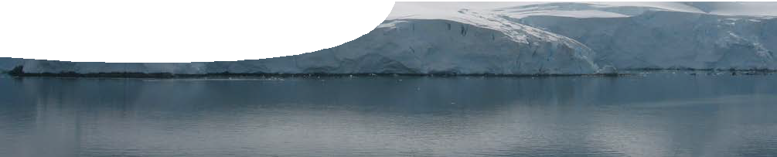
teacher guide
Life in the Solar System 1:
Conditions for life

Components

 | NAME | DESCRIPTION | AUDIENCE
 | Conditions for life  teacher guide | The guide provides information on how to use the PowerPoint presentation in this resource. | teachers
 | Conditions for life  presentation | This presentation is used to engage students’ interest in conditions that support life on Earth. | students

Purpose
To Engage students’ interest and encourage inquiry about environments that support life.

Activity summary
Outcomes
Students:
- compare features and differences in a number of environments, and
- describe factors that affect the diversity of life within a particular environment.

ACTIVITY | POSSIBLE STRATEGY
A teacher-led activity uses the presentation, Conditions for Life, to engage students. It compares images of different environments on Earth in order to raise questions about requirements for life as we know it. | teacher-led presentation
Discussion | teacher-led, whole group

Technical requirements
The presentation is provided in Microsoft PowerPoint and Adobe PDF formats. The guide requires Adobe Reader which is a free download from www.adobe. com.

Using the presentation
The presentation, Conditions for life, contains images of environments including: Antarctica, cave, coast, city, desert, mountain, rainforest, woodland and volcanic pool. It also includes a single image of the surface of Mars.
The image of Mars is not labelled. This brings out our predisposition to Earth-like habitats (in this case, students may identify it as a desert environment).
Further exploration of this image will occur in Life in the Solar System 2: Exploring environments.

Teachers display the presentation and, while moving from image to image, challenge students with a number of discussion questions. These capture students’ understanding of factors contributing to the existence of life on Earth.
While displaying the images suitable discussion questions include:
- What name is commonly used to describe this environment?
- What forms of life might be found in this environment?
- What environmental factors affect the abundance of life in this environment?
- What common features exist in all images, and how do they characterise life on Earth?

List of images
- Lemaire Channel, Antarctica (photo by Frank Wheatley)
- Jenolan Caves, New South Wales (photo by Paul Ricketts)
- Namib Desert (photo by Tjeerd Wiersma, CC-BY-2.0, commons.wikimedia.org/wiki/Image:Namibian_Desert.jpg)
- Forest, New South Wales (photo by Paul Ricketts)
- Perth city skyline at night (photo by Paul Ricketts)
- Rottnest Island coastline (photo by Paul Ricketts)
- Karri forest, Margaret River, Western Australia (photo by Paul Ricketts)
- The Eastern Hills, Mars, photographed by Mars Rover Spirit (NASA/JPL, photojournal.jpl.nasa.gov/catalog/ pia05593)
- Blue Mountains, New South Wales (photo by Paul Ricketts)
- A volcanic pool in Yellowstone National Park (photo by James Taylor, used under licence from Stock.xchng, www.sxc.hu/photo/800999)

Associated SPICE resources
Life in the Solar System 1: Conditions of life may be used in conjunction with related SPICE resources.

DESCRIPTION | LEARNING PURPOSE
Life in the Solar System
This learning pathway combines a number of SPICE resources to address the topic of the search for life in the Solar System.
Life in the Solar System 1: Conditions for life  A presentation challenges students to think about where life is found. | Engage
Life in the Solar System 2: Exploring environments  Students explore different environments to compare surface conditions and abundance of life. | Explore
Life in the Solar System 3: Planetary atmospheres  Students compare atmospheric conditions on various bodies in the Solar System. | Explain
Life in the Solar System 4: Life under extreme conditions  Life exists in extreme environments on Earth, which suggests that it may also be found in unknown environments in space. | Elaborate

Acknowledgements
Designed and developed by the Centre for Learning Technology, The University of Western Australia.
Production team: Leanne Bartoll, Alwyn Evans, Bob Fitzpatrick, Trevor Hutchison, Paul Luckas, Paul Ricketts, Jodie Ween and Michael Wheatley, with thanks to Roger Dickinson, Jenny Gull and Wendy Sanderson.

SPICE resources and copyright
All SPICE resources are available from the Centre for Learning Technology at The University of Western Australia (“UWA”). Selected SPICE resources are available through the websites of Australian State and Territory Education Authorities.
Copyright of SPICE Resources belongs to The University of Western Australia unless otherwise indicated.
Teachers and students at Australian schools are granted permission to reproduce, edit, recompile and include in derivative works the resources subject to conditions detailed at spice.wa.edu.au/usage.
All questions involving copyright and use should be directed to SPICE at UWA.
Web: spice.wa.edu.au Email: spice@uwa.edu.au Phone: (08) 6488 3917

Centre for Learning Technology (M016) The University of Western Australia
35 Stirling Highway
Crawley WA 6009

