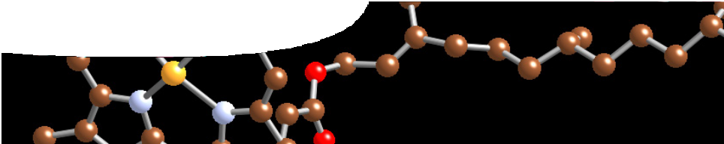
teachers guide

Structure and bonding 3:
Chemical bonds

Components

 | NAME | DESCRIPTION | AUDIENCE
 | Chemical bonds  teachers guide | This shows how the resource may be used and explains the use of the various learning materials. | teachers
 | Chemical bonds  learning object | The learning object contains animations and diagrams to illustrate four types of bonding: ionic, covalent, covalent network and metallic. | students
 | Chemical bonds  worksheet | Students answer questions as they work through the learning object. | students
 | Concept map: chemical bonds  worksheet | Students build a concept map to represent their knowledge of chemical bonds. | students

Purpose
To Explain bond formation and characteristics graphically.

Activity summary
Outcomes
Students will be able to:
- describe and explain the formation and characteristics of ionic bonds and ionic substances, metallic bonds and metallic substances, covalent bonds and covalent network and molecular substances; and
- describe and explain the relationships between the properties and structures of ionic, metallic, covalent network and covalent molecular substances.

ACTIVITY | POSSIBLE STRATEGY
View the learning object Chemical bonds. | individual, small group or whole group
Complete the worksheet and/or concept map. A sample completed concept map is included at the end of this guide. | individual or small groups

Technical requirements
The teachers guide and worksheets require Adobe Reader (version 5 or later), which is a free download from www.adobe.com. The worksheets are also provided in Microsoft Word format.
The concept map template is best printed on A3 paper.
The learning object requires Adobe Flash Player version 8 or later on the client machine (this is a free download from www.adobe.com).

Teacher notes
Students view the learning object and complete the worksheet, Chemical bonds. As an alternative to the worksheet questions, students may summarise information from the learning object, in a concept map. To guide them when making their concept maps, provide an outline of a map and instructions for its completion.
The representation of ionic bonding in the learning object shows the diameter of atoms changing as they become ions. The diameter of a sodium atom is 186 pm and that of the sodium ion 116 pm. This can be explained to students in terms of the greater ‘pulling power’ of protons on a reduced number of electrons and in terms of the outer shell now being empty.
The diameter of a chlorine atom is 100 pm and that of a chloride ion 167 pm. This can be explained in terms of the reduced ‘pulling power’ of protons on an increased number of electrons.
Carborundum (SiC) is typically man-made. It does occur naturally as the mineral moissanite, but is extremely rare. It is more common in space where it is found as stardust around carbon-rich stars.
Corundum (Al O ) is often cited as a covalent

Acknowledgements
Designed and developed by the Centre for Learning Technology, The University of Western Australia.
Project team: Shaun Barton, Alwyn Evans, Bob Fitzpatrick, Sally Harban, Trevor Hutchison, Michael Wheatley and Yvonne Woolley with thanks to Fred Deshon, Roger Dickinson, Jenny Gull and Wendy Sanderson.

SPICE resources and copyright
All SPICE resources are available from the Centre for Learning Technology at The University of Western Australia (“UWA”). Selected SPICE resources are available through the websites of Australian State and Territory Education Authorities.
Copyright of SPICE Resources belongs to The University of Western Australia unless otherwise indicated.
Teachers and students at Australian schools are granted permission to reproduce, edit, recompile and include in derivative works the resources subject to conditions detailed at spice.wa.edu.au/usage.
All questions involving copyright and use should be directed to SPICE at UWA.

2 3

network substance. Research(1) suggests that the Al-O bonds have a strong ionic component. It
is intermediate in character between ionic and covalent network structure.
The learning object is intended to build on students’ knowledge of electron configuration and valence electrons. Electron dot diagrams may also be introduced here, perhaps using the interactive periodic table as an aid.

Associated SPICE resources
Web: spice.wa.edu.au Email: spice@uwa.edu.au Phone: (08) 6488 3917

Centre for Learning Technology (M016) The University of Western Australia
35 Stirling Highway
Crawley WA 6009

Reference
1) Sousa, C. and Illas, F. (1993). Can corundum be described as an ionic oxide? Journal of Chemical Physics, 99 (9), 6818–6823.

Structure and bonding 3: Exploring conductivity may be used in conjunction with related SPICE resources to address the broader topic of structure and bonding.

DESCRIPTION | LEARNING PURPOSE
Structure and bonding
This learning pathway shows how a number of SPICE resources can be combined to teach the topic of structure and bonding.
Structure and bonding 1: Molecular structures  A short video and worksheet that introduce the concept of structure and bonding by looking at how silica capsules may be used in drug delivery. | Engage
Structure and bonding 2: Exploring conductivity  Students perform experiments to examine the conductivity of a range of materials, and sort them into groups. | Explore
Structure and bonding 3: Chemical bonds  Students learn about types of bonding by working through a learning object and worksheet. | Explain
Structure and bonding 4: Molecules by design  Students learn about different applications of bonding through a series of fact sheets on current research at The University of Western Australia. | Elaborate

