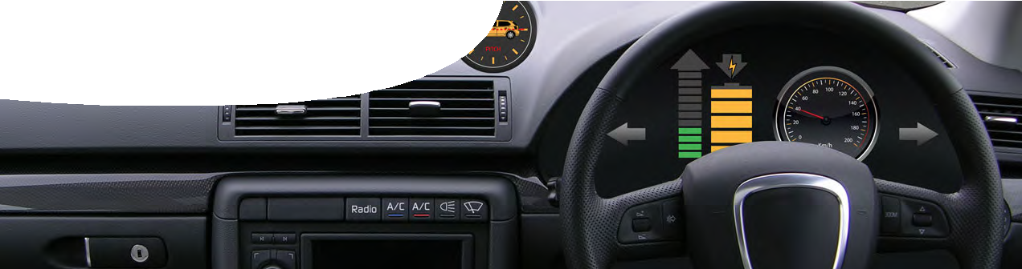
teacher guide
Energy transformations 3:
Analysing energy

Components

 | NAME | DESCRIPTION | AUDIENCE
 | Analysing energy  teacher guide | This guide explains how to use a learning object and associated fact sheet and worksheet to develop students’ understanding of energy transformations in an electric vehicle. | teachers
 | Take it for a drive  learning object | This learning object contains an eight-minute video of a journey in an electric vehicle. An animated dashboard  provides information and data to investigate relationships between road conditions, accessory use and energy consumption. | students
 | Tracking energy use  worksheet | This worksheet accompanies the learning object, Take it for a drive. Students use a graph of energy consumption versus time for the journey to explain energy transformations that occur in the vehicle. | students
 | Renewable energy vehicle  fact sheet | This fact sheet provides background information on the REV project at UWA and some characteristics of electric vehicles. | students
 | Lego car  video | This video demonstrates how the motor in a Lego car can be used to generate electricity, to model regenerative braking. | teachers

Purpose
To build students’ Explanations of energy transformations that occur in an electric vehicle.

Outcomes
Students:
- understand energy can be transformed from one form to another in useful and non-useful ways;
- create energy flow diagrams to show how energy is transformed from one form to another, including where energy is ‘wasted’ as heat;
- understand heat energy is always produced during energy transformations;
- analyse and explain energy transformations in an electric vehicle and identify the main uses of this energy;
- explain the original energy source for an electric vehicle may be renewable or non-renewable;
- describe how efficient running of an electric vehicle depends on driving conditions;
- describe regenerative braking in an electric vehicle; and
- describe advantages and disadvantages of using an electric vehicle.

Activity summary
ACTIVITY POSSIBLE STRATEGY
Students read the fact sheet, Renewable energy vehicle, for background information on electric cars. | individually
Teacher may demonstrate how the motor in a Lego car may be used to generate electricity, to model regenerative braking.  Alternatively students may perform this activity themselves. | teacher demonstration or student activity
Students use the learning object, Take it for a drive, to analyse an eight-minute journey in an electric vehicle. Students should pause the video to add notes and answer questions on the worksheet, Tracking energy use. | individually or in pairs

Teacher notes
The learning object, Take it for a drive, contains an eight-minute interactive video and animation of an electric car driving from The University of Western Australia into Kings Park. An animation
shows students a view of the road and a dashboard developed for this resource. The dashboard is ‘live’ and responds to driving conditions and accessory use.
Students should use the worksheet, Tracking energy use, while watching the animation, Take it for a drive. The worksheet contains a graph showing
the relationship between battery charge (energy consumption) and time. In the worksheet students are asked to relate what they see in the animation to the graph and then answer questions about how energy is transformed in an electric vehicle.
This animation was based on data obtained from the REV project’s electric Getz. Changes in energy consumption closely mirror those seen in reality.
The fact sheet, Renewable energy vehicle, contains information on the REV project and some important considerations when driving an electric vehicle.

Regenerative braking
Most simple electric motors use interaction between electric current supplied to the motor, and a magnetic field within the motor, to produce motion. If there’s no supplied current, but the motor shaft is rotated, the motor can work as a generator.
This is used in electric vehicles. When current from batteries is cut to the motor, during braking, motion of the vehicle turns the motor shaft and produces electricity that can ‘top up’ batteries.
A short video shows how electricity is produced from a motor when a model electric car is pushed along.
This may be demonstrated to students, or they can be challenged to build Lego cars and perform the activity themselves.

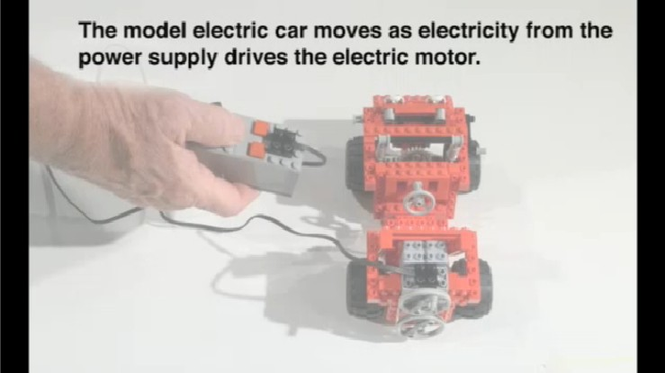

SPICE resources and copyright
All SPICE resources are available from the Centre for Learning Technology at The University of Western Australia (“UWA”). Selected SPICE resources are available through the websites of Australian State and Territory Education Authorities.
Copyright of SPICE Resources belongs to The University of Western Australia unless otherwise indicated.
Teachers and students at Australian and New Zealand schools are granted permission to reproduce, edit, recompile and include in derivative works the resources subject to conditions detailed at spice.wa.edu.au/usage.
All questions involving copyright and use should be directed to SPICE at UWA.
Web: spice.wa.edu.au Email: spice@uwa.edu.au Phone: (08) 6488 3917
Centre for Learning Technology (M016) The University of Western Australia
35 Stirling Highway
Crawley WA 6009

Technical requirements
The teacher guide, worksheet and fact sheet require Adobe Reader (version 5 or later), which is a free download from www.adobe.com. The worksheet is also provided in Microsoft Word format.
A modern browser (e g Internet Explorer 9 or later, Google Chrome, Safari 5.0+, Opera or Firefox) is required to view the learning object.

Acknowledgements
Thanks to Renewable Energy Vehicle project staff from the School of Electrical, Electronic and
Computer Engineering at The University of Western Australia: Professor Thomas Bräunl (REV Project Director) and Marcus Pham.
For more information on the REV project, see http://www.therevproject.com
Designed and developed by the Centre for Learning Technology, The University of Western Australia.
Production team: Alwyn Evans, Bob Fitzpatrick, Sally Harban, Dan Hutton, Paula Lourie, Dominic Manley, Bec McKinney, Paul Ricketts, Kate Vyvyan and Michael Wheatley with thanks to Beate Ferbert- Booth, Jan Dook, Jenny Gull, Wendy Sanderson and Jodie Ween.

Associated SPICE resources
Energy transformations 3: Analysing energy may be used in conjunction with related SPICE resources to address the broader topic of energy transfer, transformation and conservation.

DESCRIPTION | LEARNING PURPOSE
Energy transformations (overview)
Energy transformations 1: Comparing cars  A video compares conventional internal combustion powered cars to REV vehicles and introduces some associated energy transformations. | Engage
Energy transformations 2: Investigating energy  Students make model vehicles that use different energy sources to investigate energy transformations. | Explore
Energy transformations 3: Analysing energy  Students develop explanations of energy transformations by analysing data from a simulated electric vehicle journey. | Explain
Energy transformations 4: Car choices  Students use data about a range of conventional, electric and hybrid vehicles to decide and communicate which car is suited to specific purposes. | Elaborate

