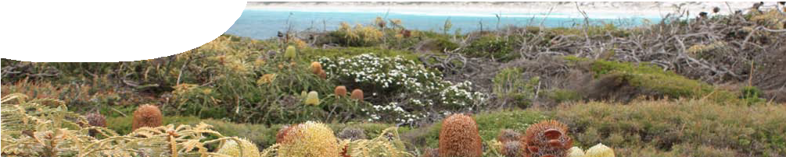
fact sheet
Species re-introduction

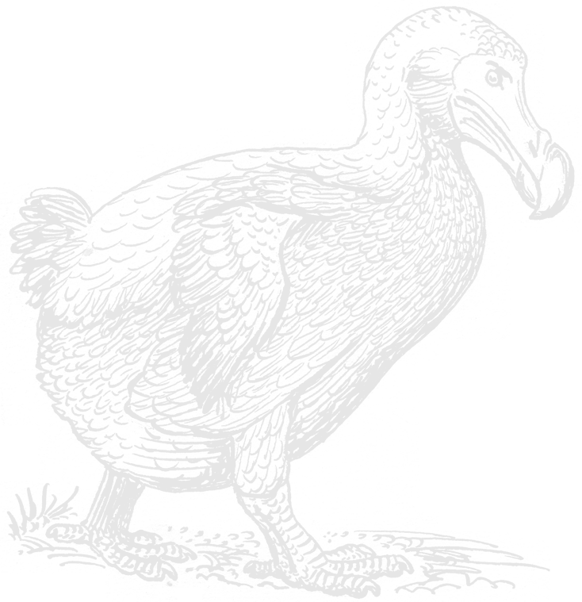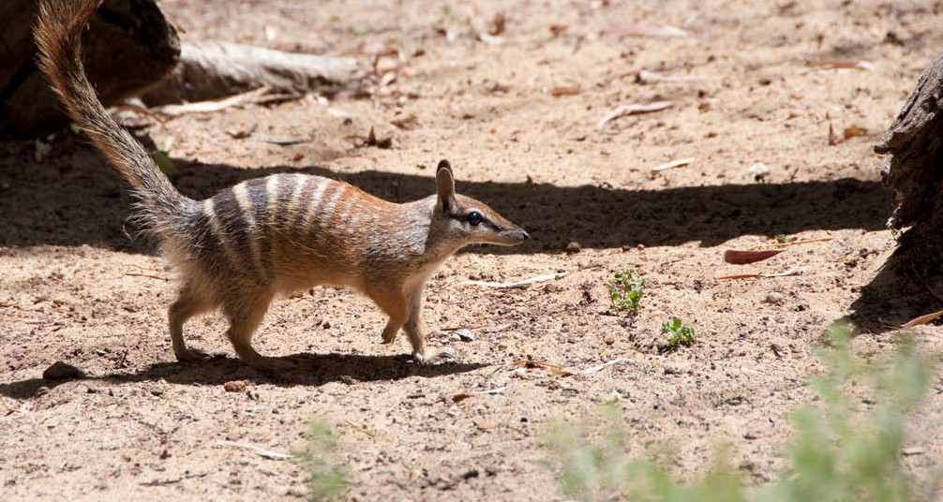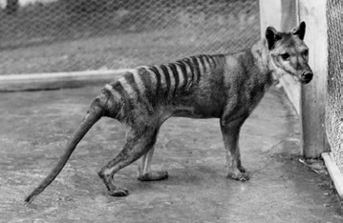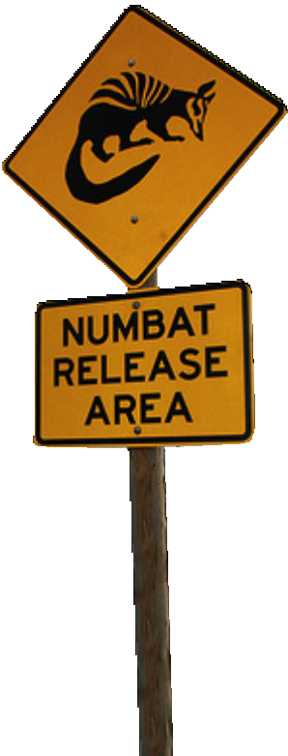DEAD END

Conservation biologists work hard to preserve our world’s plant and animal species. The challenges they face are enormous: habitat loss, the illegal wildlife trade, pollution and a changing climate, are just a few. Conservation methods vary, from protecting entire ecosystems in national parks, to targeting a species through captive breeding programs, or carrying out re-introductions.

Re-introduction
A re-introduction is the release of a number of individuals back into an area from which they’ve disappeared. The goal of a re-introduction is to establish a population that doesn’t need continual management to survive. However there’s more to a re-introduction than chucking a few animals or plants off the back of a truck and hoping for the best!
First scientists need to understand the organism’s habitat requirements, the possible threats they face and the suitability of the potential release site.

Habitat requirements
What does a species need to survive and thrive?
Things to consider include: climate, availability of water, nesting sites, shelter from predators, the presence of food. Scientists investigate the needs of a particular species through detailed research into their biology and ecology.

Site assessment
Is the proposed release site suitable?
Things to consider include: whether the site supports the species’ habitat requirements, the restoration of degraded habitats, removal of feral animals and plants.
A site survey reveals if an area meets the species’ habitat requirements, and identifies any threats.
Threats
Why did the species decline in the first place?
Things to consider include: pollution, disease, predation or competition from an introduced species, over collection, and habitat degradation due to housing developments, mining or agriculture.
Unless scientists understand the reasons for the original localised extinction, a re-introduction won’t work.

Threats to re-introduction programs in WA

Dieback – Phytophthora cinnamomi
Dieback (root-rot fungus) is an introduced plant disease that’s fatal to native plant species. If plants die, native animals lose their food source, and whole ecosystems begin to collapse.
Yellowing foliage and shoot dieback may indicate that plant roots are infested.
Evidence of dieback is mapped so scientists can monitor how far the disease has spread. Aerial photographs and evidence collected in the field is summarised on infestation maps that are available on the Project Dieback website.
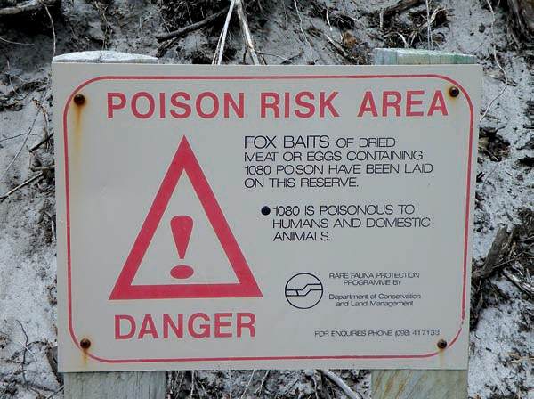
There’s no way to eradicate dieback, but scientists can stop it spreading by following strict hygiene rules. Infected soil can be carried on people’s shoes, cars and even horses’ hooves – so thorough cleaning after visiting an infected area is essential.

Which animals are re-introduced
A release population is chosen by health, age and sex, plus their genetic and physiological similarity with the original population. Numbers are important – enough individuals need to be released to ensure genetic diversity and the best chance of long-term survival.
In Western Australia the Department of Conservation and Environment decides if a re-introduction is a good idea. A
detailed proposal is required that includes
a post-release plan to monitor the population after re-introduction.
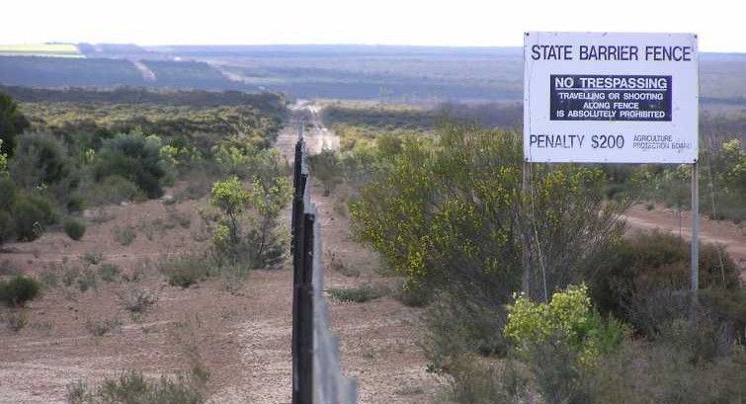
Numbats have been re-introduced into the Stirling Ranges, Western Australia. In Victoria, the brush- tailed rock wallaby has been re-introduced into the Grampian National Park.
Feral predators
Foxes and cats are two introduced predators that have a devastating impact on small mammals and ground- nesting birds.
Live trapping, spotlighting, scat counts and sand plots are all used to work out if these predators are living in an area. Sand plots are strips of smoothed sand. Any animal crossing over the plot leaves a set of identifiable footprints.
Eradication of feral animals is extremely difficult. Ongoing management is more realistic, including fencing of predator proof enclosures, shooting, trapping and baiting.

1080 (sodium fluoroacetate) is a poison used by the Department of Environment and Conservation to control feral dogs and foxes. Some native herbivores are partially immune to it as it occurs naturally in some Western Australian plants.

Re-introductions are rarely a quick fix solution. It’s far, far better to conserve a habitat from the beginning, than attempt to restore and rebuild it later.

