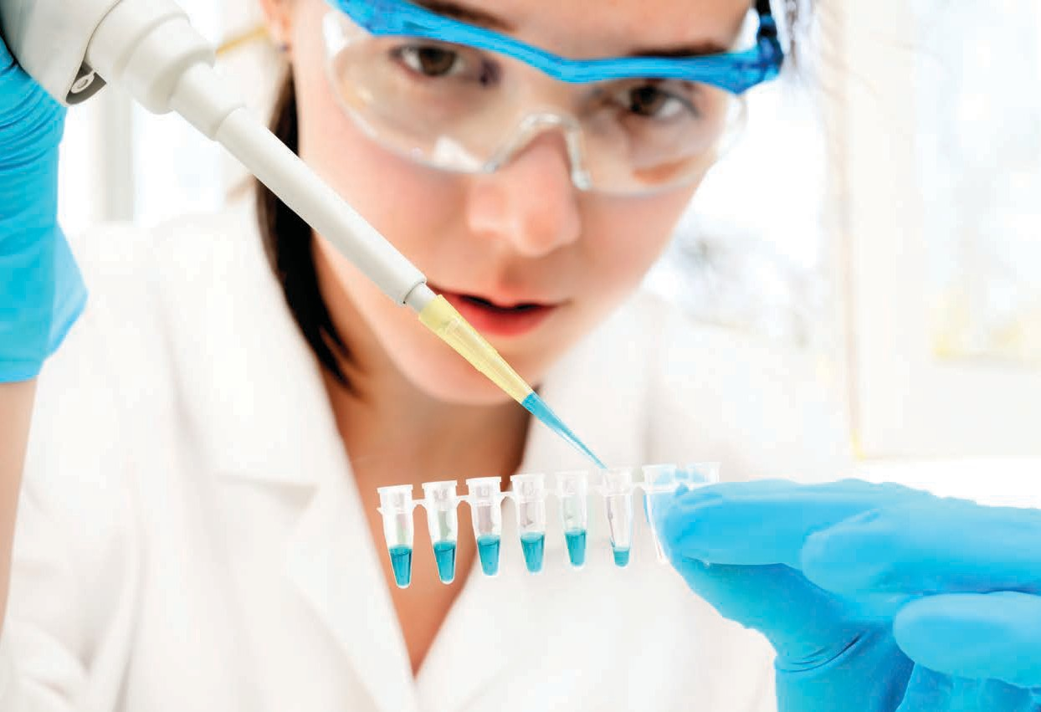Searching for mutations with polymerase chain reaction

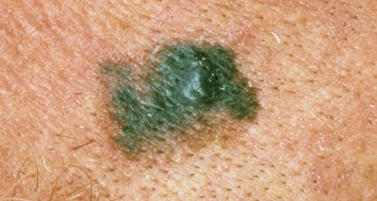
Australia has one of the highest rates of melanoma in the world. Each year 11 545 Australians are diagnosed with melanoma, and over 1500 die from the disease.
Melanoma
Melanoma is the least common type of skin cancer: 2.3% of all skin cancers; but the most dangerous, resulting in 75% of all skin cancer deaths.
Melanoma, like all cancers, occurs when one or more genes mutate. Mutations can be inherited (germline mutation) or acquired over an individual’s lifetime (somatic mutation), such as through over-exposure to ultra-violet radiation. Over 90% of all melanomas

are associated with mutations acquired during an individual’s lifetime.

Melanoma mutations
Melanoma usually occurs on the skin; rare forms appear
on the eyes and mouth. © Cancer Council Western Australia

All cancer is usually associated with multiple somatic (acquired) mutations. In melanoma, hundreds, even thousands, of somatic mutations can be present.
VEM
abnormal cell growth
It’s now possible to test melanoma patients for mutations, in genes such as NRAS, BRAF and KIT, commonly associated with the disease. These genes play an important role in melanoma development and progression, and identification can improve treatment outcomes.

BRAF and mutated BRAF
The normal BRAF gene is found in normal cells, and codes for a protein that’s part of a cell-signalling pathway involved in cell division.
Over 50% of melanomas have mutations in the BRAF gene. The most common type of BRAF mutation found in melanoma is V600E. This mutation involves a single nucleotide change: thymine (T) to adenine (A), resulting in a single amino acid change in the BRAF protein: valine to glutamic acid.
The mutated BRAF protein is continuously active, triggering the cell-signalling cascade and moving cell growth into overdrive.

Targeting BRAF mutations
Understanding the role of BRAF in cell growth has led to development of inhibitor drugs that block the action of the mutated protein. Early trials with BRAF inhibitors have produced positive results, increasing patients’ lifespan.
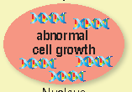
Cell-signalling pathway
– the role of BRAF
growth
factor
cell membrane
RAS BRAF
the rate of cell growth
BRAF plays a role in
and division.
MEK
requir Normally BRAF
the RAS protein to
es a signal from become active.
ERK
BRAF then signals
pr
otein MEK, resulting
its neighbouring
in cell growth.
normal cell
growth
Nucleus
Cell-signalling pathway
– the role of mutated BRAF V600E
Cell-signalling pathway
– the role of BRAF inhibitor
growth
factor
cell membrane
growth
factor
cell membrane

RAS
Mutated BRAF is
RAS
mutation
BRAF
always active.
(VEM) blocks the
Vemurafenib
It no longer needs a
action of the
signal from the RAS
BRAF
mutated BRAF
protein.
MEK
protein.
continuously signals
Mutated BRAF
MEK
pr Blocking this
otein stops the
cell-signalling
ERK
its neighbouring
cascade and
the cell grows and
protein MEK and
divides.
ERK
halts cell growth
death of cancer
or causes the
cellular
cells.
proliferation
Nucleus

Identifying mutations associated with melanoma requires a number of biotechnological techniques, including polymerase chain reaction (PCR).
Polymerase chain reaction: history and applications
Polymerase chain reaction, developed in 1985, revolutionised how DNA is used in biological and medical research. PCR is a laboratory technique that produces a large amount of DNA from a small sample. PCR amplifies (copies) DNA, producing billions of copies in just hours. This rapid amplification technique provides scientists with enough DNA for further analyses. Prior to the development of PCR, replication of DNA was complex, taking weeks to complete.
PCR is used in diverse fields from food analysis to forensic science, including:

Is there horse in my beef burger?
In 2013, routine testing by the Irish Food Safety Authority revealed horsemeat in beef burgers. The PCR technique was used to identify the type of meat. To do this DNA from burger samples was amplified (copied) using PCR, and samples were separated by size using agarose gel electrophoresis. By comparing these DNA samples with those of known size (cow, pig, horse), horsemeat was detected.

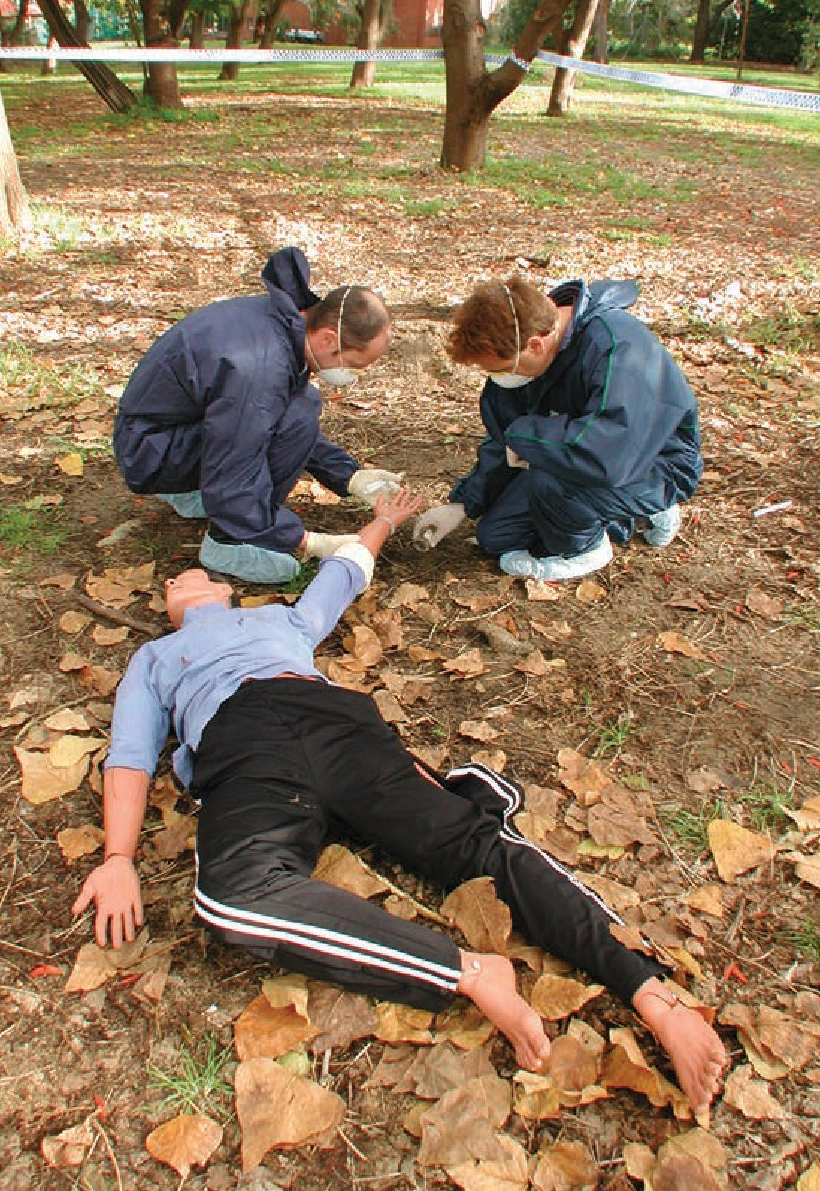
PCR and forensic science
Criminals often leave clues to their identity at crime scenes in the form of DNA. But, recovered
samples often contain only small amounts, such as a hair sample, blood, or even saliva. PCR is used in forensic science to amplify small amounts of DNA, which can be used to produce either a DNA fingerprint or a DNA profile. This technique can help link a suspect with a crime.

PCR and gene expression
Gene expression refers to the activity level of a gene, that is, the amount of functional product it makes, usually protein. Not every gene in every cell is active (turned on). When a gene is expressed, it means it’s transcribed into a gene product, such as messenger RNA (mRNA).
Measuring quantity and type of mRNA in a cell allows scientists to identify which genes are expressed, and in what amounts.
Modified PCR techniques that measure gene expression, such as reverse transcriptase PCR (RT-PCR), have been developed. This technique converts mRNA into complementary DNA (cDNA) which is amplified using traditional PCR techniques. Calculating the amount of cDNA produced is a measure of gene expression.
RT-PCR is used in disease diagnosis, including detection of BRAF V600E mutations in melanoma.

In today’s laboratory activity you’ll use two of the required techniques to identify genetic mutations associated with cancer, such as melanoma. Using PCR and gel electrophoresis you’ll produce sufficient DNA, from melanoma samples provided, for genetic sequencing. Then you’ll investigate data generated from these results.
Laboratory activity aim:

Laboratory activity:
This activity is composed of two parts:

Part I
- Combine DNA samples with reagents, including primers.
- Load DNA samples into the PCR thermocycler and produce billions of copies of the target sequence: a segment of the BRAF gene.

Part II
- Prepare an agarose gel.
- Load PCR products and control samples onto the agarose gel and apply an electrical current, separating DNA fragments.
- Stain the gel and visualise DNA fragments.
Part I: Polymerase chain reaction

The BRAF V600E mutation is commonly found in DNA of melanoma cells. To detect this mutation a segment of the BRAF gene is sequenced, that is, the order of nucleotides is established. PCR produces the quantity of DNA required for genetic sequencing by amplifying the segment of DNA containing the BRAF mutation.
The purpose of this activity is to amplify a 247 base pair (bp) segment of the BRAF gene known to contain the V600E mutation. PCR generates enough DNA to sequence melanoma cell DNA, from two patients (patient A and
patient B).
DNA samples
DNA samples are provided for this activity.
You’ll be given two sets of these three DNA samples:
- DNA from normal skin cells (non-cancerous);
- DNA from melanoma cells of Patient A; and
- DNA from melanoma cells of Patient B.
DNA sample set 1, will undergo PCR, it also includes a water sample which acts as a control.
DNA sample set 2, will not undergo PCR. These samples act as a control, determining if your PCR was successful in amplifying a segment of the BRAF gene.
There are two controls in this activity:
- DNA sample set 2, that doesn’t undergo PCR, to compare with DNA sample set 1 to see if PCR is successful; and
- the water sample, to compare with DNA sample set 1 to ensure no contaminants are present in the reagents (chemicals).

Materials for amplification
Along with reagents, you’ll add the following components to your DNA samples.

Primers
A primer is a short strand of DNA that is complementary to part of the target gene sequence. Primers are essential for DNA polymerase to attach to DNA, enabling amplification to begin. As DNA has two strands, two primers are
required: a forward primer and reverse primer. DNA has two different ends: 3’ (3 prime) and 5’ (5 prime). DNA is always transcribed from 3’ to 5’ – primers always anneal (bind) at the 3’ end.

Double-stranded DNA
5’ 3’

3’ 5’
Each strand of DNA needs a primer
5’ 3’

Forward primer
5’
5’

Reverse primer

3’ 5’

5’
3’
3’
Create a forward and reverse primer, 10 base pairs in length, for each strand of DNA.

Write both primers, in the correct position, next to each strand.

5’

Taq polymerase
Copying any DNA requires DNA polymerase. In this activity you’ll add the enzyme Taq DNA polymerase. Taq polymerase comes from the bacterium Thermus aquaticus, a bacterium that lives in hot springs and hydrothermal vents and tolerates extreme temperatures.
PCR requires application of high temperatures (> 90°C) to separate strands of DNA. Taq polymerse remains stable at temperatures up to 95°C. This stability under high temperatures means it’s commonly used in PCR.

Nucleotides
Taq polymerase requires building blocks to synthesise new DNA sequences. These building blocks are dNTPs (deoxynucleoside triphosphates), four nucleotides that make up DNA: cytosine (C), guanine (G), adenine (A), and thymine (T). Taq polymerase adds nucleotides to the end of the primer and builds a complementary strand of DNA.

Thermocycler
Primers, Taq polymerase, and nucleotides are combined with reagents and added to DNA samples. This mix is placed into a thermocycler, a machine which heats and cools DNA repeatedly, amplifying DNA.
There are three stages in PCR:
- denaturation: high temperature that causes double stranded DNA to denature (separate into single strands);
- annealing: cooling that allows primers to anneal (bind) to DNA strands; and
- elongation: increased temperature that allows Taq polymerase to add nucleotides, to build new DNA strands. Repeating these temperature cycles 25 – 35 times produces billions of copies of the target DNA sequence.
Temperature settings are pre-programmed and vary according to the DNA segment to be amplified; type of polymerase; and length and composition of primers.

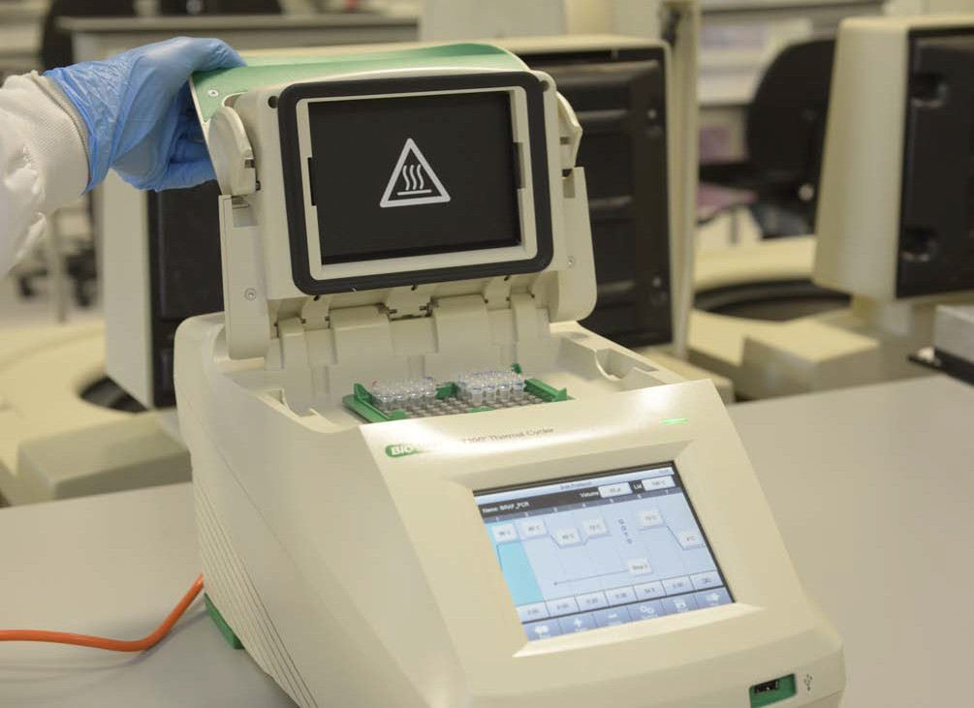

How does PCR work?

Make a Master Mix: this contains reagents required for DNA amplification.

primers

MgCl2

Taq
polymerase

Master Mix

dNTPʻs

buffer

H2O

Add the Master Mix to the DNA samples.

DNA samples

Place in thermocycler, this will run 35 cycles of heating and cooling producing billions of copies of the target segment.

thermocycler

The three stages of PCR:
- denature
- anneal
- elongate

100
90
80
70
temperature (˚C)
60
50
40
30
20
10
0
0

Three temperature cycles of PCR

denature DNA
nucleotides added
elongation

anneal primers

5’ 3’
primer
primer
3’ 5’

1 2 3 4 5
time (mins)

PCR materials
Step 2: Calculating quantities for the Master Mix
Label the 1.5 mL tube with ‘Master Mix/MM’ and your group number.
Use the table below to calculate quantities for your Master Mix.
Ensure your mix contains enough reagents for 5 reactions.
Table 1: Master Mix quantities
- 1.5 mL tube for Master Mix
- strip of 4 microtubes (3 containing 8 μL DNA; 1 containing a water control sample)
- 3 eppendorf tubes (each containing 8 μL DNA)
- p20 pipette and sterile tips
- p200 pipette and sterile tips
- 10x PCR buffer, stock solution
- MgCl2, (50 nM), stock solution
- forward primer BRAF_F, stock solution
- reverse primer BRAF_R, stock solution
- Taq polymerase
- dNTPs (A,T,C,G (10 mM))
- sterile water
- gloves and safety glasses

Method
Step 1: Preparation
Collect DNA samples:
- strip of 4 microtubes (3 containing experimental DNA samples, and 1 containing water control sample); and
- 3 individual eppendorf tubes containing control DNA samples.
Mark each with your group number.

REAGENT | STOCK CONCENTRATION | VOLUME PER REACTION (µL) | 5X MASTER MIX (µL)
10x PCR buffer | 10x | 2
MgCl2 | 50 mM | 0.6
dNTP mix | 10 mM | 0.4
BRAF forward primer | 50 ng/µL | 1
BRAF reverse primer | 50 ng/µL | 1
Taq polymerase | 5 U/µL | 0.4
PCR water |  | 6.6
 |  | 12 µL TOTAL

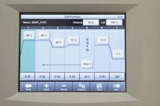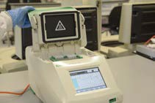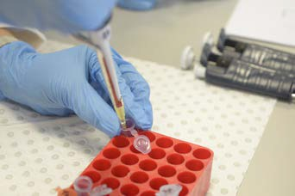
Step 6: Running PCR
Use mini-centrifuge to spin your DNA samples for 3 seconds.
Take your tubes to PCR thermocycler, as directed.
Make sure you labelled your tubes with your group number.
The technician will start the PCR thermocycler when all samples are in place.
PCR thermocycler conditions
PCR thermocycler heats and cools DNA samples 35 times according to pre- programmed steps. This process takes approximately 1.5 hours.
Table 2: PCR thermocycler conditions
Step 3: Preparing the Master Mix
Prepare Master Mix using p20 and p200 pipette.
Remember to change tips each time you add a new reagent.
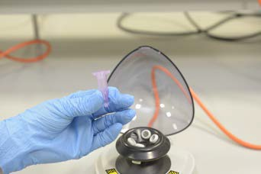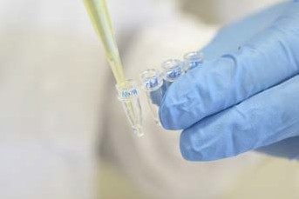
Step 4: Mixing the Master Mix
Place your Master Mix tube in vortex for 2 seconds to mix reagents thoroughly.
Use the mini-centrifuge to spin your Master Mix tube for approximately 3 seconds. Spinning ensures Master Mix pools at the bottom of the tube.
Step 5: Adding Master Mix to DNA samples
Select strip of 4 microtubes each containing 1 of the following 4 DNA samples:
- normal skin cells (norm);
- patient A – melanoma cells (pt A);
- patient B – melanoma cells (pt B); and
- a water control sample.
Use p20 pipette to add 12 μL of PCR Master Mix to each of the 3 DNA samples, and water control sample.
Remember to change pipette tips for each sample so they are not cross contaminated.

CYCLE | TEMPERATURE (°C) | TIME (SECONDS) | CONDITION
1 | 95 | 180 | initialisation
2 | 95 | 20 | denaturisation
3 | 60 | 20 | annealing
4 | 72 | 30 | elongation
Cycles 2 – 4 are repeated 3 | 5 times before cycle 5
5 | 72 | 120 | final elongation

The purpose of this activity is to separate fragments of DNA based on their length, measured in base pairs (bp), using gel electrophoresis.
Part II: Gel electrophoresis
Gel electrophoresis uses an electrical current to separate fragments of DNA which is a negatively charged molecule. Applying an electric current through an agarose gel causes DNA molecules to migrate towards the positive anode. Short segments of DNA travel faster and further through the gel, while longer segments move more slowly and cover less distance.
Visualisation of the DNA segments after electrophoresis reveals bands of DNA. The PCR aimed to produce multiple copies of a 247 bp segment of the BRAF gene where the V600E mutation is found. If your PCR was successful in making billions of copies of this segment you’ll be able to visualise this as a distinct band on the gel. Comparing your PCR samples to control samples (tubes not subjected to PCR) will confirm the success of PCR.
Your PCR samples and control samples will be run alongside a DNA ladder. A DNA ladder contains DNA fragments of known size, measured in base pairs (bp). Like a ruler, the DNA ladder allows you to estimate the size of your PCR product.
Estimate where your 247 bp PCR product would appear on the
gel, by drawing a horizontal line on the DNA ladder.
-
START
(bp)
Control samples (labelled in red) will not be amplified by PCR and
are much larger molecules.
Estimate where your control samples would appear on the gel, by drawing a horizontal line on the DNA ladder.
3000
2000
1500
Example of a 100 bp
DNA ladder. The DNA ladder allows you to estimate the size of each DNA fragment.
1000
900
800
700
600
500
400
300

200

100
+ 3% agarose

- Preparing the gel
The purpose of this activity is to prepare an agarose gel mould for your DNA samples.

Materials
- electrophoresis unit
- power pack
- gel tray
- gel tray gates
- well comb
- molten agarose gel (3% agarose, containing SYBR™ Safe DNA Gel Stain)
- gloves and safety glasses

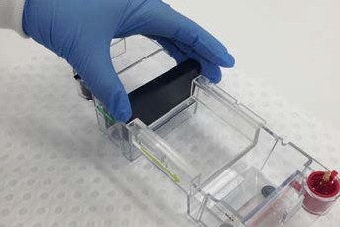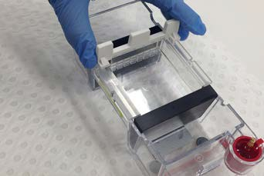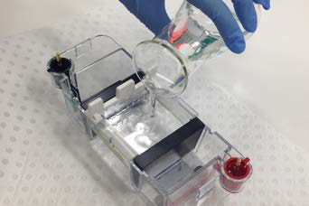Method
Step 1
Place gel tray in electrophoresis unit.
Position gel tray gates at either end of gel tray to ensure no leakage of agarose.
Step 2
Place well comb into notches at one end of gel tray.
Step 3
Pour warm 3% agarose into tray slowly, try not to introduce bubbles.
Use a toothpick to pull any bubbles to the sides.
Allow 30 minutes for gel to set.

- Loading and running the gel
The purpose of this activity is to load your DNA samples into your gel, and using an electrical current, separate DNA samples by fragment size (bp).

Materials
- electrophoresis unit
- power pack
- p20 pipette and sterile tips
- marker pen or pencil
- 500 mL beaker for waste
- 250 mL beaker
- 250 mL dilute TAE buffer
- strip of 4 microtubes containing samples that have undergone PCR
- 3 eppendorf tubes containing samples that have not undergone PCR
- 100 bp DNA ladder
- loading dye
- gloves and safety glasses

Method
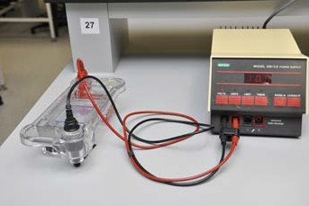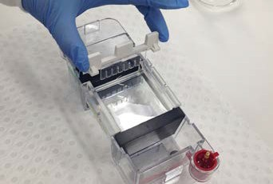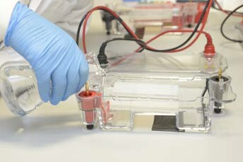
Step 1
Position electrophoresis unit and power supply close together, so the lid can be placed comfortably onto the unit without moving it.
Step 2
Remove comb from gel by gently pulling it straight up. The comb has created small wells into which samples will be loaded.
Remove gel tray gates.
Step 3
Pour 250 mL dilute TAE buffer gently over the gel.

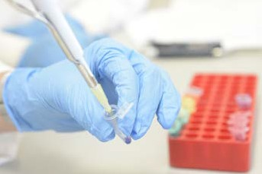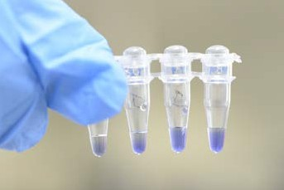
Step 5
Use the p20 pipette to add 7 µL loading dye to each sample that underwent PCR: 3 DNA control samples and water control.
Remember to change pipette tips for each sample to avoid cross contamination.
Cap tube tightly and place in vortex for 10 seconds.
Transfer to centrifuge and spin for 30 seconds.
Step 4
Before your DNA samples can be loaded into the wells of your gel, mix them with a loading dye. This dye helps samples sink to the bottom of the wells, and also allows you to visually track the progress of electrophoresis.
Loading dye only needs to be added to samples that underwent PCR.
The DNA ladder and the DNA sample tubes already contain loading dye.

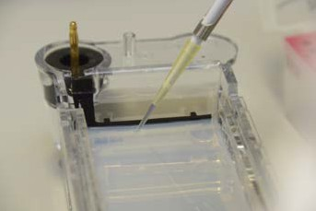Step 7
Use the table below to establish quantities of each sample to be loaded in each well of the gel.
Use p20 pipette to load wells.
Remember to change pipette tips for each sample.
Follow the order specified in the table so you don’t mix up wells.

Well # | Sample | Volume
1 | DNA ladder, pre-mixed with loading dye | 8 µL
2 | post-PCR normal skin sample | 20 µL
3 | post-PCR patient A | 20 µL
4 | post-PCR patient B | 20 µL
5 | water | 20 µL
6 | normal skin sample | 20 µL
7 | patient A | 20 µL
8 | patient B | 20 µL
Table 3: Quantities of loading dye to add to each sample.

Use the diagram below and label each well with the sample’s name.

1
wells
2
3
4
5
6
7
8

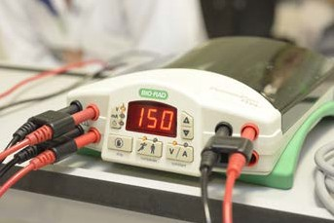
Step 8
Place lid on electrophoresis unit.
Connect leads to power supply and set to 150 V.
Run power through gel for approximately 20 minutes.

To visualise DNA bands on the gel, SYBR™ Safe DNA Gel Stain is added to agarose. This stain binds to DNA enabling you to visualise it.
Part III: Visualising results
Once the electrophoresis is complete your gel is loaded into a visualising instrument, Gel Doc EZ System. Image Lab software allows viewing and imaging of the DNA bands.

Materials
- electrophoresis unit
- disposable food container
- gloves and safety glasses

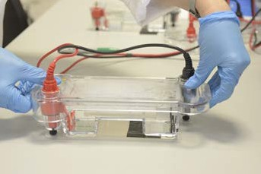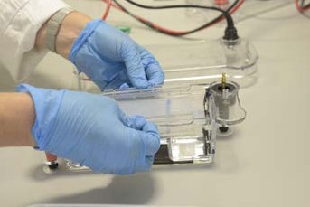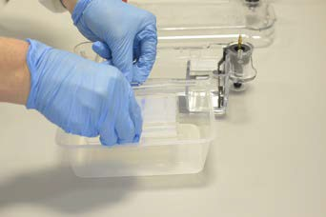Method
Step 1
Remove gently, lid of electrophoresis tank.
Step 2
Wear gloves to lift the tray on a small angle, from the tank, allowing buffer to drain back into the tank.
Step 3
Tip tray and slide gel into disposable food container.

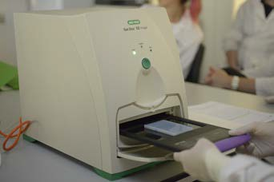
Step 4
Take the gel in container to the Gel Doc EZ System where an image is taken with imaging software.

Step 5: Visualising the PCR product
The imager will produce an image of your gel.
If your PCR successfully amplified a segment of the BRAF gene, all three samples (patient A, patient B, and normal skin) in DNA sample set 1, will appear as bands on the gel at approximately 247 bp on the DNA Ladder.
Mark on the diagram below the bands you can see on your gel image.
Comment on the position on the gel, of control DNA samples (those samples that did not undergo PCR). Why are they in this position?
Is there a band on the gel from the water control?
What could be a source of contamination in this activity?

1 2 3 4 5 6 7 8
wells
 |  | STAR | T
 |  | (bp)
 |  | 3000
 |  | 2000
 |  | 1500
 |  | 1000
 |  | 600
 |  | 500
 |  | 400
 |  | 300
 |  | 200
 |  | 100
3% | agarose  DNA  ladder
 |  |  |  | norm |  | pt A |  | pt B
 |  |  |  | (PCR) |  | (PCR) |  | (PCR) |  | water |  | norm |  | pt A |  | pt B

To determine if either patient A or patient B carries the BRAF V600E mutation, samples amplified by PCR, and visualised by gel electrophoresis, need to be sequenced.
Part IV: Sequencing
DNA sequencing involves determination of the precise order of nucleotides within a gene, chromosome, DNA fragment, or full genome. There are many sequencing technologies currently available.
Sequence results of the 247 bp segment amplified by the PCR activity are provided below for normal skin cells, and melanoma cells from patient A and patient B. The V600E mutation occurs at base number 1799 of the BRAF gene and involves a single nucleotide change from thymine (T) to adenine (A).
The sequence below shows the amplified region of BRAF from the normal skin sample.
Identify base number 1799 (start counting at base number 1674).
Write down the base found in this position. Normal skin sequence:
Forward strand: ACTCTTCATAATGCTTGCTCTGATAGGAAAATGAGATCTACTGTTTTCCTTTACTTACTACACCTCAGATATAT TTCTTCATGAAGACCTCACAGTAAAAATAGGTGATTTTGGTCTAGCTACAGTGAAATCTCGATGGAGTGGGTCCCATCAGTTTGAAC AGTTGTCTGGATCCATTTTGTGGATGGTAAGAATTGAGGCTATTTTTCCACTGATTAAATTTTTGGCCCTGAGATGCTGCTGAGTT

Sequences below show amplified regions of BRAF from melanoma cells of both patient A and patient B.
Identify base number 1799 (start counting at base number 1674) in each sequence.
Write down the base in this position for both patients.
Determine if either patient carries the BRAF V600E mutation.

PATIENT A sequence:
Forward strand: ACTCTTCATAATGCTTGCTCTGATAGGAAAATGAGATCTACTGTTTTCCTTTACTTACTACACCTCAGATATAT TTCTTCATGAAGACCTCACAGTAAAAATAGGTGATTTTGGTCTAGCTACAGAGAAATCTCGATGGAGTGGGTCCCATCAGTTTGAAC AGTTGTCTGGATCCATTTTGTGGATGGTAAGAATTGAGGCTATTTTTCCACTGATTAAATTTTTGGCCCTGAGATGCTGCTGAGTT

PATIENT B sequence:
Forward strand: ACTCTTCATAATGCTTGCTCTGATAGGAAAATGAGATCTACTGTTTTCCTTTACTTACTACACCTCAGATATAT TTCTTCATGAAGACCTCACAGTAAAAATAGGTGATTTTGGTCTAGCTACAGTGAAATCTCGATGGAGTGGGTCCCATCAGTTTGAAC AGTTGTCTGGATCCATTTTGTGGATGGTAAGAATTGAGGCTATTTTTCCACTGATTAAATTTTTGGCCCTGAGATGCTGCTGAGTT

Sequencing data reveals patient A carries the BRAF V600E mutation.
Describe what may be occurring in patient A’s melanoma cells as a result of this mutation.

Melanoma sequencing and treatment
Identification of the BRAF V600E mutation in melanoma samples provides important information to practitioners, regarding patient treatment options. Patients with inoperable metastatic melanoma who carry the BRAF V600E mutation are eligible for treatment with pharmaceuticals that inhibit the function of the BRAF mutated protein.

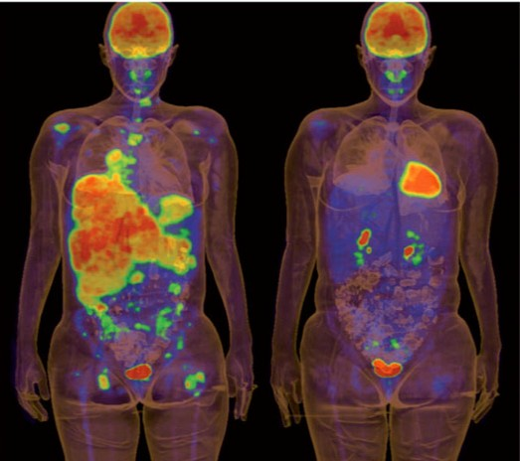
pre-treatment 2 weeks vemurafenib
PET scans of a melanoma patient before treatment with vemurafenib and after two weeks of treatment. Positron emission tomography scans reveal areas of high metabolic activity in the body, such as: the brain,
heart, bladder and kidneys, or fast growing cancer cells. In the scan, these areas appear ‘brighter’ than others. © G. McArthur and R. Hicks, Peter MacCallum Cancer Centre, Melbourne, Australia

Melanoma progression in patients taking these pharmaceuticals is halted or slowed. However, disease regression only persists for an average of 5 – 6 months. Currently, clinical trials combining two inhibitor drugs are underway, in the hope that survival rates will improve.
Metastatic melanoma has long been a difficult cancer to treat. It responds poorly to traditional cancer therapies such as chemotherapy or radiotherapy. Targeted medical treatments based on genetic profiling of tumours offers real advances in treatment options for patients. These treatments act by interrupting cell signals sent by mutated proteins that cause cells to continuously divide.
PCR and genetic sequencing technologies are used in diagnostics to detect the presence of BRAF V600E. Technological advances mean current turn around time for testing is rapid, with results available to treating physicians and patients within a week, or even days of biopsy or excision.

Aim of the game:
PCR challenge
To make as many DNA segments as you can during three PCR cycles. Using paper PCR tools provided you’ll amplify a segment of DNA.
PCR is carried out inside a thermocycler, a machine which heats and cools DNA repeatedly, amplifying DNA. There are three stages in PCR:
- denaturation
- annealing
- elongation.
Each stage occurs, within the thermocycler, at a specific temperature. In this activity you’ll recreate each stage.

Tools:
To play, form pairs.
Each pair receives a PCR kit containing:
- 1 double-stranded DNA template
- 10 forward primers – pink DNA segments
- 10 reverse primers – green DNA segments
- 1 bag nucleotides
- 1 roll of sticky tape
- 1 pair of scissors
- 1 Taq badge

How to play:

Cycle 1

Denaturation: temperature: 95°C
Take the double-stranded DNA template and cut lengthwise into two strands. Each person in your pair takes one single-stranded DNA template.

Annealing: temperature: 60°C
Choose the correct primer for your single-stranded DNA template. (Hint: it’s either forward or reverse.) Remember primers always anneal at the 3’ end of a DNA segment and follow rules of complementary base pairing.
Use tape to stick the correct primer to each single-stranded DNA template.

Elongation: temperature: 72°C
Put on your Taq polymerase badge and elongate the DNA template by adding nucleotides to the primers. Follow the rules of complementary base pairing.
Use tape to stick each nucleotide in place.
You’ve completed one PCR cycle and created a new double-stranded DNA segment, an exact copy of the DNA template.

Cycle 2
In this cycle, each PCR stage is time restricted. Temperature and PCR stage prompts will guide you.

- Use your copy of the original double-stranded DNA template to begin.

- Label the 3’ and 5’ ends of each strand.

- Follow temperature and PCR stage prompts that appear on screen and recreate the relevant stage of PCR.

- Watch and listen for the timer. When time is up move onto the next step regardless of where you’re up to.

Start.

Cycle 3
In this cycle, each PCR stage is time restricted, and temperature and PCR stage prompts will guide you.
- Use the double-stranded DNA template created in cycle two to begin the third PCR cycle.
- Label the 3’ and 5’ ends of each strand.
- Follow temperature and PCR stage prompts that appear on screen and recreate the relevant stage of PCR.
- Watch and listen for the timer. When time is up move onto the next step regardless of where you’re up to.

Start.

Compare the DNA segments you made with the original double-stranded DNA template. How many correct copies did you and your partner make?

Template suggestions:
Paper PCR kit templates

Each pair needs:
  - a double strand of DNA
  - 10 forward primers
  - 10 reverse primers
  - 96 nucleotides of each type
  - a blank piece of A3 paper
  - 2 Taq labels

- Enlarge all templates to A3 size.
- Photocopy, on pink paper (for each pair), the enlarged forward primer block.
- Photocopy, on green paper (for each pair), the enlarged reverse primer.
- Photocopy, on white paper (for each pair), the enlarged DNA template, Taq polymerase badges and nucleotide templates.
- Cut out forward primers, so each pair of students has 10 pink strips.

5’ | T | T | A | C | G | G | A

- Cut out reverse primers, so each pair of students has 10 green strips.

C | C | A | T | C | G | G | 5’

- Cut out nucleotides individually, so each pair of students has 96 of each type.
- Place these together in an envelope.
- Cut out the Taq labels and make into badges.
- Provide students with the DNA template, primers, A3 paper and nucleotides – the PCR kit.

Paper PCR templates

Forward primer template

5’ | T | T | A | C | G | G | A
5’ | T | T | A | C | G | G | A
5’ | T | T | A | C | G | G | A
5’ | T | T | A | C | G | G | A
5’ | T | T | A | C | G | G | A
5’ | T | T | A | C | G | G | A
5’ | T | T | A | C | G | G | A
5’ | T | T | A | C | G | G | A
5’ | T | T | A | C | G | G | A
5’ | T | T | A | C | G | G | A

Reverse primer template

DNA
template

3’ | 5’
C | G
C | G
G | C
A | T
T | A
G | C
G | C
C | G
C | G
A | T
A | T
C | G
T | A
A | T
G | C
G | C
C | G
A | T
T | A
T | A
5’ | 3’

C | C | A | T | C | G | G | 5’
C | C | A | T | C | G | G | 5’
C | C | A | T | C | G | G | 5’
C | C | A | T | C | G | G | 5’
C | C | A | T | C | G | G | 5’
C | C | A | T | C | G | G | 5’
C | C | A | T | C | G | G | 5’
C | C | A | T | C | G | G | 5’
C | C | A | T | C | G | G | 5’
C | C | A | T | C | G | G | 5’

Nucleotides
Taq
Taq

A | A | A | A | A | A | A | A
A | A | A | A | A | A | A | A
A | A | A | A | A | A | A | A
A | A | A | A | A | A | A | A
A | A | A | A | A | A | A | A
A | A | A | A | A | A | A | A
A | A | A | A | A | A | A | A
A | A | A | A | A | A | A | A
A | A | A | A | A | A | A | A
A | A | A | A | A | A | A | A
A | A | A | A | A | A | A | A
A | A | A | A | A | A | A | A

G | G | G | G | G | G | G | G
G | G | G | G | G | G | G | G
G | G | G | G | G | G | G | G
G | G | G | G | G | G | G | G
G | G | G | G | G | G | G | G
G | G | G | G | G | G | G | G
G | G | G | G | G | G | G | G
G | G | G | G | G | G | G | G
G | G | G | G | G | G | G | G
G | G | G | G | G | G | G | G
G | G | G | G | G | G | G | G
G | G | G | G | G | G | G | G

Nucleotides

T | T | T | T | T | T | T | T
T | T | T | T | T | T | T | T
T | T | T | T | T | T | T | T
T | T | T | T | T | T | T | T
T | T | T | T | T | T | T | T
T | T | T | T | T | T | T | T
T | T | T | T | T | T | T | T
T | T | T | T | T | T | T | T
T | T | T | T | T | T | T | T
T | T | T | T | T | T | T | T
T | T | T | T | T | T | T | T
T | T | T | T | T | T | T | T

C | C | C | C | C | C | C | C
C | C | C | C | C | C | C | C
C | C | C | C | C | C | C | C
C | C | C | C | C | C | C | C
C | C | C | C | C | C | C | C
C | C | C | C | C | C | C | C
C | C | C | C | C | C | C | C
C | C | C | C | C | C | C | C
C | C | C | C | C | C | C | C
C | C | C | C | C | C | C | C
C | C | C | C | C | C | C | C
C | C | C | C | C | C | C | C

24

