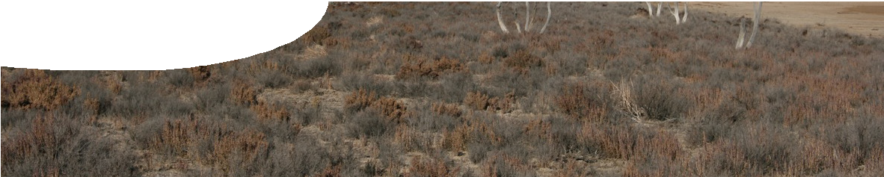
fact sheet
Salinity

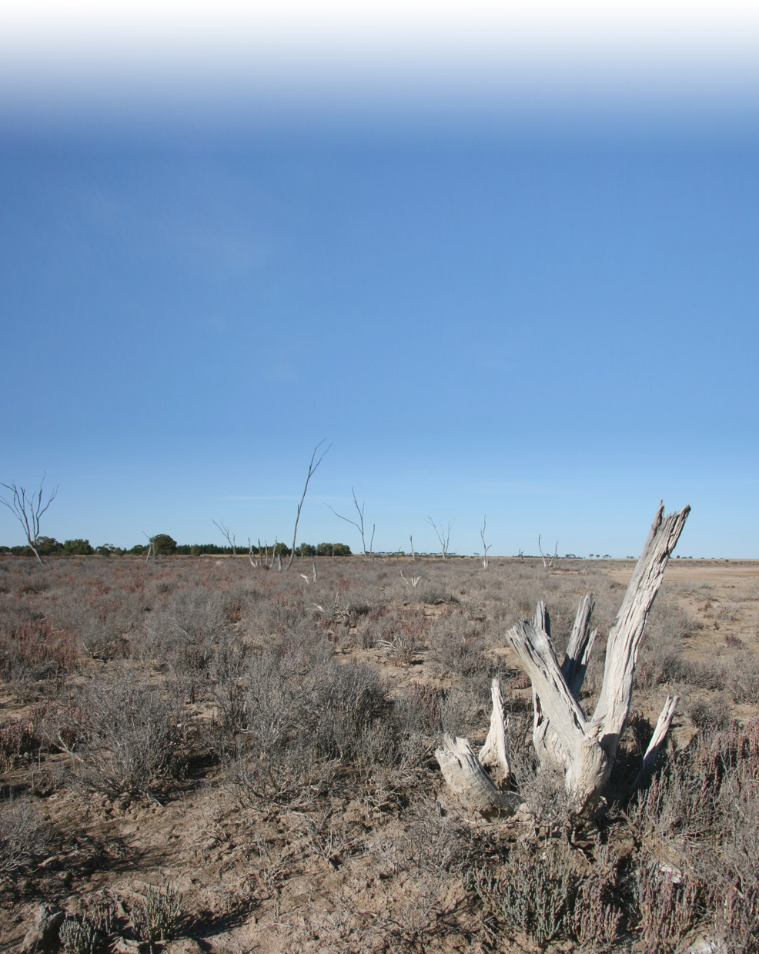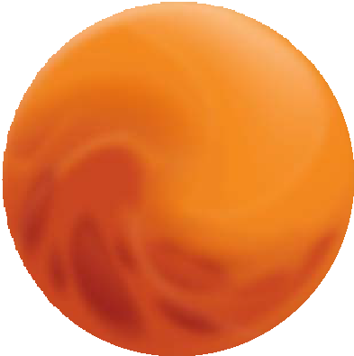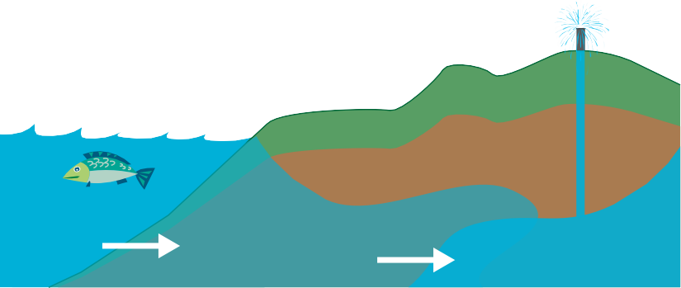Warning signs that an area is suffering from salinity are easily seen and often dramatic. Plants begin to turn brown and die, surviving plants are stunted, and salt-hardy species start to take over. In severe cases there are large areas of bare soil or areas encrusted with salt. Salts that are drawn up to the surface produce very strong acids depending on oxygenation and water availability. These acids can be as strong as car battery acid. When land is in this condition, recovery is expensive

Salinity due to salt water intrusion

sea
salt water

groundwater irrigation

groundwater

and takes a long time.
Salts (or ions) that cause salinity problems in Australia include: chlorides, sulphides, carbonates, sodium, potassium, magnesium, calcium, aluminium, zinc, iron and manganese.
Three types of environmental salinity are recognised.
- Dryland salinity occurs where salty water rises from the soil profile to scald the surface vegetation. Plants turn brown and die, and the soil becomes very poor.

Salinity is the presence and
concentration of soluble salts in solution, soil or other medium. Soil salinity occurs when salt that is normally locked within
the soil profile rises to the surface.
- Saltwater intrusion occurs in coastal
aquifer systems. Use of groundwater results in seawater being drawn up by capillary action to replace it.
- Irrigation salinity occurs where the overuse of water for irrigation purposes causes a rise in the water table, bringing salts from deep soil profile to the surface. Ground becomes waterlogged and soil becomes poor.
Development of land salinity
depends on the chemistry of the soil surface and upper levels of the soil profile. These are affected by:
  - landscape characteristics,
  - soil quality,
  - chemical composition of the soil profile,
  - vegetation,
  - water availability, and
  - climate characteristics (wet/dry and hot/cold).
The effects of human activity are combined with these factors.

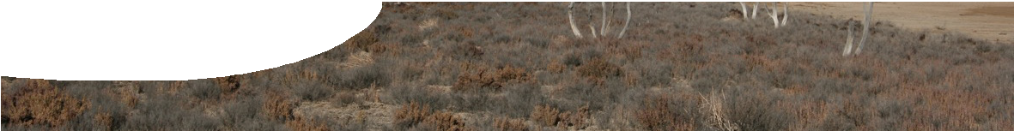
fact sheet
Salinity
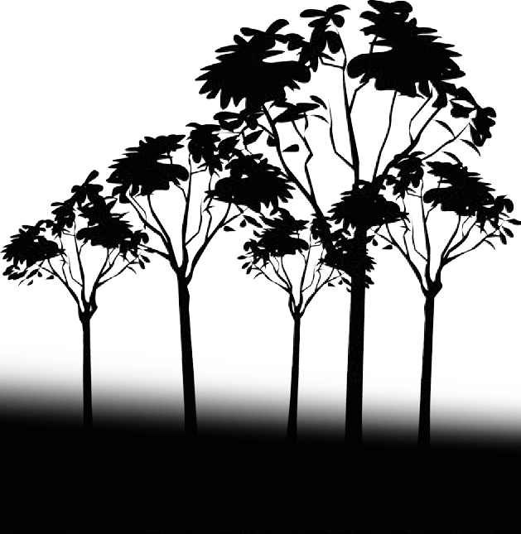Where does the salt come from?

Western Australia is the most salinity affected state in Australia. Over the next 30 years 3 million hectares of suitable trees and shrubs need to be planted to combat salt, at an estimated cost of $3 billion.
The road to recovery
Monitoring is pivotal for the detection and recovery of salty lands. It is important to find affected areas and predict where the next problem will occur. The earlier the problems are detected, the easier and cheaper they are to correct. Currently monitoring is done by a combination
of techniques, including area measurement of electromagnetic radiation reflected from the
Earth’s surface, electrical conductivity, ground sample testing and observation by farmers.
New farming and land development practices are also being applied.
Native vegetation has been replanted close to crops and farmers are looking for deep-root crop rotations.
The deep roots of native plants prevent groundwater from rising to the soil surface, and importantly contain salt underground.
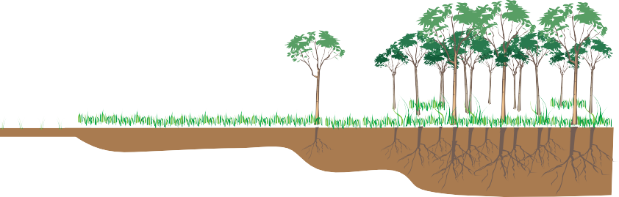A great deal of salt is naturally present in Australian soils, built up over a long period of time. Great salt lakes are found in the interior, sea salt is blown in from the oceans as dust and in rainfall, and there is a natural release of salts from rock weathering. In Western Australia, before land clearing and cultivation, salts were locked deep in the soil profile, and had little effect on surface plant life. Deep roots of native vegetation kept groundwater in the
lower soil levels and ensured that salts remained deep below the zone where damage can occur.

high water table
deep water table
The human role in salinity: farming practices

When Europeans first came to Australia they used farming practices that were successful in their homelands, unaware of the unique characteristics of the Australian landscape and climate.
Native deep-rooted vegetation was replaced with European shallow-rooted crops and pastures. But these European plant species had been developed in rich soils and their shallow-root systems did not take up water from the deep soil profile. These vegetative changes meant that groundwater didn’t get used up and the amount of water present in the water table increased, causing it to rise through the soil profile.
The movement of water through the soil profile also causes the movement of material dissolved in the deep soil, such as salts.
Salty water is brought to the surface and high-temperature, dry-climate conditions mean that water evaporates leaving salt crystals behind. This is dryland salinity.
Over-irrigation of farmland, inefficient water use and poor drainage cause irrigation salinity. Excess water increases the amount of groundwater which causes the water table to
rise bringing salts to the surface. Waterlogging also fills up air spaces in soil and limits the amount of oxygen available to plants.
Bore water use is common in Western Australia, where water is drawn from underground reservoirs. If too much water is removed this way in coastal regions salt water gets drawn in from the sea to replace it, resulting in saltwater intrusion. This is a significant problem in areas such as Cottesloe, where bore-water usage is high due to large lawns and a golf course.

References
Australian Water Association. (n.d.). Salinity. Retrieved 30th August 2007, from http://www.awa.asn.au/AM/Template.cfm?Section=Salinity
Department of Environment and Conservation (n.d.). Threats to Wetlands. Retrieved 30th August 2007, from http://www.naturebase.net/index2.php?option= com_co ntent&task=view&id= 817&pop=1&page= 0&Itemid= 868
Queensland Government. (n.d.). Natural Resources and Water. Retrieved 12th September 2007, from http://www.nrw.qld.gov.au/salinity/whatis.html Water and Rivers Commission. (2000). Water Facts 15 – Salinity. Western Australia: State Government of Western Australia
Waterwatch Australia. (2002). National technical manual, module 4: physical and chemical parameters. Canberra ACT: Environment Australia

