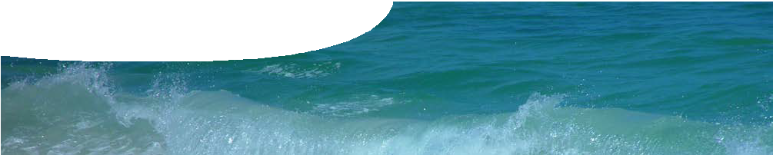
fact sheet
Researching ocean buffering

Just like our bodies, oceans have natural buffering capacity. This is good news, because a constant pH is important for marine life. Seawater contains ions, such as chloride and sodium from salt, as well as calcium, hydrogencarbonate and carbonate ions that are essential for living organisms that produce calcium carbonate skeletons. These ions are part of the buffering process.

The oceans’ natural buffer is the carbonate/hydrogencarbonate system. This maintains pH between 8.1 and 8.3, in a series of equilibrium reactions.

CO2( g ) + H2O(l )  H2CO3(aq )  H+
(aq
−
3(aq )
) + HCO

photo: ‘Industry smoke’ by Uwe Hermann

This chemical equilibrium between various chemical forms of carbon and hydrogen ions (protons) forms a buffering system that is the most important factor controlling the pH of seawater.
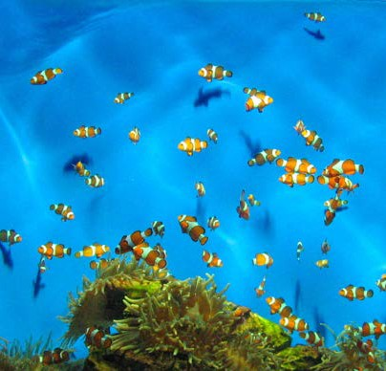
The dynamic ocean environment
There’s a lot going on in the oceans, including changes to the chemical environment, and this has an impact on pH.
Le Chatelier’s principle tells us that an increase in concentration of dissolved carbon dioxide causes the equilibrium to move to the right. This leads to increased concentration of hydrogencarbonate and hydrogen ions, and lower pH.
At the oceans’ current pH level another equilibrium reaction that involves some of the same species also takes place.
photo: Liza Naude, Stock.xchng
CO2( g ) + H2O(l ) + CO2 − )  2HCO−
3(aq
3(aq )

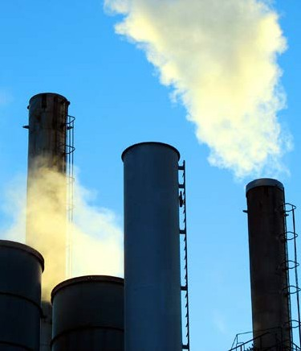Although this reaction doesn’t involve a change in pH, it does use up carbonate ions and produces hydrogencarbonate ions. Most of the carbon in today’s oceans is in the form of hydrogencarbonate, rather than carbonate ions or carbonic acid.
Ocean acidification
The amount of carbon dioxide produced has increased because of human activity, largely through burning fossil fuels. This has led to increased concentration of carbon dioxide in the atmosphere and also in the oceans.
A higher concentration of dissolved carbon dioxide in the ocean has resulted in an increase in the concentration of hydrogen ions. And that means the ocean pH has decreased as pH = -log10(H+).
This pH change is referred to as acidification. Even though the ocean pH is above 7 (which is on the basic side of neutral), pH is moving in a direction towards more acid composition.
The pH at the oceans’ surface has declined by about 0.1 pH unit in the past 200 years; and it’s predicted that it could drop a further 0.3-0.6 pH units by the end of the century, depending on how much additional CO2 is emitted into the atmosphere. The pH scale is logarithmic, which means even
this seemingly small decline equates to a doubling of hydrogen ion concentration.
This is bad news because data from gases trapped in ice cores shows that current ocean pH is already lower than it has been for 800 000 years.

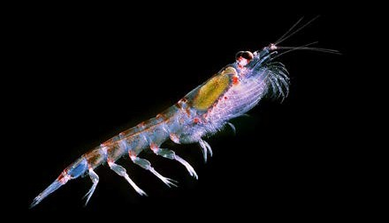Information from coral cores
Krill in the spotlight
Researcher Robert King, biologist with the Australian Antarctic Division of the Department of Environment and Heritage, is looking into how ocean acidification might impact on one of the marine systems most important animals, krill.

Krill are thought to have the largest biomass of any multi-cellular animal species on the planet. In the Southern Ocean alone there are an estimated 500 million tonnes of krill. These tiny organisms are an integral part of the marine ecosystem, particularly as they form an important food source for many marine animals, including commercial fish species.
Increased ocean acidification is a potential threat to the future abundance of krill. Robert King and his team have been able to determine the effect of increased levels of dissolved carbon dioxide on growth and development of krill.
What they found was when they tripled levels of carbon dioxide in the ocean, krill seemed to be doing just fine; but when they doubled it again, krill larvae failed to hatch. These results are concerning, when predicted carbon dioxide levels are four times current levels by the end of this century.
The research team is currently investigating the impact of a range of carbon dioxide concentrations on the different stages in the krill lifecycle.
What are krill?
Krill is a general term used to describe multiple species of free-swimming, open ocean crustaceans. Antarctic krill are about 6 cm long, and weigh around a gram.

Photo: ‘Antarctic krill, Euphausia superba’ by Uwe Kils
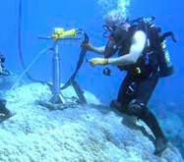
When marine organisms build their calcium carbonate shells and skeletons, other elements, such as boron, are incorporated.
Professor McCulloch measures the concentration of boron and carbon isotopes in the skeletons of corals by testing core samples.
photo: Oceans Institute
Corals can live for hundreds of years, so samples from older corals, or parent corals, allow Professor McCulloch to build up a picture of ocean chemistry over a long period of time.
Boron is used in these studies as it is incorporated into coral skeletons. Like carbon, boron has a set of pH- sensitive reactions that involve conversion of boric acid to borate ions. Boron also has two stable isotopes, 10B and 11B, and the relative concentrations of these two isotopes depends on ocean pH. Professor McCulloch’s research
has shown that 11B levels are dropping, which indicates decreasing pH. This research has already shown that ocean pH has decreased over the past 200 years, from 8.12 to approximately 8.06 pH units.
The study also compared the concentration of the stable isotope 13C in coral core samples to the more common isotope 12C. 13C is present in normal atmospheric carbon dioxide. It is also present in fossil fuels, but in far lower quantities relative to 12C. As carbon dioxide from burning fossil fuels mixes with atmospheric carbon dioxide,
the relative percentage of 13C decreases. In this way measurement of 13C/12C ratios allows scientists to measure the impact of human industry.
Core samples showed corresponding drops in 13C and 11B, which demonstrate a link between increasing industry and lowering of ocean pH.
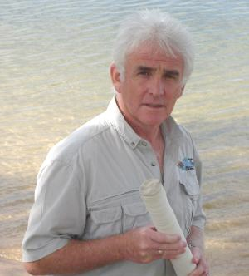
Professor McCulloch’s research is continuing and addresses questions such as: How will corals cope with chemical changes in the ocean? Will our reefs disappear altogether or will some be able to relocate? Are some corals more resilient than others? What is the critical level of atmospheric carbon dioxide beyond which corals are unable to produce calcium carbonate skeletons?

