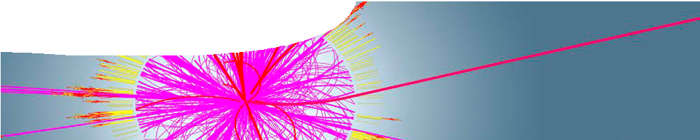
sequence overview
The Standard Model

Links to the Australian Curriculum: Senior Secondary Physics (Unit 4)

Science understanding concepts include:
The Standard Model
- The Standard Model is based on the premise that all matter in the universe is made up from elementary matter particles called quarks and leptons; quarks experience the strong nuclear force, leptons do not (ACSPH141)
- The Standard Model explains three of the four fundamental forces (strong, weak and electromagnetic forces) in terms of an exchange of force-carrying particles called gauge bosons; each force is mediated by a different type of gauge boson (ACSPH142)
- Reactions between particles can be represented by simple reaction diagrams (ACSPH143)
- Variations of reactions can be found by applying symmetry operations to known reactions. These include reversing the direction of the reaction diagram (time reversal symmetry) and replacing all particles with their antiparticles and vice versa (charge reversal symmetry). Energy and momentum must also be conserved for such a reaction to be possible. (ACSPH145) 1
- Lepton number and baryon number are examples of quantities that are conserved in all reactions between particles; these conservation laws can be used to support or invalidate proposed reactions. Baryons are composite particles made up of quarks (ACSPH144)
- High-energy particle accelerators are used to test theories of particle physics, including the Standard Model (ACSPH146)
- The Standard Model is used to describe the evolution of forces and the creation of matter in the Big Bang theory (ACSPH147) 2
Science as a human endeavour concepts include:
- Models and theories are contested and refined or replaced when new evidence challenges them, or when a new model or theory has greater explanatory power (ACSPH123)
Science inquiry skills concepts include:
- Select, construct and use appropriate representations, including text and graphic representations of empirical and theoretical relationships, simulations, simple reaction diagrams and atomic energy level diagrams, to communicate conceptual understanding, solve problems and make predictions (ACSPH119)

Australian Curriculum Senior Secondary Physics (Unit 4) includes a science understanding concept within the Standard Model in the area of cosmology. This is addressed in the SPICE resource package, Cosmology, which includes a useful revision of concepts from the Standard Model.
It is recommended that the The Standard Model package be completed before tackling Cosmology.

- Not specifically addressed in this resource
- Addresed in the SPICE package, Cosmology

Lin

Background
These SPICE resources may be drawn together into a learning pathway to develop students’ understanding of particle physics. The pathway is structured around a constructivist model based on the 5-Es where teachers may:
- Engage student students’ interest in particle physics through watching a popular TED talk.
- Guide students to Explore aspects of the Standard Model through a series of teacher-led presentations.
- Allow students to develop their Explanation of the Standard Model through calculations with particles.
- Elaborate on students’ understanding of the Standard Model by considering a quantum view of fundamental interactions.
- Evaluate students’ progress through the pathway and through summative reflection.
The resource is designed for year 12 students. It is recommended that other material in Physics Unit 4 (wave particle duality and the quantum theory; and special relativity) be covered before tackling the Standard Model.

A note on terminology
The Australian Curriculum refers to fundamental forces, force-carrying particles and reactions between particles. However in this resource we have chosen to use a terminology used by contemporary particle physicists: that of ‘interactions’. This approach is described in detail in the background sheet, The Standard Model 2: Interactions and forces, included in this resource package.

Learning pathway
ENGAGE
EXPLORE
EXPLAIN
ELABORATE
The Standard Model 1: Big physics
Big physics comprises a teacher guide and student worksheet.
Students watch a popular talk about the Large Hadron Collider. A KWL worksheet is used to record what students already know about the structure of matter; what scientists hope to discover with the LHC; and what the LHC has already achieved. See the teacher guide for detailed information on the purpose and use of this resource.

ENGAGE
EXPLORE EXPLAI

The Standard Model 2: Structure of matter
Structure of matter comprises a teacher guide, background sheet, video, three presentations and a glossary.
A video makes connections between electromagnetism and relativity. Students are stepped through three presentations that focus on different aspects of the Standard Model: the particulate nature of matter; ways quarks create composite particles; and fundamental interactions. See the teacher guide for detailed information on the purpose and use of this resource.

ENGAGE
EXPLORE EXPLAI

N
ELABORATE
N
ELABORATE

The Standard Model 3: Particle calculations
Particle calculations comprises a teacher guide and student worksheet.
Students perform calculations with particles in the context of the Large Hadron Collider. See the teacher guide for detailed information on the purpose and use of this resource.

ENGAGE
EXPLORE EXPLAI

The Standard Model 4: Quantum approach
Quantum approach comprises a teacher guide, presentation and student worksheet.
Students are introduced to a quantum view of fundamental interactions. Simple Feynman diagrams are introduced. See the teacher guide for detailed information on the purpose and use of this resource.

N
ELABORATE

Acknowledgements
Thanks to Professor Ian McArthur (School of Physics, The University of Western Australia). Much of the content of this package is based on workshops that Professor McArthur has presented for SPICE.
Designed and developed by the Centre for Learning Technology, The University of Western Australia.
Production team: Alwyn Evans, Jenny Gull, Dan Hutton and Michael Wheatley with thanks to Beate Ferbert- Booth, Bob Fitzpatrick and Wendy Sanderson.
Production by the Centre for Learning Technology, The University of Western Australia.
Banner image: ‘Simulated ATLAS collision event in which a microscopic-black-hole is produced in the collision of two protons’ © 2008 CERN. cds.cern.ch/record/1096078

SPICE resources and copyright
All SPICE resources are available from the Centre for Learning Technology at The University of Western Australia (“UWA”). Selected SPICE resources are available through the websites of Australian State and Territory Education Authorities.
Copyright of SPICE Resources belongs to The University of Western Australia unless otherwise indicated.
Teachers and students at Australian and New Zealand schools are granted permission to reproduce, edit, recompile and include in derivative works the resources subject to conditions detailed at spice. wa.edu.au/usage.
All questions involving copyright and use should be directed to SPICE at UWA.
Web: spice.wa.edu.au Email: spice@uwa.edu.au Phone: (08) 6488 3917
Centre for Learning Technology (M016) The University of Western Australia
35 Stirling Highway
Crawley WA 6009

