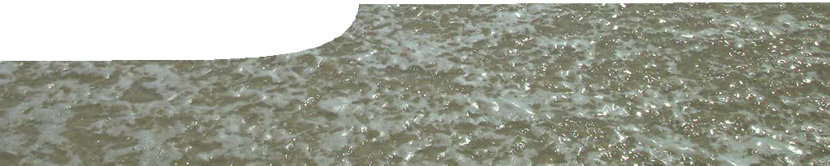
sequence overview
Buffers

ENGAGE
EXPLORE EXPLAI

Background
N ELABORATE
These SPICE resources may be drawn together into a learning pathway to develop students’ understanding of buffers. The pathway is structured around a constructivist model based on the 5-Es where teachers may:
- Engage students’ interest in the concept of buffers. Students watch a video about changes in pH in the human body during exercise and the need to keep pH levels constant.
- Provide opportunities for students to Explore the buffering ability of different muscles. Students perform an experiment, then analyse their data graphically to find how different muscles vary in their ability to buffer.
- Explain the concept of buffering. Students use an animation to examine how a buffer works. A worksheet links these concepts back to buffering in the body.
- Elaborate on the ideas presented. Students apply their knowledge of buffering to the context of ocean acidification and possible environmental consequences facing marine ecosystems.
- Evaluate students’ progress through the pathway.
The resource is designed for students studying year 12 chemistry, but may also be used with students in earlier years at the discretion of the teacher.

ENGAGE

EXPLORE EXPLAI

N ELABORATE

Buffers 1: pH control in the body
pH control in the body includes a teachers guide, background sheet and video.
This resource introduces students to buffers. It shows how the body’s pH changes during exercise and explains the need for buffering to sustain athletic performance. This resource can also be used to explore the role of science in society. See the teachers guide for detailed information on the purpose and use of this resource.

ENGAGE
EXPLORE EXPLAI

N ELABORATE

Buffers 2: Buffering ability of muscles
Buffering ability of muscles comprises a teachers guide and student procedure sheet with questions.
Students measure the buffering capacity of different muscles of a chicken. This exploration leads students to question how buffering occurs. See the teachers guide for detailed information on the purpose and use of this resource.

ENGAGE
EXPLORE EXPLAI

Buffers 3: Explaining buffers
Explaining buffers comprises a teachers guide, learning object and student worksheet.
This resource uses an interactive learning object to explain what a buffer is and how it works. Students answer questions on an accompanying worksheet to check their understanding and link theory back to the context
of buffering in the body. See the teachers guide for detailed information on the purpose and use of this resource.

ENGAGE
EXPLORE EXPLAI

Buffers 4: Buffering in the ocean
Buffering in the ocean comprises a teachers guide, student worksheet, fact sheet and procedure sheet.
This resource extends and applies students’ understanding of buffering in the context of ocean acidification. Students examine scientific data, read about the research of two scientists investigating ocean acidification and its possible consequences, then conduct an experiment to compare the buffering capacity of seawater and freshwater. See the teachers guide for detailed information on the purpose and use of this resource.

Acknowledgements

N ELABORATE

N ELABORATE
Banner image:
Thanks to Kagan Ducker, School of Sport Science, Exercise and Health, The University of Western Australia; Prof Malcolm McCulloch, School of Earth and Environment, The University of Western Australia; and Robert King, Australian Antarctic Division, Department of Sustainability, Environment, Water, Population and Communities.
Designed and developed by the Centre for Learning Technology, The University of Western Australia.
Production team: Pauline Charman, Jan Dook, Bob Fitzpatrick, Jenny Gull, Sally Harban, Dan Hutton, Emma Pointon, Paul Ricketts, Jodie Ween and Michael Wheatley, with thanks to Wendy Sanderson and Charmaine White.

SPICE resources and copyright
All SPICE resources are available from the Centre for Learning Technology at The University of Western Australia (“UWA”). Selected SPICE resources are available through the websites of Australian State and Territory Education Authorities.
Copyright of SPICE Resources belongs to The University of Western Australia unless otherwise indicated.
Teachers and students at Australian schools are granted permission to reproduce, edit, recompile and include in derivative works the resources subject to conditions detailed at spice.wa.edu.au/usage.
All questions involving copyright and use should be directed to SPICE at UWA.
Web: spice.wa.edu.au Email: spice@uwa.edu.au Phone: (08) 6488 3917
Centre for Learning Technology (M016) The University of Western Australia
35 Stirling Highway
Crawley WA 6009

