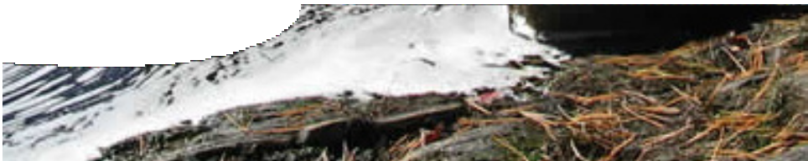
fact sheet
Nutrient enrichment
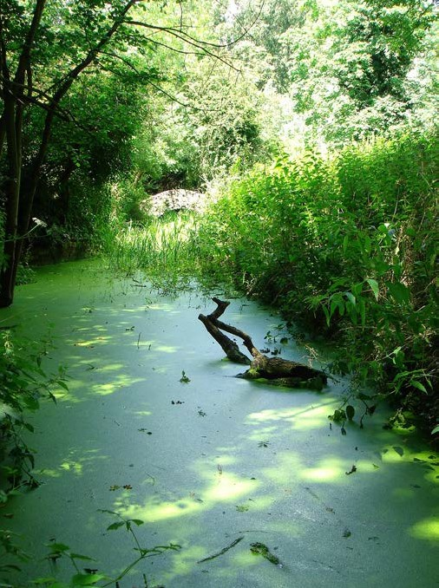
What are nutrients and fertilisers?
Nutrients are chemical elements and compounds that plants and animals need to grow and survive. Plants use simple nutrients such as water, phosphorus, nitrogen and oxygen and combine them into more complex molecules such as proteins and vitamins.
A fertiliser is any substance that promotes plant growth when added to the soil or water. Fertilisers are made from inorganic or organic materials that in combination
with soil conditioners, such as lime and gypsum, ensure plant health.
Organic fertilisers are manufactured from animal or plant by-products, which may include manure, fish meal, blood and bone. The composition of these organic fertilisers is
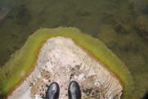
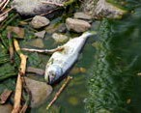

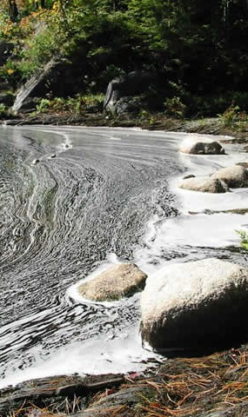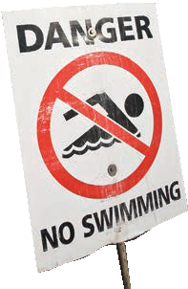highly variable from batch to batch. Inorganic fertilisers are made from ionic salts in industrial processes. The most common elements in inorganic fertilisers are nitrogen, phosphorus and potassium.
Which is better?
Both organic and inorganic fertilisers provide the same elements to plants through roots in the form of water-soluble ions. Organic fertilisers contain fewer nutrients than inorganic fertilisers but the fibrous material that many of them contain helps to build
up structure in the soil. Inorganic fertilisers provide super-boosts of their ingredients giving a great short-term gain, but any excess not used directly by plants can disrupt soil and water environments almost immediately. Soil pH
can be changed substantially, particularly when the nutrients are ammonium-based. Misuse of fertilisers can cause serious environmental damage.
The main difference between organic and inorganic fertilisers is the time they take to break down in the soil and become available for plants
to use. Inorganic fertilisers contain compounds that are highly soluble in water (highly ionic) and so are quickly available for uptake by plant roots.
Organic fertilisers produce a much slower release of compounds to the soil because they are held in an organic, fibrous matrix. The nutrients in this matrix are released by bacteria.

fact sheet
Nutrient enrichment
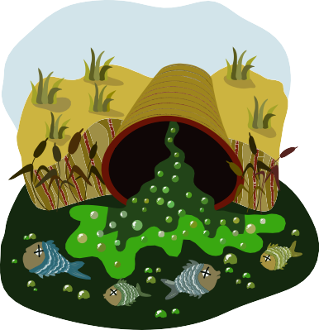What is ecological sanitation?

Why can nutrients and fertilisers cause a problem?
Increased use of fertilisers can result in excess nutrient concentration in run-off water that ends up in lakes and streams. High concentration
of phosphorus causes an increase in naturally-occurring organisms that feed on it, such as cyanobacteria (blue-green algae), that cause algal
blooms. These blooms clog waterways, produce toxins and lower oxygen concentrations in water. A waterway clogged with algal bloom smells
really bad. Nutrient enrichment of a waterbody is known as eutrophication. This can cause suffocation and death of marine animals, livestock, wildlife and humans.

i
kitchen
toilet shower
waterworks
agriculture
constructed wetlands
compost
compost separator

There are various classifications of waste material, including two important groups: excreted human waste and grey water waste. Human and animal waste are a significant source of pollution in water resources in many countries. Disease outbreaks such as gastrointestinal diseases, typhoid fever, cholera and leptospirosis can be linked to water contamination by human waste.
organics
faecal material
Excreted human waste is rich in organic nutrients that are washed away to treatment plants when we flush the toilet. This waste is transported to sewage plants where it undergoes a multistage sanitation process. Large solids and non- biodegradeable materials are removed by sedimentation. Biological treatments and filtering procedures clean the remaining water. A large input of energy is needed to make human waste safe.
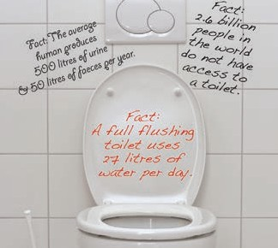Ecological sanitation is a way of treating human waste products using natural systems. The idea is that urine, faeces and water are resources in an ecological loop. This approach returns valuable nutrients and humus to the soil and recycles water, while seeking to protect public health and prevent pollution. It is a low- energy, three-step system that involves the containment and collection of waste, sanitising the waste with the removal of pathogens, and recycling any useable materials.
Grey water or sullage is water that has been used for cleaning, washing and cooking. It is not contaminated with materials such as faeces and hazardous chemicals, so does not need to go though the rigorous and expensive processes that excreted waste requires. Grey water makes up 18–50% of domestic wastewater. Grey water can be easily treated and recycled with a home system.
Recent concerns about the dwindling supply of groundwater and high costs of sewage treatment have lead to interest in recycling grey water using eco- treatments. One organic system that has been suggested is the ‘constructed wetlands’ model. This uses artificial wetlands as a biological filter. Wetland
vegetation can play an important role in filtering out the nutrients and improving the quality of water that passes through them.

References
EcoSanRes (Stockholm Environmental Institute). (2005).The main features of ecological sanitation. Fact Sheet
2. Retrieved 14th September 2007, from http://www.ecosanres.org/pdf_files/ESR-factsheet-02.pdf
Morgan D (Ed) (1990). Biological Science: the web of life – Part 1(3rd ed.). South Australia: Griffin Press Ltd
USGS Toxic Substances Hydrology Program (2006). Nutrients. Retrieved 13th September 2007, from http:// toxics.usgs.gov/definitions/nutrients.html
Waste. (2005). What is Ecological Sanitation or Ecosan? Retrieved 14th September 2007, from http://www. ecosan.nl/page/447
Water and Rivers Commission. (2001). Water Facts 16 – Living Wetlands: An Introduction to Wetlands. Western Australia: State Government of Western Australia

