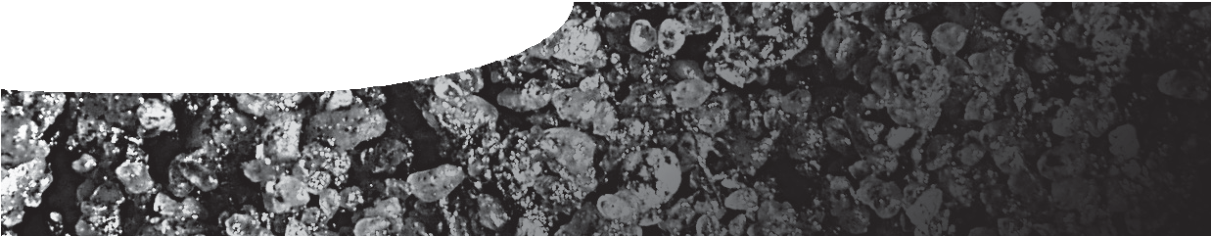
procedure sheet 5
Measuring soil pH and electrical conductivity
SAFETY
Handling soil and compost: Always wear safety glasses. Do not ingest or smell the soil/ compost, and avoid inhaling its dust, since harmful bacteria and fungi could be present. Wash your hands thoroughly with soap and water afterwards.

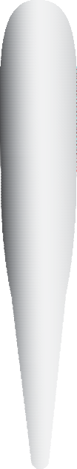Prepare the pH and E.C. meter
- Remove the electrode cap on both the pH meter and the E.C. meter and immerse their electrodes in tap water for one hour before use. Never immerse the meters above their colour band.
- Calibrate both meters according to their instructions.

Prepare the soil sample solution
- Leave the sample bags open for 24 hours to dry in the air.
- Crumble your soil sample (A5 or B5) within its sample bag to break down any clumps and mix thoroughly.
- Measure 20 mL of soil and add it to a 250 mL beaker. Then pour in 100 mL of distilled water. This gives you a 1:5 ratio of soil to distilled water.
- Stir for two minutes, then leave to settle for five minutes.

Take the meter readings
- Measure pH: Remove the electrode cap from the pH meter and switch on. Dip the electrode 1-2 cm into the solution and stir. Wait for the display to stabilise, then record the reading in the record sheet. Rinse the electrode in distilled water between each sample.
- Measure electrical conductivity: Remove the electrode cap from the E.C. meter and switch on. Dip the electrode 1-2 cm into the solution and stir. Wait for the display to stabilize, then note down the EC1:5 reading and its units (for example dS/m).
- Transfer your results to the collected data sheet.

record sheet
pH and electrical conductivity

 | A5 | B5
pH
electrical conductivity (soil salinity)

