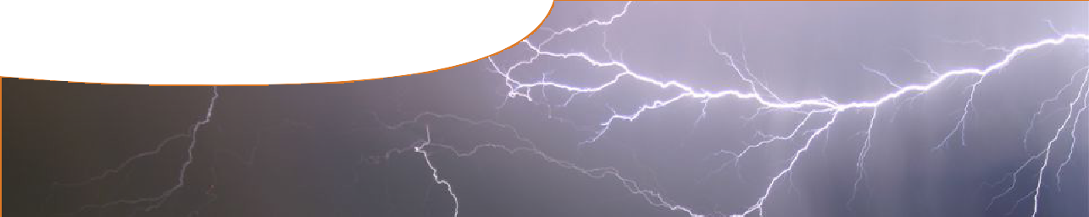
fact sheet
Lightning

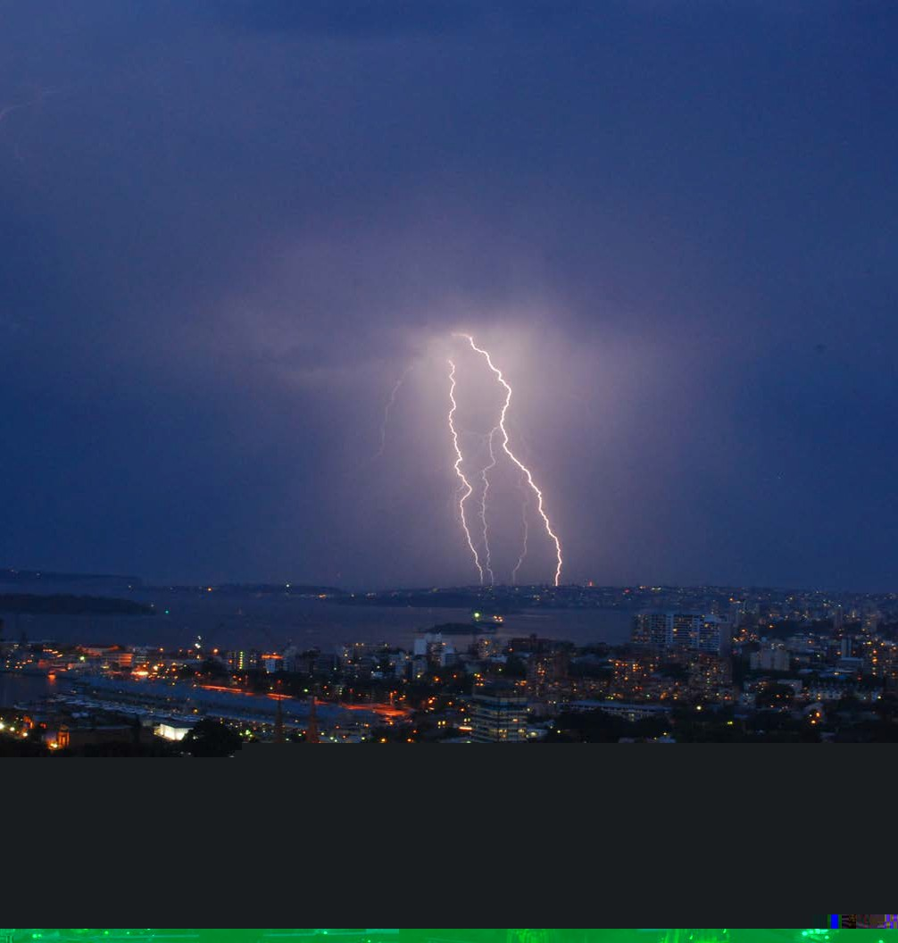An estimated 2000 thunderstorms occur globally at any one time, producing up to 100 lightning strikes per second. That’s almost 10 000 000 strikes every day!
Kampala, Uganda, is home to the most lightning on Earth, with 280 thunderstorm days per year.
The amount of energy in an average lightning bolt is 5 billion joules. That’s enough to run a 100 watt lightbulb for 18 months.
There are between five and ten deaths from lightning strikes in Australia each year, and over 100 injuries.
About 80 of these injuries result from the use of landline telephones during thunderstorms.
Lightning heats the surrounding air, creating super temperatures up to 30 000 oC.
Lightning hotspots in Australia are found in the far north, closest to the equatorial zone.

Myths!
Lightning over Sydney Harbour: Izzy Perko
- Lightning never strikes the same place twice. FALSE
- People who have been struck by lightning should not be touched
as they are electrified. FALSE
- Lightning only occurs when there are thunderstorms. FALSE
  - Lightning always strikes the tallest object. FALSE

- Lightning is often associated with active volcanoes.
FACTS IN A
FLASH
- Lightning is responsible for hundreds of livestock deaths every year.
- Approximately half of all bush fires in Australia are the result of lightning strikes.
- Lightning is seen less frequently over the oceans, and is very rare over the north and south poles.
- Lightning also occurs on other planets. NASA has documented spectacular lightning strikes across Saturn’s surface.
- Some scientists predict global warming will increase the number of severe storms around the world.
This means more lightning, up to three times the current number of strikes.

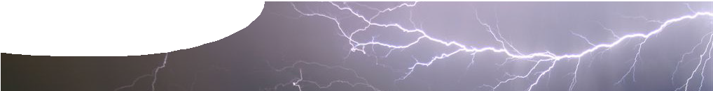
fact sheet
Lightning

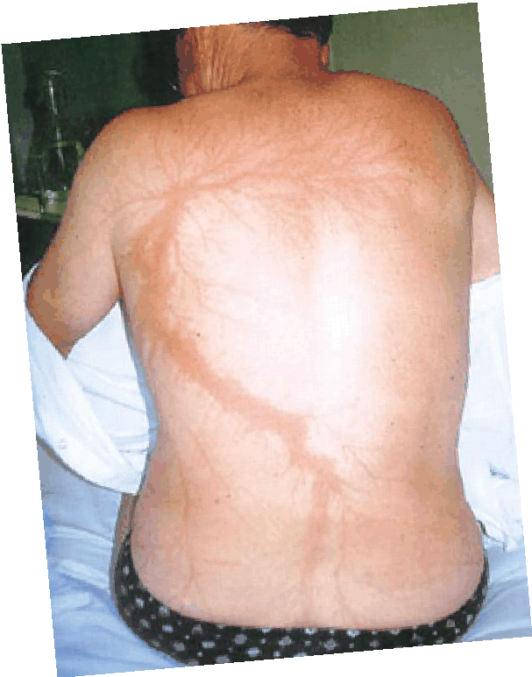Lightning strikes: what gets damaged and how
SURVIVORS
of lightning strike
Physical effects of lightning strike include:
- neurological effects, amnesia, dysfunction of short-term memory and personality changes;
- cardiac arrest and paralysis of respiratory muscles;
- surface burns to the skin;
- broken bones due to impact injuries;
- damage to hearing, industrial deafness and semi-permanent ringing in the ears;
- loss of consciousness after the initial strike;
- post-concussive symptoms nausea and vomiting;
- chronic headaches and intense pain.
- internal organ failure, abdominal effects such as gastrointestinal haemorrhage and bowel perforation.
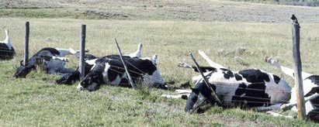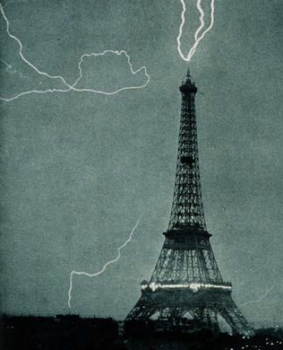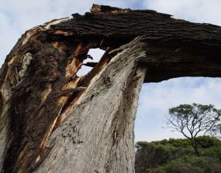In 2008, the National Lightning Safety Institute estimated costs and losses due to lightning at over $5 billion in the USA alone.
Structural damage to buildings is a common result of lightning strikes. In 1902 the Eiffel Tower (right)
had to be repaired after a damaging lightning strike.
Lightning often damages electrical circuitry in our homes and workplaces. It also damages power lines and communication systems.

Lightning almost caused a disaster during the launch
Lightning demolishes a tree

of NASA spacecraft Apollo 12, when it struck the rocket.

Lightning can enter a building in three ways:
  - a direct strike,
  - through external wires and pipes, or
  - through the ground.
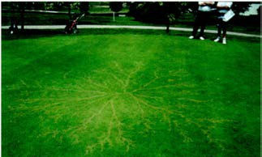Lightning strike on electric fence. photo: Ruth Lyon-Bateman
Lightning strike on golf course
Sporting fields like golf courses and soccer pitches are highly susceptible to lightning strikes.
Aircraft and lightning
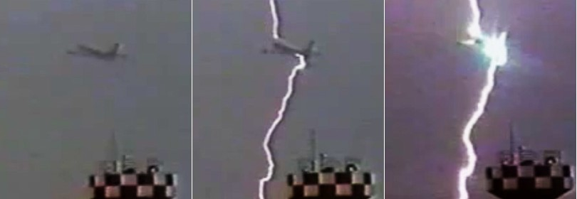

Image credits
On average, each commercial aircraft is struck by lightning once every year. Aircraft can trigger lightning when moving through cloud. Lightning has resulted in aircraft crashes. In 1976 an Iranian military Boeing 747 crashed after being struck by lightning.
Since the 1970s our knowledge of how lightning can affect aircraft has expanded, and planes are designed differently. Aircraft must meet certification standards for lightning protection. Even if struck, modern aircraft shouldn’t experience any serious problems.

‘Lightning over Sydney Harbour’ by Izzy Perko, all rights reserved, by with permission. ‘Lichtenberg figures due to a lightning strike’ © 2000 Massachusetts Medical Society, all rights reserved, used by permission. ‘Lightning striking the Eiffel Tower, June 3, 1902’, PD, en.wikipedia.org/wiki/File:Lightning_striking_the_Eiffel_Tower_-_NOAA.jpg. ‘Unlucky tree 3’ by Brant Ward, used under licence from stock.xchng. ‘Lightning strike on electric fence’ by Ruth Lyon-Bateman. ‘Lichtenberg burn pattern in the grass of a
golf course’, Injury, 34(5), 367-371, used by permission.

