fact sheet
Life cycle of stars

Star clusters are groups of stars, formed from the same giant gas cloud, that are held together by gravity. Because of their special properties, star clusters provide astronomers with a unique environment to study the age and evolution of stars.

Star clusters are important to astronomers because their stars formed at about the same time, so they are roughly the same age; the same distance away from us; and are made of the same materials. Despite this, stars within clusters vary in brightness and colour.
Brightness is related to a star’s mass. Stars with greater mass tend to be brighter than stars with lesser mass.
Star colours vary because more massive stars ‘burn up’ quicker. They go through different stages of their life cycle sooner and emit different coloured light because of the nuclear fuels they burn and their surface temperatures.
There are two types of star cluster:
- Open clusters contain stars that can be observed individually through a telescope. These star clusters eventually break up due to gravitational interactions with other objects in the galaxy. Open clusters, such as the Jewel Box, typically contain hundreds of younger stars.

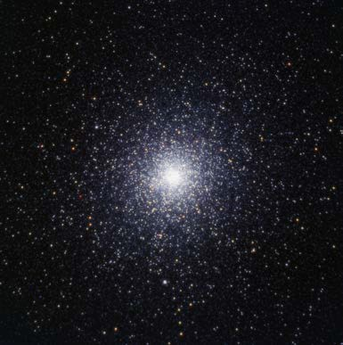
Massive globular cluster NGC 104
(47 Tucanae) contains millions of stars.
credit: SPIRIT image by Paul Luckas

Globular clusters may contain up to a million stars in a spherical array. They typically contain some of the oldest stars in a galaxy. Globular clusters contain little free gas or dust, so no new stars are being formed in them.
Star colours
Most stars appear white to the naked eye. But some, such as Betelgeuse (a red supergiant star), are orange or reddish in appearance while others, such as Rigel (a blue supergiant star), are bluish-white. A star’s surface temperature is the major factor in determining the colour of light emitted.
surface temperature and colour of stars

STAR SURFACE TEMPERATURE (K) | STAR COLOUR
<3700 | red
3700 – 5200 | orange
5200 – 6000 | yellow
6000 – 7500 | yellow-white
7500 – 10 000 | white
10 000 – 30 000 | blue-white
>30 000 | blue

Why do stars change throughout their life cycles?
Stars change throughout their lives because of the fuels they ‘burn’ in their cores. When their core temperature is high enough hydrogen atoms fuse together in nuclear reactions to make helium and release huge amounts of
energy. Our Sun has been doing this for about 5 billion years and is currently about halfway through this stage of its life cycle that astronomers call ‘main sequence’.
When a star runs out of hydrogen it starts ‘burning’ helium to make heavier elements. But before this can happen, gravity causes its core to collapse. As it does, outer layers of the star expand and cool and it grows to form a red giant. Red giants can grow to hundreds of times a star’s original size.
The most massive stars in the Universe fuse heavier atoms together, releasing so much energy that the stars explode in supernovae, blasting their outer layers into space. Matter and energy released in supernovae creates all elements in the Universe heavier than iron.
The length of a star’s life depends on its mass. High-mass stars have more fuel, but they burn it faster so they have short lives. Low-mass stars have less fuel, but use it at a slower rate, so they live longer lives.

THE END OF STARS
low-mass stars  < 4 solar masses | Their cores shrink to form white dwarf stars that are about the same size as Earth. Their outer layers form gas clouds called planetary nebulae that spread out in space and eventually fade from view.
medium-mass stars 4 – 8 solar masses | These explode in massive supernovae. Their cores shrink to form neutron stars that may be only 10–20 km in diameter. Gravity is so strong in cores of  neutron stars that protons and electrons are forced together to form neutrons.
high-mass stars  > 8 solar masses | These release energy so rapidly that they explode in supernovae. Energy released is sufficient to create all elements heavier than iron. If enough matter is left in the star remnant, gravity may cause the core to collapse into a black hole. Not even light can escape the intense gravity of black hole.

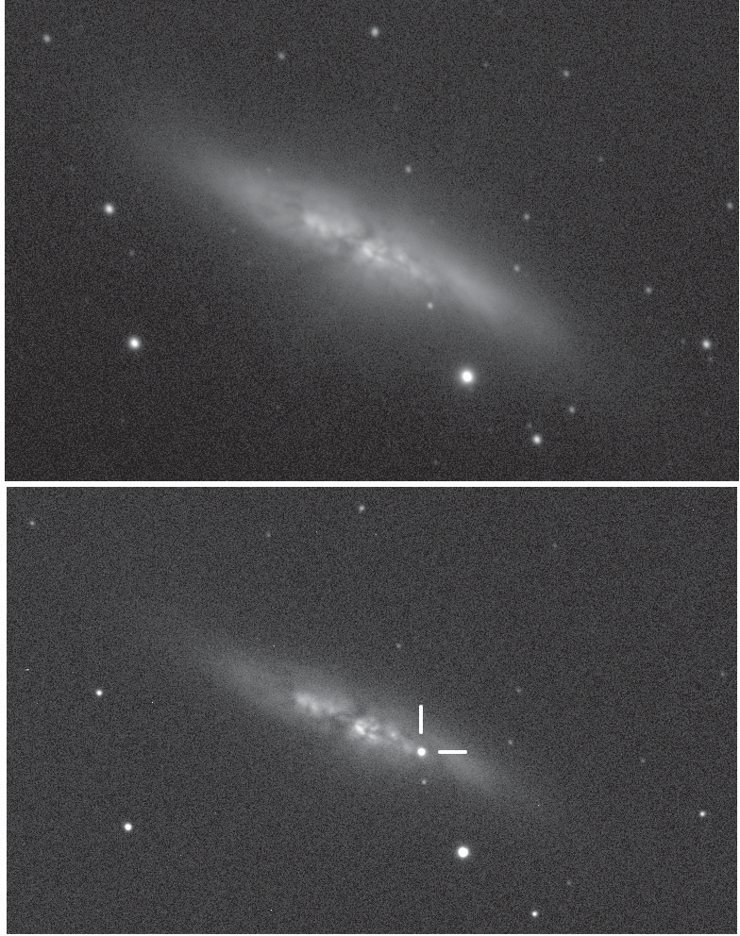
Dramatic end of a star
These two images show M 82 (the Cigar Galaxy) on 10 December 2013 (upper image) and 21 January 2014 (lower image). The more recent image shows what appears to be a new star.
This is a supernova, now named SN 2014J, which is formed by a collapsing star.
Supernovae can be billions of times brighter than the Sun.
SN 2014J is a type 1A supernova, believed to be formed by the collapse of a double star system.

credit: University College of London (Dr Steve Fossey, University of London Observatory)
For more information on SN 2014J, discovered by students during an astronomy class, see http://www.ucl.ac.uk/maps-faculty/maps-news- publication/maps1405

stellar nursery
Stars form in a nebula from collapsing clouds of interstellar gas and dust.

Sun-like stars (up to 4 times the mass of the Sun)

red giant

planetary nebula
massive stars (more than 4 times the mass of the Sun)

red supergiant

supernova

white dwarf

remnant less than 3 solar masses

remnant more than 3 solar masses

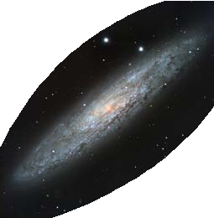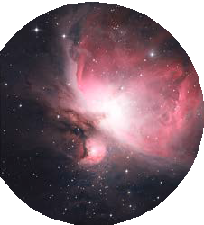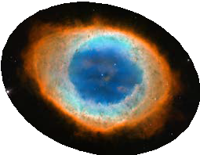

black dwarf neutron star black hole

credit: planetary nebula – NASA, ESA and the Hubble Heritage; stellar nursery and supernova – SPIRIT image by Paul Luckas

