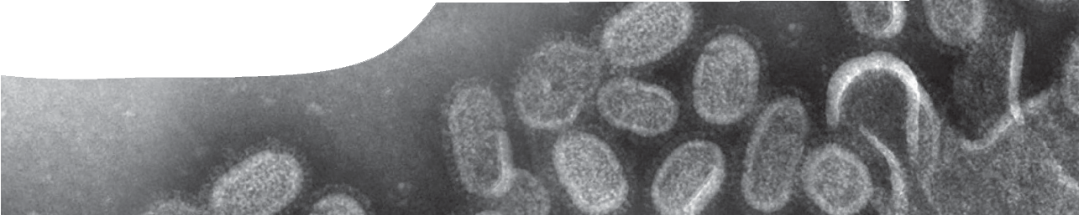
background sheet
Influenza

Influenza is a virus, that is, a pathogen (anything that causes disease). It causes respiratory tract infections with symptoms, including headache, sore-throat, body ache, high temperature, and cold-like symptoms such as coughing and runny nose, that are usually quite mild. However there have been pandemics of influenza that caused millions of deaths, eg the 1918 Spanish ‘flu (50 million deaths); 1957 Asian ‘flu (1.5–2 million deaths); and the 1968 Hong Kong ‘flu (1 million deaths).
Influenza viruses can be transmitted by direct contact with infected people, contact with contaminated objects, and inhalation of virus-laden aerosols. Annually between 250 000 and 500 000 people die of influenza around the world (data from the World Health Organisation).
Viruses are extremely small (between 20–300 nm). They are able to enter host cells where they produce virions (individual virus particles). Virions may then leave infected cells, travel to new cells, and infect them.
Whether a virus is living is controversial. Viruses are unable to reproduce by themselves even though they contain genetic material. In essence they are intracellular parasites. Most living things only use DNA as genetic material, but some viruses contain DNA, others RNA.
Influenza viruses produce eleven different proteins that attach to molecules located on body cells, such as those found in the human respiratory system, so they can enter these cells and produce new viruses. Two of the eleven proteins are used to name the virus: haemagglutinin (H) and neuraminidase (N). There are 17 types of H and 10 types of N, and strains of influenza are named according to the type of surface protein present (CDC, 2012). For example, H5N1 has H type 5 and N type 1 on its surface.
Influenza viruses contain eight strands or segments of RNA within a protein coat. These code for all proteins and enzymes that the virus requires to reproduce and spread. RNA segment 4 codes for haemaggluttinin and segment 6 codes for neuraminidase.

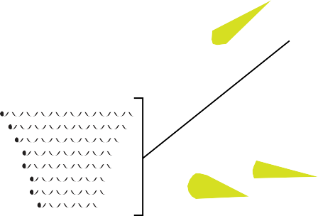neuraminidase (N) haemagglutinin (H)
RNA

influenza A virus

Influenza A infection cycle
To infect a cell, an influenza virus must bind to a cell via one of the cell’s surface glycoproteins (a molecule that consists of a protein and a carbohydrate) or glycolipids (a molecule that consists of a protein and a lipid). The virus attaches to one of these molecules using its haemagglutinin protein (H). Through this interaction the virus is taken into the cell, and viral RNA strands released into the cytoplasm.
RNA contained in a virus is called ‘negative strand’. To reproduce and make viral proteins, negative strand RNA must be copied into a complementary, positive strand RNA. This is done with an RNA dependent RNA polymerase. Proteins are translated from this complementary strand.

Animals get the ‘flu as well
Influenza A infects a variety of animals including humans, pigs, horses, sea mammals and birds (Webster et al, 1992). It’s believed that aquatic birds are the source of all influenza viruses in other species. Ducks, for example, harbour influenza virus in their intestinal tract with apparently no disease symptoms. By defecating in water, ducks deposit faecal material containing infectious influenza virus particles. Contact with contaminated faeces, even in small amounts, can pass influenza to other ducks and other species, including humans.
Influenza A viruses H1N1, H1N2 and H3N2 are the main subtypes of influenza that affect humans. Humans also get influenza B viruses, but they are not categorised into subtypes.

3’ -RNA
5’ In 2009 a new strain of A H1N1, called swine ‘flu (it originated in pigs), emerged through changes to viral RNA. Although still an H1N1 virus it was quite different from the usual H1N1 subtype. Transmission of this virus was from pig to pig, but more unusually, it could also be transmitted to

mRNA synthesis
5’ 3’

+RNA
(complementary strand)

3’ (3 prime) or 5’ (5 prime) refers to the chemical orientation of an RNA or DNA molecule. Nucleic acids can only be synthesised in the 5’ to 3’ direction (positive strand). RNA in influenza viruses is negative strand when it enters cells.
Synthesis of viral mRNA is prone to errors. DNA replication is much more stable and accurate, as DNA polymerases (enzymes that copy DNA templates) effectively ‘proofread’ templates to recognise and replace any errors (incorrect or mismatched nucleotides). Viral RNA polymerases are unable to check or proofread newly formed viral mRNA, so errors accumulate. Point mutations (such as nucleotide substitutions) in RNA that code for surface proteins may result in small changes in their structure. This is called antigenic drift.
humans. The swine ‘flu pandemic resulted in approximately 16 000 deaths.
Bird ‘flu is caused by the highly pathogenic A H5N1 virus which originates from birds. Between 2003 and 2010 there have been 605 cases worldwide (none in Australia) with 357 deaths. The majority of cases have been in Indonesia: 189 cases with 157 deaths. These cases have occurred in cohorts of people who have had close contact with birds, such as poultry farmers. As the H5N1 strain has a high mortality rate in humans, scientists are concerned that a combination of H1N1 and H5N1 could form a new virus and cause a serious pandemic.

References
Centers for Diease Control, (2012). Types of Influenza Viruses. Retrieved 20 May 2013 from http://www.cdc.gov/ flu/about/viruses/types.htm
Webster, R.G., Bean, W. J., Gorman, O. T., Chambers, T. M.Kawaoka, Y. (1992). Evolution and ecology of influenza A viruses. Microbiological Reviews, March, 152-179.
Cumulative number of confirmed human cases of Avian influenza A (H5N1) reported to WHO, 2003–2012. WHO/ GIP, data in HQ as of 5th June 2012. Retrieved 6 June 2012 from http://www.who.int/influenza/human_animal_ interface/EN_GIP_20120605CumulativeNumberH5N1cas es.pdf
Virology blog, about virology and diseases. Retrieved 6 June 2012 from http://www.virology.ws/influenza-101/
banner image: ‘Electron micrograph of influenza virus’ by Center for Disease Control / Cynthia Goldsmith, public domain, phil.cdc. gov/phil/details.asp?pid=8160

