Star clusters
Star clusters are groups of stars held together by gravity. All stars in a cluster formed from the same gas cloud, at roughly the same time, and have similar composition. However, they vary considerably in colour and brightness. There are two distinct types of star cluster:
- globular clusters are tight groups that contain hundreds of thousands of old stars; and
- open clusters are loose groups that usually contain a few hundred, or less, young stars.

Photographing a star cluster
In this activity you will use one of the SPIRIT telescopes to produce a full-colour image of a star cluster, and find out why stars vary in colour and brightness.
SPIRIT I and II, like most professional telescopes, are fitted with monochrome (black and white) cameras and coloured filters. Monochrome cameras are used for maximum sensitivity. Your task is to program the telescope to capture images of a star cluster, using red, green and blue filters, then combine them using photo editing software to produce a full-colour image.
The same rules apply when taking filtered images as for basic imaging. Bright objects, such as star clusters, can be imaged in short exposures of 20 seconds or less. Faint objects, such as galaxies and nebulae, require longer exposures of 60 seconds or more.
These are the steps to take a colour series with SPIRIT:
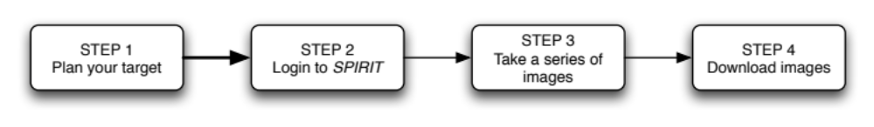

STEP 1: Plan your target
Discuss with your teacher which open or globular star cluster to select as your target.

STEP 2: Login to SPIRIT
The web site for accessing SPIRIT is http://spice.uwa.edu.au/spirit
Select the link Telescope access then choose either SPIRIT I or SPIRIT II. Enter your user name and password. Once the web site has loaded, you will be asked to enter these details a second time.
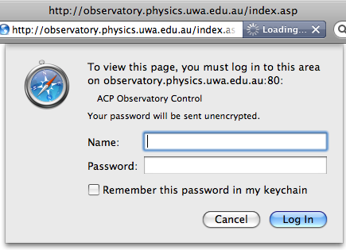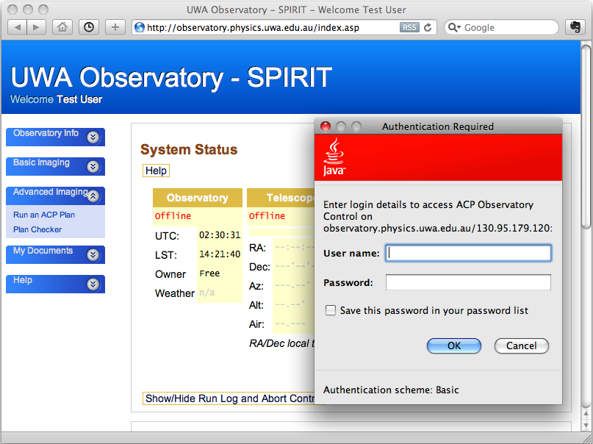
figure 1: Enter your user name and password, twice.
The SPIRIT home page (‘Observatory Info’) displays three panes: System Status, Weather and Welcome. Use the left hand menu to display other pages, such as ‘Take a series of images’. Check the weather status before you start imaging.
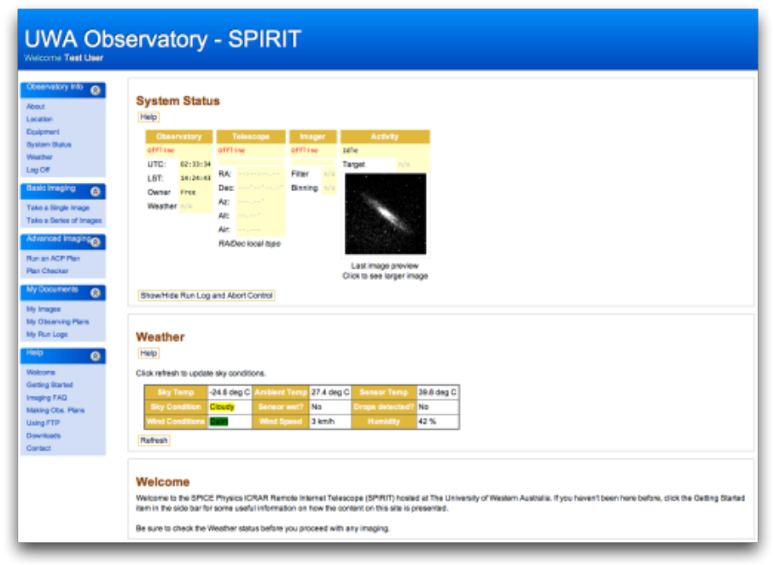
figure 2: SPIRIT home page

STEP 3: Take a series of images
Select Take a series of images from the left hand menu.
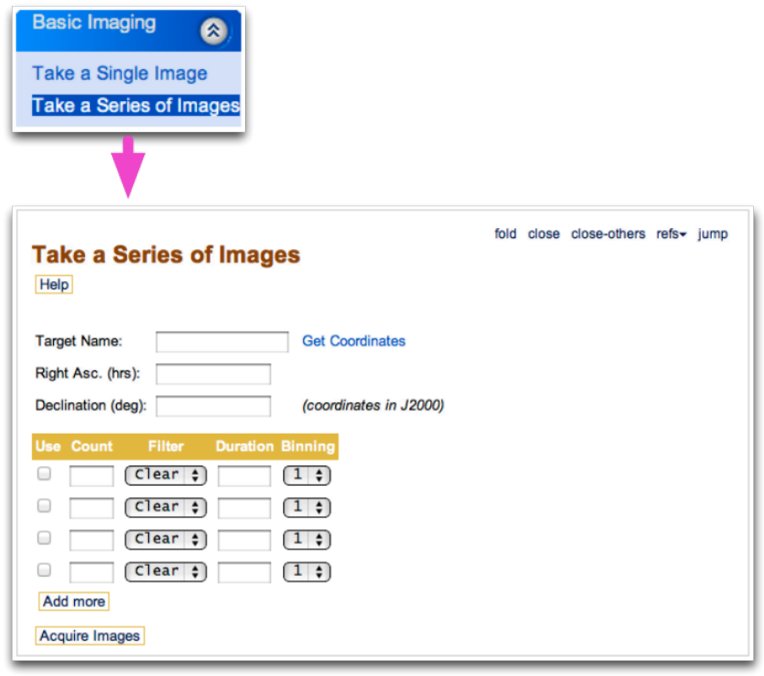
figure 3: Select ‘Take a Series of Images’ from the left hand menu.

- Enter your target name. Be sure to leave a space between the catalogue and number
(eg ‘ngc 4755’, not ‘ngc4755’).
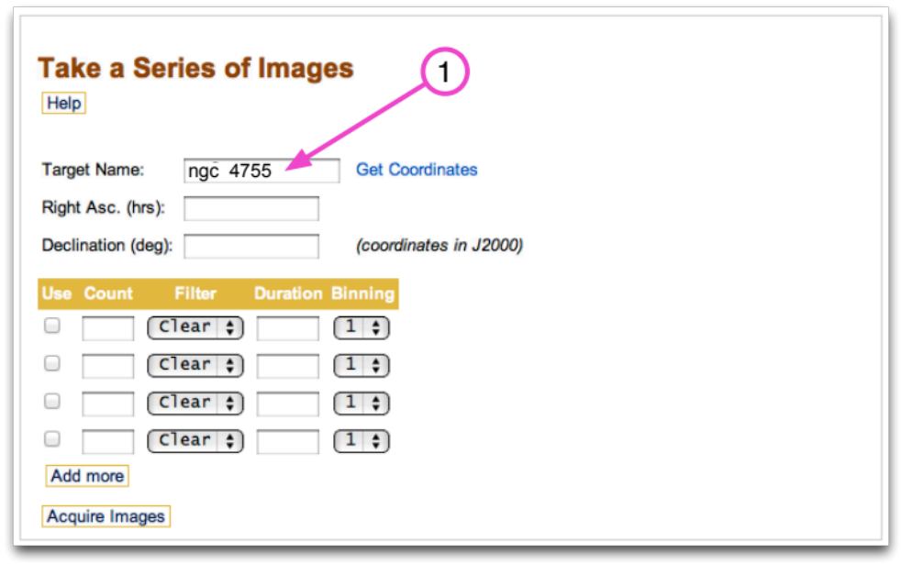
figure 4: Enter your target name.

- Select Get Coordinates. This will automatically put values into fields for ‘Right Asc.’ (RA) and ‘Declination’ (Dec).
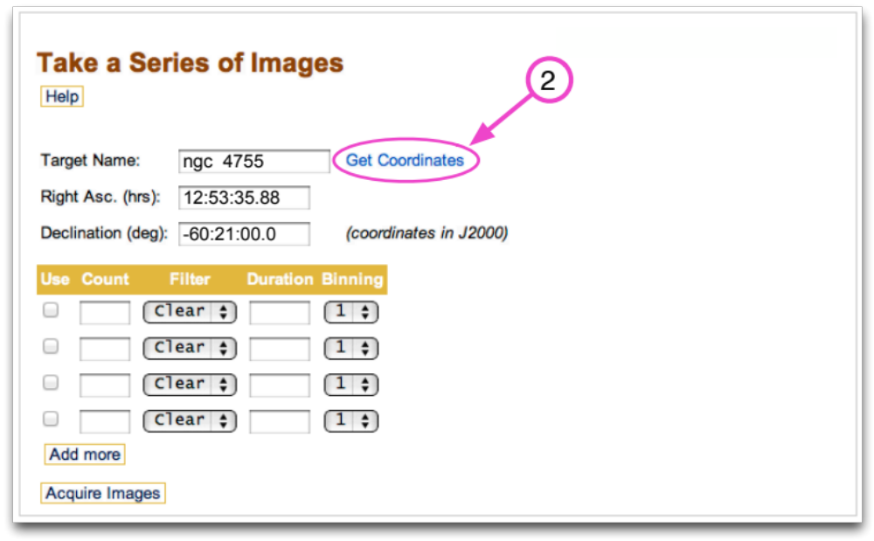
figure 5: Get the coordinates of your target.
- Enter values for Count (the number of images to be taken), Filter and Duration (exposure length). Leave Binning set to its default value (‘1’ for SPIRIT I and ‘3’ for SPIRIT II).
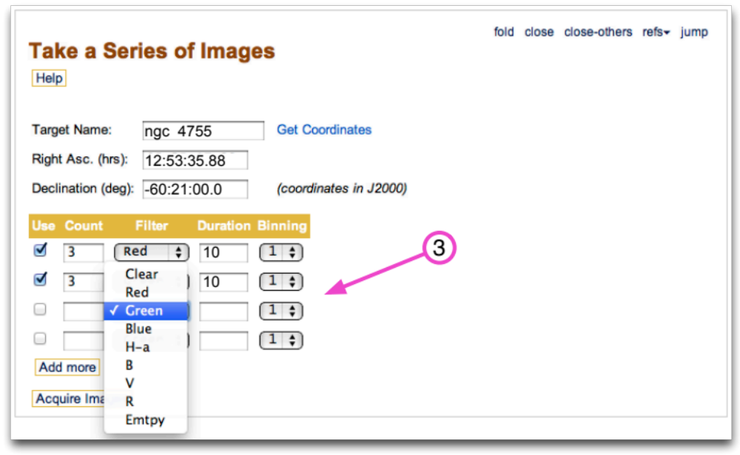
figure 6: Select exposure details, such as filter choice, for each image set.
Program SPIRIT to capture three images, at three different exposures, for each filter, to ensure that you capture at least one image at each exposure that is clear of clouds, haze, satellite tracks or other unwanted elements. Star clusters are relatively bright, so most can be imaged with exposures of less than 10 seconds.
Select Add more to create additional rows, if required. Figure 7 shows SPIRIT programmed to capture three images at 10 and 15 second durations for the red, green and blue filters. This will produce 18 images in total.
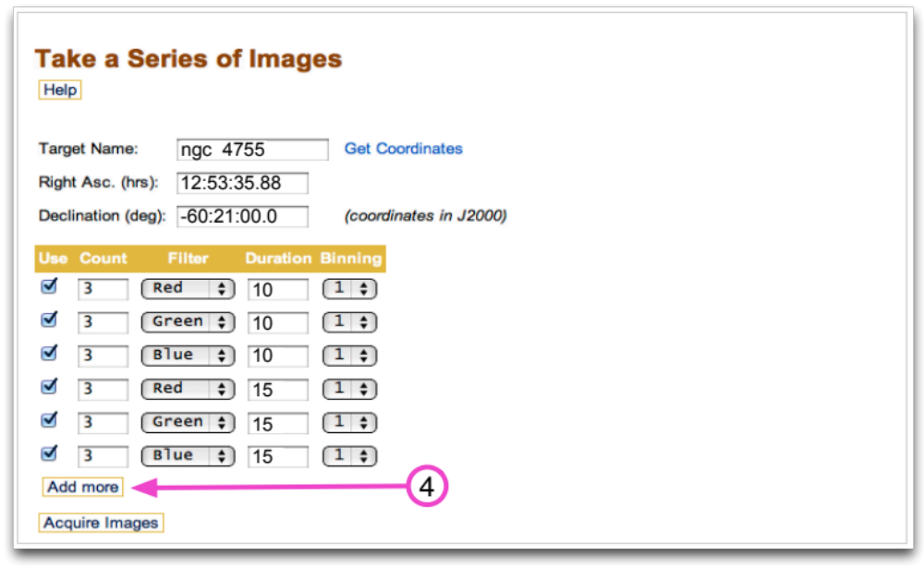
figure 7: Add as many rows as required.
- Select Acquire Image when you have finished adding exposure details. The sequence of commands to take the images will now commence. You can monitor progress in the ‘System Status’ pane. Select Show/Hide Run Log and Abort Control to expand the progress window.
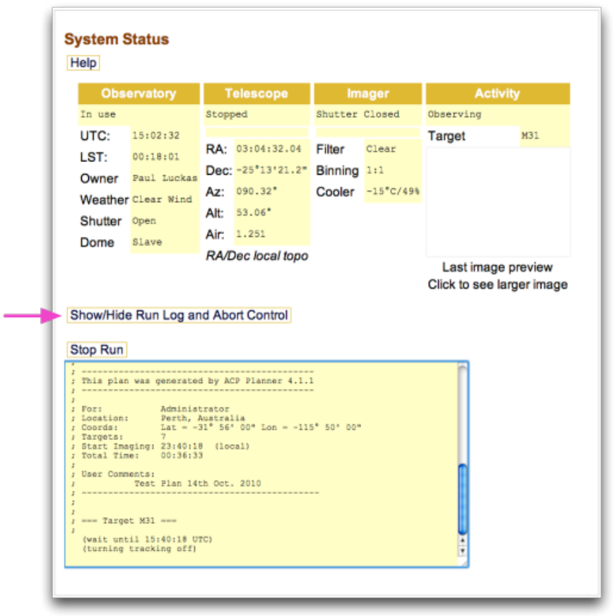
figure 8: Monitor the progress of image acquisition.

STEP 4: Download images
Once imaging is complete, a low quality image thumbnail appears in the ‘System Status’ pane. Select the image to enlarge the view.
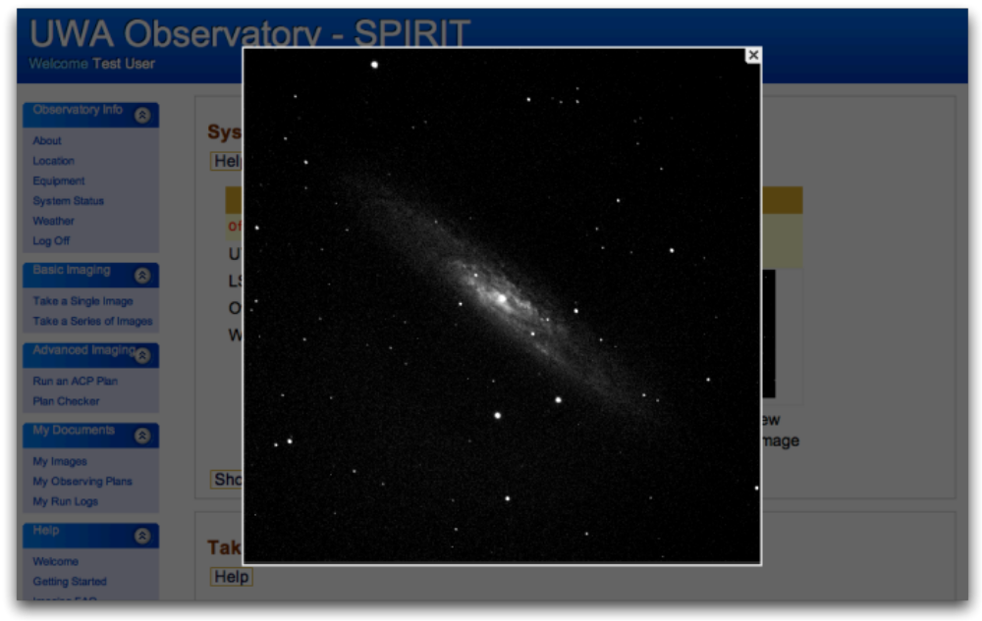
figure 10: Preview your image.
Your images can be viewed and downloaded from My Images under ‘My Documents’. Images are grouped into folders, by date.
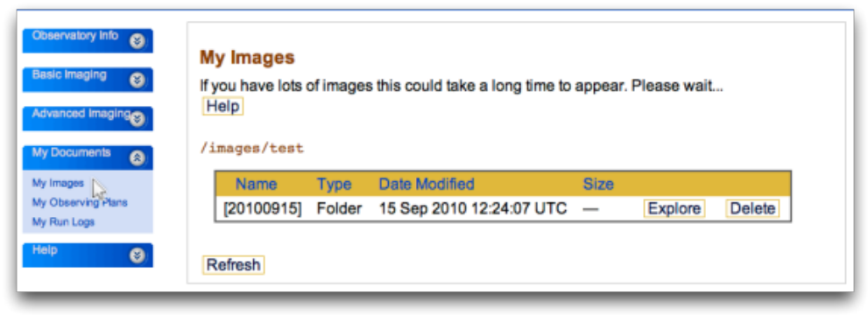
figure 11: Display a list of your images.
Navigate to the folder containing images you wish to download. JPEG versions of images may be downloaded and viewed without special software.
View your images and decide which exposure duration produced the best images. From these, select the best image taken with the red, green and blue filters. Be patient, downloading multiple images takes time!
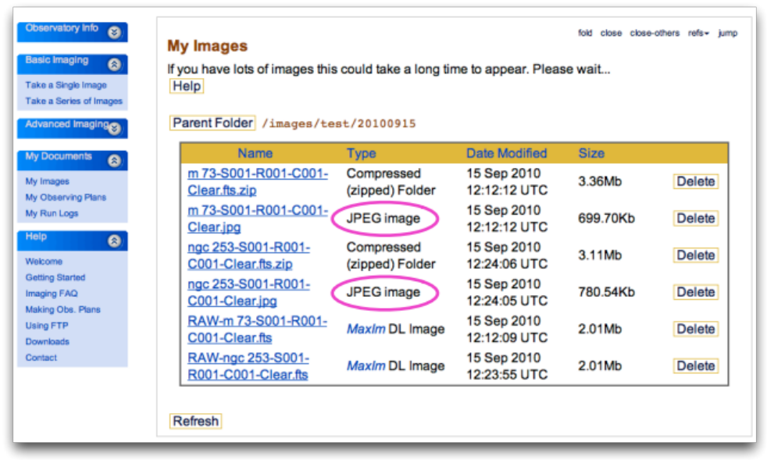
figure 12: JPEG images can be viewed without special software.

STEP 5: Log out
Log out of SPIRIT so others can use the telescope.

STEP 6: Process images
The final step in this activity is to combine red, green and blue images into a single full-colour image. To do this, you will:
- import three selected images (taken with red, green and blue filters) into a photo editing software package;
- adjust brightness and contrast of each image to increase detail; and
- combine and align images to produce a full-colour image.
These steps are described in the quick guide, Changing Universe 4: Image processing.

