fact sheet
Forensic palynology

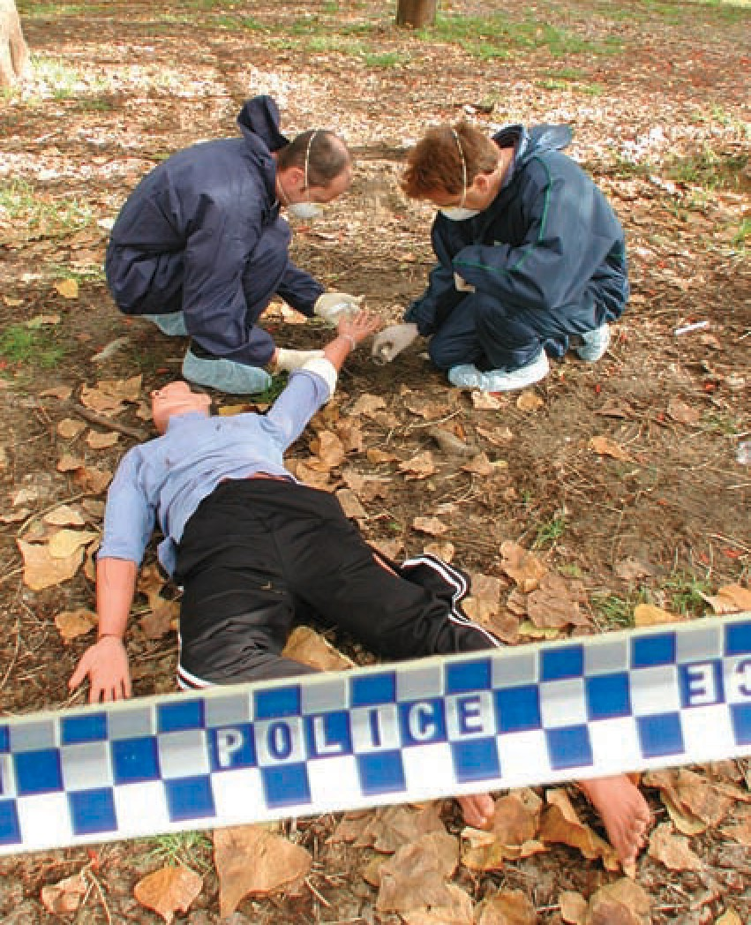Pollen grains and investigative science
What is forensic palynology?
Forensic palynologists use pollen grains to assist in solving crimes. By examining pollen collected from a crime scene, or suspect, it is possible to be specific about where a person or object has
been. Palynologists have extensive knowledge about pollen dispersal and plant productivity patterns, which helps to establish the origins of a particular pollen type, and make inferences about where a suspect, victim or object has been.

The remarkable properties of the outer wall (exine) of pollen grains make pollen a useful tool for scientists, across a range of disciplines. The exine’s resistance to
environmental damage means pollen grains that are thousands of years old can still retain their original wall texture and pattern, whilst the uniqueness of each pollen type allows for scientific identification.
Pollen grains are well represented in fossil records, particularly those from plants that produce large amounts of pollen and rely on wind for pollination. Over time, large quantities of pollen build up in layers of sediment. Palynologists sample these sediment layers and identify pollen grains, creating a pollen profile. Analysis of pollen profiles has wide ranging applications.

Taxonomists use pollen profiles to investigate botanical evolutionary pathways, and archaeologists use them to understand the diet and agricultural conditions of past civilisations. The most widespread uses are in geography and mining. Geologists
use pollen analysis to date rocks for petroleum exploration, and geographers use it to model climate patterns. Forensic science is a more recent application of pollen analysis.

References
Denbow, J. (2008). Palynology. The University of Texas at Austin, Department of Anthropology, Retrieved June 27, 2008 from http://www.utexas. edu/courses/denbow/labs/palynology.htm

Vaughn and Midenhall, (2009) Forensic Palynology: A New Way to Catch Crooks. Crime and Clues: The Art and Science of Criminal Investigation, Retrieved June 25, 2008 from http://www.crimeandclues.com/ index.php/physical-evidence/trace-evidence/67- forensic-palynology-a-new-way-to-catch-crooks

Milne, Dr Lynne (2005) The Garden of Good and Evil. Interview transcript from Australian Story. Australian Broadcasting Cooperation. Retrieved June 25, 2008 from http://www.abc.net.au/austory/ content/2005/s1440971.htm

fact sheet
Forensic palynology

Case study:

Forensic science and palynology
Meet Australia’s foremost pollen detective,
Dr Lynne Milne, who is based at the School for Earth & Environment at The University of Western Australia. Dr Milne is considered an expert in the field of forensic palynology, and her considerable skills have contributed to a number of successful criminal convictions.
Pollen grains make excellent forensic tools for a number of reasons: they are morphologically
distinct, resistant to damage and decay, produced in vast quantities, and found on almost every surface. A pollen grain is almost as useful as a fingerprint.

On the pollen trail
In the late 1990s Lynne was recruited as an expert scientist in a Queensland murder trial. A woman’s body had been discovered in coastal Queensland amidst flowering Acacia (wattle) trees. Police were keen to establish if pollen samples collected at the site matched those found on the principal suspect’s clothing and the vehicle allegedly used to transport the body. The problem for police was that there were two wattle species at the crime scene, and there were also wattle trees growing near the suspect’s home. Police needed someone with specialist skills, which led them to Lynne Milne.
Lynne found pollen from the crime scene was different from the type collected near the suspect’s house. She also knew the dispersal patterns of these species differed. Lynne next managed to
differentiate between the two pollen types collected from the crime scene. A major challenge for Lynne was separating pollen grains from forensic samples taken from the suspects clothing, and also vacuum samples from the vehicle. She eventually achieved this using a combination of chemical applications, light microscopy and scanning electron microscopy techniques. Through these analyses Lynne was able to establish that pollen on the suspect’s clothing
was indeed the same as pollen found at the crime scene. This was important evidence that aided in the suspect’s arrest, subsequent trial and conviction.

Forensic pollen analysis is also a useful way to establish the origin of illegal merchandise or drugs. Lynne is able to link people with cannabis crops through pollen analysis, and even more remarkably she can work out where a crop was grown. Lynne’s work also helps police in their pursuit of various leads. By examining pollen samples collected from vehicles and other objects, police can localise their search for suspects.
Palynologists need to take particular care that crime scene samples are not contaminated from other sources, by ensuring laboratories are clean and sterile. Preparation of exine for forensic analysis involves a number of steps, including application of chemicals to remove minerals and internal pollen contents.
Whilst forensic palynology is a relatively new science in Australia, recent successes at trials using this type of evidence suggest that pollen grains have a definite future in forensic science.

