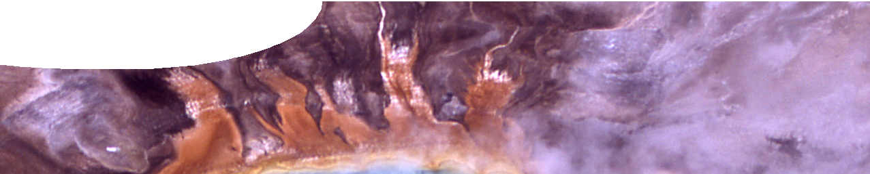
Image: D. J. Patterson
Image: NOAA
fact sheet
Extremophiles: Life at the limits
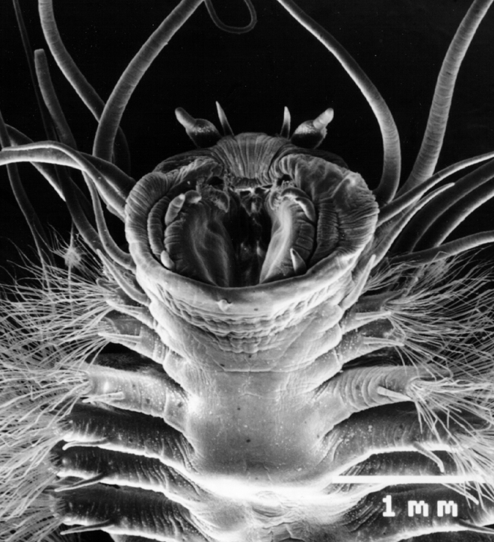
Alien invention?
Not quite: Meet an ice worm.
These worms like to live around methane ice mounds deep down on the ocean floor. Temperature, pressure, and methane levels, all extreme!

Some of the hottest, driest, darkest and most radioactive places on Earth are home to specialised organisms known as extremophiles. These critters are tough: we’re talking about life under conditions generally considered uninhabitable.
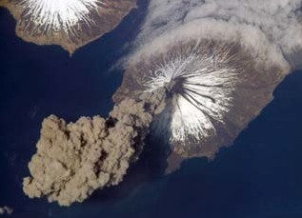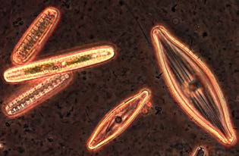Home for extremophiles might be three kilometres under ground, where it’s hot, dark and dry; or in the boiling waters of a hot spring at a
Extremophiles are organisms that grow optimally in extreme conditions.
Most extremophiles are single- celled organisms, such as bacteria.

Since the 1970s scientists have investigated this amazing group of organisms, all capable of flourishing in exceptionally harsh environments. The discovery of extremophiles has effectively challenged our ideas about the conditions necessary for life.
Many environments extremophiles inhabit are thought to be similar to those of early Earth, helping scientists investigate how life first appeared and survived.

Extremophiles also provide vital clues about life on other planets; if organisms can exist on Earth under hostile extremes, maybe they can also survive out in space. Astrobiologists believe studying extremophiles on Earth can guide the search for life elsewhere in the Solar System.
volcanic eruption: ISS013-E-24184 NASA
phenomenal 113 °C; or in acid as strong as the inside of a car battery. And what about some of the coldest places on Earth, packed in ice, where the average temperature is a low -5 °C.

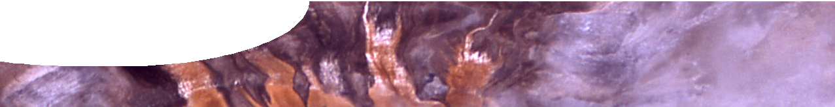
fact sheet
Extremophiles: life at the limits

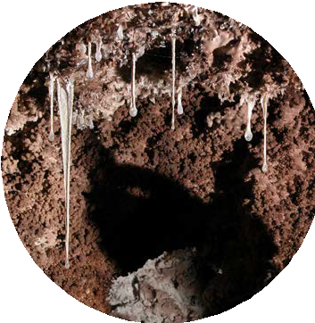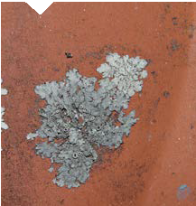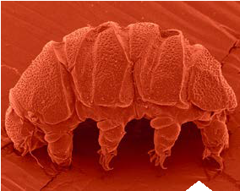Check out these extreme survivors. Snottites are found in some of the toughest environments on Earth.
Other great survivors
Lichen in space
Some organisms, such as lichens, whilst not extremophiles, are also capable of enduring extreme conditions. They do this by entering a state of inactivity, or suspended animation.
Lichens are found in some of the most inhospitable places on Earth: mountains, deserts, and even Antarctica.
In 2005 lichen survival skills were trialled in space. For 16 days two species of lichen had to deal with extreme cold, intense solar and cosmic radiation, desiccation and the space vacuum.
Although unable to function under these hostile conditions, once back on Earth the lichens returned to normal functioning within 24 hours.
The adventurous journey of these lichens shows that multicellular organisms can exist outside Earth’s atmosphere, and might even survive the varied atmospheric conditions of other planets.

The water bear
This is tardigrade, also known as the water bear, another organism capable of withstanding extremes. In 2007 this tiny invertebrate made the important journey into space, spending twelve days exposed to extreme conditions. Like lichens, tardigrades endure hostile conditions by entering a state of inactivity. Early results look promising, with many tardigrades surviving the trip and returning alive to Earth.
These bacterial extremists line the walls and ceilings of caves, where acid levels exclude all other life, and the only thing to eat is sulphur.

Meet the snottites!

Extremophiles – who’s who
Image: © 2003 Kenneth Ingham
There are many types of extremophiles and it’s possible to group them on the basis of conditions they like
Image copyright: Paul Ricketts (DUIT Multimedia)
best. One thing that’s important to note is that most extremophiles live under a number of extreme conditions.

ACIDOPHILES
Organisms that live in highly acidic conditions, ph ≤ 5

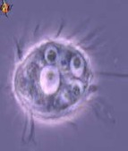
Places you might find them:
image: L Amaral-Zettler & D. J. Patterson
- Crater Lake, New Zealand
- Rio Tinto River, Spain

HALOPHILES
Organisms that live in places where salt concentrations are 2–5 times the concentration of seawater, up to 30% salinity

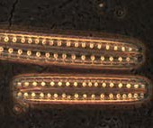
Places you might find them:
image: D. J. Patterson
- Dead Sea, Middle East
- Great Salt Lake, Utah, USA

PSYCHROPHILES
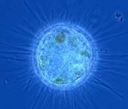
Organisms that literally live in the freezer, flourishing in extremely low temperatures.
image: Michele Bahr & D. J. Patterson
Image: L. Michalczyk & L. Kaczmarek, courtesy of www.tardigrada.net

Places you might find them:
- Lake Vostok, subglacial lake Antarctica
- Kolyma Lowlands, Siberia (frozen in permafrost)

THERMOPHILES
Turn up the heat, these organisms like the temperature extreme, anything above 45 °C. Hyperthermophiles like it even hotter, thriving in temperatures ranging from 70 -113 °C.

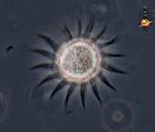
Places you might find them:
image: D. J. Patterson
- Grand Prismatic Spring, Yellowstone National Park, Wyoming, USA
- Deep sea hydrothermal vents, Galapagos Rift, Ecuador

