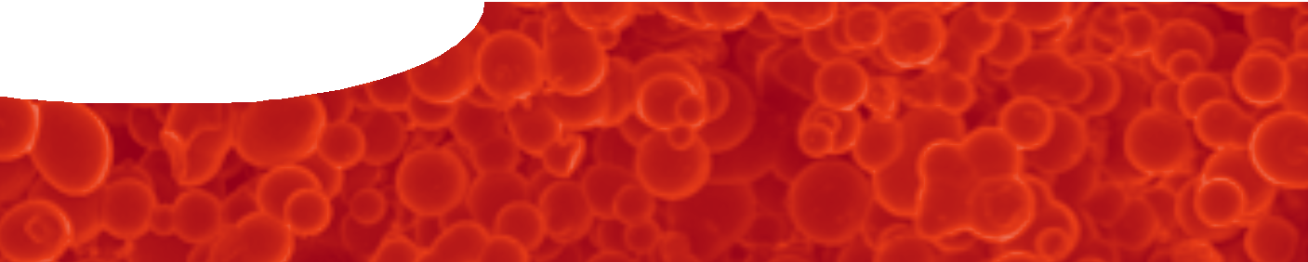
fact sheet
Engineering biomaterials

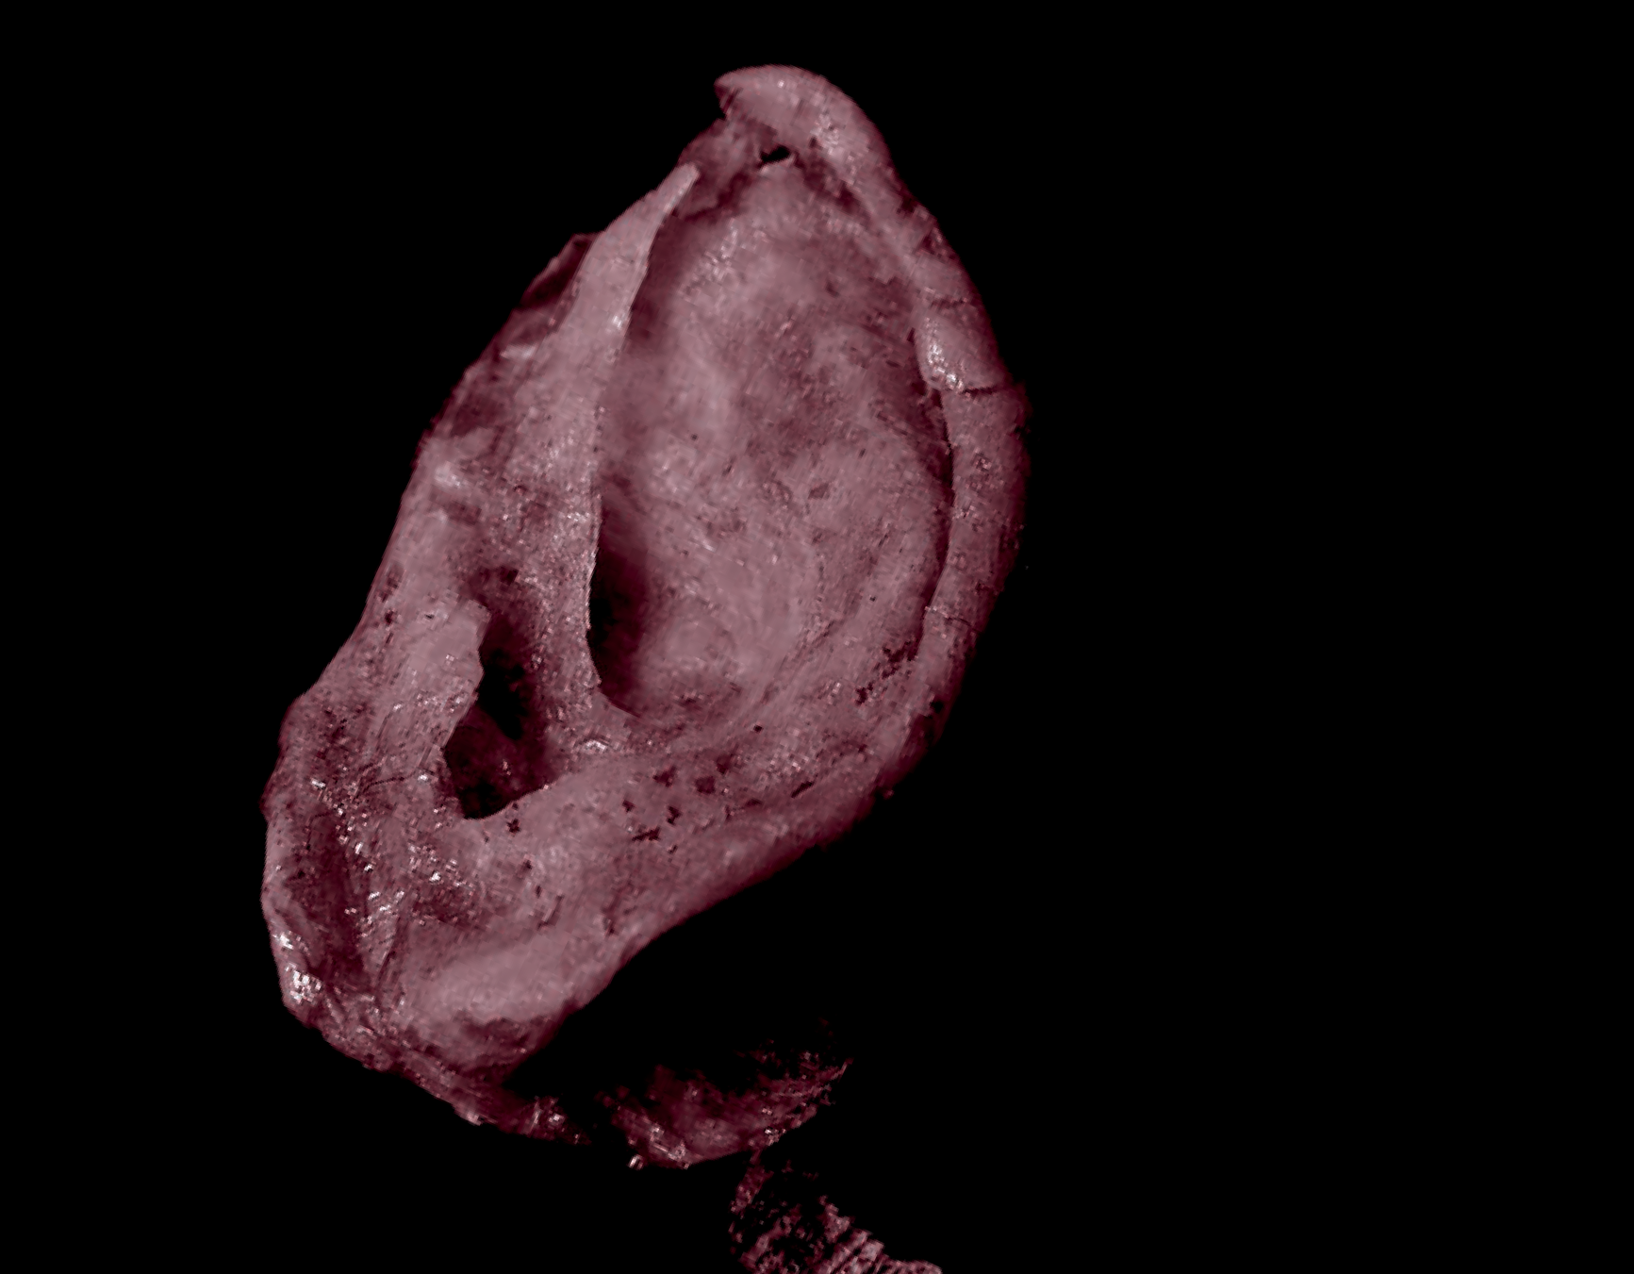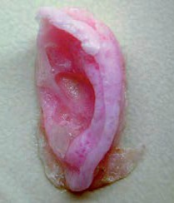This quarter-scale replica of a human ear was grown using human cells. The ear was built using tissue cultur technology, and is not the result of genetic engineerin Scientists are able to grow cartilage cells (the type
e g.  w | Key properties of scaffolds used in tissue engineering  - Bioscaffolds must be non-toxic and biodegradable so that they are gradually ‘resorbed’, that is, removed, degraded, stored elsewhere or excreted, once they have served their purpose of providing a template for regenerating tissue. This is important as foreign materials  may be rejected by the body, or cause infection.  - The ideal material for medical applications needs to be strong, but not too strong for the application. For example, a rigid metallic implant used to repair a broken bone may not allow the new bone to develop enough strength if it does not allow the new bone to take the body’s weight. If the implant gradually degrades and is resorbed by the body, load is slowly transferred to bone as it heals. Ultimately, bone strength is increased.  - The scaffold material must be flexible where it is used to  repair flexible materials in the body, such as cartilage.  - It must be possible to make the bioscaffold material in the shape required.  - The scaffold must have a structure that allows cells and blood vessels to grow within it, so new tissue can access nutrients and get rid of waste products. Pores in the scaffold need to be the right size,  micron-scale (10-6 m) rather than  nano-scale (10-9 m), and spread throughout the material.  - Scaffold material has to be chemically matched to the cells to be grown. The material must be biocompatible, so regenerating tissue cells  will attach to it, but other components of the body, such as blood cells, don’t.

of cell that makes up the structure of the ear) on a biodegradable scaffold or template. This technology was developed in the 1990s when scientists cultivated cartilage cells in the shape of a human ear on the back of a living mouse.

The same technology helped twelve year old Sean McCormack. Sean was born with a congenital condition that resulted in him having no bone or cartilage
on his left chest. His heart was virtually unprotected and it could be seen beating under the skin. Sean loved to play baseball, but every game was a risk as a single ball to the chest could kill him. A biodegradable scaffold was made and moulded to the shape of Sean’s chest. Cells were scraped from what cartilage Sean did have and added to the scaffold in a laboratory incubator. In several
weeks a ‘chest’ grew which doctors implanted into Sean. No Sean has a normal looking chest that is able to grow with him.
Sean’s case is a glimpse into the future of medicine. Some day doctors will order newly grown living body parts whenever existing ones fail. Laboratory- grown bone, cartilage, blood vessels and skin are all being tested in humans. Creating the most complex organs seems possible, though it is still five to ten years in the future.

A human ear: the result of work by The Tissue Culture Project at Symbiotica
(The University of Western Australia).
20 mm

fact sheet
Engineering biomaterials

Synthetic biomaterials are the subject of a great deal of research, mostly focussed on the use of polymers.

H₂C
CH₃ CH₃

CH₃

These are large, carbon-based molecules made of small,
repeating units linked by strong covalent bonds. Figure 1 shows how molecules of propene are joined to make the
n HC CH₃
CH
CH₂
CH CH
CH₂

CH₂

polymer polypropene (polypropylene).
The polymer pHEMA (see Figures 2 and 3) is a commonly used biomaterial. It is used for soft contact lenses
Figure 1: Units of propene are linked together to make the polymer
polypropene.

OH
H₂C

and for permanent medical implants such as artificial corneas where it is important that the polymer is not biodegradable.
A team of scientists, led by Associate Professor Murray Baker at The University of Western Australia, and Professor Traian Chirila, Senior Scientist at the Prevent Blindness Foundation (Queensland) and Professor at The University of Queensland, have been investigating ways to make this polymer biodegradable. Why bother

O
C
replace H with
H
H₂C C

CH₃

CH₂
O

H₂C

O O
C H₂C C
CH₃
OH

CH₂

to make it biodegradable? It happens to be easy to make pHEMA in a porous form where cells readily grow in an implanted bioscaffold. To make pHEMA biodegradable,
Figure 2: A hydrogen atom in propene is replaced with the
group shown to make a molecule known as HEMA (2-hydroxyethyl methacrylate).

peptide molecules are used to crosslink short chains of pHEMA together.
In addition to unreactive C-C bonds, the peptide chains

H₂C
OH

CH₂

H₂C
OH

CH₂

H₂C
OH

CH₂
OH
H₂C
CH

contain more reactive C-N bonds, which are susceptible ^{O} O
n
C
to enzyme attack. It is hoped that, when these materials
O O O O O O C C C

are implanted into the body, enzymes will slowly break down the peptide links, releasing small pHEMA chains. These chains should be small enough to be resorbed. In
H₂C C

CH₃
C CH₃
CH₂
C CH₃
CH₂
C CH₃

this way the pHEMA polymer becomes biodegradable.
Laboratory tests have been done with the enzyme papain. This plant enzyme is extracted from pawpaw, and used as a meat tenderiser. In the trials, pHEMA is successfully broken down but further research in living tissue is now planned.
Researchers have also been able to make pHEMA in a
Figure 3: Units of HEMA are linked together to make the polymer pHEMA.

crosslinked pHEMA
enzyme

peptide

way that makes it naturally porous, so it is an attractive
crosslink pHEMA chain

short pHEMA chains

material for tissue engineering. Figure 6 shows spheres of porous pHEMA material containing a peptide crosslinking agent. The dark patch below centre is a pore where cartilage cells could grow to build a support structure before pHEMA is resorbed by the body.
It is easy to see how pHEMA can be used to regrow cartilage tissue in damaged joints. In the future, more complex tissues and organs could be scaffolded by this versatile, covalently-bonded, carbon-chain polymer.

Reference
La Porte, Richard J. (1997). Hydrophilic polymer coatings for medical devices: structure/properties, development, manufacture, and applications. CRC Press: Massachusetts.
McLucus, Reason (2004, October 13). The Invisible (Adult Stem Cell) Revolution. Retrieved on May 12, 2008 from http://www.freerepublic.com/focus/f-news/1242984/posts
The A to Z of Materials (2004). Research Suggests New Way to Repair Cartilage Using Natural Polymers. Retrieved on January 12, 2008 from http://www.azom.com/news.asp?newsID=1095
Figure 4: Short pHEMA chains are linked by biodegradeable peptide molecules. These are broken down by enzymes to create short, resorbable pHEMA chains in the body.
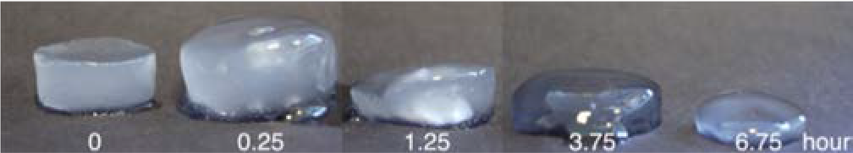
Figure 5: Degradation of a peptide-crosslinked pHEMA sample under the action of the enzyme papain in a laboratory test over about 7 hours. (photo courtesy Dr Ylenia Casadio)
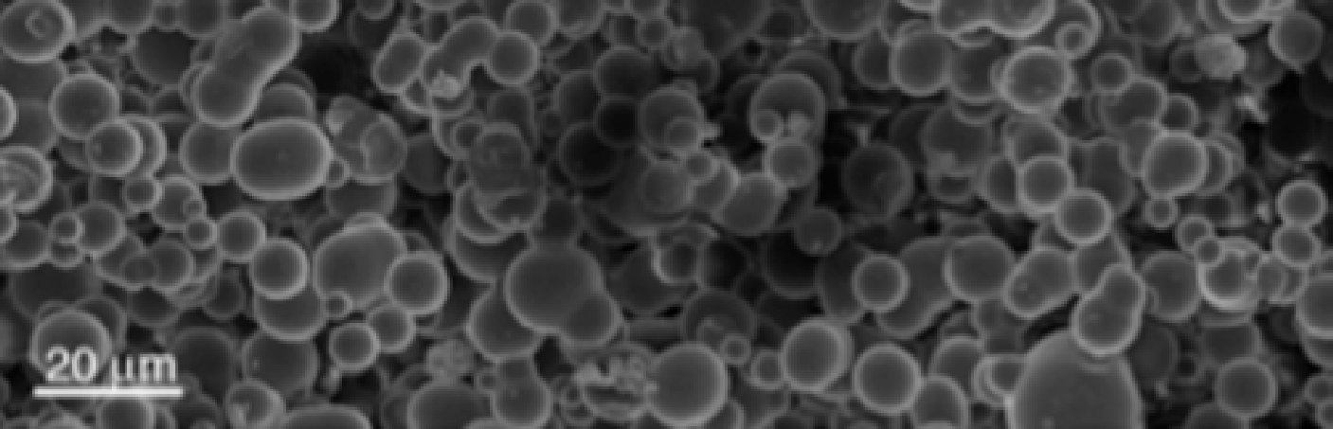
Figure 6: Photomicrograph of peptide-crosslinked pHEMA

