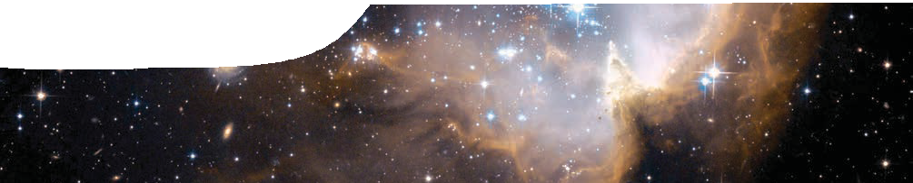
background sheet
Deep sky objects
NCG 602 in the Small Megallanic Cloud
credit: NASA, ESA and the Hubble Heritage Team (STScI/AURA) — ESA/Hubble Collaboration and S. Stolovy (Caltech)

When we turn our eyes to the night sky, we see far more than stars and planets. Viewed through a telescope, it becomes clear that many celestial objects have considerably more structure than simple stars. SPIRIT I and II are research grade telescopes that are optimised for viewing deep sky objects (objects beyond our Solar System).
Using SPIRIT, objects can be imaged that are hundreds of millions of light years away, beyond the range of normal backyard telescopes. These deep sky objects include open star clusters, globular star clusters, nebulae and galaxies.
The following information provides an introduction to some of these objects.

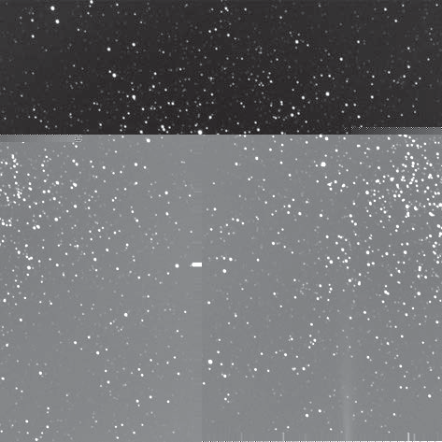
Open star cluster
An open star cluster is a group of up to a few thousand stars that were formed from the same giant interstellar cloud of gas at roughly the same time. Stars in an open cluster are loosely bound to each other by gravitational attraction. They can be disrupted by close encounters with other star clusters or gas clouds as they orbit the galactic centre. This may result in loss or gain of cluster members. Open clusters generally survive for a few hundred million years.

right: NGC 2477 open star cluster, SPIRIT image

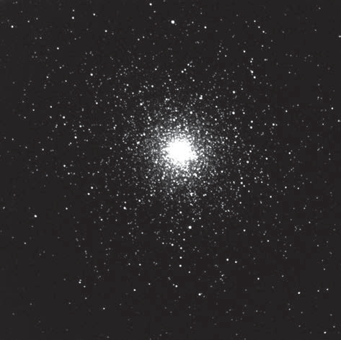
Globular star cluster
A globular star cluster is a spherical collection of stars that orbits the centre of a galaxy. Globular clusters are held together by gravity, which gives them their spherical shape and relatively high stellar density.
The Milky Way galaxy contains about 150 known globular clusters, with perhaps 10 to 20 yet to be discovered.

right: NGC 104 globular cluster, SPIRIT image

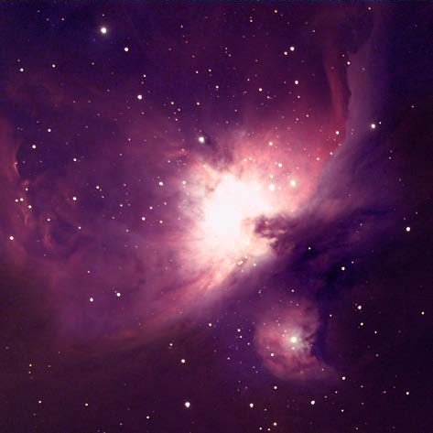
A nebula is an interstellar cloud of dust, hydrogen, helium and other ionised gases.
Large nebulae frequently become places where star clusters are formed. In these regions, gas, dust and other materials clump together to form larger masses which attract further matter and eventually become large enough to form stars. Any remaining materials are believed to form planets and planetary system objects.

right: Orion nebula, SPIRIT image

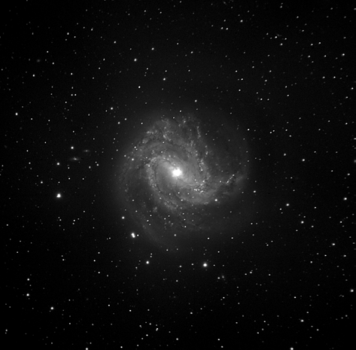
Galaxy
A galaxy is a massive conglomeration of stars, stellar remnants, interstellar gases, dust and dark matter held together by gravity.
Galaxies range in size from dwarfs with as few as ten million stars, to giants with hundreds of trillions of stars orbiting the galactic centre of mass.
Galaxies are classified according to their apparent shape: elliptical, spiral or irregular. There are probably more than 170 billion (1.7 × 1011) galaxies in the observable Universe.

right: M 83 galaxy, SPIRIT image

Naming astronomical objects
Most astronomical objects have been catalogued and are known by their reference number. However some, such as the Andromeda Galaxy, are also known by traditional names.
Three astronomical catalogues are in common use.

Messier catalogue
One of the earliest attempts to name and catalogue astronomical objects was made by Charles Messier in 1771. Messier was a comet hunter who simply grouped together objects that looked like comets, but were not. His catalogue eventually grew to include the
110 brightest objects in the sky, including open star clusters, globular star clusters, nebulae and galaxies.
M 1 is the Crab Nebula; M 31 is the Andromeda Galaxy and M 45 is the Pleiades open star cluster.

NGC catalogue
The New General Catalogue (NGC), published in 1888, was an attempt to collect many lists in existence at that time into one master list. It catalogues almost 8000 objects, including galaxies, nebulae and star clusters.
NGC 1 is a spiral galaxy in the constellation Pegasus; NGC 188 is an open star cluster in the constellation Cassiopeia; and NGC 2022 is a planetary nebula in Orion.

PGC catalogue
The Catalogue of Principal Galaxies (PGC) is an astronomical catalogue published in 1989 that lists about 73 000 galaxies.
Many astronomical objects are known by more than one catalogue reference number.

SPIRIT I and II are optimised for viewing deep sky objects (objects beyond our Solar System), such as star clusters, nebulae and galaxies. It is not suitable for viewing very bright objects, such as the Sun or Moon. SPIRIT can be used to image the brighter planets, such as Jupiter and Saturn, if short exposures (less than one second) are used. However, the resulting images tend to appear small and unremarkable.
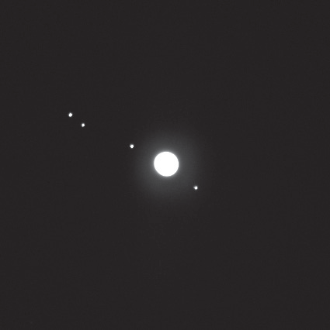
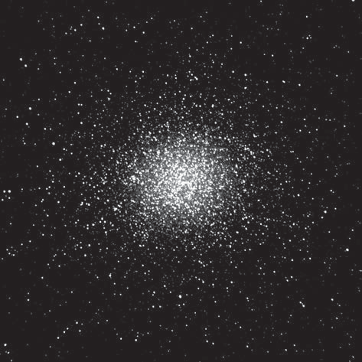
Jupiter and four of its moons NGC 5139 Omega Centauri globular star cluster

Quality of images captured with the telescopes can be improved by taking into consideration the following information.

Exposure
The brightness of deep sky objects varies greatly. When they are imaged the exposure (length of time that the camera’s shutter is open) must be adjusted to ensure that sufficient light is gathered to produce a good image. Images of brighter objects, such as open star clusters or globular star clusters, can be captured using exposures of less than 20 seconds. Some nebulae require an exposure of at least 30 seconds, while faint galaxies may require 60 seconds or more.
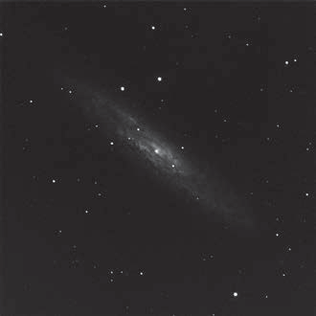
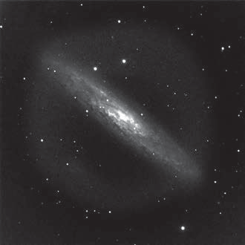
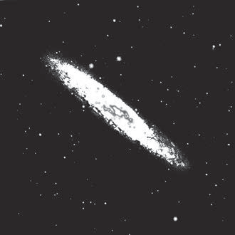
NGC 253 Sculptor Galaxy: under-exposed, correct exposure and over-exposed

SPIRIT I and II cannot be used to image objects below an altitude of 20° (ie less than 20 degrees above the horizon) due to the presence of neighboring obstacles. Nor should they be used to image objects that are low in the east, because light from Perth’s city lights together with atmospheric pollution can reduce image quality.
For best image quality, try to image objects as high in the sky as possible. Objects imaged above 60° elevation will always give the best results.
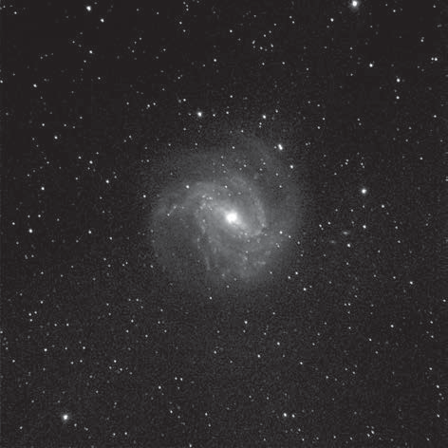
M 83 galaxy, SPIRIT image NGC 5139 Omega Centauri globular star cluster

The Moon’s position in the sky
On nights just before and just after a full Moon, exposures should be kept to less than two minutes to prevent its glow from spoiling the image. This is especially noticeable when imaging under hazy or partially cloudy conditions.
For the same reason, avoid trying to image objects within 50° of a near-full Moon.

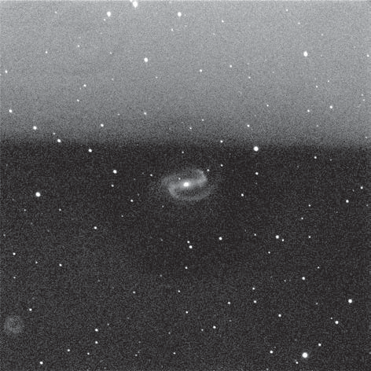
faint galaxy imaged too close to a near-full Moon

Filters
SPIRIT I and II have monochrome CCD cameras for maximum sensitivity to light. Their filters include:
- narrow band blue, visual and red (B, V, and R) filters used for photometric studies of stars, such as measuring their temperatures and luminosity;
- red, green and blue photographic filters used for creating colour images;
- an H-a (hydrogen alpha) filter used for imaging faint, hydrogen-rich nebulae; and
- a clear filter for all other imaging.
The clear filter is recommended when using the telescopes for the first time.

