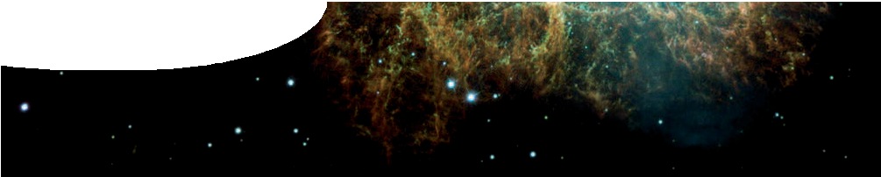
fact sheet
Death of a star

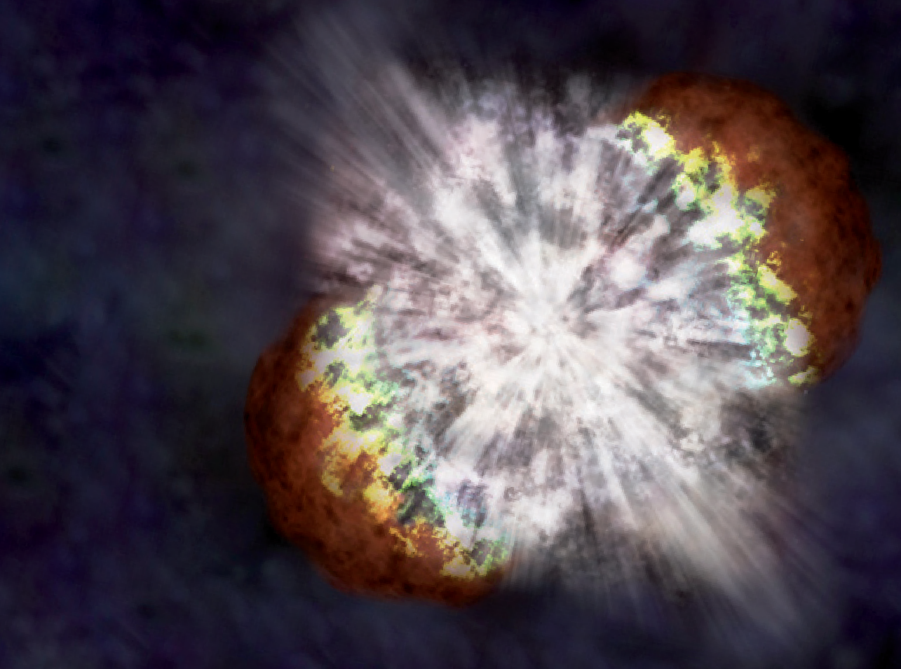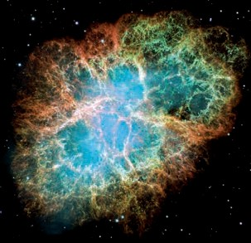The dying days of a star can be explosively spectacular, creating some of the most energetic events in the Universe.

Exploding stars
Artists impression of supernova. Credit: Illustration: NASA/CXC/M.Weiss; X-ray: NASA/CXC/UC Berkeley/N.Smith et al.; IR: Lick/UC Berkeley/J.Bloom & C.Hansen
Stars do explode, and when that happens they’re known as supernovae.
A supernova creates an explosion billions of times brighter than our sun, with enough energy to outshine its own galaxy for weeks. These massive explosions throw large amounts of matter out into space.
Supernovae are fundamental to our understanding of how the world around us came into existence. An exploding star flings enormous amounts of material out into space, including elements such as carbon, oxygen and iron. Over billions of years these elements may eventually form new objects, including planets.

Going supernova
Astronomers classify supernovae into two main groups: type I and type II.

Crab Nebula — the remnant of a supernova first seen by Chinese astronomers in 1054.



Type II supernovae involve the collapse of a single massive star. As the star uses up available fuel, the pressure within the core increases causing atoms to become unstable. Eventually the core collapses, producing a powerful supernova that throws heavy elements out into space.
Type II supernovae

m
Some type 1 supernovae are used to calculate distances and study the motion of galaxies through space.

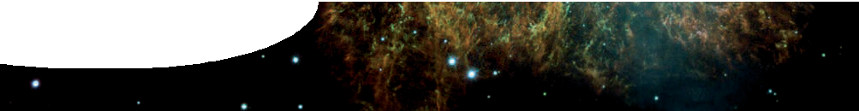
fact sheet
Death of a star

cools and contracts to white dwarf
red giant sheds outer layers
star, similar to the Sun
expands to red giant

Sunshine forever?
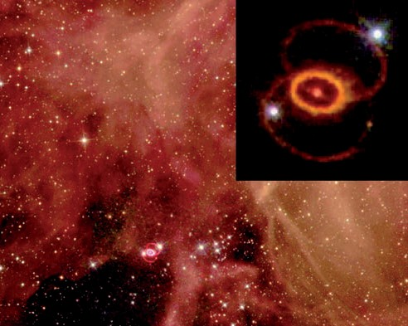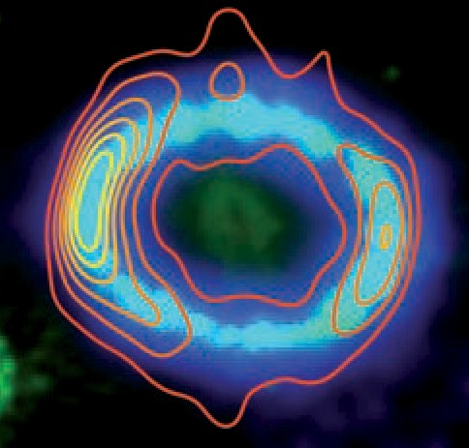Stars create enormous amounts of energy throughout their lives in a process called nuclear fusion. Nuclear fusion occurs in the core of a star where billions of tonnes of hydrogen are converted into helium every second.
In 1987 a type II supernova (SN 1987a) occurred in the Large Magellanic Cloud. This supernova was powerful enough to be viewed with the naked eye.

Catching up with a supernova
Scientists at The University of Western Australia are studying the remnant of Supernova 1987A.
The team use very sensitive radio telescopes to study the expanding supernova remnant.
Supercomputer simulations are used to study the supernova and investigate how magnetic fields are generated, and particles accelerated. Contours in this image represent the location of hot electrons that have been accelerated close to the speed of light by the supernova.
Most stars have enough fuel to last billions of years.
credit: ESA/STScI and NASA/Hubble Heritage team
When hydrogen runs out, stars that are about the size of the Sun expand and become a red giant — up to one hundred times their original diameter. As a red giant loses heat its core loses mass, blowing off outer layers and shrinking to become a white dwarf star. In a few billion years our Sun will become a red giant, before finally disappearing. As a red giant our Sun will swallow Mercury and Venus, and will likely wipe out all life on Earth.
Stars larger than the Sun may become supernovae.

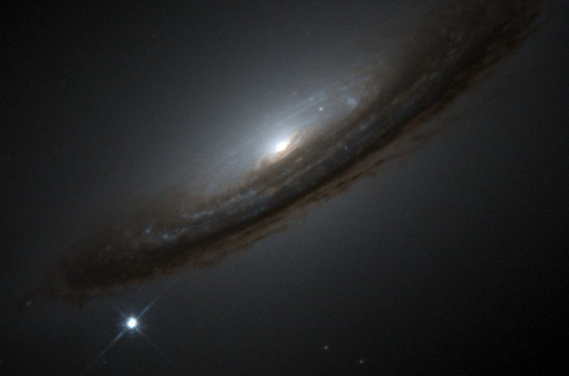
Supernova 1994D

Supernova 1994D
credit: High-Z Supernova Search Team, HST, NASA

Hunting supernovae
Supernovae are rare events that occur in distant galaxies, so finding them requires persistence. Astronomers compare images of galaxies captured at different times in the search for new ‘star-like’ objects. Some of these objects are supernovae; others may be asteroids, comets, or variable stars (stars that vary in brightness). Supernovae are important astronomical events and many telescopes survey the skies for them, including the Zadko telescope at Gingin, WA. Hundreds of galaxies are imaged each night and compared to previous images in the hope of finding a new supernova.

credit: International Centre for Radio Astronomy Research, The University of Western Australia



