fact sheet
DDT and heavy metals

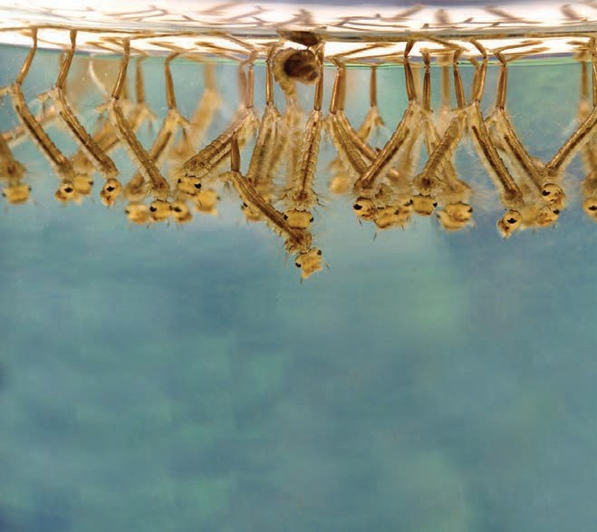so accumulate in the food chain. DDT has a half-life of eight years in animal fat, which means that it takes eight years for half of the concentration of the DDT in the body to be removed.

What is DDT?
DDT or Dichloro-Diphenyl-Trichloroethane is an organochlorine. These are organic compounds that contain chlorine. DDT inhibits enzymes in some insects, which ultimately kills them. Dr Paul Müller of Geigy Pharmaceutical in Switzerland discovered the insecticidal properties of DDT and was awarded the Nobel Prize in medicine and physiology for his discovery in 1948. By the early 1970s the use of DDT as a pesticide had been banned in the USA and there has been a total ban on DDT use in Australia since 1987.
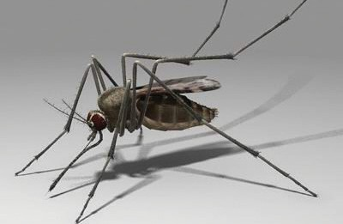
Adverse effects of DDT include birds producing eggs with soft shells, which causes higher death rates in chicks; and in humans an increased risk of having a premature baby.

Culex mosquito larvae. Image: James Gathany, CDC.
Gross L (2006) A New Model for Predicting Outbreaks of West Nile Virus. PLoS Biol 4(4): e10

DDT and resistance
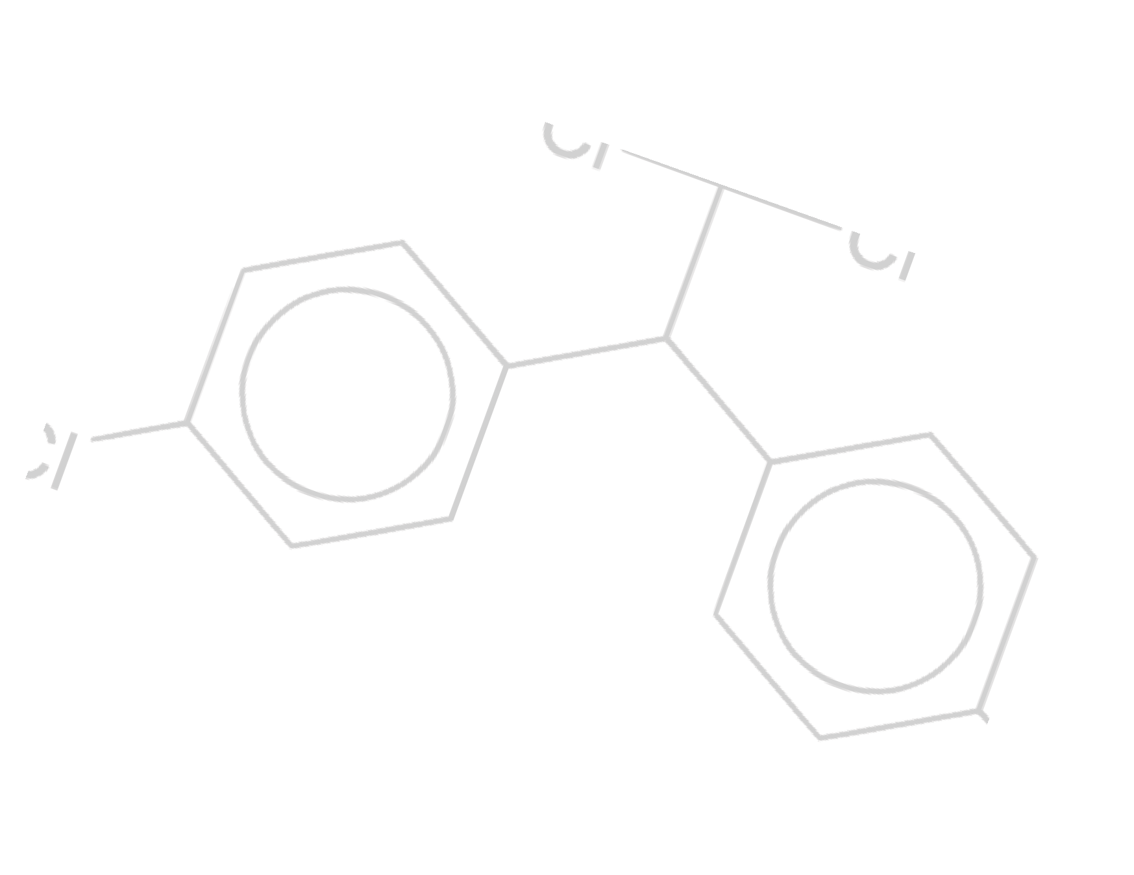DDT-resistant mosquitoes were first reported in India in 1959. Today they are present in most populations in small numbers where spraying has previously occurred. When an area is sprayed with DDT, mosquitoes without

What was it used for?
DDT was introduced into Australia and New Zealand for agricultural use in the 1950s. The two main uses for DDT were to reduce the spread of disease by killing the species of mosquito
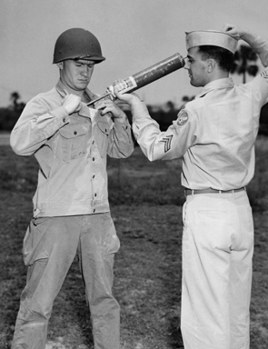
that spreads malaria and the lice that carry typhus; and in agriculture as an insecticide/pesticide to prevent insect damage to crops.

Why was it banned?
DDT has been banned in many countries due to problems associated with:
development of insect resistance to the chemical,
toxicity of DDT to animals other than insects,
lack of biodegradability causing bioaccumulation, and
high fat-solubility.

DDT and bioaccumulation
DDT and some other insecticides are only slightly soluble in water (they are weak electrolytes) but they are quite soluble in non-polar fats and oils.
As a result, these chemicals become concentrated in fatty tissues of fish and other animals. They degrade slowly and
resistance genes die. But any small population of resistant mosquitoes survive to breed and so increase in number rapidly. Once a spray program starts a wholly resistant population can be seen within months, so that eventually a different pesticide has to be used.
DDT has helped save millions of lives worldwide by eradicating or controlling diseases such as malaria and typhus, but there is concern over the direct effects to human health.

Various organochlorine compounds have been used in Australia
including herbicides, pesticides, fungicides and industrial chemicals. The compounds are often very stable. This property can be a problem when chemicals become distributed in
the environment and persist long after their original use DDT can take more
than 15 years to break down.

ast0238 | Wetlands chemistry: DDT and heavy metals (fact sheet) developed for the Department of Education WA
© The University of Western Australia 2009 for conditions of use see spice.wa.edu.au/usage version 1.2, reviewed June 2014 page 1 Licensed for NEALS

fact sheet
DDT and heavy metals

Toxic and heavy metals

What are toxic and heavy metals?
Although these terms are commonly used, they have no precise chemical definition.
Toxic metals are poisonous to humans either as elements or compounds.
Metals such as cadmium, chromium, cobalt, gold, lead, mercury, silver, thallium and vanadium, are often included as heavy metals. Other elements that can cause problems in elevated concentrations include arsenic and selenium.
Some of these metals are essential for biological function. For example cobalt is present in vitamin B12. Properties of heavy metals such as technetium have been used in medicine to help diagnose disease. Platinum-containing drugs have been used for the treatment of various cancers.

What’s the problem?
References
Heavy metals and toxic metals are natural components of the Earth’s crust. In small amounts they are harmless.
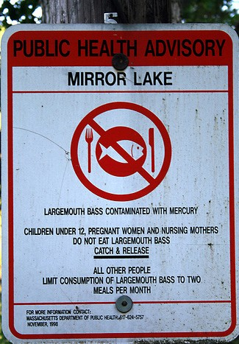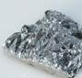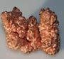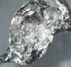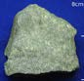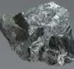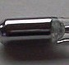But agriculture, industry, pollution and waste production increase the presence of such chemicals in the environment. A rise in groundwater acidity, due to agricultural activities, may increase leaching of heavy metals through the soil.

What is bio-accumulation?
Over time heavy metals can become concentrated in the environment, sometimes to toxic levels in animals. Humans can also develop increased levels of heavy metals within their body systems due to industrial or domestic use of these materials.
Chuck Seggelin/Sagewood Studios

The book Alice in Wonderland includes a character called the Mad Hatter. This related to nineteenth century hat makers who used mercury in the felting process.
Inhalation of the fumes could result in mercury accumulation in neurological tissues, including the brain. Side effects included
psychotic episodes, altered ability to speak and distorted vision. In this period anyone acting strangely was considered mad.

Uses of heavy metals
Antimony: batteries, ceramics, glass and pigments

Cadmium: batteries, corrosion protection, PVC stabilisers, fertilisers

Chromium: steel, metal alloys, green pigments for paint, cement, paper, rubber

Copper: water pipes, chemicals for the control of algae, computer circuits, currency

Lead: batteries, alloys, pigments, cable sheathing, shot and
ammunition, protective shielding

Mercury: batteries, non-ferrous metal production, coal combustion, preservative,
dental amalgams, photography, catalysts, tanning, dyeing

Nova, Australian Academy of Science (1999). The bitter-sweet taste of toxic substances. Retrieved 19th Sept 2007, from http://www.science.org.au/nova/036/036box03.htm
Department of the Environment and Heritage. (1997). Some previous uses of organochlorine pesticides in Australia. Scheduled Wastes Fact Sheet 4. Retrieved 19th Sept 2007, from http://www.environment.gov.au/ settlements/publications/chemicals/scheduled-waste/ocpfactsheet4.html
Lenntech (n.d.). Heavy Metals. Retrieved 19th Sept 2007, from http://www.lenntech.com/heavy-metals.htm
US Department of Labor, Occupational Safety & Health Administration (n.d.). Toxic Metals. Retrieved 19th Sept 2007, from http://wwwosha.gov/SLTC/metalsheavy/index.html
US Environmental Protection Agency (2008). Persistent Bioaccumulative and Toxic (PBT) Chemical Program. Retrieved 29th Aug 2007, from http://www.epa.gov/pbt/pubs/ddt.htm

Electronic waste can contain high concentrations of toxic metals and other hazardous substances.

ast0238 | Wetlands chemistry: DDT and heavy metals (fact sheet) developed for the Department of Education WA
© The University of Western Australia 2009 for conditions of use see spice.wa.edu.au/usage version 1.2, reviewed June 2014 page 2

