fact sheet
Crude oil distillation

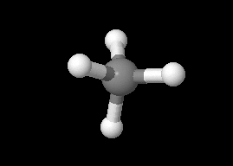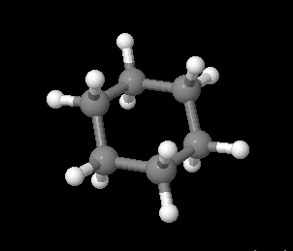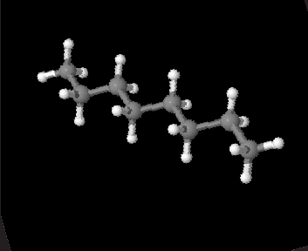Crude oil is a complex mixture of hydrocarbon molecules of all different shapes and lengths. This rich soup is where we get petrol for our cars, bitumen for our roads, and oils for our engines, amongst many other things.

methane

octane

cyclohexane
To create any of the thousands of useful things made from oil different hydrocarbons have to be separated. This is done by separating or refining using a distillation process.
Hydrocarbons
Hydrocarbons are molecules made from carbon and hydrogen atoms. With a chain of carbon as their ‘backbone’, hydrocarbons differ in their length and can form chains, branches or even rings. This backbone can range from just one carbon atom in length to more than 60 atoms.
Methane has a single carbon atom; cyclohexane has six carbon atoms in a ring; and octane has eight carbon atoms in a chain.
Even slight differences in length and structure of hydrocarbon molecules can give different chemical and physical properties. The refining process separates molecules according to their different boiling points.
Hydrocarbons are jumbled together as thick black crude oil. The most efficient way to separate them into smaller fractions is by a process called fractional distillation.

Hydrocarbons are found as solids, liquids and gases based on their length

Short hydrocarbons (one to four carbons) are gases at room
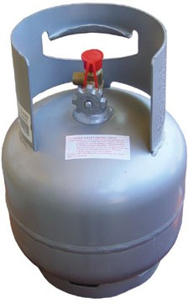
temperatures because they have such low boiling points.
A backbone of five or more carbons will give you a liquid hydrocarbon. Shorter liquid hydrocarbons will boil on a hot day while others can only boil on your stove top.
Once a hydrocarbon gets so large and cumbersome that it has a backbone of more than 20
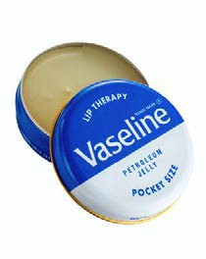
carbons it exists as a solid at room temperature. To boil a mixture of these tangled and stringy molecules you’d have to turn the heat up well beyond 300ºC.

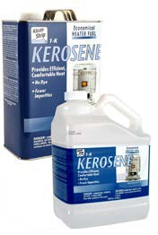
The longer the molecule, the more carbons it has, and the higher its boiling point.

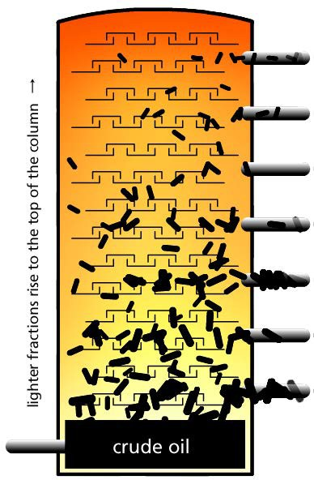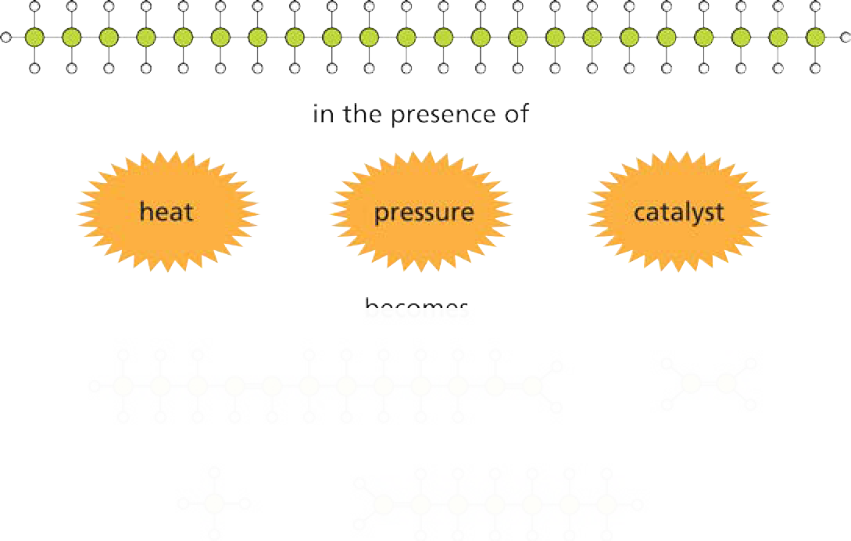Fractional distillation: a recipe
- Add 1 barrel (159 L) of crude oil to a super-heated furnace. Bring to the boil. To ensure that your recipe is successful the temperature should be around 600 ºC.
- Feed the boiling oil into a large distillation column. You should notice that gaseous hydrocarbons escape the simmering liquid oil and rise up the distillation column. As hydrocarbons travel up the column the molecules gradually cool. When gaseous hydrocarbons cool below their boiling point they will begin to return to their liquid state.
- The inside of your distillation tower should be lined with dozens of distillation trays, each with many small holes. Use these trays to collect condensing hydrocarbons whilst still allowing vapours to continue rising up through the column.
- Drain the distillation trays and remove condensed fractions for further treatment.
- Further treatment will be required for separated fractions. A distillation will typically produce 25% petrol and 75%
of other fractions. Petrol, however, is the most important fraction or product generated. More petrol can be produced through chemical processing: breaking long-chain hydrocarbons down into smaller chains through heating (cracking); combining small hydrocarbons to create larger ones (unification); or altering the structure of hydrocarbons (alteration).

- After all fractions have been processed excess impurities are removed leaving pure, clean fractions of hydrocarbons.
- Mix fractions to the correct quantities to produce the chemicals you need – products for cars, medicine cabinets or kitchens.

heat

