The Kimberley region in north-west Western Australia is home to a unique range of wildlife. Its ecosystem contains native plants and animals that interact with each other in many different ways. The area is sparsely populated by humans, so many species, wiped out or endangered in other parts of Australia, still live here.
A number of Aboriginal communities throughout the area live in their traditional way, showing great respect for landscape and animals. Their practices reflect their role as caretakers of the environment, and ensure the ecosystem is sustained.
However, this balanced environment is showing signs of a cane toad invasion. No one is sure what their total impact may be, but locals are keeping track of wildlife so they can see effects as cane toads arrive.

Food webs
A food web shows how plants and animals interact through eating. Your job is to make a food web of plants and animals, from the Kimberley. All are found at an Aboriginal community, near Kununurra.

Follow these instructions:

- Cut out plant and animal cards provided.
- Collect large piece of blank paper.
- Arrange plant cards (producers) at bottom of paper.
- Find animals (first order consumers) that eat plants and spread above plants, leaving room to draw arrows.
- Place animals (second order consumers) that eat first order consumers, above first order consumers.
- Place remaining animals (third order consumers) above second order consumers, at top of paper.
- Glue cards onto paper.
- Draw arrows to show what each animal eats - they may eat several things.
Remember, arrows must point from the species being eaten to the one that’s eating it.
- As cane toads arrive in the Kimberley they will upset the balanced food web. Add the cane toad card to your food web, and use different coloured arrows to show its feeding relationships.

The table on the next page shows what the animals eat.

Alternatives
Cards and information are available for two other Western Australian locations: Herdsman Lake in the Perth metropolitan area, and Cottesloe reef. Use the same instructions to make food webs for these locations. Add the cane toad to the Herdsman lake food web.

Kimberley food web
ORGANISM | DIET
cane toad | invertebrates (eg insects), small rodents, birds’ eggs, birds, amphibians, small reptiles
cicada | plant sap
eucalyptus | producer
freshwater crocodile | fish, frogs, toads, lizards, turtles, crayfish, birds, small mammals, bats
frilled-neck lizard | insects, spiders, toads
green tree frog | insects, spiders, smaller frogs, very small mammals
meat ant | plants, insect secretions, toads, dead insects, dead spiders, dead mammals, dead reptiles, dead amphibians, dead birds
native stingless bee | pollen, nectar
northern quoll | small mammals, small reptiles, insects, spiders, frogs, toads
rainbow bee-eater | bees, flying insects
straw-necked ibis | molluscs, fish, grasshoppers, crickets, locusts, frogs, toads, small mammals, crabs, lizards, small snakes, marine plants, worms
tussock grass | producer
yellow-spotted monitor | insects, spiders, snakes, small mammals, lizards, turtle eggs, frogs, toads

Kimberley food web organisms
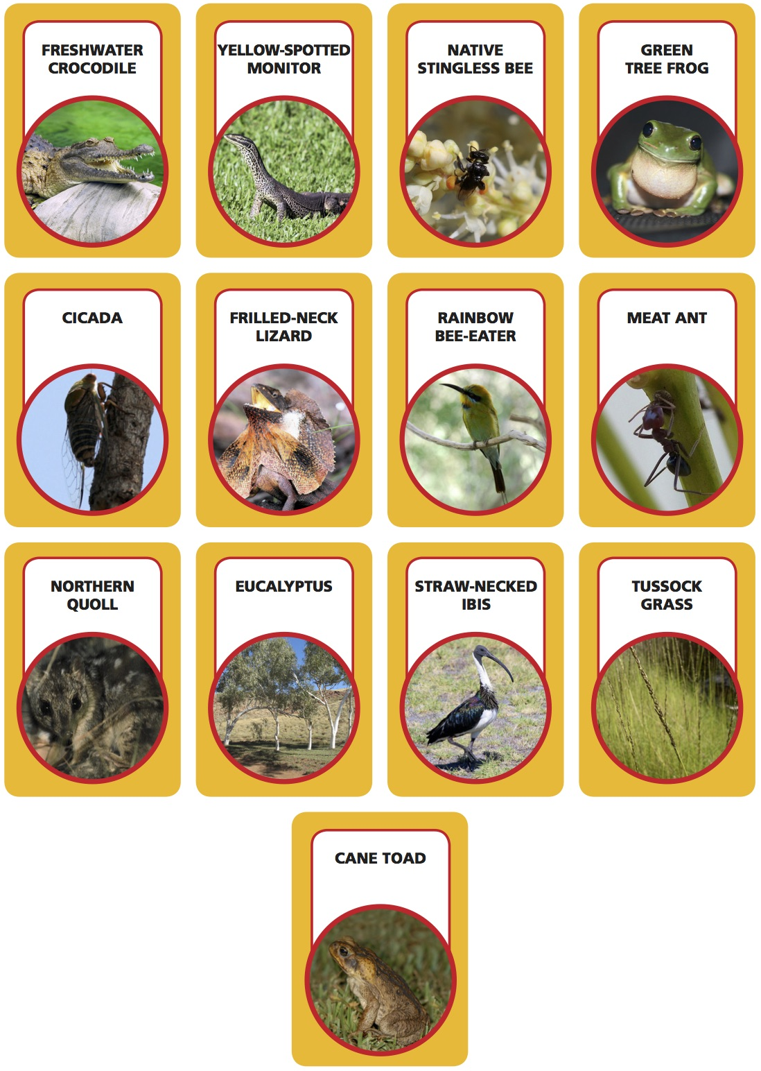

Herdsman Lake food web
ORGANISM | DIET
black duck | grass, algae, water weed, bulrush, seeds, roots, macro-invertebrates
bulrush | producer
cane toad | invertebrates (eg insects), small rodents, birds’ eggs, birds, amphibians, small reptiles
coot | grass, algae, water weed, bulrush, detritus
dragonfly nymph | tadpoles, fish, mosquito larvae, other aquatic macro-invertebrates
gambusia | mosquito larvae, midge larvae, water flea and other aquatic macro-invertebrates
grass | producer
motorbike frog | smaller frogs, fish, lizards, aquatic macro-invertebrates, insects, spiders
purple swamphen | grass, bulrush, water weed, detritus, frogs
spoonbill | tadpoles, fish, lizards, aquatic macro-invertebrates
swamp harrier | coots and other water birds, small mammals, reptiles, frogs, fish, carrion
tiger snake | frogs, small birds, lizards, small, mammals, eggs
water flea | algae, water weed, bulrush, detritus
water weed | producer

Herdsman Lake food web organisms
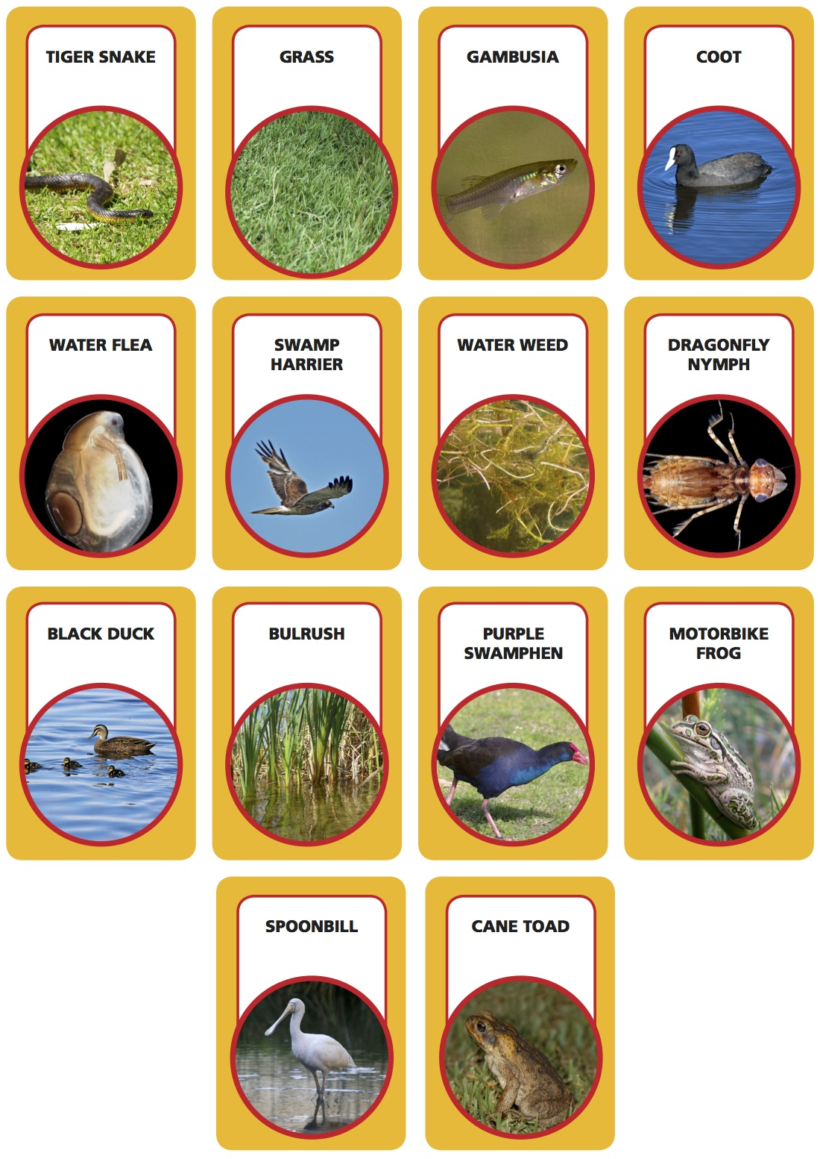

Cottesloe Reef food web
ORGANISM | DIET
11-armed sea star | abalone, bivalves
Australian pelican | fish, crustaceans, small birds
Australian sea lion | fish, lobsters, sea birds, cephalopods
blue swimmer crab | small fish, invertebrates, algae, seagrass
bottlenose dolphin | fish, squid, crustaceans
brown-lipped abalone | kelp
gloomy octopus | crustaceans, shellfish, small fish
grey nurse shark | fish, crustaceans, squid, small sharks
kelp | producer
mysid shrimp | algae, detritus, plankton
phytoplankton | producer
scallop | phytoplankton, detritus
seagrass | producer
striped stingaree | bivalves, crustaceans, worms
weedy seadragon | shrimp, other small crustaceans
western scalyfin | algae, small invertebrates

Cottesloe Reef food web organisms
