Build a model aquifer from food and drink.

What you will need

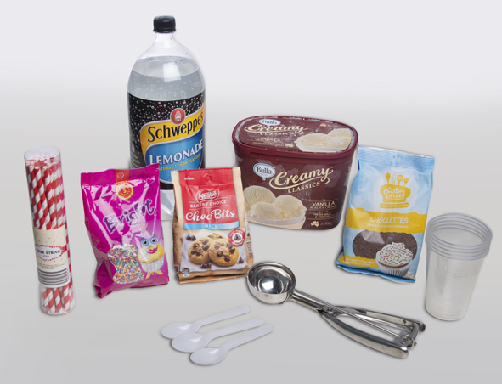
- clear plastic drinking cup
- ice cream scoop or large spoon
- plastic teaspoon
- plastic drinking straw
- vanilla ice cream or fruit sorbet
- lemonade
- chocolate chips or cereal
- coloured cake sprinkles

What to do
1. | Get a plastic drinking cup. | 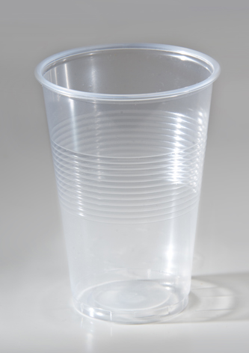
2. | Put some chocolate chips in the cup.  This stands for sand and gravel at the bottom of an aquifer. | 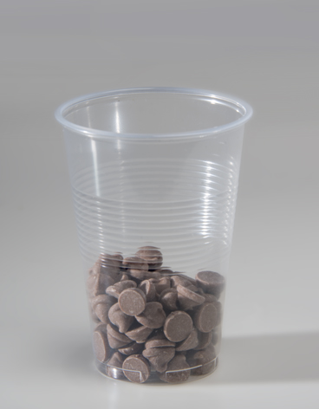
3. | Pour in lemonade so it just covers the chocolate chips.  This stands for water in an aquifer. | 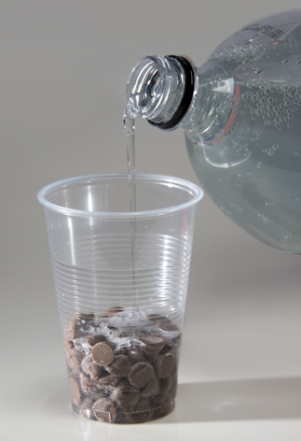
4. | Add a scoop of ice cream on top of the chocolate chips.  This stands for a layer of rock or soil that traps groundwater. It’s called a confining layer. | 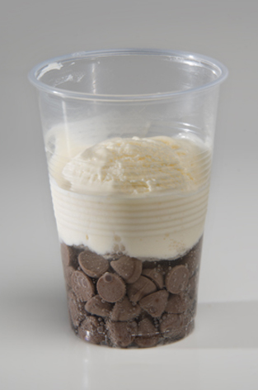
5. | Add a teaspoon of sprinkles over the ice cream.  This stands for soil and leaves near the surface. | 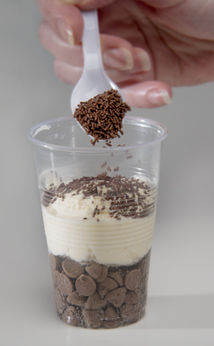
6. | Push a straw through the ice cream into the chocolate chips.  Drink the lemonade.  This stands for a bore that pumps up water from an aquifer. | 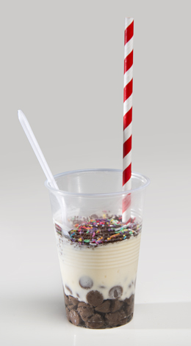

Questions
- Name the parts of a real aquifer the food and drink stand for.
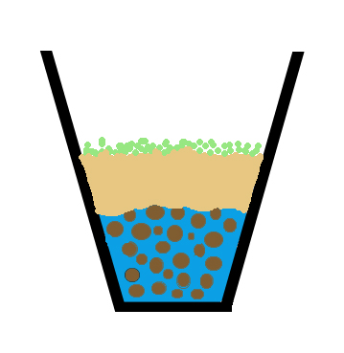
sprinkles
ice cream
lemonade
choc chips
- The lemonade fills spaces between the chocolate chips. We say the chocolate chip layer is porous. What fills the spaces in a real aquifer?

- You used a straw to get to the lemonade. How can you get to water in a real aquifer?

- What happened when you drank the lemonade?

- What happens to a real aquifer when water is pumped out?

- Does your model help to show what a real aquifer is like?
What parts help? | What parts don’t help?

