You will need
- small glass aquarium or clear plastic container (L 25 cm x W 17 cm x H 15 cm)
- 5 L gravel, white or light colour
- 1.5 L water dyed blue
- 1 L water dyed yellow
- 60 mL water dyed red
- hand pump (from soap dispenser or lotion)
- 4 packets plasticine
- 2 small beakers or containers
- 100 mL sand or soil (optional)
- paper towels

What each item stands for
ITEM | AQUIFER EQUIVALENT
glass aquarium | aquifer
gravel | saturated zone and unsaturated zone
water (dyed blue so it is more visible) | groundwater
water (dyed yellow) | another groundwater source
hand pump from lotion or soap dispenser | bore — to pump out groundwater
plasticine or plastic wrap | confining layer — impermeable rock layer confining groundwater
100 mL beaker of water (dyed red) | contaminants getting into the aquifer
sand or soil | topsoil layer

What to do

Part 1: Aquifer model, extraction (pumping out) and recharge (refill)
1. | The base of the aquarium stands for the bottom of an aquifer. It stops groundwater going deeper. It’s called an impermeable layer.  Pour 3 L gravel onto the base of the aquarium.
2. | Smooth the gravel to make a 5 cm deep layer.
3. | Add 1.5 L blue-dyed water until most of the gravel is covered.  Groundwater fills spaces between bits of gravel because the layer is porous.  This is a model of an unconfined aquifer. It has different zones layers or zones:  - gravel with water is the saturated zone;  - dry gravel is the unsaturated zone; and  - the top of the water is the water table.
4. | Now, move some gravel to make a pool of water.  A lake at the surface is called surface water.  Water in the saturated zone is called groundwater. | 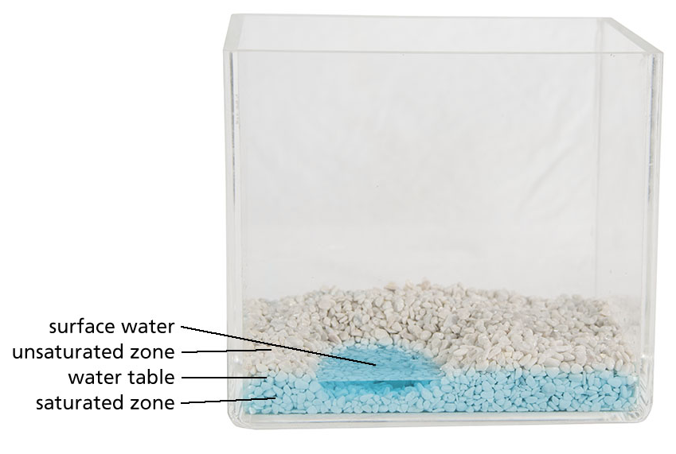
5. | Put the hand pump in one corner of the aquarium.  Put a beaker under the pump and extract (pump out) the water.  Watch what happens to the water table and surface water as you extract water.  Bores extract groundwater from the saturated zone for us to use.
6. | Near a corner of the aquarium pour back the water you extracted.  Aquifers need to be refilled. This is called recharging.  Watch what happens to the surface water and water table as you recharge the aquifer.  Where do you think recharge comes from? | 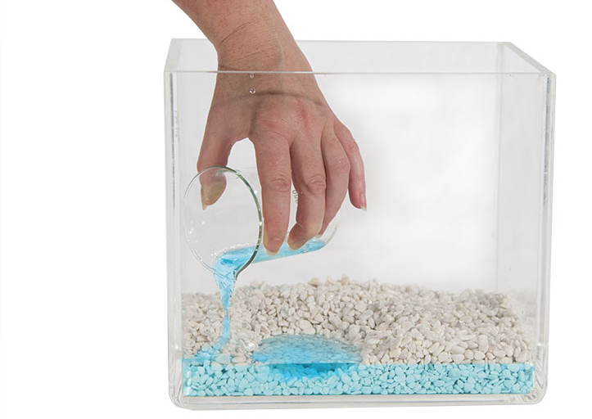

Part 2: Confined aquifers
7. | Smooth the gravel so there’s no surface water. | 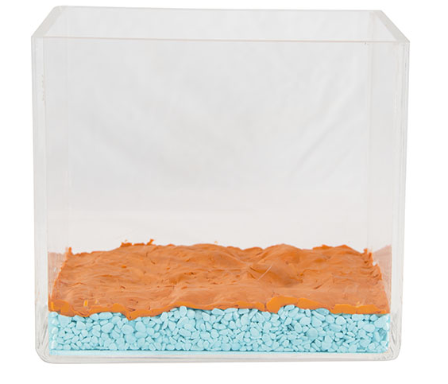
8. | Flatten plasticine over the gravel.
9. | Fix the plasticine to the sides of the aquarium. Try to make it watertight.
10. | Pour a little yellow-dyed water over the plasticine. It should collect in a pool on the surface.  The plasticine stands for a confining layer. In a real aquifer this kind of layer is rock or clay that won’t let water through (it is impermeable).  If groundwater is trapped below an impermeable layer, the aquifer is called a confined aquifer.
11. | Pour 2 L gravel onto the plasticine layer.
12. | Move some gravel until you have a pool of surface water.  If you like you can sprinkle sand or dirt on the gravel layer to create topsoil.
13. | Pour 800 mL yellow-dyed water on the gravel layer. | 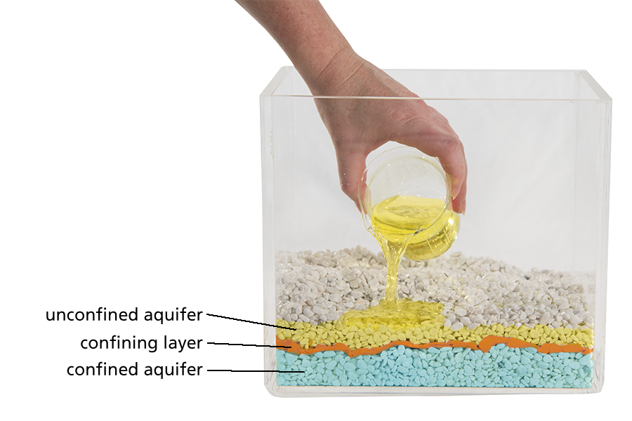
The different layers of the model aquifer are:
- confined aquifer, shown by blue-dyed groundwater below the plasticine.
- confining layer (impermeable rock that traps groundwater), shown by the plasticine.
- unconfined aquifer, shown by porous gravel with yellow-dyed groundwater.

Challenge: How are confined aquifers recharged?
14. | Make a hole in one corner of the plasticine.  Push the pump through the hole.
15. | Put a beaker under the pump and pump out water.  Watch what happens to the water table as water is pumped out.  Water table and surface water levels drop as you pump out 60 – 100 mL of water from the aquifer.
16. | Pour the water you pumped out back, through the hole you made.  This hole is called the recharge site of the confined aquifer.  Sometimes the recharge site of a confined aquifer is in an area where the aquifer is unconfined. This may be a long way from the confined aquifer area.

Part 3: Contaminants (things that pollute water) in groundwater
17. | In one corner, slowly pour 60 mL red-dyed water to unconfined aquifer.  For best results add this water near the recharge site.  This water stands for contaminants.  This shows how contaminants get into unconfined and confined aquifers. | 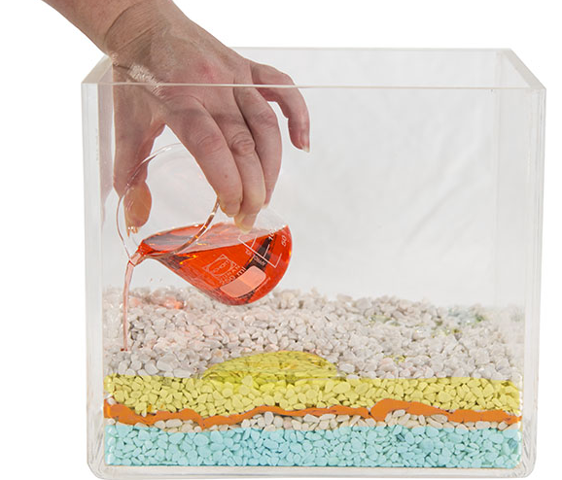
18. | Put hand pump into the recharge hole.
19. | Put a beaker under the pump.
20. | Keep pumping out water until you see contaminants in the extracted water.  These contaminants are in the water supply.  Runoff from landscape around aquifers can carry contaminants into the groundwater.  What might contaminate groundwater?  Challenge: How might contamination affect humans, industry and the environment? | 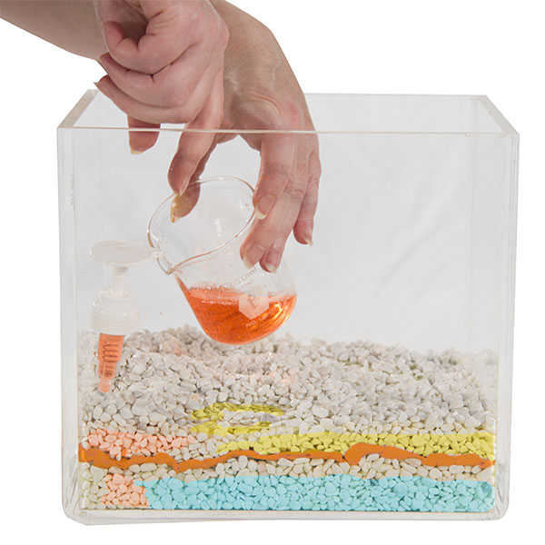

21. | Extra activity: Change landscape around the model aquifer, building mountains, streams and wetlands. See what happens to the water table and surface water levels.  Experiment with different materials, such as sand and larger rocks.
22. | Clean up!

