fact sheet
A whale of a time

Echolocation

- All toothed whales, including dolphins, river dolphins, porpoises, orcas and sperm whales, use echolocation by creating a focused beam of high-frequency clicks. Each burst of sound may have more than 600 clicks per second.
- Dolphins can detect golfball-sized objects from 100 m away using echolocation.
- Dolphins can use echolocation to ‘see’ through materials. They can easily identify objects behind brick walls and can even see what a fellow dolphin has just eaten for dinner by ‘seeing’ into their stomach!
- Sound waves travel through water at 1.5 km s-1. That’s 4.5 times faster than sound travelling through air.
Many animals that move in darkness or live in environments where vision is difficult have evolved a method of ‘seeing with their ears’ known as echolocation. The technique is common amongst mammals such as bats, dolphins and whales, and two cave-dwelling bird species have developed echolocation to navigate through their dark environments.
Echolocation in whales and dolphins works in the same way as sonar in boats. Both create
a strong pulse of sound and listen for returning echoes. The animal can learn a lot about the surrounding environment from
the loudness of the echoes and the time it takes them to reach each ear. Echolocation normally gives an incredibly accurate picture of the distance, position, size and movement of an object.
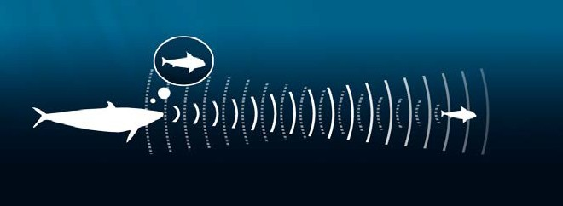
Because echolocation uses acoustic (sound) waves, physicists have figured out how these signals work. Echolocation pulses are subject to the same physical laws as all waves: they reflect off surfaces, they create interference with other waves, and they can lose energy and weaken (or ‘attenuate’) as they travel.
Physicists have also discovered that echolocation can sometimes let an animal down. Since whales and dolphins rely strongly on these signals to feed and navigate around the ocean, if they get the wrong signal (or no signal at all)
due to interference with the sound waves, it can get them into some serious trouble.

incoming sound is channelled by lower jaw to inner ear

outgoing sounds

incoming sounds
outgoing sound is focused by skull and fatty organ called the ‘melon’
(echoes)

fact sheet
A whale of a time

