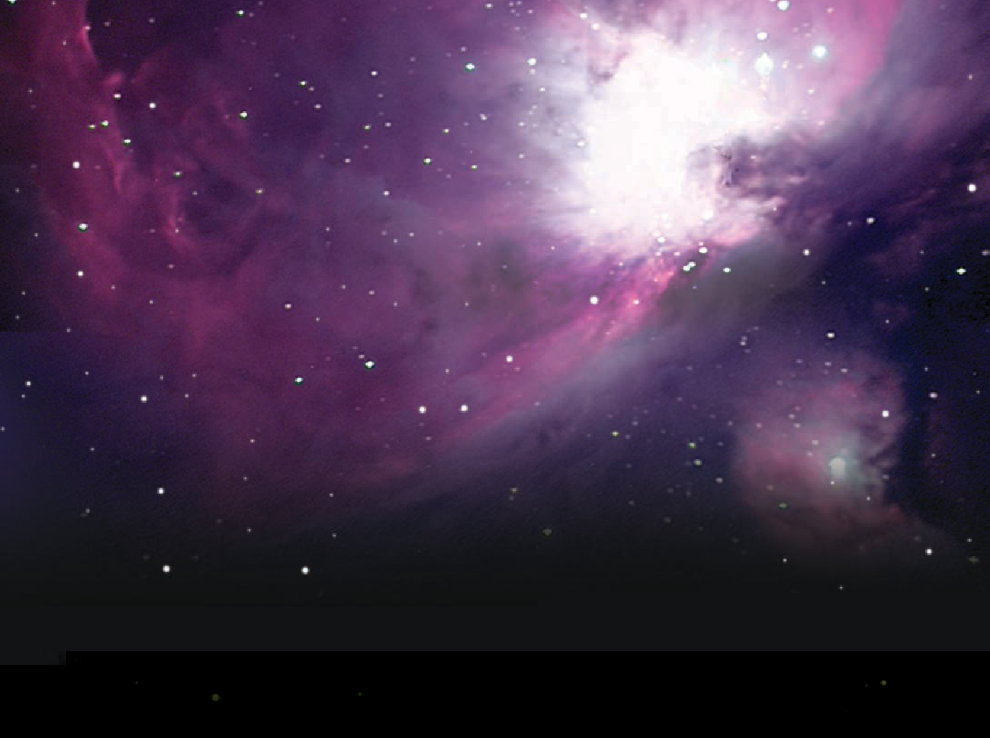
spiri
Spice-Physics-Icrar Remote Internet Telescope
t

A guide to using
Stellarium

Stellarium is an interactive planetarium program that allows you to explore the night sky from any location on earth, at any time of the year.
Stellarium can be used as an educational tool to learn about the night sky, as well as a tool for planning observations through a telescope. It is ideally suited as a resource for gaining an understanding of the celestial sphere, and the seasonal movement of astronomical objects across the sky
The default installation (current version 0.12.4) contains over 600,000 stars as well as numerous deep sky catalogues and images. Stellarium is also expandable, with a many free plug-ins and educational resources available for download. In addition, Stellarium includes a basic scripting interface that allows custom simulations to be created by the user.
Stellarium is provided as an open-source project. Its source code is available and is freely modifiable and redistributable as per the GNU Public License.
Stellarium can be downloaded at www.stellarium.org

Stellarium
Stellarium is an interactive planetarium program that allows you to explore the night sky from any location on earth, at any time of the year.
Stellarium can be used as an educational tool to learn about the night sky, as well as a tool for planning observations through a telescope. It is ideally suited as a resource for gaining an understanding of the celestial sphere, and the seasonal movement of astronomical objects across the sky.
The default installation (current version 0.12.4) contains over 600 000 stars as well as numerous deep sky catalogues and images. Stellarium is also expandable, with a many free plug-ins and educational resources available for download. In addition, Stellarium includes a basic scripting interface that allows custom simulations to be created by the user.
Stellarium is provided as an open-source project. Its source code is available and is freely modifiable and redistributable as per the GNU Public License.
Stellarium can be downloaded at www.stellarium.org

On opening a new installation of Stellarium, you will be presented with a 60° view of the sky, as currently seen from Paris.
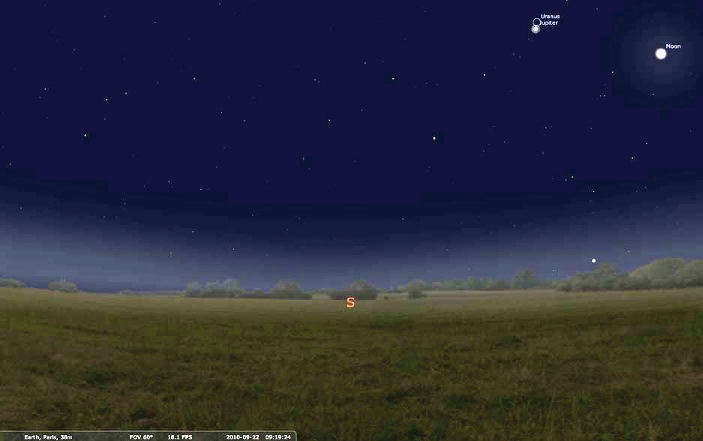

At the bottom of the screen additional information describes your location, date and time.
Cardinal indicators, located on the horizon, show the direction you are facing.

Selecting objects
Left mouse click on any object to display additional information in the top left hand corner of the screen.
Right mouse click to clear the selection.

Position the mouse in the lower left hand corner of the screen to reveal the main tool bars. They automatically disappear when the mouse is moved away.

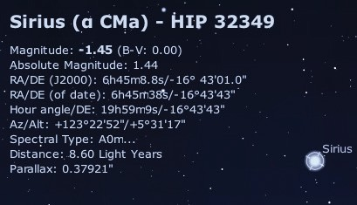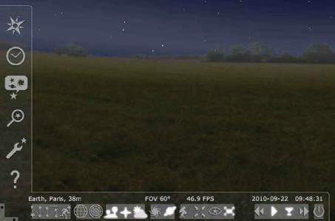

Mouse and keyboard commands are used to move around Stellarium.
Hold the left mouse button down, while moving the mouse, to change orientation. You can also use the cursor keys on your keyboard to change orientation.
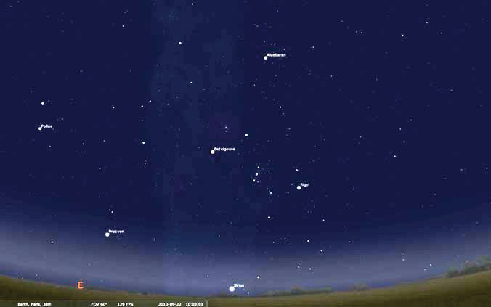
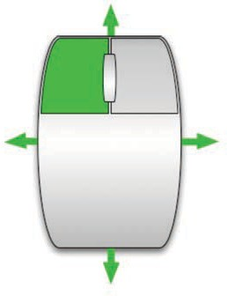

Press and hold keyboard Page Up and Page Down keys to zoom in and out.
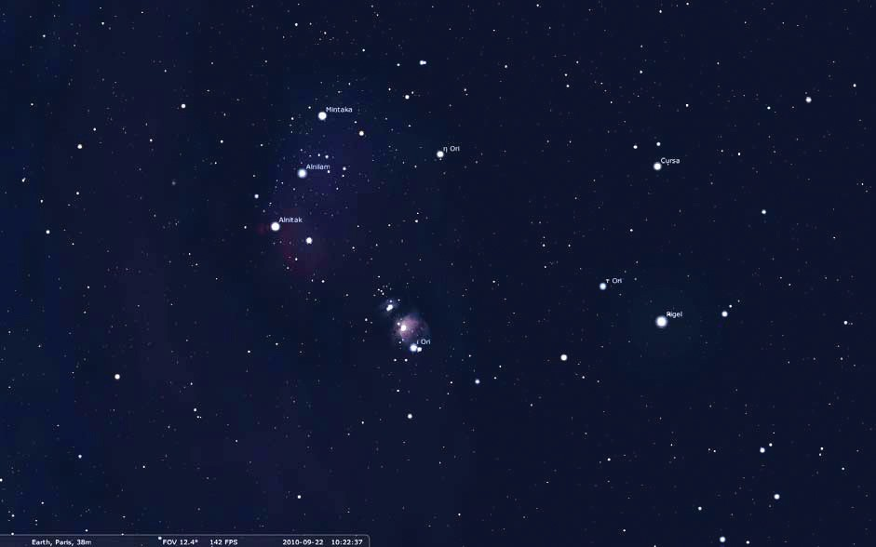

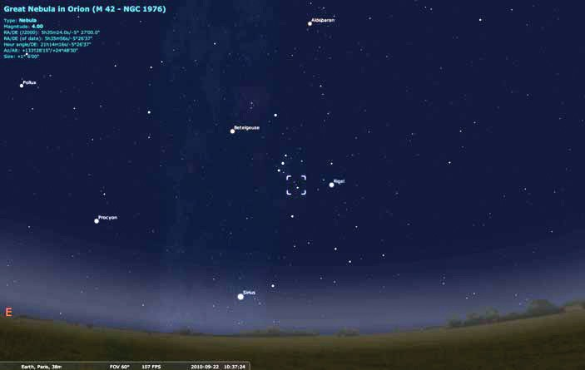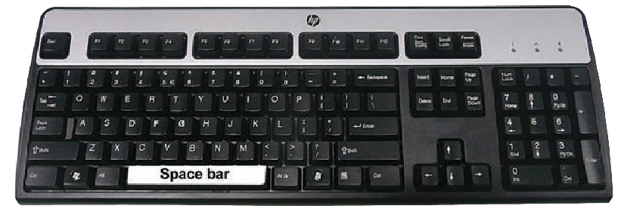
Press space bar to centre a selected object.

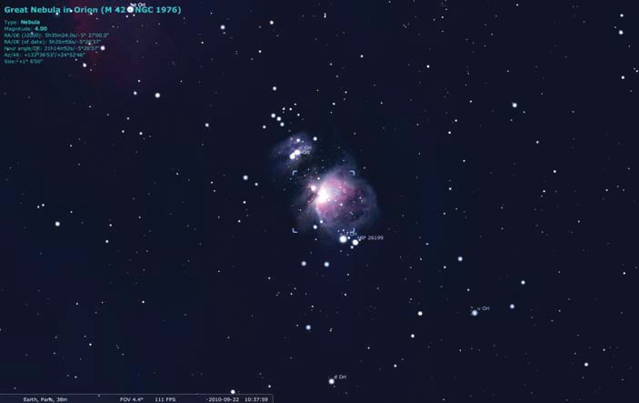
Press forward slash key ‘ / ‘ to quickly zoom in on a selected object.

Press back slash key ‘ \ ‘ to return quickly to a 60° field of view.

The correct location and time must be set before Stellarium can be used to plan an evening’s observations. Press F6 to open the Location window. Alternatively, select the Location window icon in the tool bar.
Type the name of a city in the search box, then select it. Select Use as default if you wish to retain the setting next time Stellarium starts. Close when finished.

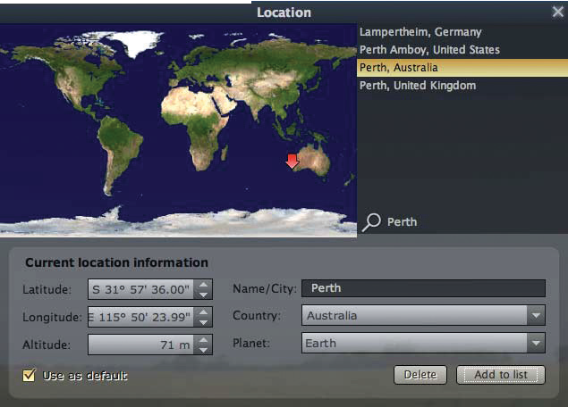
4
2
1
3

The main display should reflect the new location details.
Press F5 to bring up the Date and Time window. Set time to 8:30 PM.
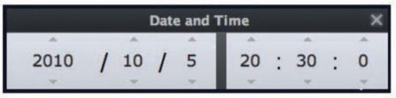

Stellarium also allows you to manipulate time.
Press ‘L’ key three times to see stars move across the sky. Press ‘K’ key to return time to normal speed.
Press ‘J’ key repeatedly to make time move backwards. Press ‘8’ key to reset the date and time to current.
Press ‘7’ key to freeze time.

If you get lost, remember:
the ‘8’ key sets date and time to current, and the ‘K’ key sets the simulation to normal speed.
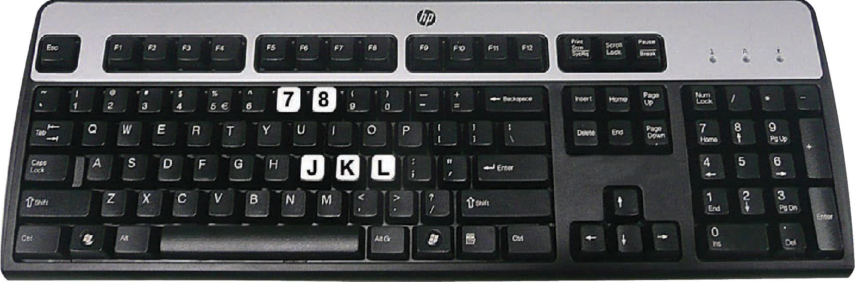

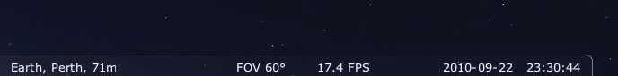Refer to the status bar at the bottom of the screen to check date, time and simulation speed.

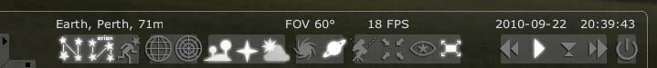
Controls for time can also be found on the lower tool bar.

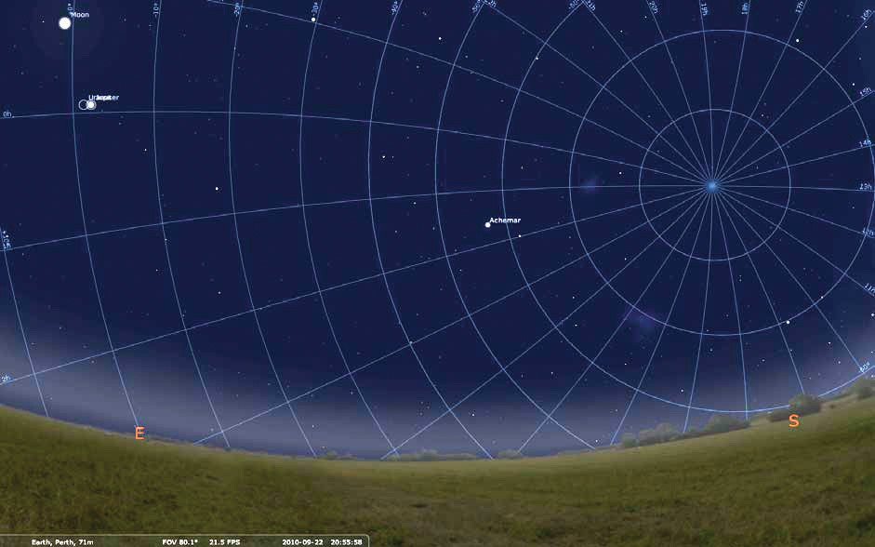
Various grids, lines and markings can be displayed on the celestial sphere. Press ‘e’ to hide or show an equatorial grid.

Press ‘z’ to hide or show an altitude / azimuth grid.
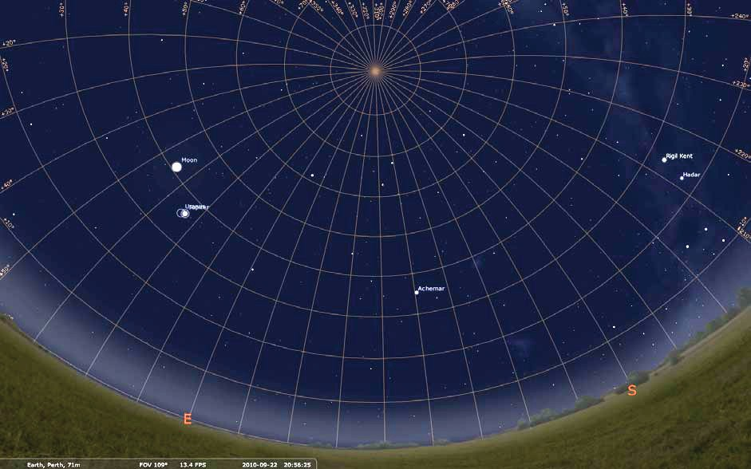

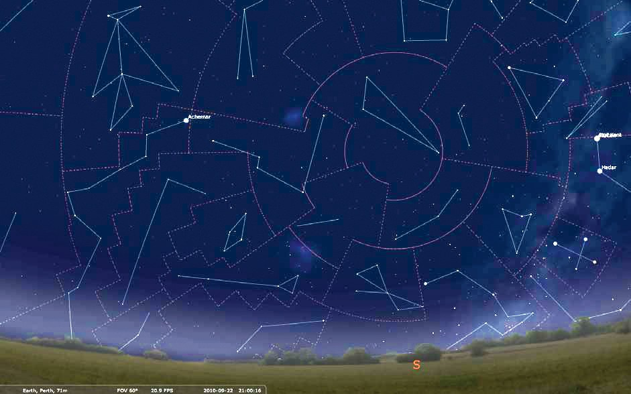
Constellation lines and boundaries are toggled on and off using ‘c’ and ‘b’ keys.

Show or hide constellation art with ‘r’ key.
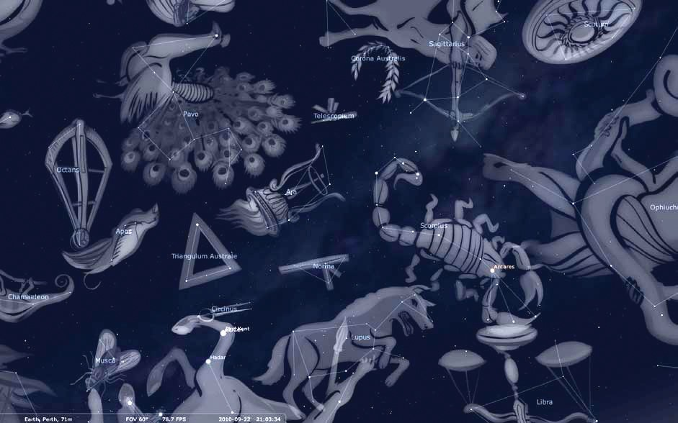

Labels can be toggled on and off using the Sky and Viewing Options menu, or by pressing ‘F4’. Density of object labels is adjusted with sliders.
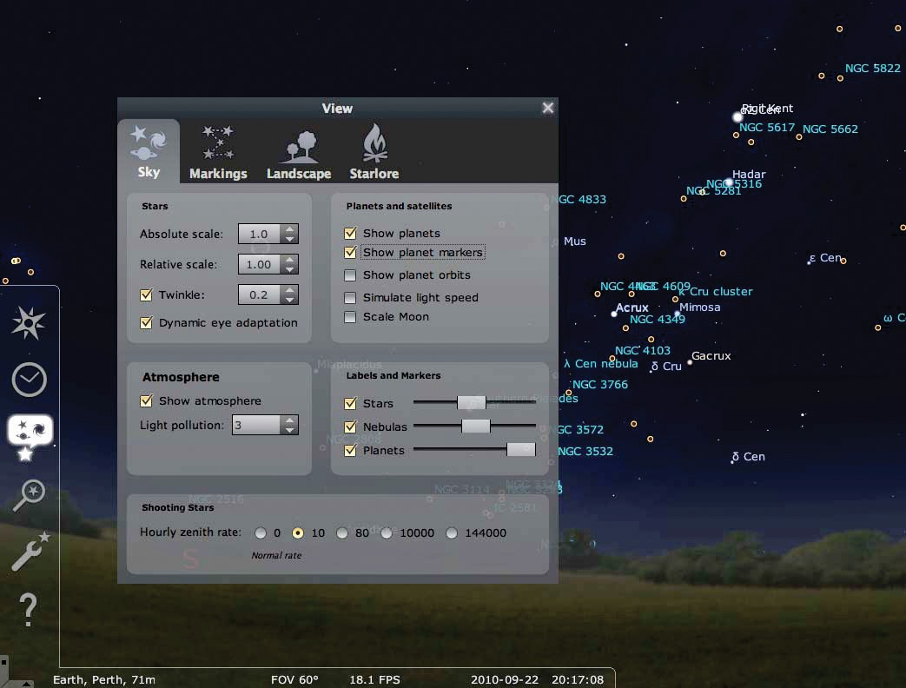
2
3
1

Deep sky objects, including galaxies and nebulae, can be toggled with ‘n’ key.
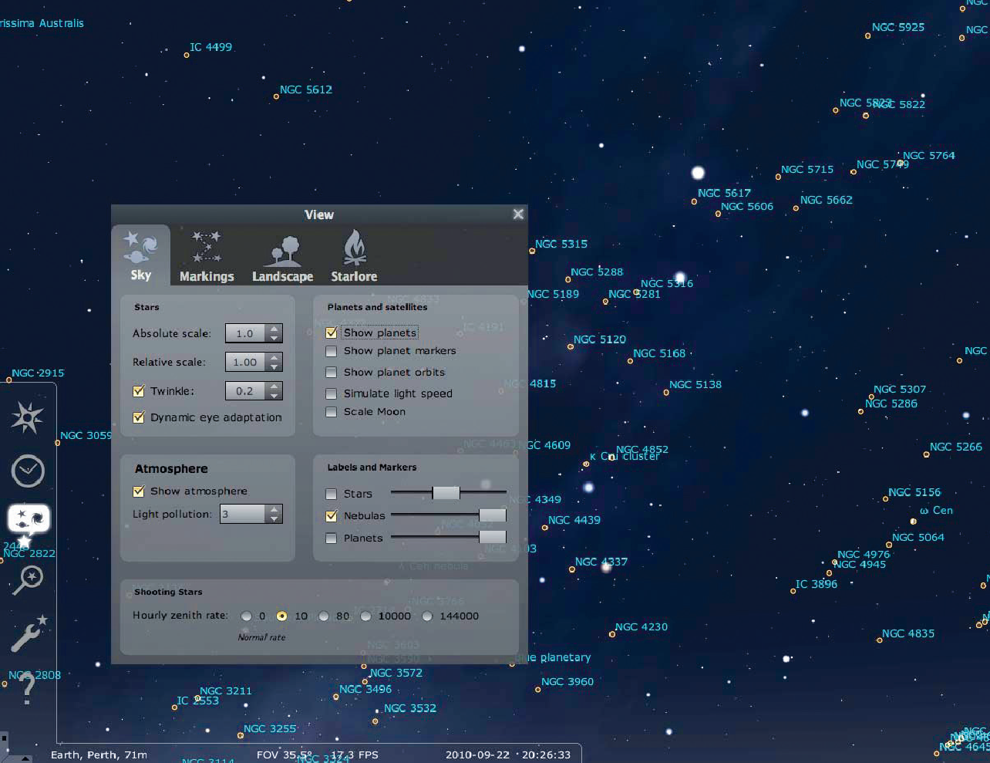Density of displayed deep sky objects at the default 60° view is controlled using the Nebula slider in the Sky and Viewing Options menu.

Under normal use, object density will increase as you zoom in and decrease as you zoom out.

Press Command + F to activate the Find Object window.
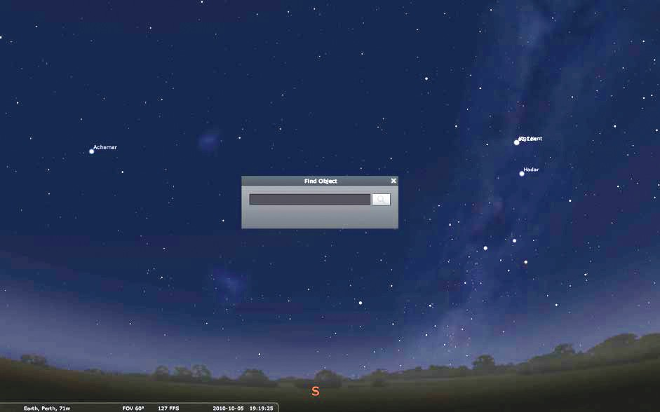

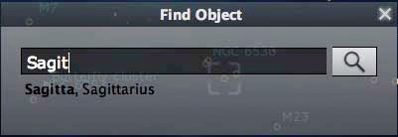
Search functions are extremely powerful in Stellarium. Various syntaxes can be used, including: planet names, eg Jupiter;
star names, eg Achernar; NGC objects, eg NGC 5128; Messier objects, eg M8;
common names, eg Lagoon nebula; and constellation names, eg Sagittarius.

Press enter to centre a found object.
Press forward slash key ‘ / ‘ to zoom in to an object.

Stellarium can help find the best time to observe particular objects for any time of the year. In this exercise you will find the best time to image M42 on 25 November 2010.

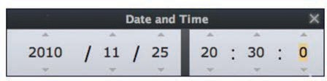
- Set date and time to 2010 November 25, 20:30:00 (8:30 pm).

- Search for M42 using the Find Object dialog (Command + F) and press Enter.
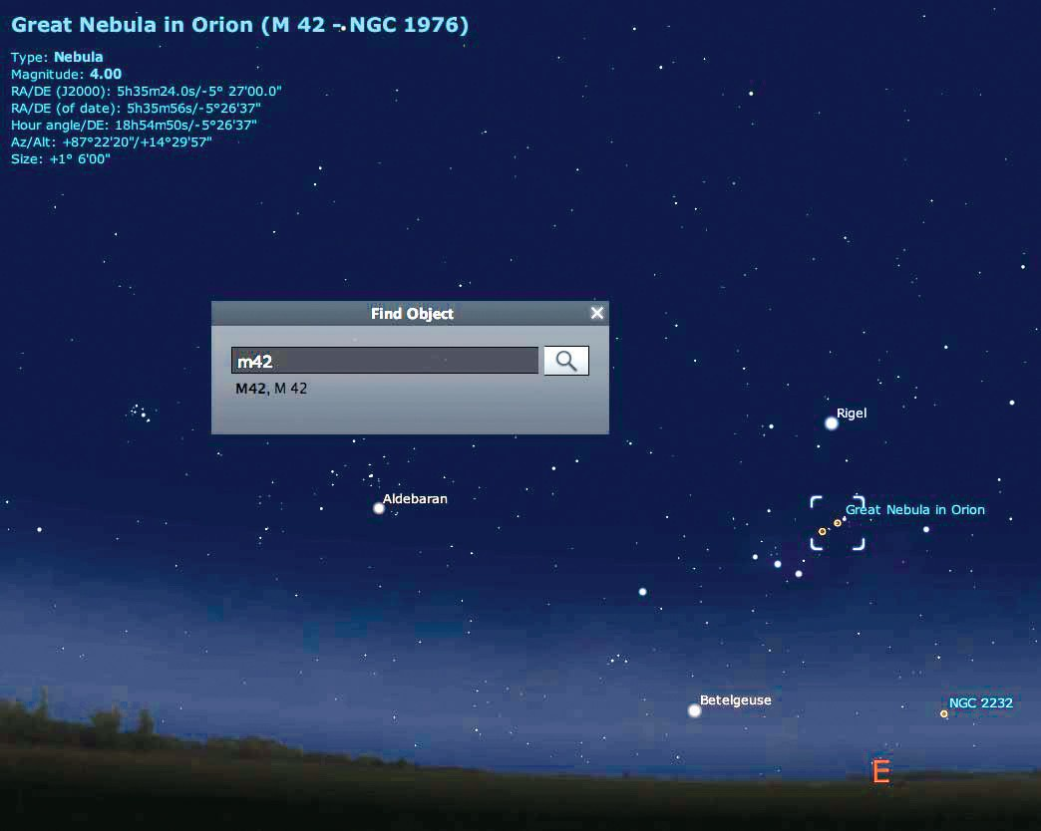

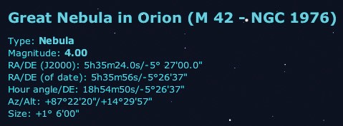From our view of the sky and from information at the top of the screen we see that M42 is in the east at an altitude of approximately 14° at 8:30 pm on
25 November 2010.

- 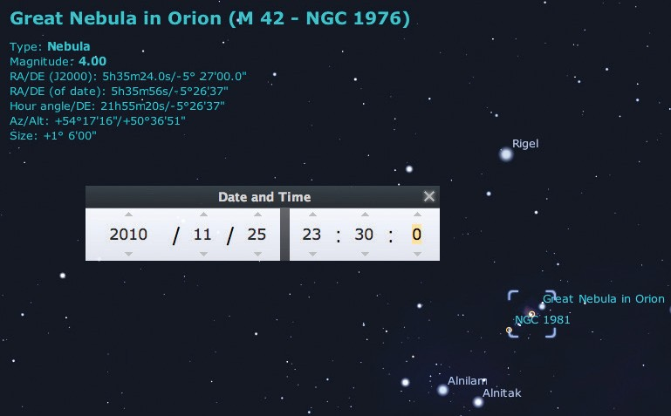Advancing time by three hours we see that M42 is in a much better position in the sky for viewing and imaging, as it has risen to 50° above the horizon in the north east.

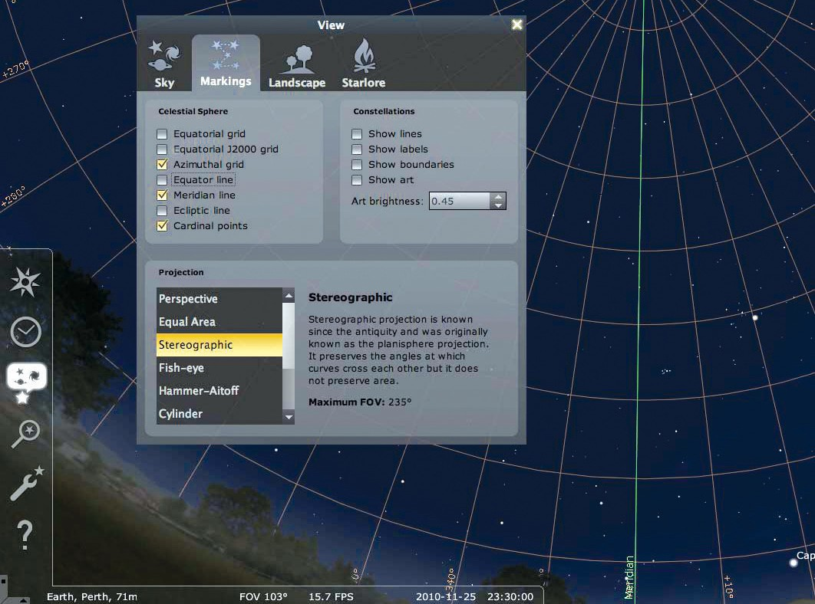
- Display the Meridian line in Sky and Viewing Options.

- Advance time, slowly, using the ‘L’ key. Note the time that M42 crosses the meridian. At just over 63°, this is the highest that M42 reaches when observed from this location.
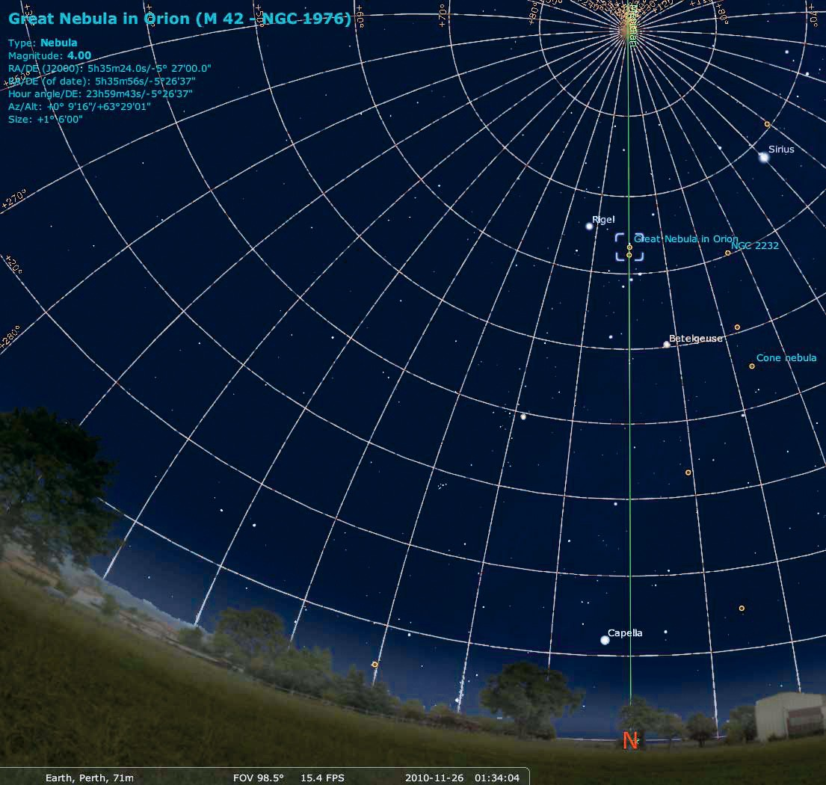

Target planning exercise 2
Stellarium can help you choose the brightest objects to observe, and provide object coordinates for telescopes.
- Set date and time to 2011 April 25, 18:45:00 (6:45 pm).
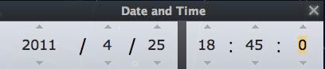

- At this time we see that the Virgo cluster of galaxies is about 20° above the eastern horizon.
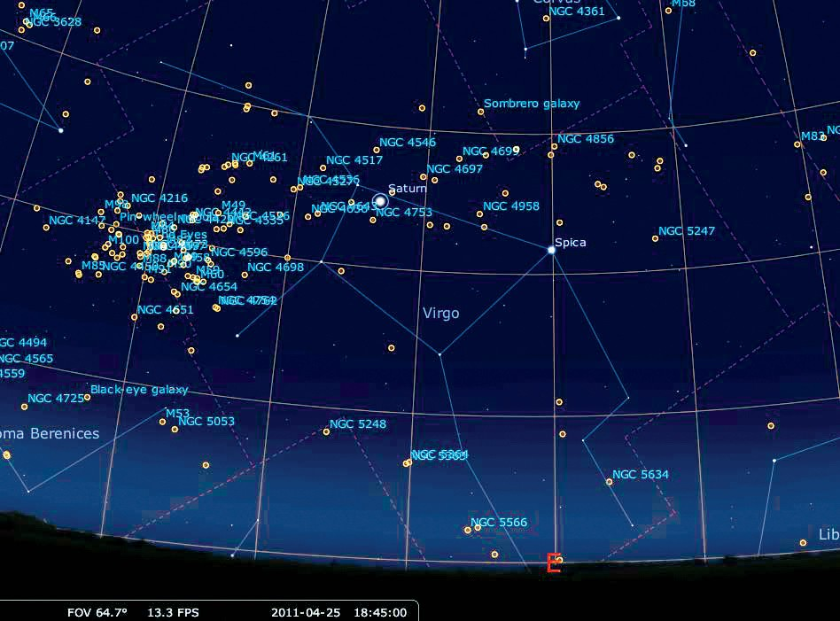

- Advance time using the ‘L’ key and watch the cluster rise higher in the sky.

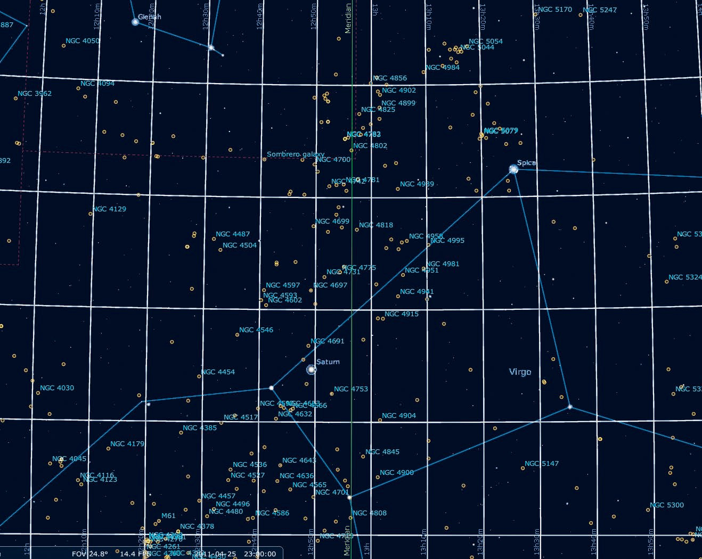
By adjusting time and zoom levels, it is possible to examine movements of thousands of deep space objects through this altitude.

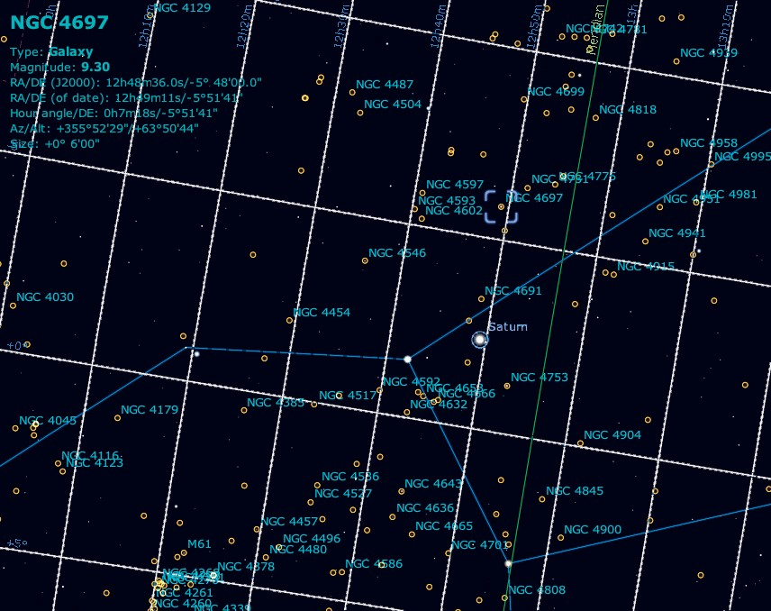

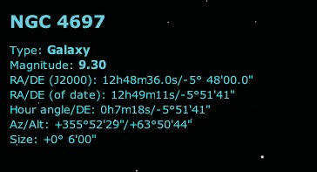NGC 4697 is a magnitude 9.3 galaxy, about 6 arc minutes

