Coping with COVID Anxiety

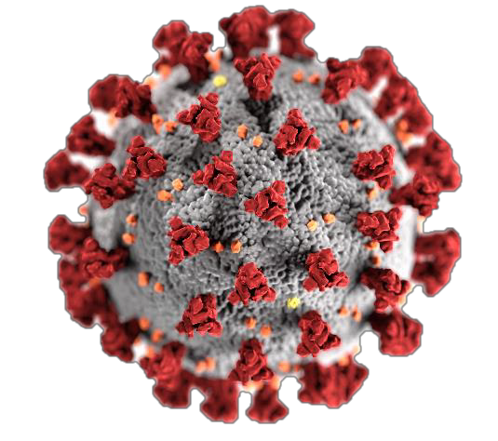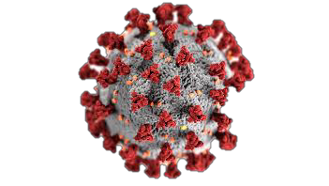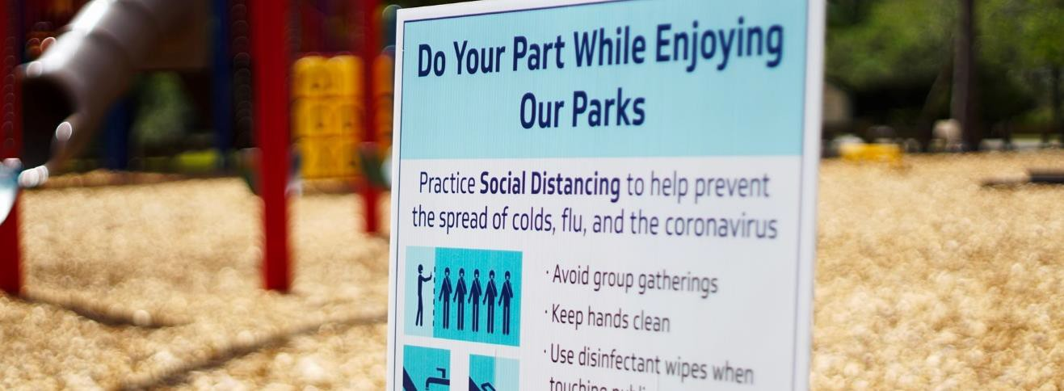During this global COVID-19 pandemic and time of uncertainty, we are all feeling worried and anxious – this is very normal. We may worry about how this might affect our families, our broader community, and us. The physical isolation necessary to meet social distancing requirements can also be very difficult and leaves many feeling alone.
It can be of help to understand more about these difficult emotions and to learn how to navigate your way through this stressful time. Talking about how you are feeling and connecting with others can also be helpful. ‘Coping with COVID Anxiety’ is an 8-week group therapy program for adults conducted online via free Zoom software by provisional psychologists at the Robin Winkler Clinic (UWA) (under supervision by experienced Clinical Psychologists). Access to a device with videoconferencing capabilities is required (e.g., android mobile or laptop). All materials and correspondence will be in an electronic format. The group will run for eight weekly 90-minute sessions. You will understand more about your emotions and develop some practical coping skills to help build resilience during this difficult time.

What are the fees for our service?
There is no fee for attending the program. Attending the program does first require an initial online assessment session to check that the program is right for you.

How to find out more or apply?
Please get in touch if you would like to find out more about the program, or click here to complete an application form. Submit application forms via email to clinic-sps@uwa.edu.au.

Dates will be advertised via uwa.edu.au/facilities/robin-winkler-clinic or you can register your interest by emailing: clinic-sps@uwa.edu.au or call: 6488 2644. Opening hours: Mon - Fri 8:30am-5pm

CRICOS Provider Code: 00126G

