instructions
glossary

- The aim is to visit all the planets, in any order, starting and finishing at Earth.
- Take turns to throw dice and move anticlockwise along orbits from circle to circle (). Orbit jumping circles and planets also count as spaces.

Orbit jumping
- If your throw takes you through an orbit jumping circle you can choose to jump orbit, towards or away from the Sun.
- To jump orbits you have to answer a question correctly.
- Another player reads the question to you.
- If your answer is right then the orbit jump takes one space of your throw.
- If your answer is wrong you must keep going around the same orbit.
- If you finish your turn on an orbit jump circle you must wait for your next turn to answer the question.
- Used questions go to the bottom of the pile. They may come round again.

Planets
- Mark off planets on your tally as you pass or land on them.
- 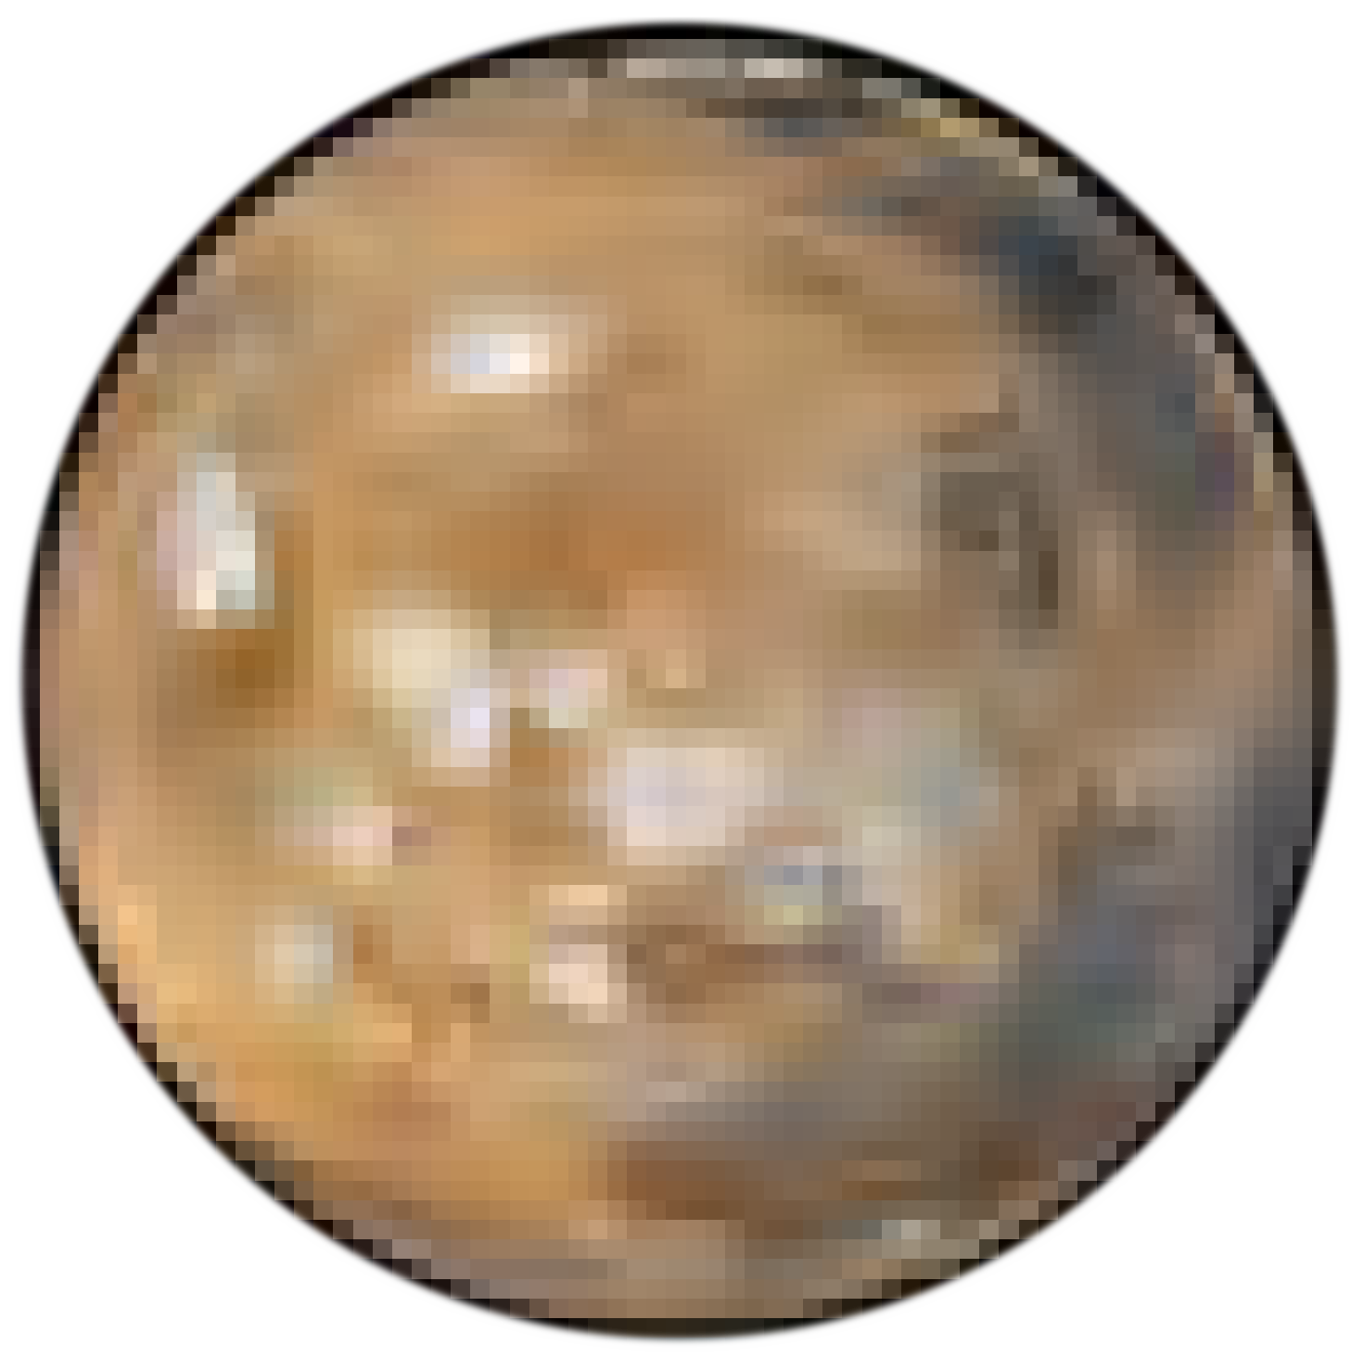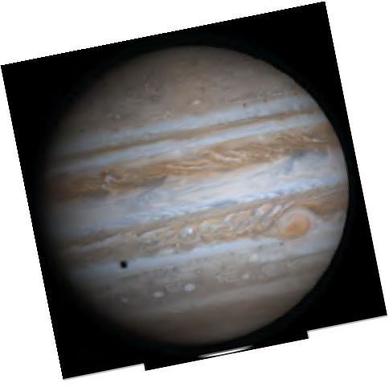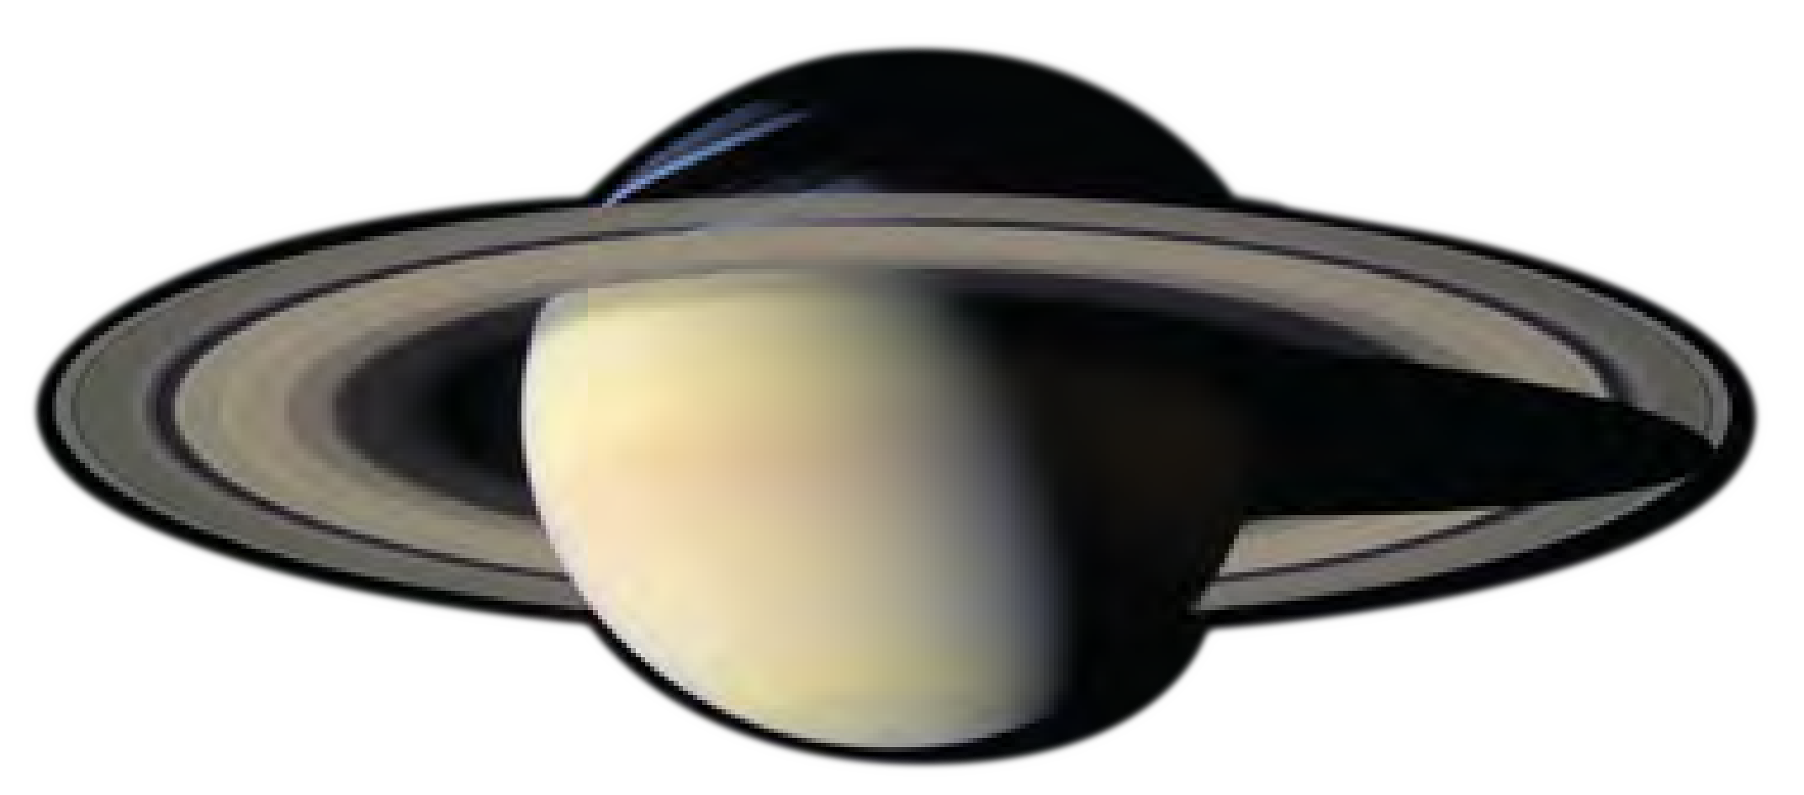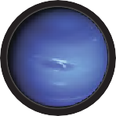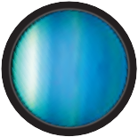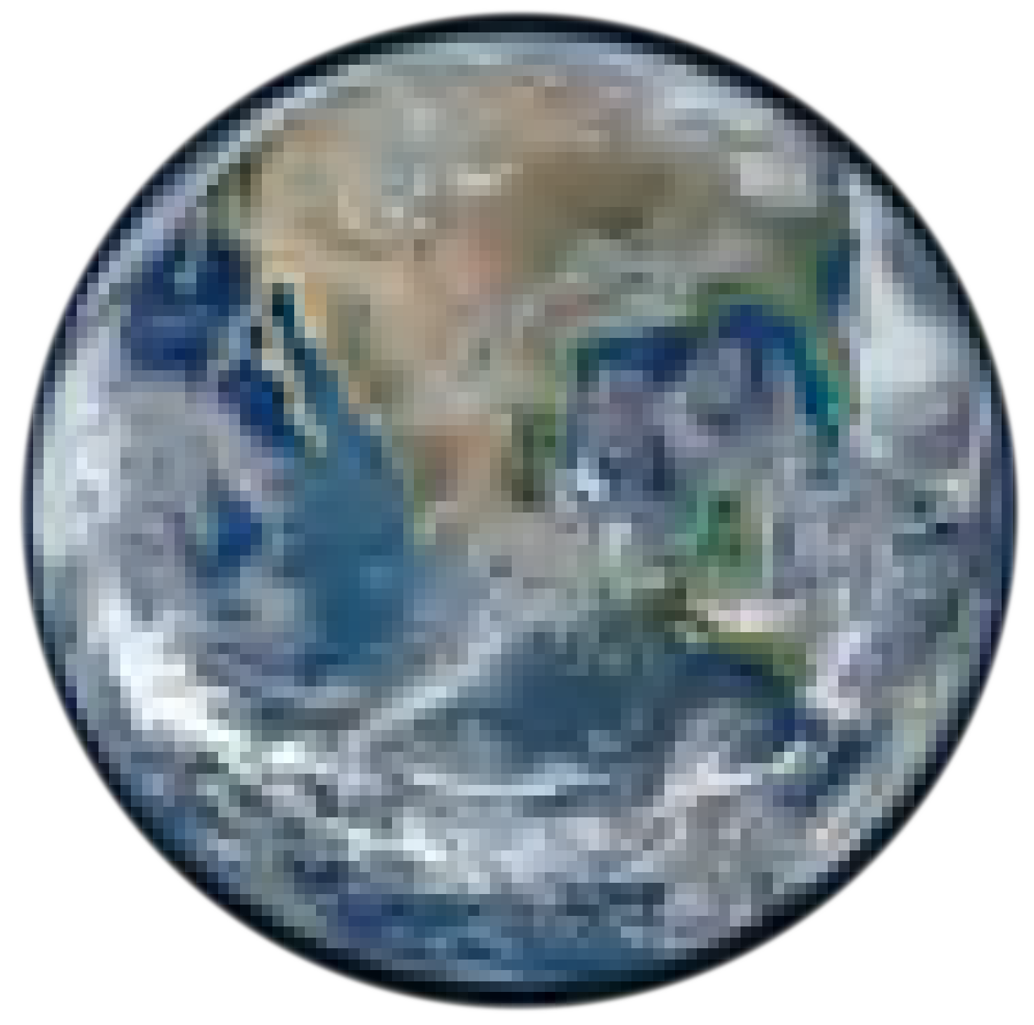You do not have to stop at a planet. You can even pass a planet, tick it off, make an orbit jump and move several spaces along another orbit if you roll a large enough number!
mercury venus
earth
mars
jupiter
saturn
uranus
neptune

asteroid This is a rocky or metallic object that orbits the Sun. It is smaller than a planet.
comet This is an object made of ice and dust that orbits the Sun. Comets may develop a tail as they pass close to the Sun.
dwarf planet These objects are too small to clear all other objects from their orbit. Dwarf planet Pluto shares its orbit with other bodies in the Kuiper Belt.
galaxy This collection of stars, planets gas and dust are held together by gravity. Our Solar System is part of the Milky Way galaxy.
meteorite An asteroid or comet that hits Earth’s atmosphere and burns up is called a meteor. If part of it survives and lands on Earth it is called a meteorite.
moon A space object that orbits a planet is called a moon. Earth has only one moon, called the Moon, but some other planets have many moons.
orbit This is the continuous path that an object takes around a star or other object.
planet This is a large, roughly spherical object that orbits a star.
Planets in our Solar System orbit the Sun.
star This unbelievably hot ball of gas shines with its own light.
The Sun is a star at the centre of the Solar System.
Solar System This is the collection of space objects orbiting the Sun.
Other stars have their own planetary systems.

tally

ast1439 | Exploring the Solar System 6: Race around the planets (player sheet)
© The University of Western Australia 2015 version 1.0

developed for the Department of Education WA for conditions of use see spice.wa.edu.au/usage Licensed for NEALS

