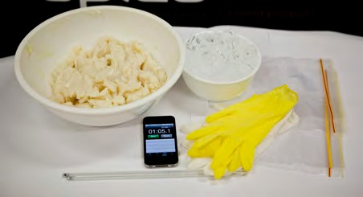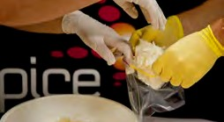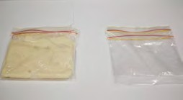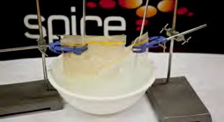

student sheet 3

Part 1
Emperor penguins find and catch their food in waters around Antarctica where the temperature is a freezing -1.9˚C. To stop their internal organs from freezing they have a thick layer of fat beneath the surface of their skin. Fat acts as an insulator; this means it prevents heat from escaping, so the body heat of emperor penguins isn’t lost to the frigid water.

Aim
Using vegetable shortening investigate how a thick layer of fat helps emperor penguins stay warm when they dive underwater for food.

What you will need
- 4 plastic or zip-lock bags
- masking tape
- vegetable shortening (softened)
- basin/bucket of cold water
- ice cubes
- 2 thermometers
- stopwatch/timer
- gloves

What to do
- Predict which will stay warmest in icy water: a plastic bag insulated with vegetable shortening or an empty plastic bag? Write your answer in your workbook or investigation planner.
- Fill a plastic bag with vegetable shortening.
- Place a second plastic bag inside this bag. Spread the shortening evenly. Place a thermometer inside the inner bag.
- Place another two plastic bags inside one another, with no shortening. Place a thermometer inside the inner bag.
- Fill basin with cold water. Place a thermometer in the basin.
- Add ice until the temperature reaches 10°C.
- Record water temperature and remove thermometer.
- Secure each pair of bags with masking tape or using zip-lock feature. It’s important water doesn’t enter bags.
- Place both plastic bags into the icy water basin.
- Record temperatures inside the bags after two minutes, and again after four minutes.
- Record your observations in your workbook or investigation planner.

Page 7

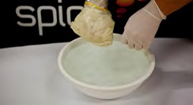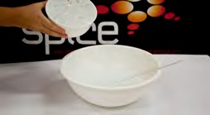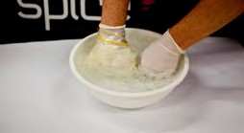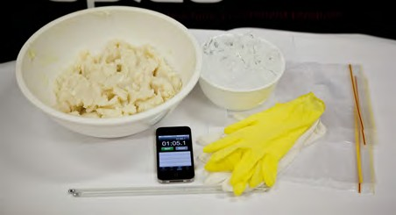

student sheet 4

Part 2

Aim
Use vegetable shortening to discover how insulation protects your own skin from icy water.

What you will need
- 2 plastic or zip-lock bags (extra bags may be required)
- masking tape
- vegetable shortening (softened)
- basin/bucket cold water
- ice cubes
- disposable gloves, 1 pair per student
- stopwatch
- thermometer

What to do
- Predict which hand will stay warmest in icy water: the one insulated with vegetable shortening or the one inside a glove with no shortening? Write your answer in your workbook or investigation planner.
- Put on your disposable gloves.
- Fill basin with cold water. Place a thermometer in the basin.
- Add ice until the temperature reaches 10°C.
- Record temperature of water.
- Fill a plastic bag with vegetable shortening.
- Place one hand inside the bag containing vegetable shortening. Spread the shortening evenly around your hand. Seal the bag around your hand to prevent water entering.
- Place your other hand inside the empty glove. Seal the bag around your hand to prevent water entering.
- Place both hands into the basin of icy water.
- Observe how long it takes before your hands begin to feel cold.
Remove your hand immediately.
- Record your observations in your workbook or investigation planner.

Note: Do not put your hands in cold water for longer than one minute.

Page 8

