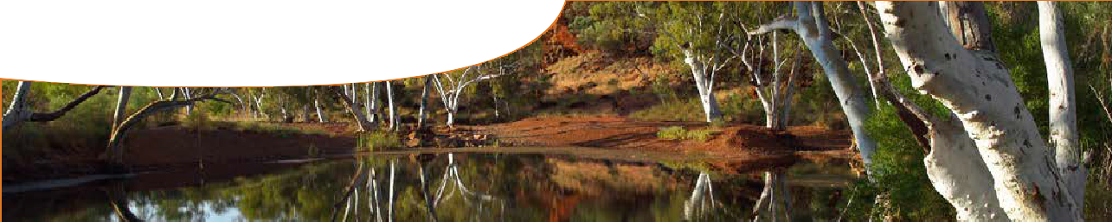
background sheet
Explaining feeding relationships
A food chain shows how species are linked to each other by what they eat, and it illustrates the direction in which energy passes from one species to the next. Eg:
grevillea native stingless bee green tree frog king brown snake

A food web links several food chains together to describe all feeding relationships within an ecosystem. E g:

ibis

green tree frog

king brown snake

brush tailed phascogale
graphic flutterer dragonfly

native stingless bee

Plants as producers
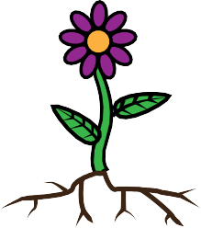All food chains start with an autotroph (producer). These are species that can make their own food, such as plants, algae and many bacteria.
light energy
oxygen
carbon dioxide
Plants produce their own food using light energy from the sun, in a process called photosynthesis. This chemical process is carried out in organelles, by chloroplasts inside plant cells. Chlorophyll, found in chloroplasts, absorbs light energy from the Sun. This energy powers a reaction: carbon dioxide and water combine to produce oxygen and sugars, a process vital for life on Earth.

grevillea

acacia

Animals as energy consumers
Animals require energy for maintenance, growth, development and reproduction and, unable to produce energy, must eat plants or other animals for their energy requirements. Hence their name (in this context): consumers.
Food chains and food webs are useful for showing what species an animal eats. Arrows in food chains and webs indicate the direction of energy flow: from an organism being consumed to the organism consuming it. Consumers may be identified by their position in a chain: first order (primary) consumers eat producers; second order

(secondary) consumers eat primary consumers; third order (tertiary) consumers eat secondary, and so on along a chain.
Consumers high in a food chain do not necessarily eat all species lower down. For example, crocodiles might eat grasshoppers, and grasshoppers eat grass, but crocodiles don’t eat grass. High order consumers aren’t always the largest or most powerful animals in a chain. For example, meat ants can eat live cane toads even though they’re smaller than toads. A food chain simply shows feeding relationships.

Biomass pyramids
A biomass pyramid is a way of  showing comparisons of the total mass of each species in a balanced food chain. Generally,  producers have largest mass, with decreasing amounts of consumers at progressively higher levels in a chain.  Only 10% to 20% of an animal’s | BIOMASS  10 |  |  |  |  |  |  | TROPHIC LEVEL  tertiary consumers (snakes)
energy is passed on to the next
consumer in a chain. Most of their | 100 |  |  |  |  |  |  | secondary consumers
energy is converted to heat or used |  |  |  |  |  |  |  | (toads)
during processes essential for life,
such as respiration and movement.
Food chains are usually not very long because higher order consumers wouldn’t be able to get enough energy from the diminishing supply, to survive.  A biomass pyramid also shows that changing numbers of either predator | 1000  10 000 |  |  |  |  |  |  | primary consumers (grasshoppers)  producers (acacia)

(g m-2)
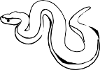

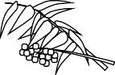
or prey affects numbers of other
species in a chain, upsetting ratios between each level of consumer.

Cane toads: upsetting the balance
Food chains and food webs reveal the complex balance of life. They demonstrate how, when numbers of one species alter, all other species in an ecosystem are affected; eg, the introduction of cane toads to the finely balanced ecosystem of the Kimberley in Western Australia.
Cane toads eat insects (amongst many other things), such as native stingless bees. If cane toad numbers increase, native stingless bee numbers decrease. There’s a follow-on effect. Native stingless bees pollinate grevillea, so with fewer bees grevillea may decrease in number.
Not only are species that have a direct feeding relationship with cane toads altered, other species, in the food chain or web, are affected. For instance, species that compete directly with cane toads for food. Green tree frogs eat native stingless bees, so cane toads will remove some of their food resources and potentially result in a drop in green tree frog numbers. Numbers of animals that can
safely consume cane toads, for example ibises, will potentially increase because more food is available.
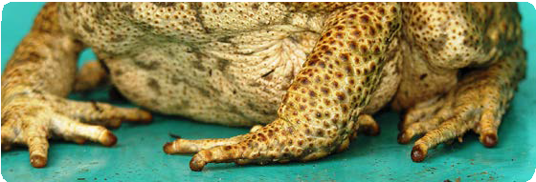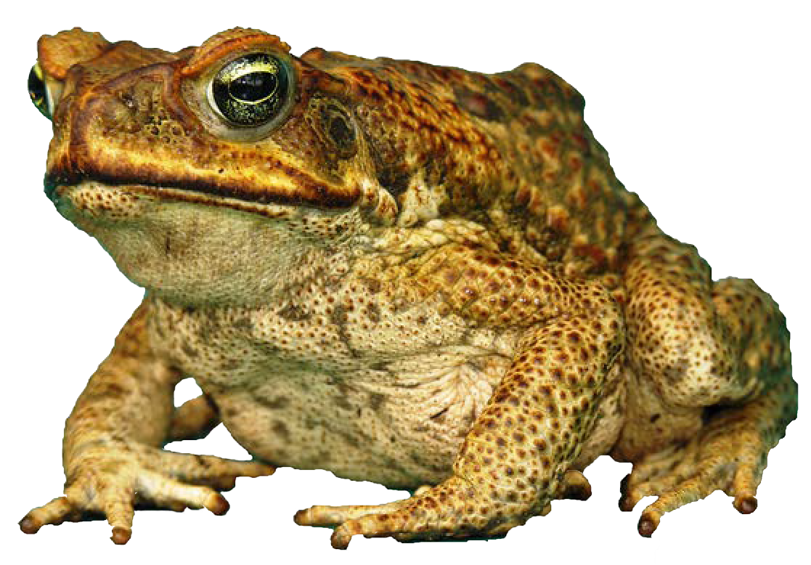The introduction of cane toads has a further, more unusual, wider effect on an ecosystem because cane toads poison so many of their predators (consumers). As high order consumers succumb to cane toad poison the consumers’ numbers drop, leading to an increase in toad numbers. As a result, numbers of high order consumers such as brush-tailed phascogales and king brown snakes actually drop as more toads become available.
The impact of this introduced species on its food web is widespread.

Image from Kimberley Toad Busters

