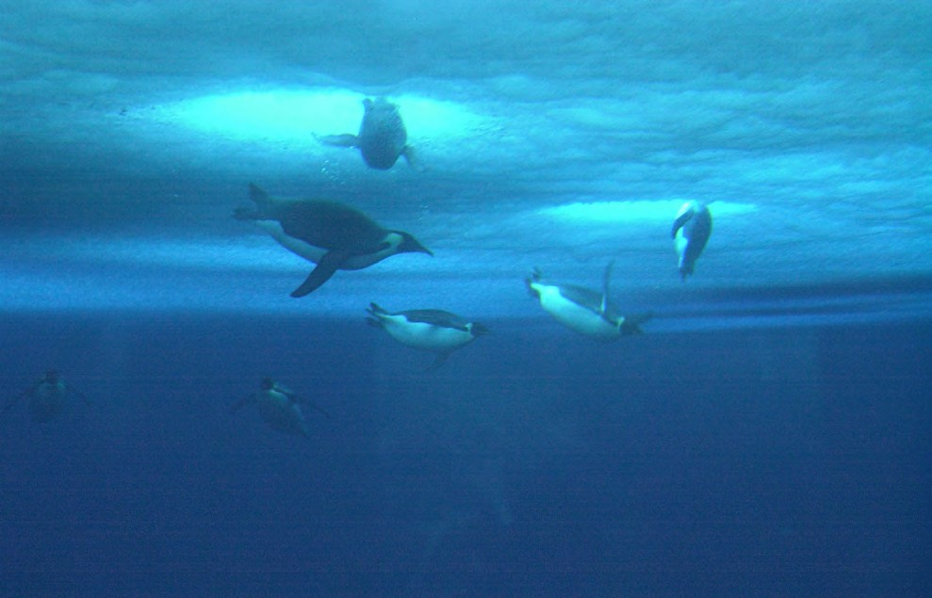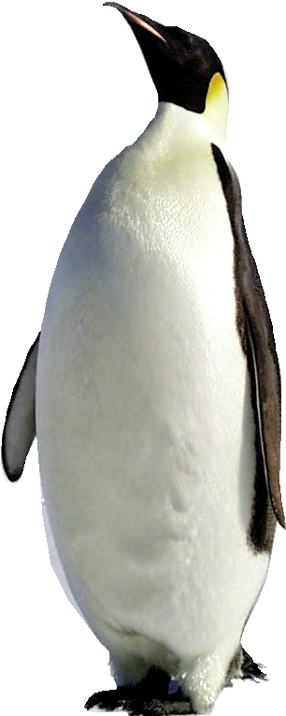

student sheet 2

(aPtenodytes forsteri)
There are 17 species of penguins, and all are found in the Southern Hemisphere.
Emperor penguins live around the Antarctic continent, and are one of the top predators in the Antarctic food chain. They hunt in the Southern Ocean, diving after prey such as squid, fish, and krill.

surviving antarctic extremes
In the Antarctic, emperor penguins live in some of the harshest conditions on the planet. Coping with extreme cold and living mainly in water means emperor penguins have many special features to help them survive. These features are known as adaptations.

Staying warm underwater
Emperor penguins dive underwater for food, where temperatures can be as low as -1.9°C. Staying warm is essential, so they have a thick layer of fat under their skins. This keeps cold out and their body heat in.
Emperor penguins also have four layers of feathers that help them stay warm. The outer layer of feathers is waterproofed with special oil which stops icy cold water coming into contact with their skin.

© National Science Foundation
© Scripps Institution of Oceanography at UCSD

While they might look awkward on land, the body shape of emperor penguins is superbly adapted for life at sea.

The emperor penguin is the largest of all 17 penguin species.
On average 122 cm tall, and weighing between 22 - 45 kg.

Page 5

student sheet 2: emPeror Penguin

The toughest winter on Earth
During the bitingly cold Antarctic winter most penguin species migrate to warmer areas, but emperor penguins are famous for spending winter on the Antarctic sea ice.
Emperor penguins breed on sea ice, the frozen seawater surrounding the Antarctic continent. However, that doesn’t mean breeding colonies are close to the sea, some have to trek 50 - 120 kilometres to reach it.
At the start of winter female emperor penguins lay a single egg. Males are left to incubate (keep warm) the
eggs while females return to the ocean to feed. Males delicately balance the eggs on their feet beneath a pouch of skin, known as the brood pouch, where it stays warm. If they drop their eggs onto the ice it’s a disaster, as the eggs quickly freeze, killing developing chicks inside.
Males have to withstand the extreme Antarctic winter: temperatures below -40°C, wind speeds up to 200 kilometres per hour, and up to 20 hours of darkness per day.
Emperor penguins huddling during a severe storm.
© Australian Antarctic Division

© Australian Antarctic Division

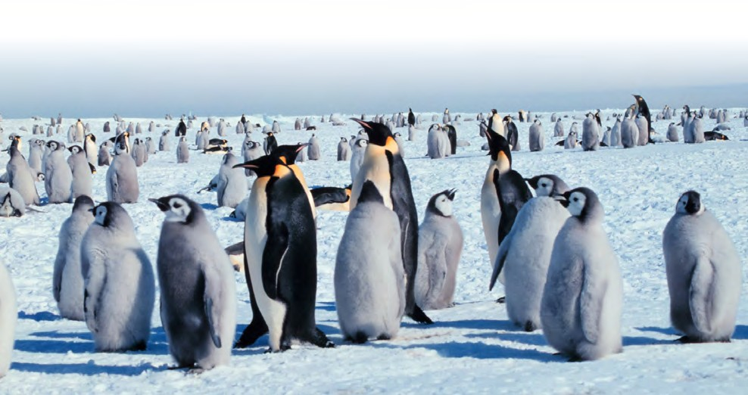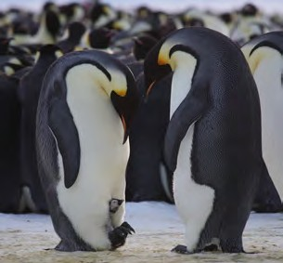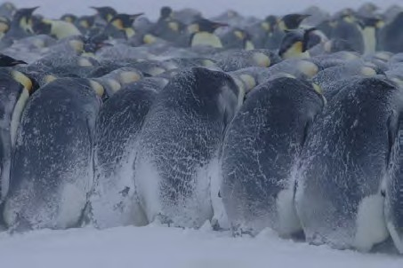During extreme weather conditions male emperor penguins huddle together to stay warm and save energy. Temperatures at the centre of these huddles can be as high as 24°C. Huddles are never still: the penguins constantly shuffle around so even those on the outside get to benefit from conditions in the centre.
When females finally return at the end of winter males won’t have eaten for up to 115 days and can lose up to 20 kg in body weight. During the next month both males and females forage and feed their chicks.
These are just some of many adaptations emperor penguins have to allow them to live in one of the coldest and harshest environments on Earth.

© Michael Van Woert, NOAA NESDIS, ORA

Page 6

