atmosphere 750 CO2
carbon cycle

121.3

0.5
vegetation 610 5.5

60
60 1.6
fossil fuels and cement production 4,000

soils 1,580

90
50

marine biota 3

92
rivers
surface ocean 1,020

40
91.6 100

6 4 deep ocean

dissolved organic 6
carbon <700
38,100
storage in GtC fluxes in GtC/yr

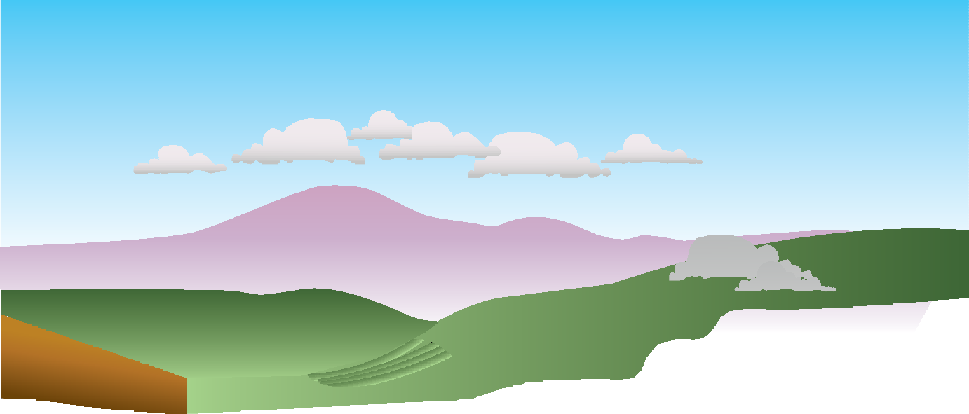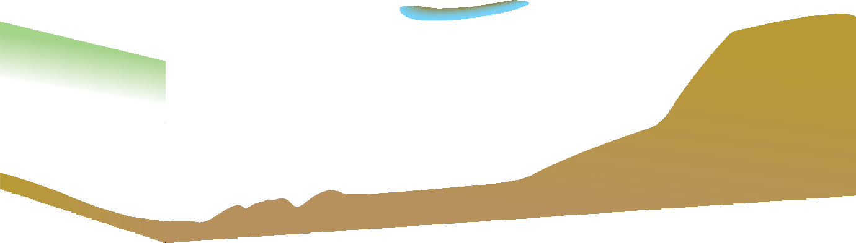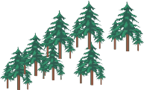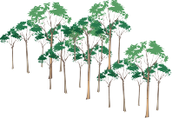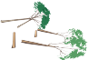0.2
sediments 150

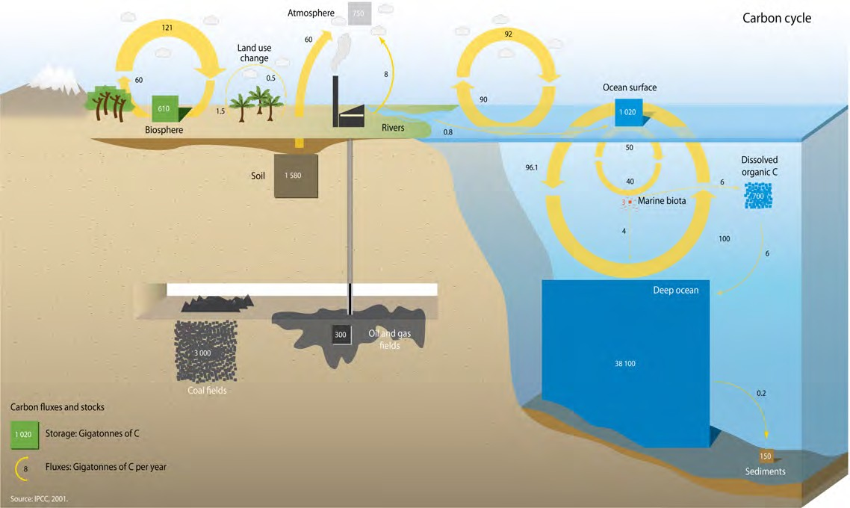121
92

