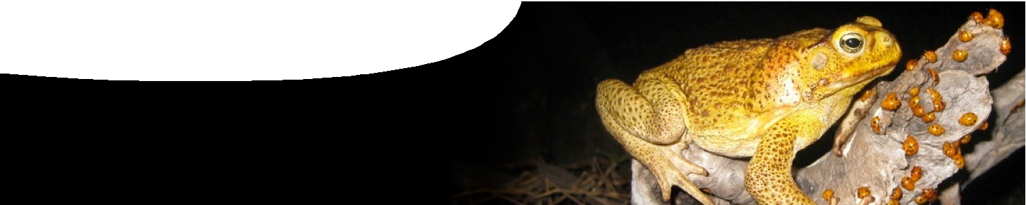
background sheet
Cane toads

ane toads are one of Australia’s most notorious introduced species. They breed prolifically, and are spreading alarmingly across northern Australia. Both local and scientific communities are
C
conducting projects aimed at slowing their progress, and discovering more about them.

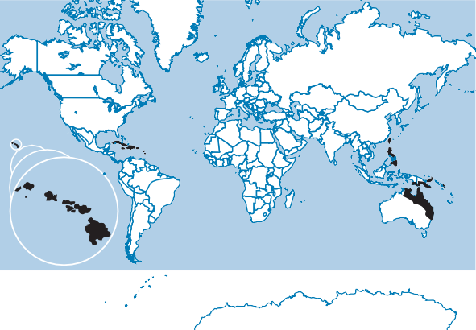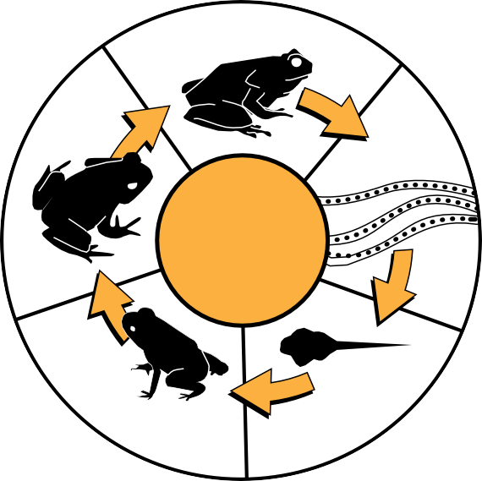Introduction into Australia
CANE TOAD QUICK FACTS
LATIN NAME: Rhinella marina (formerly Bufo marinus) DESCRIPTION: large, brown warty toads, about 15 cm long LIFE CYLE:
Adult females can lay
30,000 eggs in a clutch
Young adult
Eggs are laid in long strands
cane toad
lifecycle
Metamorphs contain less poison than adults
Tadpoles are pure black
DISTRIBUTION:
NATURAL DIET: invertebrates (eg insects), small rodents, birds’ eggs, birds, amphibians, small reptiles
NATURAL PREDATORS: caiman (alligator); banded cat- eyed snake; fish including killifish, rock flagtail, catfish and eels; ibis; meat ants
Key:
native habitat introduced habitat
Cane toads are native to Central and South America. They were introduced into Queensland in 1935 in an effort to control cane beetles which were destroying sugar cane crops. They had previously been successfully introduced to other countries, including Hawaii.
One hundred and one cane toads were brought to Queensland from Hawaii and bred rapidly. Three thousand toads were released later the same year!
Cane toads were unsuccessful in controlling cane beetles. However, they have been successful in spreading across Queensland, to New South Wales, the Northern Territory and Western Australia.

Cane toads in Western Australia
Cane toads were first found in WA in 2009, near the Northern Territory border, and have since spread past Kununurra. Toads move quickly during the wet season, and annually average about 50 km. This means that large areas of the Kimberley are likely to be home to cane toads in the next few years.
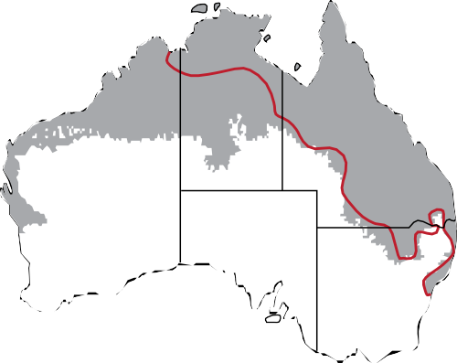A few toads, ‘hitching a ride’ in trucks and cars travelling from the north of the state, have also been found further south, as far away as Perth. Potentially, toads could survive a long way down the western coast, although they cannot survive in temperatures of less than 5°C.

Distribution in 2008 Potential habitat

Secrets to success of the cane toad population
Cane toads are adaptable: they can survive temperatures from 5 – 46°C, in a wide range of locations, from sand dunes to rainforests. They prefer fresh water but can tolerate salty water for short periods of time, and have even swum from the coast of the Northern Territory to inhabit small islands. Cane toads move further, and breed more, during the wet season. However in dry conditions, adult toads can lose up to half of their moisture and still survive.
They lay up to 30 000 eggs, twice a year, many more than native frogs which lay about 2000 eggs at a time. It is estimated that about one in two hundred cane toad eggs develop, and survive to adulthood. They reach sexual maturity after one
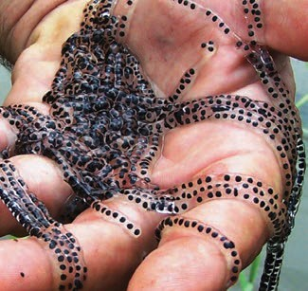
to two years, depending on climatic conditions, and they breed for about five years. Records show that cane toads have survived, in captivity, for up to 15 years!
They are opportunistic feeders, consuming mostly insects but also frogs, small mammals, reptiles, snails, baby birds and fruit, in fact anything that crosses their paths that is small enough to swallow. They also take advantage of human civilisation, eating food scraps and pet food.
Another key to their success is that cane toads are evolving quickly. Often we think of evolution taking place over thousands of years but scientists noticed significant changes in cane toads as they travelled west: toads at the front of the
pack have longer, stronger legs, enabling them to move more quickly. It is a survival advantage to have long legs so these toads are more likely to reach maturity and pass on this characteristic. However, there is a negative effect: longer legs have caused an increase in arthritis.

Problems with cane toads
photo: Kimberley Toad Busters

Cane toads compete for food with, and eat, Australian native species, including frogs. For instance the rainbow bee-eater is now endangered as cane toads eat their nesting chicks. Scientists are concerned that there could be an impact on the number of honeybees, which are also part of cane toads’ diet. If this happens, native flora would be affected as flowers depend on bees for pollination.
Cane toads in most life stages contain a poison called bufotoxin which is toxic to animals that eat them. Bufotoxin contains a number of different poisonous chemicals, including bufagin and bufotenine. Bufagin stimulates the heart, causing increased pulse, ventricular fibulation and cardiac arrest. Bufotenine is a hallucinogen that causes psychedelic effects. Small toxic molecules of these poisons can be absorbed directly into the blood stream of predators, from their mouth tissues.
Cane toad eggs are particularly toxic. They are poisonous to fish and toxins released into waterways cause water to become toxic.
As tadpoles, the poisons spread throughout their bodies. Toxin levels drop as tadpoles develop and baby toads are the least poisonous life stage. Adult toads produce bufotoxin which is concentrated in paratoid glands, behind their ears. When cane toads are scared they may secrete or squirt poison as a milky white fluid.
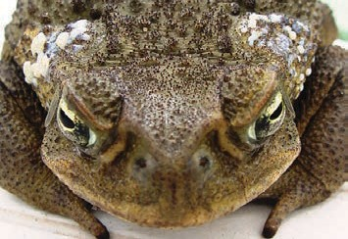
Native animals that eat cane toads die almost instantly when they bite into them. These native predators include: quolls, frilled necked lizards, goannas, some snakes and even crocodiles. After the cane toad front has passed through a habitat, some of its animals, particularly quolls, have become threatened species in that area. However, after a while, numbers seem to increase again, possibly because animals learn not to eat toads.
Interestingly, most birds, some snakes and some rodents seem to have developed immunity as they are able to eat cane toads safely. This is thought to be because they have a closer evolutionary relationship to species from Asia, where other poisonous toads are common. In some areas, numbers of hawks have increased because they eat cane toad road kill.
No-one in Australia has died from cane toad poisoning but overseas there has been a few reports of people who died from mistakenly eating cane toads, or soup made from their eggs. Cane toad poison can also kill pets that try to eat them.
photo: Kimberley Toad Busters

The future for cane toads
There are now an estimated 200 million toads in Australia moving across the country at a rate of about 50 km a year. Scientists and community members must continue to work together to find a way to control cane toad impact on our native ecosystem.

