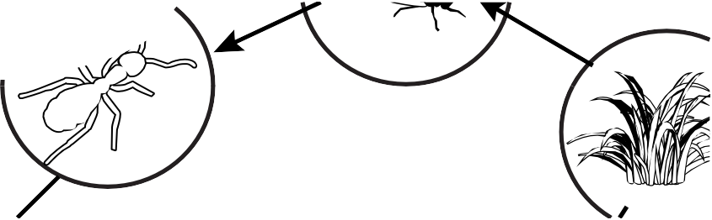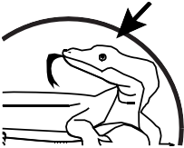
fact sheet
All about food webs
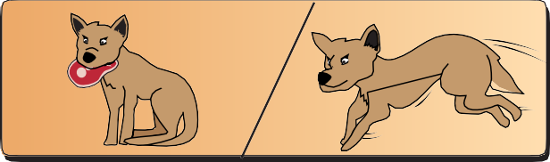

We all need energy to live, so do other animals! An animal’s energy is derived from the food it eats.

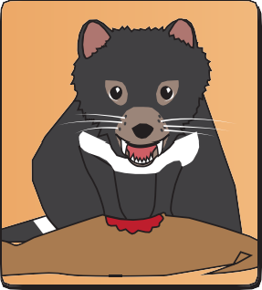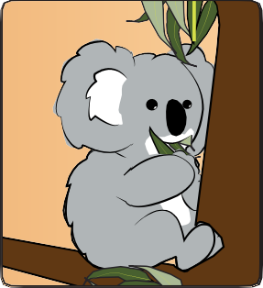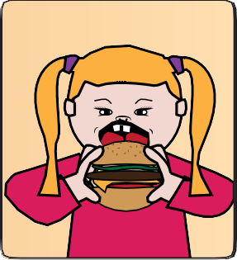
Different animals eat different things as their energy source:
carnivores
only eat animals (meat)
herbivores only eat plants
omnivores
eat animals and plants

water + carbon dioxide + sunlight

food + oxygen

Plants produce their own food, using energy from the sun, by a process called
photosynthesis. Because they make their own food plants are called ‘producers’.
Animals are called ‘consumers’, because they get their energy by consuming other things.

- insectivore
What do you think these eat?
- nectarivore
- frugivore

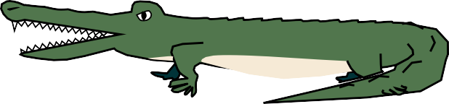
A food chain shows what consumes what in an environment, that is, species that are linked to each other by what they eat. It also illustrates the direction in which energy passes from one species to the next.
acacia cicada green tree frog freshwater crocodile
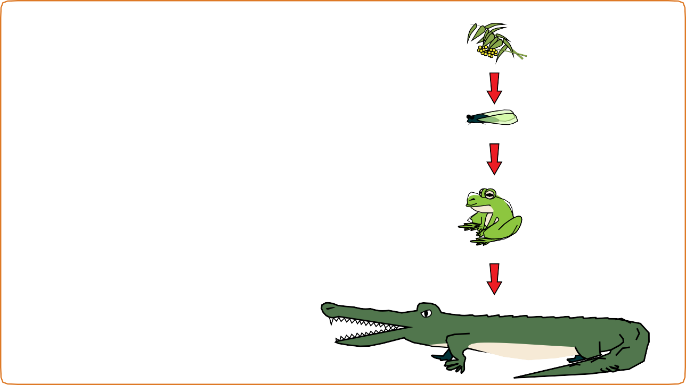
Acacia plants are producers.

The arrow shows at the beginning of the food chain, cicadas eat acacia,
so cicadas are called ‘first order’ consumers.
Next in the food chain, green tree frogs eat cicadas,
so green tree frogs are ‘second order’ consumers.
Then, freshwater crocodiles eat frogs,
so freshwater crocodiles are ‘third order’ consumers.
Each animal is named a different order of consumer, based on its position in a particular food chain. Arrows in a food chain always point in the same direction, from the species being eaten to the species doing the eating. They also show the direction in which energy is passed from one species to the next.

crocodile

A food web shows how food chains interconnect.

ibis

A food web shows all feeding relationships (links) in an ecosystem, and it may include many different plants and animals.

Food webs normally have producers at the bottom of the diagram and high order consumers at the top.

butterfly

frog

cicada

goanna

acacia bush tomato

