Look closely at the picture on your postcard and read the message on the back.

Observe
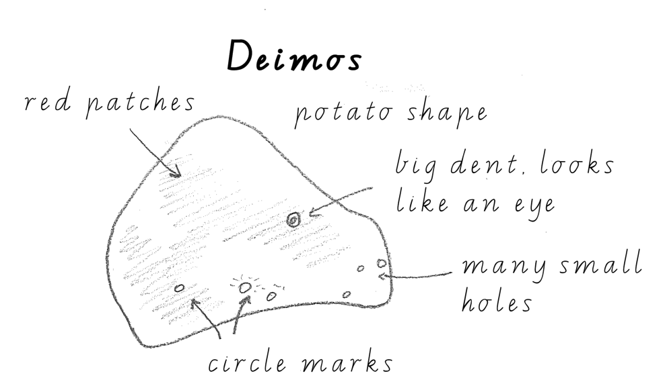
Draw and label a diagram of the space object on your postcard.
Look for patterns, shapes, colours and shades.

Example:
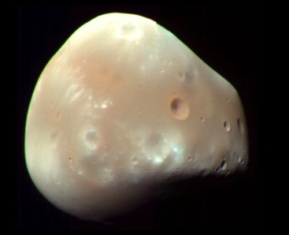

Compare
How do features on your postcard compare to things that you are familiar with, such as mountains and oceans on Earth?
This space object
looks like

Deduce or infer
What do you think about this space object, and why? For example, I think this space body has rivers because it has patterns like rivers on Earth.
I think this space object
because

Questions
What questions do you have about your postcard? For example, how was this picture taken? Why is there a shape like a bear on it?
How
?
Why
?
Where
?
What
?

