Acid sulfate soils
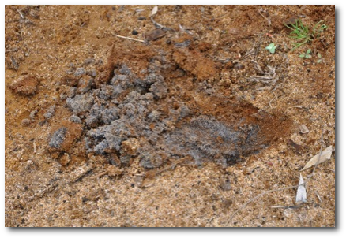
Acid sulfate soils are naturally occurring soils that form in coastal, inland and wetland areas. These soils are harmless when they remain in their waterlogged, anaerobic, oxygen-depleted state. But activities such as excavating or dewatering soils can expose them to atmospheric oxygen.
Iron sulfides (usually pyrite, FeS₂) in acid sulfate soils react with oxygen to produce sulfuric acid, which can be mobilised by surface or subsurface water flow.
Acid may release metal ions such as aluminium, lead and arsenic that can contaminate drinking water or kill plants and animals. It may also corrode structures such as building foundations and bridges.

Spoonbill Lake
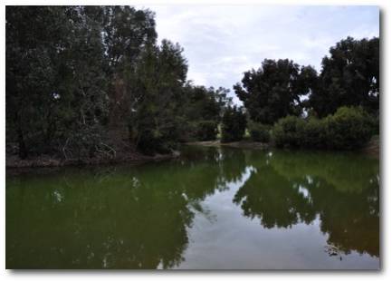
The area around Spoonbill Lake, in Perth’s northern suburbs, has a problem with acid sulfate soils. This condition has been caused by land developments around the lake which have resulted in the release of sulfuric acid and metals such as aluminium and arsenic into local groundwater flows.
Scientists have been working with local authorities to find the best way to deal with the acid sulfate soil problem at Spoonbill Lake. Three possible solutions have been proposed.

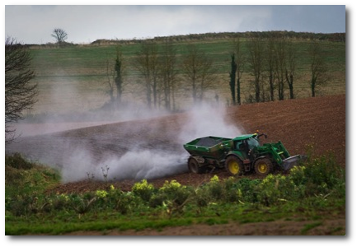
Option 1: Add base
Perhaps the most obvious solution is to neutralise acidic soil and waterways by adding a base. In fact farmers have been doing this for many years in a process known as ‘liming’.
There are a few common bases that can be added, including magnesium oxide, magnesium hydroxide, calcium carbonate and calcium hydroxide.

Questions
- Write neutralisation reactions between each of the listed bases with sulfuric acid (H₂SO₄).

- For each base, calculate the mass required to neutralise the lake if its current pH is 3, assuming 100% effectiveness. It is estimated that the lake is 120 m long by 50 m wide and has an average depth of 1.5 m. (show your working here)

- Cost is one factor in deciding which base to use. Scientists also have to consider the solubility of the base, other reactions that could take place and impacts on the environment. Which base do you think would be best to add? Why?

- What are disadvantages of treating acid sulfate soils by adding a base?

Option 2: Bioreactors
Bioreactors raise the pH of acidic soil by creating an environment in which micro-organisms such as sulfate-reducing bacteria thrive. Bacteria use up oxygen through respiration, which creates reducing conditions.
The bacteria produce hydrogencarbonate ions and hydrogen sulfide according to the following reactions: (CH₂O represents a general formula for carbohydrates in organic matter such as straw, leaves and twigs.)
1. |  | pH > 7 (basic conditions)
Hydrogen sulfide reacts with dissolved metal ions according to the following general equation:
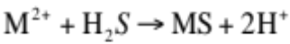
2. |  | pH < 7 (acidic conditions)
As shown by equation 1, reactions with bacteria produce hydrogen ions that initially cause the pH to drop, increasing the acidity problem. Once the metal ions have been removed the pH will rise as hydrogen ions are consumed, as shown in equation 2.

Questions
- In equations 1 and 2 above, what is being oxidised and what is being reduced. Are either of these equations redox reactions?

- Acid sulfate soils often contain harmful metals. What is an advantage of a reaction between the metals and hydrogen sulfide?

- Iron can cause environmental problems in high concentrations. Write an equation to show the reaction of iron (II) ions with hydrogen sulfide.

- In some areas where bioremediation has been used, pH decreases at first (acidity increases). Why is this? Would you expect the problem to continue over a long period of time?

- What advantages does bioremediation have over other options?

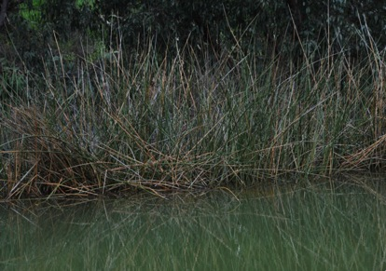
Option 3: Aerobic filtration
In aerobic filtration water from areas containing acid sulfate soils is passed through ponds that contain reeds planted in organic matter.
The primary function of these wetlands is to remove iron and manganese from the water. Large concentrations of these metal ions can damage the wetland ecosystem and slow down the effectiveness of adding base because they interfere with the neutralization process.

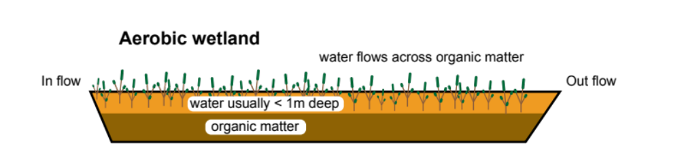
As water passes slowly through the wetland it mixes with enough oxygen for iron and other metals to oxidise and precipitate as oxyhydroxides (general formula [MO_{x}OH_{y}]). A small amount of hydrogen ions are produced during the process so this method is only suitable for neutral, alkaline or mildly acidic water. It is often used after another method has been used to remove hydrogen ions. Reeds must be replaced regularly as precipitated solids build up on them.

Questions
- A two-step reaction occurs in aerobic wetlands to remove iron ions. The following incomplete equation shows the first step:
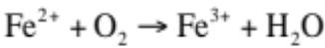
a. Write two balanced half equations to show what is happening.

b. Which half equation shows oxidation and which shows reduction?

c. Write a balanced redox equation for this reaction.

- Goethite (FeOOH) is an example of an iron oxyhydroxide. It is produced in the second step of this reaction, according to the following equation:
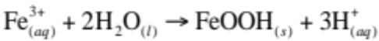
a. What is the oxidation number of iron in goethite?

b. Is this a redox process? How do you know?

- Aerobic wetlands can be used to oxidise manganese ions, but this process doesn’t occur until all of the iron has been oxidised. Explain why.

- What solids would be precipitated on the reeds?

- What are some advantages and disadvantages of this remediation method?

The approach at Spoonbill Lake
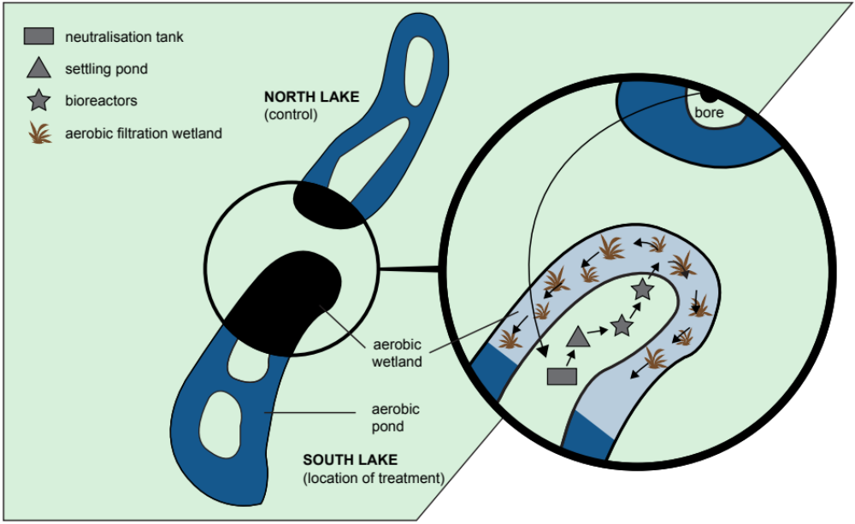
A groundwater treatment system to reduce acidic water and soil levels has been installed on an island in the southern lake at Spoonbill Shearwater Reserve, by the City of Stirling, in collaboration with Edith Cowan University.
The innovative groundwater treatment system uses a combination of liming technology developed by Curtin University and biological remediation technologies developed by Edith Cowan University. This pilot project is the first of its kind in the Perth metropolitan region.
The treatment process involves three principal phases:
1. Neutralisation
Acidic water is neutralised as it passes through a vat where lime is added, followed by clarification in a settling tank.
2. Bioreactors
Neutralised water is then passed through a series of two organic bioreactors to lower dissolved oxygen levels and to convert heavy metals and arsenic into stable minerals. Essentially, the bio-reaction phase reverses the oxidation process that formed acids in the first instance. The bioreactors are stimulated by the addition of rotting potatoes and hardwood mulch sourced from municipal tree prunings.
3. Aerobic filtration
Treated water is re-aerated through bio-filtration amongst native reeds and rushes in the lake. Establishment of the bio-filter has involved planting 2500 plants purchased by the City of Stirling and planted by students from Edith Cowan University.
Early results indicate the system is a success, with lake water readings shifting from an incoming pH 3.0 (highly acidic) to an outgoing pH of 7.9 (slightly alkaline). Additionally, testing of shallow groundwater has shown that sulfate concentrations have been reduced by 90%, nitrate concentrations by 73% and arsenic concentrations by 40%.

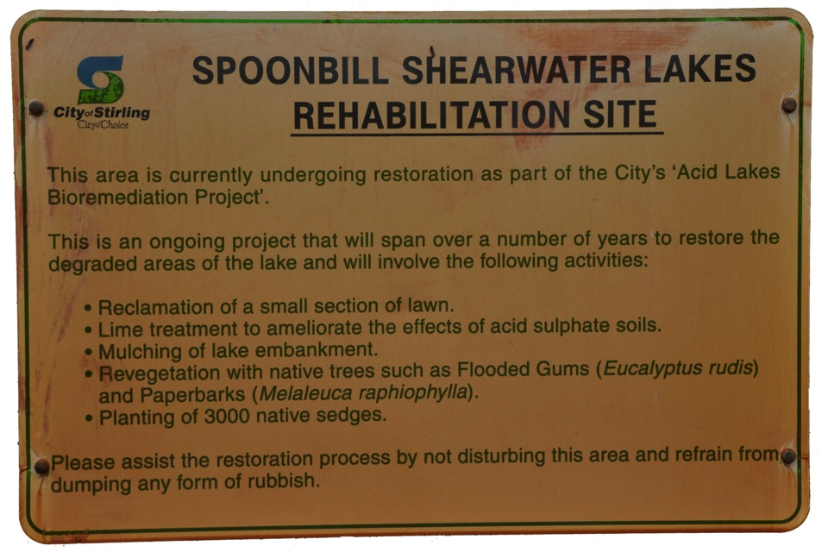

Question
- How were the characteristics of each method combined to solve the problem at Spoonbill Lake?

