Part 1
A community swimming pool, heated by geothermal energy, is to be built in a large West Australian town. As an expert in using geothermal energy for heating, you have been appointed by town planners to lead a team to conduct a feasibility study into the project. You will need to use existing borehole data to find the best possible site for a swimming pool.
Some information about water temperature and depth has been gained from nine exploratory boreholes in the area. You will need to use graphic modelling to predict heat distribution in the underground geothermal system.
Temperatures at different locations and depths can be predicted by drawing isotherms on cross-sections. Isotherms are lines that connect points at the same temperature. The ideal temperature for geothermal water to be brought to the surface to heat the pool is 43 °C. Study the isotherm graphs, together with a map of the town, to decide where to site the swimming pool.
The town map shows major facilities, the location of three cross-sections (A, B and C, shown in Figures 2–4) and a proposed site for the swimming pool (X).
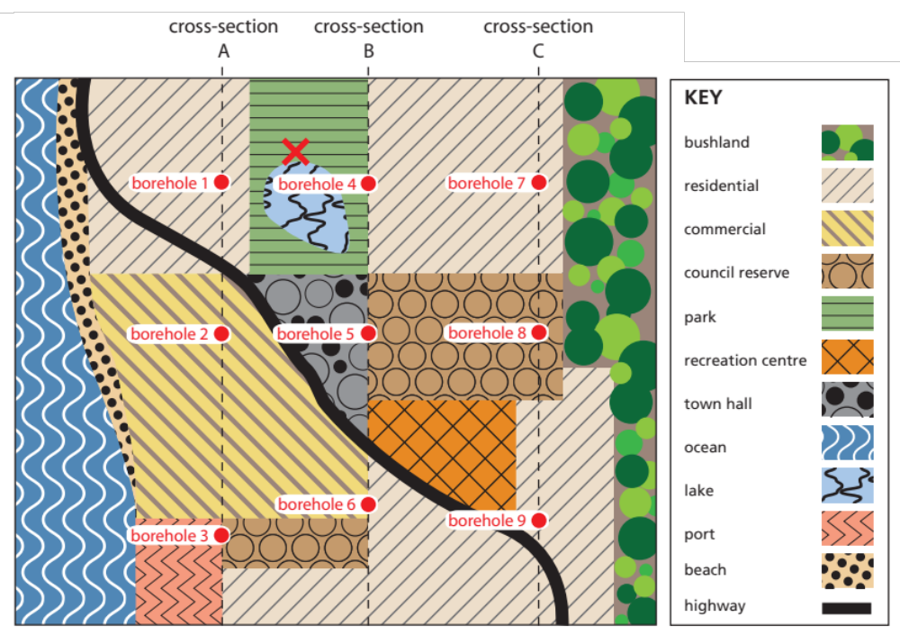
Figure 1: town map
Nine boreholes have been drilled, three holes along each cross-section A, B, and C. The temperature of underground water has been measured in these boreholes at 200 m intervals. The temperature data are tabulated on pages 4–6, for use in graphic modelling.
- Use the temperature data to plot 30 °C, 35 °C, 40 °C and 45 °C isotherms on the cross-sections on pages 4–6.

Part 2
- Use the modelling completed in Part 1 to respond to the town planner’s questions about the swimming pool project.
- Using only temperature and depth measurements, which borehole would be the best choice for a heated swimming pool? Why?

- Use the town map to answer the following questions.
- The town planner wants to locate a bore for a geothermally-heated swimming pool at site X. Site X lies between boreholes 1 and 4, but the underground temperature at this site is unknown. Use data from boreholes 1 and 4 to estimate the drilling depth required to bring water at 43 °C to the surface. Explain how you reached your answer.

- The town planner has asked you to suggest other possible locations that may be suitable for a geothermally-heated swimming pool. List criteria you would use to choose a suitable site.

- Using the town map, identify two possible locations that fit your criteria. Identify boreholes close to your proposed sites, then use data from these boreholes to estimate, for each site, the depth required to bring up water at 43 °C.

- Underground water is found in tiny spaces between sand and rock. A high flow rate is needed to pump water efficiently from underground. The rate of the flow of underground water through a borehole (flow rate) varies, depending on rock type.
- The town lies above an aquifer that is made of two types of rock: clay and sandstone. Sandstone contains sand-sized minerals or rock grains and has an average flow rate of around 20 litres per second (L s⁻¹). Clay is more compact and less porous than sand, and has an average flow rate of less than 5 L s⁻¹. For efficient heating of the swimming pool using geothermal energy, water must be sourced from sandstone.
- Use information on the sub-surface geology (included on the cross-sections) to compare your two potential locations. Which is the best site for a geothermally-heated swimming pool? Explain your answer, using criteria you listed in question 4.

- Compare your selected site from question 6 with the site proposed by the town planners (site X). Which site is more suitable? Give reasons for your answer.

Use data for boreholes 1, 2 and 3 to plot 30 °C, 35 °C, 40 °C and 45 °C isotherms on cross-section A.

BOREHOLE 1 |  |  | BOREHOLE 2 |  |  | BOREHOLE 3
DEPTH (m) | TEMP (°C) |  | DEPTH (m) | TEMP (°C) |  | DEPTH (m) | TEMP (°C)
0 | 15 |  | 0 | 15 |  | 0 | 15
200 | 25 |  | 200 | 26 |  | 200 | 27
400 | 29 |  | 400 | 30 |  | 400 | 32
600 | 35 |  | 600 | 37 |  | 600 | 39
800 | 39 |  | 800 | 46 |  | 800 | 43
1000 | 44 |  | 1000 | 52 |  | 1000 | 51

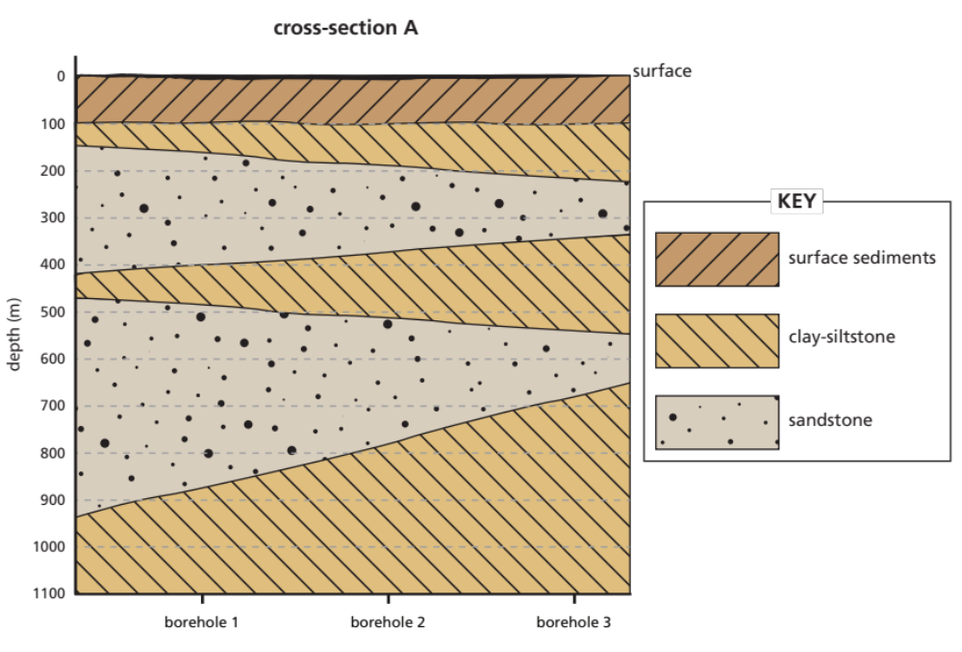
Figure 2: cross-section A
Use data for boreholes 4, 5 and 6 to plot 30 °C, 35 °C, 40 °C and 45 °C isotherms on cross-section B.

BOREHOLE 4 |  |  | BOREHOLE 5 |  |  | BOREHOLE 6
DEPTH (m) | TEMP (°C) |  | DEPTH (m) | TEMP (°C) |  | DEPTH (m) | TEMP (°C)
0 | 15 |  | 0 | 15 |  | 0 | 15
200 | 26 |  | 200 | 26 |  | 200 | 26
400 | 30 |  | 400 | 31 |  | 400 | 30
600 | 37 |  | 600 | 40 |  | 600 | 37
800 | 41 |  | 800 | 43 |  | 800 | 41
1000 | 47 |  | 1000 | 50 |  | 1000 | 47

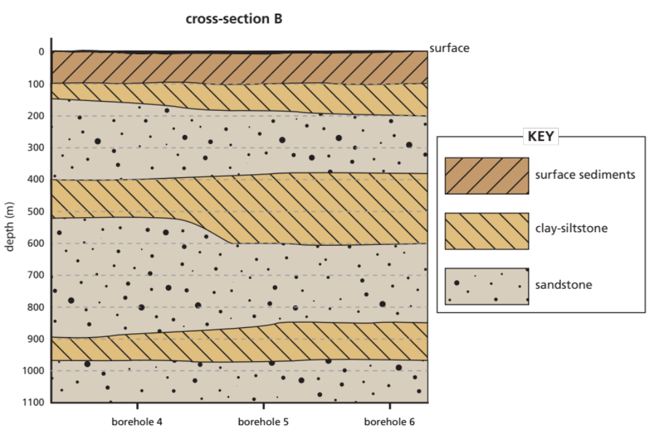
Figure 3: cross-section B
Use data for boreholes 7, 8 and 9 to plot 30 °C, 35 °C, 40 °C and 45 °C isotherms on cross-section C.

BOREHOLE 7 |  |  | BOREHOLE 8 |  |  | BOREHOLE 9
DEPTH (m) | TEMP (°C) |  | DEPTH (m) | TEMP (°C) |  | DEPTH (m) | TEMP (°C)
0 | 15 |  | 0 | 15 |  | 0 | 15
200 | 26 |  | 200 | 26 |  | 200 | 27
400 | 30 |  | 400 | 31 |  | 400 | 32
600 | 37 |  | 600 | 39 |  | 600 | 39
800 | 41 |  | 800 | 43 |  | 800 | 43
1000 | 47 |  | 1000 | 50 |  | 1000 | 51

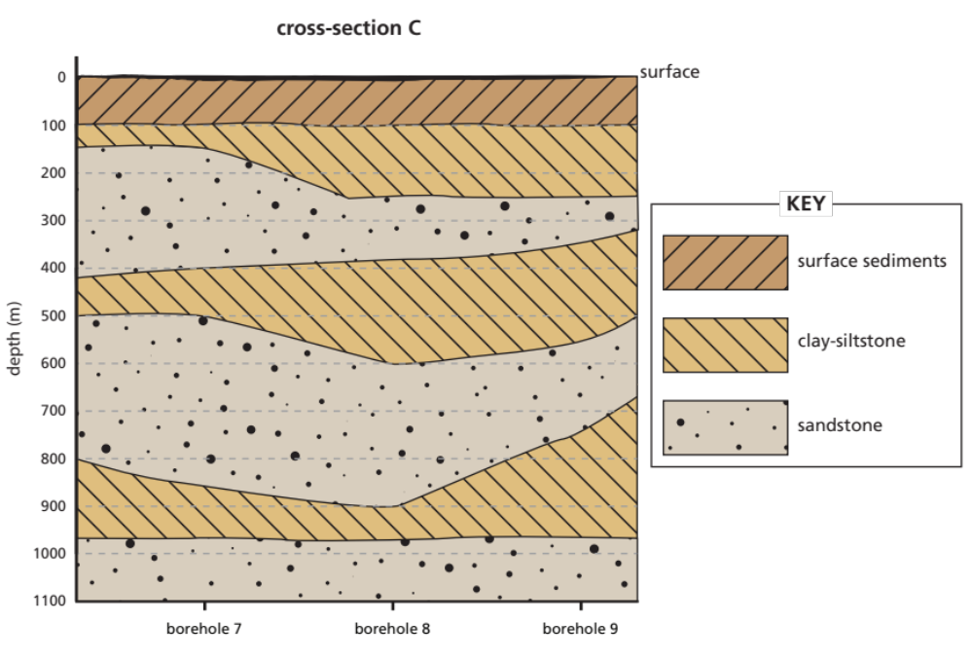
Figure 4: cross-section C

