The US Department of Commerce/National Oceanic & Atmospheric Administration (NOAA) has collected data about sea surface temperatures (SST), over many years, to produce annual maps similar to that shown in Figure 1.
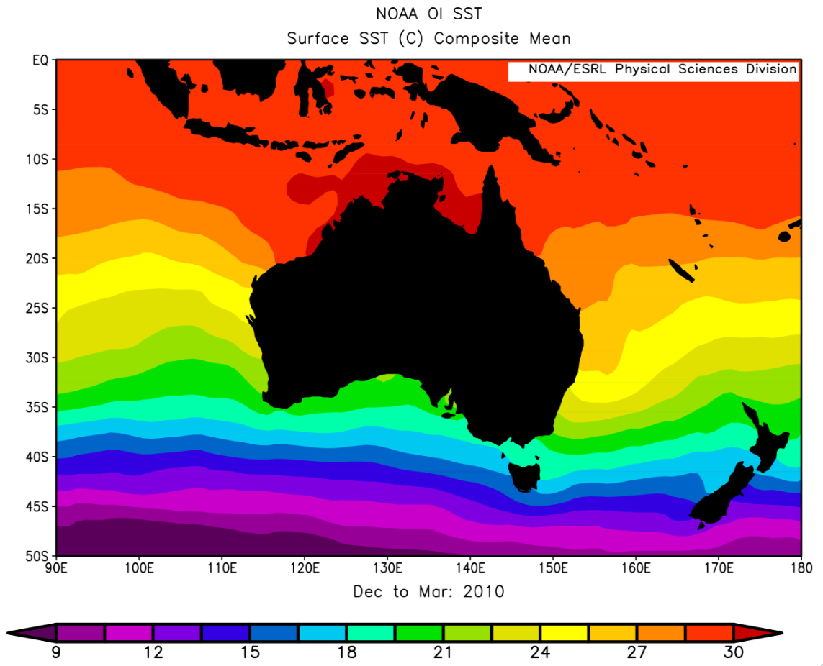
Figure 1: sea surface temperatures in the Australian region (source: NOAA)
January is the middle of the cyclone season in Western Australia, so January maps for 1985–2010 have been used to extract SST data for six WA coastal towns. These data are shown in Table 1.
 | Broome | Port Hedland | Carnarvon | Geraldton | Perth | Albany
1985 | 29 | 29 | 24 | 22 | 19.5 | 19
1987 | 29 | 28.5 | 25 | 22.5 | 19.5 | 19
1990 | 29 | 28 | 26 | 22 | 20.5 | 19
1993 | 29.5 | 28.5 | 26.5 | 22.5 | 20.5 | 19.5
1995 | 29.5 | 28.5 | 26.5 | 22.5 | 20.5 | 19.5
1997 | 29.5 | 29 | 26 | 22.5 | 20 | 19
2000 | 30 | 29 | 26 | 22.5 | 20.5 | 19
2003 | 29.5 | 29.5 | 26 | 22.5 | 21 | 19.5
2005 | 30 | 30 | 24.5 | 23 | 21 | 19.5
2007 | 30.5 | 29.5 | 25 | 23 | 21 | 19.5
2010 | 30.5 | 29 | 26 | 24 | 21.5 | 20
Table 1: mean January sea surface temperatures for six Western Australian coastal towns
- Graph data from Table 1, either on graph paper below or use a spreadsheet. Plot ‘year’ on the x-axis and ‘sea surface temperature’ on the y-axis. Plan to extend the x-axis to the year 2100 and the y-axis to 35 °C in a later activity.

Figure 2: mean January sea surface temperatures for Western Australian towns
Figure 3 shows observed and predicted increases in global mean surface temperatures. To make these predictions scientists divide the Earth into sections and model what will happen to surface temperatures into the future. In some sections surface temperature increases and in others it decreases, but through careful analysis of all models a global-mean surface temperature is calculated.
Two scenarios for projected global mean surface temperature are included in Figure 3: one where carbon dioxide emissions are limited; and one where there is no climate policy.
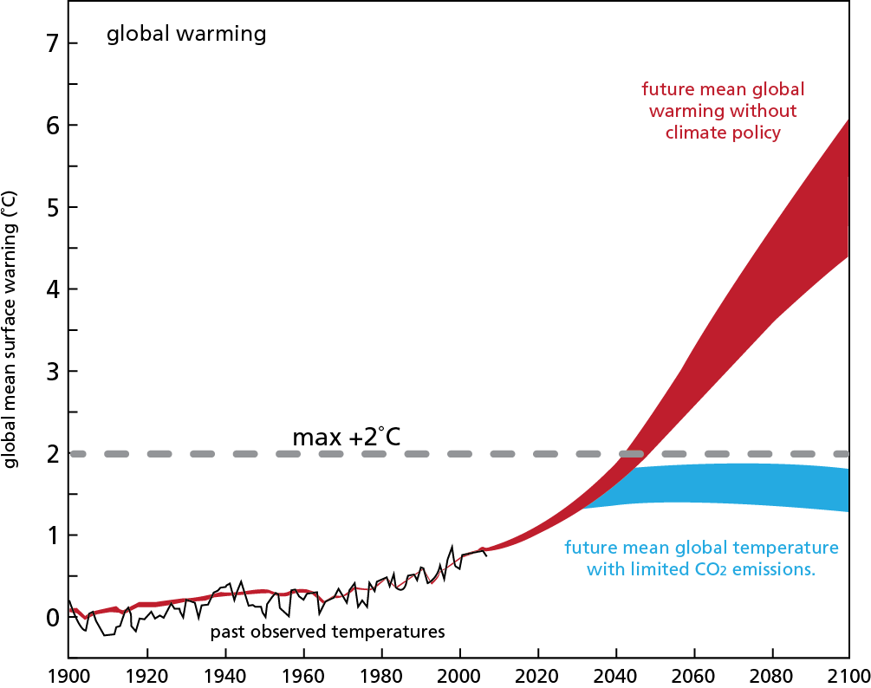
Figure 3: observed and predicted increases in global mean surface temperatures, 1900–2100
(source: The Science of Climate Change: Questions and Answers, Australian Academy of Science, 2010)
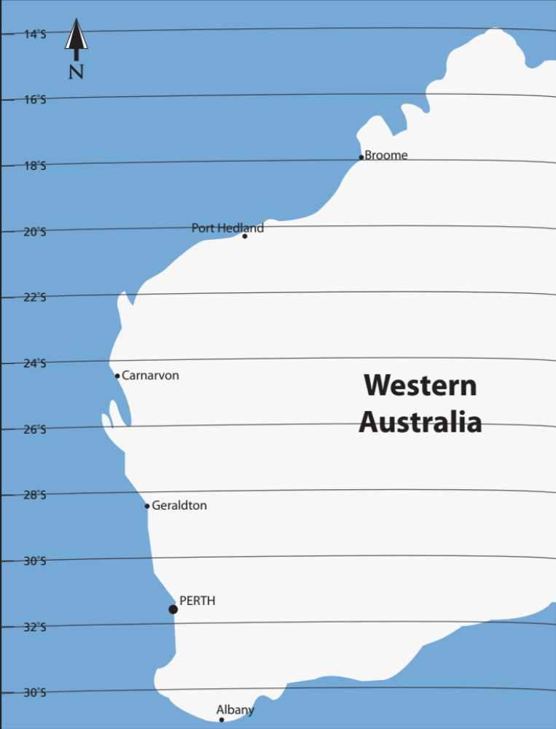
Figure 4: Western Australia

- Do you think there is any relationship between sea surface temperature and global mean surface temperatures? Explain your answer.

- Extract data from Figure 3 to complete Table 2 below. Note there is an upper and lower limit to each scenario.
 | 2020 | 2040 | 2060 | 2080 | 2100
Scenario 1  upper limit | 1.1 °C
Scenario 1
lower limit
Scenario 2
upper limit
Scenario 2
lower limit
Table 2: projected mean global surface warming (°C)
- Use data in Table 2, and the January sea surface temperature graph you produced for Figure 3, to predict how sea surface temperature might change up to 2100. You will need to plot points based on estimated sea surface temperature increases for each town. Discuss with other members of your group which scenario to use, whether to use the upper or lower limit, and the shape of the trend line between 2010 and 2100.
- Draw trend lines for each of the six coastal towns through to 2100.
- As sea surface temperature is an important factor in the formation of tropical cyclones you may now use your own graph to make predictions about future tropical cyclone activity for each of the six towns.
- How would you expect tropical cyclone activity to affect Western Australian towns over the next 90 years? Explain your answer.

- Use your forecast to predict in what year cyclones might form regularly off the coast of Geraldton.

- Projected sea surface temperature data on your graph are based on observations recorded between 1985 and 2010. What do you think about using this range of data to make predictions through to 2100? What changes (if any) in data range would you suggest?

- How did projected global warming data affect your predictions for sea surface temperature and predicted cyclone activity for WA coastal towns?

- Scientists believe a sea surface temperature of at least 26 °C is necessary to support formation of tropical cyclones. What other factors influence formation of tropical cyclones?

- What factor(s) might contribute to differences between your answers to questions 5 and 6 and those of other students?

- The exercise you have undertaken in graphing and extrapolating data is a form of modelling. What is the major limitation of your model in predicting future tropical cyclone activity?

- In reality, meteorologists use a number of models to predict severe weather events such as tropical cyclones. What is an advantage of using multiple models to predict events?

- ‘Hindcasting’ is a tool used by climate modellers. Research hindcasting and describe how it assists in predicting future events?

