The following questions relate to impacts of satellites and associated technologies on everyday life.
- Geostationary satellites remain in position over the same location on Earth at all times. What uses do geostationary satellites have, and how do these impact on everyday life?

- Explain why most satellites are launched in an easterly direction from locations close to the equator.

The Hubble Space Telescope (HST) has provided the best images of the sky ever achieved and has extended our understanding of the Universe. The HST’s orbit is inclined at 28.5°. The following illustrations show the ground track of the HST projected onto a two-dimensional map of Earth.
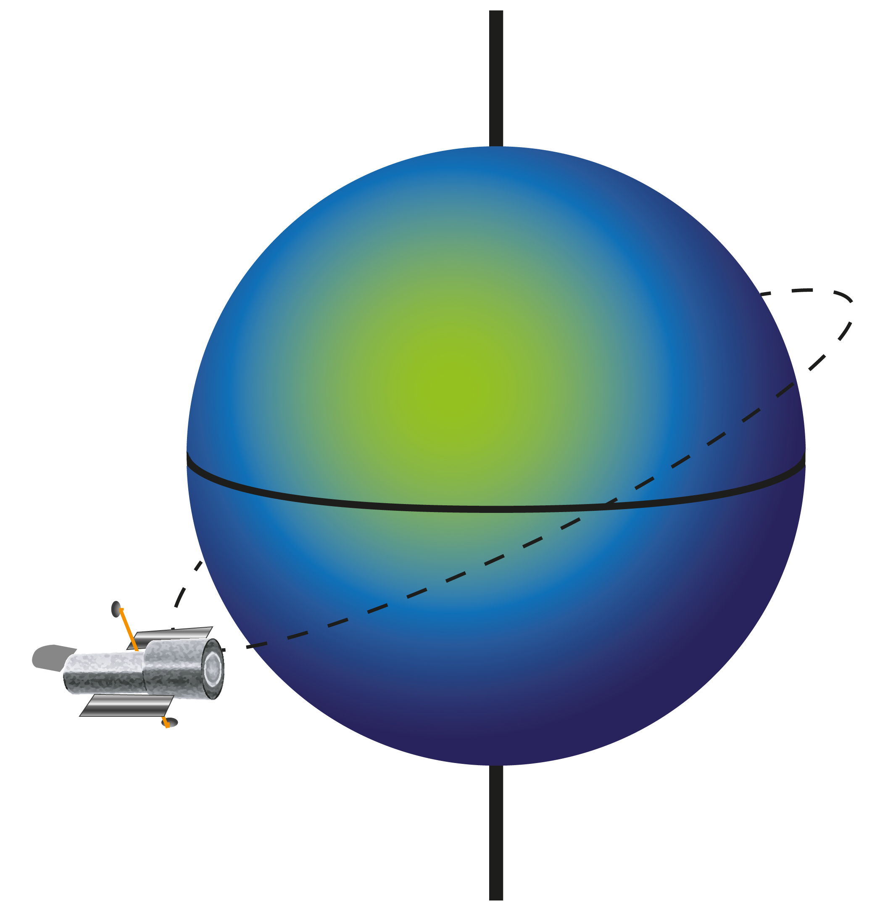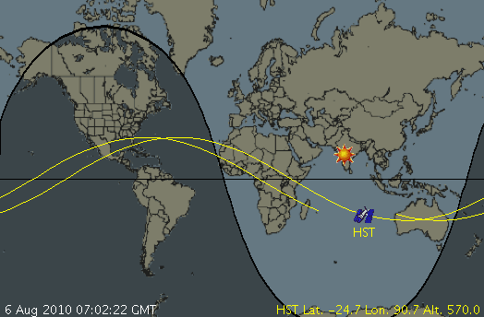
HST orbit inclined at 28.5º to the equator. Ground track of the HST.

- Why does the ground track of HST’s circular orbit appear as a sine wave?

- Why does the position of the sine wave progress across the map each time the HST completes an orbit?

- Describe the orbit of a satellite whose ground track is a straight line along the equator.

- If the orbit of an Earth-monitoring satellite traced out a similar ground track to that of the HST, what kind of information could it be used to gather?

- The Hubble Space Telescope’s altitude of 570 km means that it orbits in the outer limits of Earth’s atmosphere. State one advantage and one disadvantage of having it orbit at that altitude?

- What are the advantages of placing a weather satellite in a polar geosynchronous orbit?

- What kind of instruments would a satellite need to carry to make observations about the weather?

- Complete the following table, stating one benefit of each type of satellite and its associated technologies to everyday life.
purpose of satellite | beneficial impact
telecommunications
weather
Earth observation
(eg monitoring glaciers)
scientific research
global positioning (GPS)
- Many satellites orbiting Earth have a military purpose. State one benefit and one threat to our everyday lives from using satellites for military purposes.

- When satellites lose speed they gradually spiral towards Earth and burn up in the atmosphere. What precautions are taken to ensure that returning debris doesn’t crash into aircraft or major cities?

