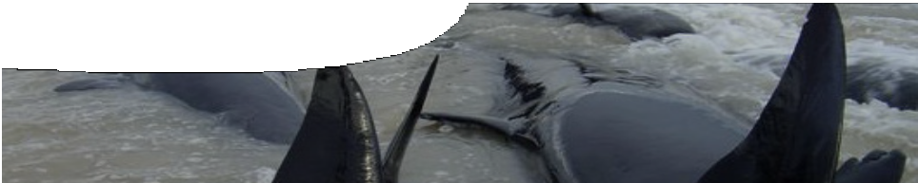
background sheet
Whales and microwaves

Formation of a hypothesis
Dr Ralph James gave up a life as a musician to begin working in the School of Physics at The University of Western Australia (UWA). His early research involved finding ways to stop microwaves from bouncing around inside the equipment of communication systems. For this he used a ‘terminator’, a tube with a ramp of carbon at the end of it. Any microwaves sent into it reflect along the ramp and decrease in intensity (‘attenuate’) to the point where no waves are reflected back to the source.
During his time at UWA Ralph was called away by friends to help a group of beached whales in Augusta. Whilst there he noticed that the beach slope was similar to that of the ramp used in the
terminator. Knowing that whales and dolphins use echolocation to navigate underwater, he wondered whether waves from their signals were attenuated to the point of termination, just like microwaves in his research. If so, whale signals would return no echo and the environment ahead would look like open ocean.

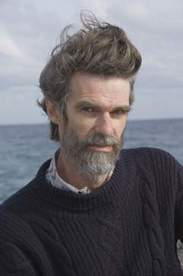

Wave frequencies
dolphin: 1 – 120 kHz
toothed whale: 0.04 – 300 kHz
navy sonar: 1 – 50 kHz
microwaves: 1 – 300 GHz

Current approaches
Dr James and his team are currently undertaking four lines of research.

Investigate the ‘dynamic range’ of species at risk of stranding
This research compares the limits of a whale’s hearing ability with limits of its call strength (i e dynamic range). By investigating this natural range, Ralph and his team can determine how much a signal would have to attenuate before it became inaudible to a whale.
The team has identified frequencies where whales are at risk of not hearing their own echoes. Findings show that high and low frequency signals need only lose a small amount of intensity to fall below whales’ hearing range. Ambient noise, such as falling rain and fast winds, has also been identified as a risk to the effectiveness of whales’ echolocation signals.

Test sonar signals in shallow waters of sloping beaches

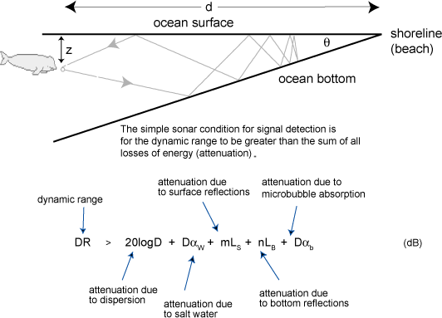

The research team tests beach conditions that cause a signal to attenuate to the point where it can no longer be detected by an animal (according to the team’s findings on the dynamic range). These tests are performed in a lab with simulation tanks and in the field at beaches such as Port Beach near Fremantle, Western Australia.
To date, the team have identified several major factors that influence signal intensity and lead to attenuation. These are:
- natural dispersion of signals as they travel through water;
- attenuation of signals by salt water (which reduces sound intensity 100 times more than fresh water);
- reflections off seafloor and ocean surface, where each reflection causes a reduction in intensity; and
- absorption by microbubbles.

Investigate microbubble interference
Bubbles of air created by impact of rain and surface waves are spread throughout the water column
by tidal and wave motion. Tiny bubbles can each absorb acoustic energy of a specific frequency, depending on their size. A bubble of 65 nanometres will resonate to a sound at 50 kHz near the water surface, but if it is five metres down it resonates at 61 kHz.
By simulating water conditions which contain these microbubbles Ralph’s team has found that a combination of scattering and absorption of a signal’s energy by large numbers of microbubbles can dramatically decrease effectiveness of echolocation over long distances.

Compile a database of whale strandings in Western Australia
Dr James and his team have created a geographical record of whale strandings in Western Australia. All recorded strandings have occurred on beaches that support Dr James’ hypothesis. Many beaches around Dunsborough and Augusta have sloping beaches of between 0.5 and two degrees. Beaches that show these high risk signs are being tagged as ‘whale traps’.
More information on research conducted by Dr James’ research group is available at
http://www.biophysics.uwa.edu.au/Bioacoustics

