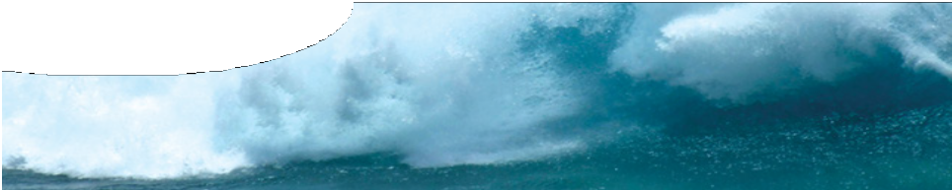
fact sheet
Tsunami!
Waves of destruction

Buildings washed away, cities damaged and lives destroyed. These are just some effects of massive waves that Japanese fishermen originally named ‘harbour waves’, or tsunami. The name arose because fishermen, who had been fishing on a gentle ocean swell, returned home to scenes of great destruction and so assumed that damaging waves had arisen within the harbour. Now we know more about how tsunamis behave we can do more to limit damage they cause.

The 2004 ‘Boxing Day’ or ‘Asian’ tsunami was caused by an enormous
earthquake off the coast of Sumatra in Indonesia where 1600 km of sea floor rose several metres and displaced an estimated 30 km3 of water! (1)
What causes tsunamis?
Most tsunamis are created by dramatic events in the Earth’s crust such as volcanic eruptions, landslides or earthquakes. Sudden movement of the seafloor can displace a huge volume of water and cause rings of waves (a tsunami) to race across the ocean at great speed.

The effect of water depth
A tsunami may have a wavelength of hundreds of kilometres and can travel at up to 900 km h-1
(the speed of a jumbo jet) but its amplitude on the surface of the deep ocean may be less than a metre. The Boxing Day tsunami was the first to be accurately recorded by satellites and scientists estimate that the maximum height of the wave in the deep ocean was a tiny 60 cm (2) . Fishermen in their boats out on the ocean did not even notice the tsunami passing!
However, as a tsunami reaches shallow water it slows down and rises in height to become a
massive, continuous wall of water weighing millions of tonnes and carrying tremendous energy.
This increase in wave height is called the ‘run-up’ and can cause intimidating waves. As the Boxing Day tsunami approached shorelines in Indonesia and Thailand it piled up to create waves estimated to be up to 24 m high. (3)
Tsunami in deep water
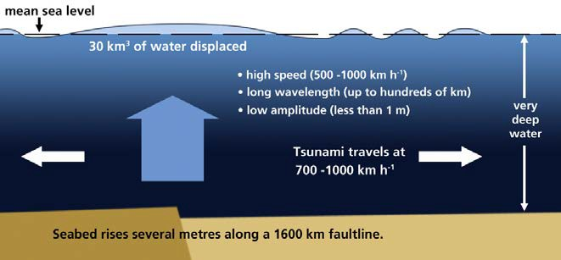
Tsunami in shallow water
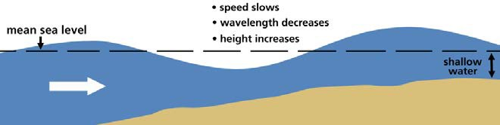

Tsunami strikes coast
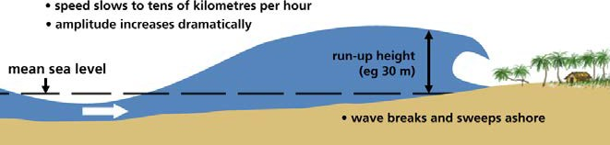

ast0006 | Mechanical waves 4: Tsunami! Waves of destruction (fact sheet) developed for the Department of Education WA
© The University of Western Australia 2008 for conditions of use see spice.wa.edu.au/usage version 1.3 reviewed July 2014 page 1 Licensed for NEALS

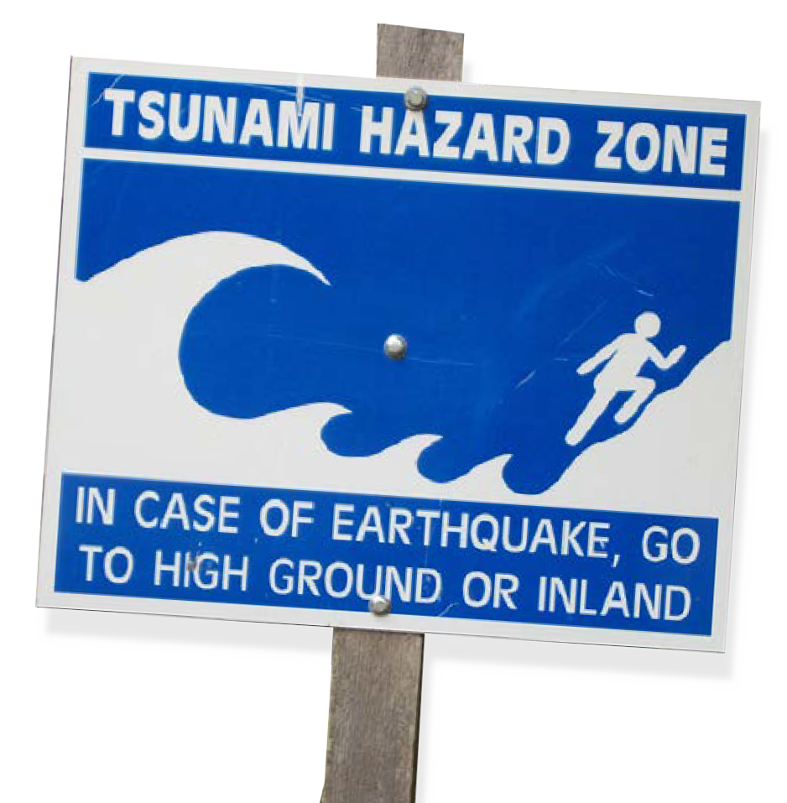
- McKee, M. (2005). Radar satellites capture tsunami wave height. NewScientist.com news service, 6th January 2005. Retrieved 2nd August 2007, from http://www. newscientist.com/article.ns?id= dn6854
- Paulson, T. (2005). New findings super-size our tsunami threat. Seattle Post, February 7th 2005. Retrieved 2nd August 2007, from http://seattlepi.nwsource.com/
local/211012_tsunamiscience07.html
- Gibbons, H. & Gelfenbaum,G. (2005). Astonishing Wave Heights Among the Findings of an International Tsunami Survey Team on Sumatra. U.S. Geological Survey. Retrieved 14th June 2007, from http://soundwaves.usgs.gov/2005/03/
- British Geological Survey. (2006). The 2004 Sumatra–Andaman Earthquake and Tsunami, one year on. Retrieved 14th June 2007, from http://www.bgs.ac.uk/esissues/ sumatraupdate.html
- Cook-Anderson, G. & Beasley, D. (2005). NASA Details Earthquake Effects on the Earth. NASA. Retrieved 14th June 2007, from
http://www.nasa.gov/home/hqnews/2005/ jan/HQ_05011_earthquake.html
ast0006 | Mechanical waves 4: Tsunami! Waves of destruction (fact sheet)
© The University of Western Australia 2008
developed for the Department of Education WA for conditions of use see spice.wa.edu.au/usage
version 1.3 reviewed July 2014 page 2
Facts and figures about the Boxing Day tsunami
- More than 200 000 people were killed, making it the most destructive tsunami in recorded history.
- Seismographs were shaken like never before on the day of the disaster. The reading of 9.3 on the Richter scale
is the second biggest ever recorded.
- The total amount of energy released from the quake was equivalent to 23 000 atomic bombs. (4)
- This earthquake was so powerful it also affected the Earth’s rotation. The change meant that Boxing Day 2004 was 2.68 µs shorter. (5)
fact sheet
Tsunami! Waves of destruction
The Boxing Day disaster
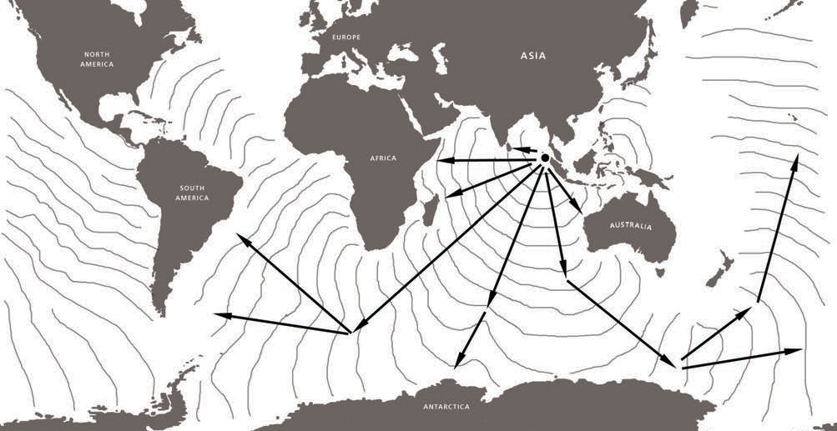
The Boxing Day tsunami spread rapidly across the Indian Ocean to Thailand, India, Sri Lanka, Africa and across the southern Atlantic to Brazil. It struck the shores of Western Australia, the southern coast of Australia and went on to New Zealand. Waves a metre high even reached the shores of Mexico – truly a global event. The diagram below has been prepared from satellite photos of the waves racing around the globe.

Tsunami warning signs
- The ocean seems to retreat like a rapid low tide: as far as 2.5 km in some places.
- A loud roaring sound may accompany the arrival of a wave.
- The first wave may not be the largest.
- You may feel the earthquake that has caused the wave before the tsunami itself arrives because earthquake waves can travel through the Earth at up to 28 800 km h-1 (that’s as fast as a space shuttle!).

