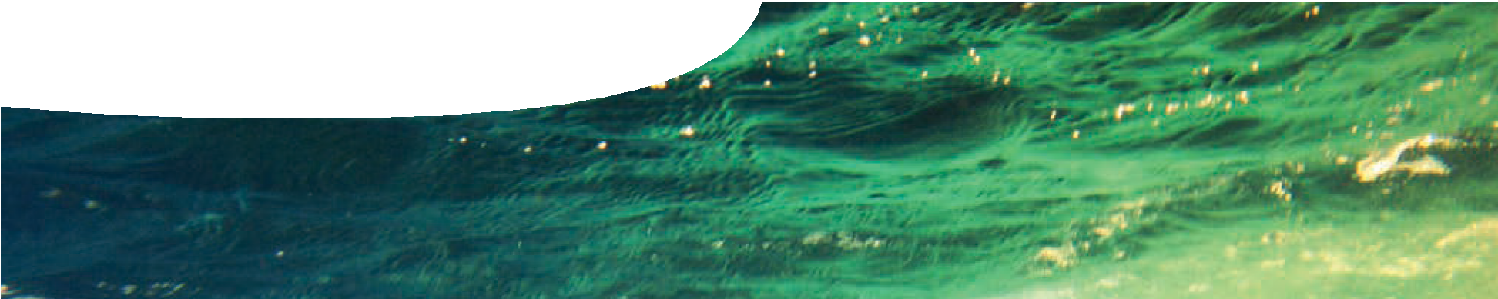
background sheet
Water in Western Australia
Hani Aimir http://www.flickr.com/photos/haniamir/
Current sources of water in WA
Western Australia’s Integrated Water Supply Scheme delivers 279 billion litres of water to 1.5 million people in Perth, the Goldfields and parts of the South West. This water comes from three main sources: groundwater, surface water and desalination. Water collected from these sources is treated, to be safe for consumption (potable water), and piped to domestic and commercial customers. Wastewater is also collected, piped to treatment plants, and returned to the water cycle.
Western Australian water supplies are under mounting pressure from increased demand due to population growth and changing climate. This has led to use of new water sources, including desalination of ocean water and recycling of wastewater. Scientists continue to investigate alternate ways of supplying water to the population.

Surface water

What is surface water?
Surface water refers to any water found on Earth’s surface, including rivers, lakes, dams and oceans. Traditionally, Perth has relied on reservoirs for drinking water. Water that runs into a reservoir is collected from a much larger area, known as a catchment area.

How is surface water being used in Western Australia?
The first dam built in Western Australia was Victoria Dam (on the Darling Scarp, near Lesmurdie), in 1891. It provided clean water to early settlers. From 1895 to 1903, Mundaring Weir and a 557 km steel pipeline was built in order to pump water to Kalgoorlie. This pipeline still provides water to the Goldfields. Since then, many other dams have been built to service the Perth metro area. The largest include: Canning (near Roleystone), Wungong (near Armadale), Stirling (near Harvey), North Dandelup, South Dandelup and Serpentine.

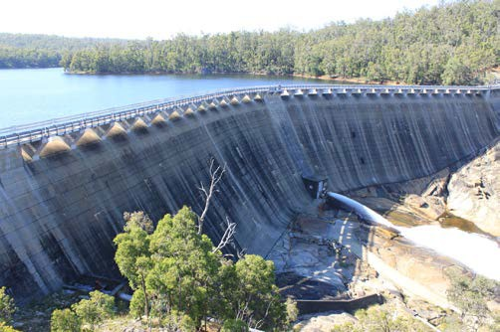

Dams are found across other regions of Western Australia: including Goldfields, Mid West, North West, Great Southern and South West.

Concerns about surface water
Since the 1960s concerns have been raised about efficiency of dams. Climate change has led to declining rainfall and reduced stream flows in the South West region, including Perth. Evaporation of water from a dam’s surface also reduces productivity of dams.

The case against dams
Environmental concerns arising from use of dams:
- environmental impacts during construction, including flooding of ecosystems;
- disruption to river systems below and above constructed dams;
- risk of lowering water tables;
- increased risk of floods;
- accumulation of sediments, including toxic materials; and
- organic materials trapped at the bottom of dams may form methane, contributing to global warming.
Human health risks of dams:
- large bodies of still water can lead to high numbers of mosquitoes;
- leisure activities by humans can contaminate dam water;
- presence of wildlife can contaminate dam water; and
- catchment areas are large, exposing them to many contaminants.
Since 2002 no new dams have been built in Western Australia, although current reservoirs are still used for water storage. Much of Western Australia’s water now comes from alternate sources: desalination plants or groundwater.

Groundwater – underground aquifers, wells and bores

What is groundwater?
Groundwater is found beneath Earth’s surface in cracks and spaces between rock particles.
An aquifer is formed when permeable rocks become saturated with water. The uppermost surface of an aquifer is known as the water table. Aquifers occur at different depths below the surface. Shallow aquifers are more accessible for groundwater collection, and also recharge (refill) more quickly as surface water moves downwards.
Aquifers can be confined or unconfined:
  - An unconfined aquifer is exposed to the surface or has porous rocks above it.
  - A confined aquifer has a layer of impervious rock above it, trapping water.
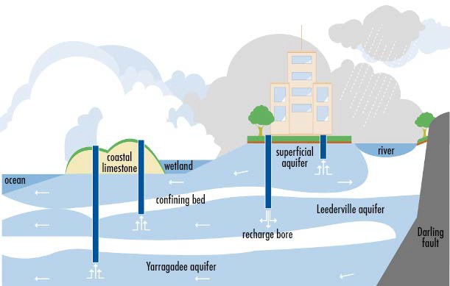
Wells or bores are excavated to access groundwater. Confined aquifers are usually under pressure because the water is trapped between rocks. When a bore is sunk, water may rise above the surface of the aquifer, but generally pumping is required.

adapted from the Water Corporation Perth Groundwater System diagram

How is groundwater being used in Western Australia?
In Perth there are three main layers/aquifers:
  - superficial aquifer — an unconfined aquifer close to the surface and usually seen as seasonal lakes and wetlands
  - Leederville aquifer — a confined aquifer, hundreds of metres thick/deep, that reaches the surface in some places
  - Yarragadee aquifer — a confined aquifer, the oldest, largest and most dependable water supply, more than 3 km thick

Concerns about groundwater
Environmental concerns arising from use of aquifers:
- Aquifers can dry out if too much water is removed as it takes time to recharge from rainwater, which filters into them slowly.
In the Perth region less water is taken from the superficial aquifer in inland metro areas, to prevent wetlands drying out, and more water is drawn closer to the ocean. This raises a new issue though, as water close to the ocean has higher salinity levels.
Human health risks of aquifers:
- Superficial aquifers may be affected by leaking septic tanks or storage tanks.
- Groundwater may contain high levels of salinity and dissolved contaminants from rocks and minerals, such as iron or calcium carbonate which may require more treatment.

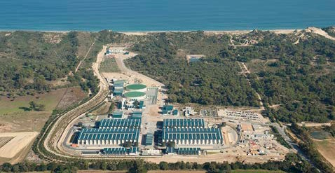Desalination

What is desalination?
Ninety six percent of Earth’s water is found in oceans, but it’s not very useful for human consumption unless treated. The desalination process removes salt from seawater or brackish water, to make it potable. Importantly, in our changing climate, this method of accessing water is not dependent on rainfall.
Seawater contains 34 000 – 38 000 mg L-1 of dissolved solids, most of which need to be removed before it’s classed as potable. Water regulations state dissolved solids must be less than 500 mg L-1 for human consumption.
Desalination plants filter seawater, to remove larger particles, before being treated by reverse osmosis. In this process, seawater is pumped through a membrane at high pressure, impurities are left behind, and only fresh water passes through the membrane. This water is treated with lime, chlorine and fluoride before it’s ready to drink.

How is desalination being used in Western Australia?
Currently, two desalination plants operate in Western Australia, providing almost half of Perth’s water supply. In future this is likely to increase. Perth Seawater Desalination Plant in Kwinana opened in 2006 and Southern Seawater Desalination Plant in Binningup opened in 2012.
Concerns about desalination include:
- Reverse osmosis requires large amounts of energy, increasing greenhouse gas emissions.
- Reverse osmosis creates a concentrated saline solution which can kill marine life, unless disposed of carefully. The Water Corporation has strict regulations to control salinity levels in brine released to the ocean.
- Desalination is expensive.
Western Australia is addressing environmental concerns by using renewable energy sources such as solar energy and wind farms to offset electricity required for reverse osmosis. However, this increases water costs even further because these methods of producing electricity are expensive to
set up.

Possible water sources for the future in WA

Accessing water from the Fitzroy River

How could this work?
Whilst rainfall in southern Western Australia is declining, the north has high rainfall, largely due to tropical storms.
In 2006 a study investigated the idea of transporting water from the state’s north to the south. This water was to come from Lake Argyle to supply Perth.
Four proposals were examined:
- building a 1900 km pipeline;
- constructing a 3700 km concrete canal;
- transporting water in ocean tankers; and
- towing water in large bags behind tug boats.
Similar ideas have been used successfully in Greece and California.

What are the problems?
- All four ideas were costed and found to be prohibitively expensive to set up.
- Water travelling in a canal would have a high rate of evaporation.
- Parts of the region, through which water would be transported, are prone to cyclones which may damage a pipe or canal.
- No bag suitable for towing large volumes of water long distances has been constructed, although scientists are working on the idea.
- Land would need to be acquired for a pipeline or canal.
- Indigenous communities in the Kimberley would be affected and they don’t support the ideas.
- Ocean transport would produce large amounts of greenhouse gas emissions, three times more than land options.

Icebergs

How could this work?
Seventy percent of Earth’s fresh water is ice in Antarctica. Every year about 1000 km3 of this ice breaks off as icebergs, which slowly melt into the ocean. Since the 1970s, scientists have examined possibilities for towing icebergs to places where fresh drinking water is needed, including Australia.
French engineer, Georges Mougin, developed computer simulations showing how it might be possible to wrap an iceberg in a protective ‘skirt’ and tow it slowly across the ocean.

What are the problems?
- It’s expensive to set up.
- Icebergs would melt during transportation and may be damaged by ocean currents.
- Icebergs are large and would need to be docked offshore.
- Transporting useful portions from a docked iceberg would be difficult.

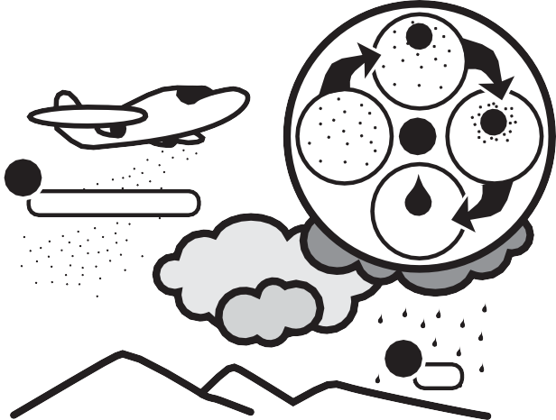Cloud seeding

How could this work?
Traditionally, Native Americans performed rain dances in times of drought. Whilst it sounds far-fetched, this practice may have helped produce rain. During the rain dance particles of dust, disturbed by stamping, rose into the air. If they travelled far enough they may have acted as a nucleus, for water in the atmosphere to adhere to, causing rain.
Cloud seeding using chemicals such as silver iodide or dry ice works on the same principle. Chemicals are fired from the ground or dispersed from aeroplanes near clouds. Each tiny particle acts as a nucleus to which droplets of water adhere. Depending on temperature, chemical and cloud type, either rain droplets or ice crystals may form.

1
silver iodide or dry ice

gaseous H2O

introduction of chemical

2

liquid H2O

3
rain

H2O
condenses

Cloud seeding is generally used to increase rainfall in regions that already have some precipitation. It’s currently used
in the Snowy Mountains, New South Wales, to increase snowfall for tourism, and in Tasmania to increase rainfall for hydropower generation.

What are the problems?
Cloud seeding only works under specific conditions, for instance cloud tops must be in the temperature range of -10˚C to -12˚C. Cloud seeding also requires some
precipitation and isn’t suitable for arid regions, such as the interior of Western Australia.

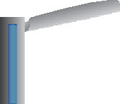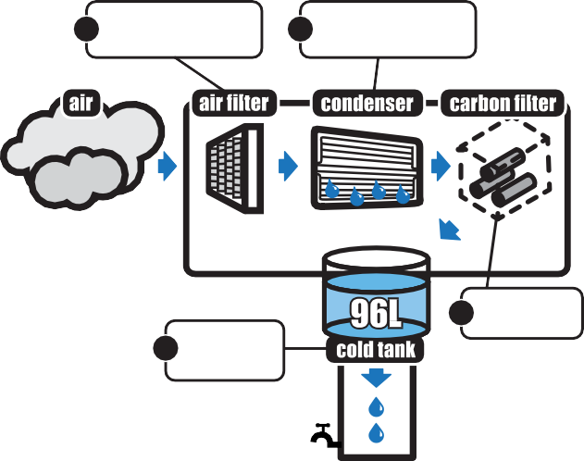Reducing water use
Recycling
Why recycle water?
All methods of obtaining water have accompanying concerns. This makes recycling water extremely important.
Recycled wastewater can be treated and re-used for irrigation, flushing toilets, industrial processes or replenishing groundwater.
How is recycling being used in Western Australia?
Currently in Western Australia 13.6% of treated wastewater is recycled. This figure has increased from 10% in 2002 and the goal is to reach 30% by 2030. In future more treated wastewater may be recycled into rivers or wetlands. Houses may also be fitted with an extra water pipe to supply treated wastewater for uses such as toilets and irrigation. At this stage treated wastewater is not suitable for drinking.
What are the problems?
This new technology is expensive. Wind turbines cost about
$660 000 each, require winds of at least 24 km h-1, and rely on humid conditions, which makes them unsuitable in dry regions.
Water billboards are cheaper, $1200 per board, but are powered by electricity, an expensive way to make water. Potentially cost could be offset by selling advertising space on large billboards.
One turbine is able to produce 1000 L of water per day, enough drinking water for 3000 people.
water exit goes into base of turbine for basic treatment and storage
Cold tank
4 stores water
ready for use.

inlet air is forced into the turbine
Carbon filter
3 purifies water.
humidity condenser extracts water vapour from air and turns it into liquid water
cooling compressor removes heat by compressing air
blades spin in the wind to produce electricity
Five condensers extract
2 and condense water vapour from air.
Air filter draws in air through a filter in front of board.
1
A similar method of extracting moisture from air is being trialled in Peru. Using this method almost 100 L of water can be produced in a day.
Extracting water from air
How could this work?
A large amount of water is stored in the atmosphere as water vapour, which we feel as humidity, but is generally inaccessible for use as drinking water. Scientists have explored ways to tap into this resource, which could be particularly useful in hot or remote areas of the world where other water sources aren’t available.
Wind turbines that condense atmospheric water vapour into liquid are currently being trialled in Abu Dhabi.

Why reduce water use?
The most sustainable plan for long-term water supply is to use less water. This is the most cost effective and environmentally friendly solution to our water problem.

How is water reduction being used in Western Australia?
Perth is one of the cities in Australia with the highest water use per capita; the average person uses about 130 000 L of water a year. The goal is to reduce Perth’s water use 15% by 2030. This means making people aware of how much water they currently use, educating them about how they could use less, and correcting problems such as leaks. Devices such as smart meters, as well as community, business and school education programs are assisting achievement of this goal.

Development of smart meters
From 2010 to 2012 Water Corporation ran a smart meter trial in Kalgoorlie-Boulder by installing them in all properties serviced by the town water supply. Smart meters can be read daily through a wireless collection system and give customers as well as Water Corporation a precise indication of when and where water is being used. This can assist customers to reduce their water use and detect leaks early. Water supply fell by 837 500 kilolitres or 10% during the trial period.

