worksheet
Treating melanoma
Personalised medicine is a new approach where medical decisions are guided or based on a person’s genetic profile. This new approach to medicine means the right patient gets the right drugs at the right time!
In this activity you will meet Dr Yin, a specialist skin cancer doctor, and several patients who’ve attended Dr Yin’s clinic. As Dr Yin makes decisions about procedures and treatment options for patients you will analyse these decisions and comment on why they have been made.

Background
Dr Yin has recently seen seven patients in her skin clinic who have suspicious-looking moles on their skin. Each patient has had the mole excised (cut out) from his or her skin and samples tested for melanoma.
The tests show four patients don’t have melanoma. They have their skin carefully checked and don’t require further treatment. All resolve to take care of their skin and check it regularly.
However the other three patients (Tim, Sally and Rob) are confirmed to have melanoma. They make further appointments with Dr Yin, who orders a PET scan for each of them.

PET scan
PET (positron emission tomography) scans are whole body scans that use a radioactive substance as a tracer to look for disease in the body. PET scans measure the level of metabolism or cellular activity in an organ.
The injected radioactive substance, usually radioactive glucose, gathers in areas of the body where there’s high metabolic activity, such as the brain, heart, bladder, kidneys and fast-growing cancer cells. In the PET image, these cells appear darker than normal cells.

Q1. Why do you think Dr Yin orders a PET scan for each patient?

.............................................................................................................................................................................

.............................................................................................................................................................................

.............................................................................................................................................................................
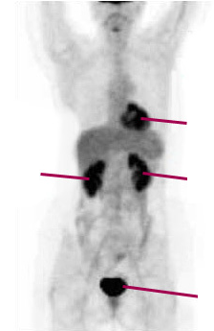
PET scan results

normal comparison | Tim | Sally | Rob
normal heart  normal normal  right left  kidney kidney  normal bladder | 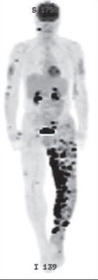 | 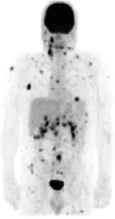 | 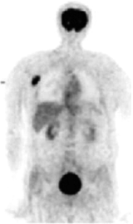

Q2. What do you think PET results show for each patient?

Tim: ......................................................................................................................................................................

.............................................................................................................................................................................

Mel: .....................................................................................................................................................................

.............................................................................................................................................................................

Rob: .....................................................................................................................................................................

.............................................................................................................................................................................

The best treatment option for cancer remains excising or cutting out the tumour. If cancer has spread to other parts of the body (metastasised), surgery may not be possible. Dr Yin decides to operate on Rob.

Q3. Why has Dr Yin decided to operate on Rob and not the other patients?

.............................................................................................................................................................................

.............................................................................................................................................................................

.............................................................................................................................................................................

Pedigree
Different patients have different family histories with regard to cancer. Dr Yin discusses with her patients their family history of skin cancer.
A pedigree of family relationships is a diagram in which symbols represent people and lines represent relationships. They are often used to determine if a particular disease is inherited, as well as the type of inheritance. Pedigrees for the three patients and an additional patient (Sue) are shown below.
Key:

= male = female
– = mating | = offspring
= male with melanoma = female with melanoma
* = patient

normal (no melanoma) | Tim |  | Sally
(i) | (i) |  | (i)
(ii) | (ii) |  | (ii)
(iii)  (iv) | (iii)  (iv) * |  | (iii)  (iv) *
Rob |  | Sue
(i) |  | (i)
(ii) |  | (ii)
(iii)  (iv) * |  | (iii)  (iv) *

Q4. Melanoma, like all cancers, can be an acquired or inherited disease. Based on the above pedigrees, which patients are most likely to have inherited (familial) melanoma? Explain your answer.

.............................................................................................................................................................................

.............................................................................................................................................................................

.............................................................................................................................................................................

.............................................................................................................................................................................

Q5. How is familial melanoma most likely inherited: autosomal recessive, autosomal dominant or sex-linked?

.............................................................................................................................................................................

.............................................................................................................................................................................

.............................................................................................................................................................................

Q6. Why might Sally have melanoma in her family?

.............................................................................................................................................................................

.............................................................................................................................................................................

.............................................................................................................................................................................

Q7. Explain what information Dr Yin has discovered so far about each of her patients.

Tim: .....................................................................................................................................................................

.............................................................................................................................................................................

.............................................................................................................................................................................

Sally: ....................................................................................................................................................................

.............................................................................................................................................................................

.............................................................................................................................................................................

Rob: .....................................................................................................................................................................

.............................................................................................................................................................................

.............................................................................................................................................................................

Rob has successful surgery to remove his melanoma tumour. At this stage, Dr Yin isn’t going to continue with more treatment, apart from regular surveillance and monitoring.
However, Tim and Sally need help. To work out what type of treatment will be most beneficial, Dr Yin needs the genetic profile of each patient’s melanoma tumour.
To determine this, Dr Taylor, a medical scientist, carries out a PCR and visualises the PCR products on a gel.

PCR and gel electrophoresis
Dr Taylor extracts DNA from each patient’s melanoma sample, as well as a control sample from each patient’s normal skin cells. Then he runs PCR protocols designed to amplify fragments of DNA where suspect mutations might be found.
Several genes are often mutated in melanoma. Dr Taylor is looking at three specific genes: BRAF, KIT and NRAS. He designs three separate PCR protocols to amplify fragments of the three separate genes.
Following PCR, fragments are visualised via gel electrophoresis. Gels show PCR products from normal and melanoma cells, for three separate PCR reactions, plus a DNA ladder.

Q8. What is the purpose of performing PCR?

.............................................................................................................................................................................

.............................................................................................................................................................................

Q9. What is the purpose of the gel electrophoresis?

.............................................................................................................................................................................

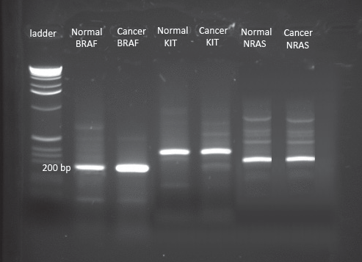
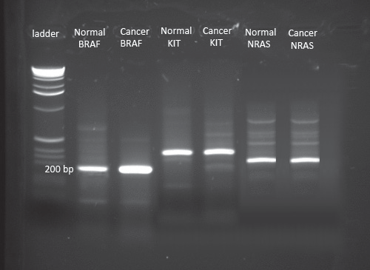
.............................................................................................................................................................................

Tim | Sally
400 bp | 400 bp

Q10. Approximately how big, in base pairs (bp), is the PCR product for each fragment?

BRAF normal:............................................................ BRAF cancer: .................................................................

KIT normal: ............................................................... KIT cancer: .....................................................................

NRAS normal: ........................................................... NRAS normal: ................................................................

Q11. Gel electrophoresis shows that PCR has produced fragments that are all roughly the same size.
Why does this happen?

.............................................................................................................................................................................

.............................................................................................................................................................................

.............................................................................................................................................................................

.............................................................................................................................................................................

Genetic sequencing
To find out if each patient’s melanoma has a specific genetic mutation, Dr Taylor sends the PCR products to a colleague for sequencing. Some melanomas have mutations which result in changes to one or more nucleotides.
Sequencing reveals the order of nucleotides in each DNA fragment. Each of the four nucleotides in DNA is labelled with a different fluorescent dye, which the sequencer visualises. As a result, each nucleotide appears as a different colour peak in the computer readout.
Some PCR fragments are found to have a mutation. They’re shown below.

Q12. For each patient, complete the EXPLANATION row in the table below, using sequence data and codon table supplied. The first row provides an example.

Codon chart
second position

first positi
 | T | C | A | G
 | phenylalanine PHE | serine SER | tyrosine TYR | cysteine CYS | T
T | phenylalanine PHE | serine SER | tyrosine TYR | cysteine CYS | C
 | leucine LEU | serine SER | STOP | STOP | A
 | leucine LEU | serine SER | STOP | tryptophan TRP | G
 | leucine LEU | proline PRO | histidine HIS | arginine ARG | T
C | leucine LEU | proline PRO | histidine HIS | arginine ARG | C
 | leucine LEU | proline PRO | glutamine GLN | arginine ARG | A
on | leucine LEU | proline PRO | glutamine GLN | arginine ARG | G p
 | isoleucine ILE | threonine THR | asparagine ASN | serine SER | T
A | isoleucine ILE | threonine THR | asparagine ASN | serine SER | C
 | isoleucine ILE | threonine THR | lysine LYS | arginine ARG | A
 | methionine MET | threonine THR | lysine LYS | arginine ARG | G
 | valine VAL | alanine ALA | aspartic acid ASP | glycine GLY | T
G | valine VAL | alanine ALA | aspartic acid ASP | glycine GLY | C
 | valine VAL | alanine ALA | glutamic acid GLU | glycine GLY | A
 | valine VAL | alanine ALA | glutamic acid GLU | glycine GLY | G

(5’)

Codon charts usually relate to mRNA where thymine (T) is replaced by uracil (U).
third osition (3’)

 | normal sequence |  | mutated sequence |  | patient X |  | patient Y
example mutation |  | G A T G A T G A T |  | G A T G A T C A T |  | G A T G A T C A T |  | G A T G A T G A T
 | name of gene mutation: |  |  | M531
 | nucleotide change: |  |  | ATG ATC
explanation | amino acid change: |  |  | methionine to isoleucine
 | patient X: |  |  | has the mutation
 | patient Y: |  |  | doesn’t have the mutation

A T C
 | normal sequence | mutated sequence |  |  |  | Tim |  |  |  |  |  | Sally
BRAF | A G T G A A A T C | A G A G A A A T C | A | G | A | G A | A | A T C | A | G | T | G A A
explanation | name of BRAF gene mutation: V600E  nucleotide change: .......................................................................  amino acid change: .......................................................................  Does Tim have the mutation? .......................................................................  Does Sally have the mutation? .......................................................................
 | normal sequence | mutated sequence |  |  |  | Tim |  |  |  |  |  | Sally
KIT | A A C T T C C T T | A A C C T C C T T | A | A | C | T T | C | C T T | A | A | C | C T C
explanation | name of KIT gene mutation: L576P  nucleotide change: .......................................................................  amino acid change: .......................................................................  Does Tim have the mutation? .......................................................................  Does Sally have the mutation? .......................................................................
 | normal sequence | mutated sequence |  |  |  | Tim |  |  |  |  |  | Sally
NRAS | G G A C A A G A A | G G A C G A G A A | G | G | A | C A | A | G A A | G | G | A | C A A
explanation | name of NRAS gene mutation: Q61R.  nucleotide change: .......................................................................  amino acid change: .......................................................................  Does Tim have the mutation? .......................................................................  Does Sally have the mutation? .......................................................................

C T T

G A A

Q13. Explain why sequence data is useful to Dr Yin.

.............................................................................................................................................................................

.............................................................................................................................................................................

.............................................................................................................................................................................

.............................................................................................................................................................................

From sequence data, Dr Yin now knows Tim’s melanoma has a key mutation different from the key mutation in Sally’s tumour.
Tim has a mutation known as V600E in the BRAF protein. This means in position 600 of the protein there’s a mutation that changes the amino acid valine (V) to glutamic acid (E). The V600E mutation is the most common mutation found in melanoma.

Microarray
Dr Yin conducts another test: a microarray. Microarrays assess gene expression by measuring the amount of mRNA in a cell. Dr Yin is interested in expression of some important genes, before she decides on each patient’s treatment.
As RNA is unstable it’s first converted into cDNA (complementary DNA) and tagged with a fluorescent marker: red for cancer cells and green for normal cells. In the microarray below, if a gene is expressed:
- only in a cancer cell, there’s a red signal (R);
- only in a normal cell it’s green (G);
- in both cancer and normal cells it’s yellow (Y); and
- if a gene is not expressed in either cancer or normal cell it’s black (B). The column headed ‘normal’ shows gene expression in normal skin cells.

Q14. Complete the interpretation column in the table below, which shows gene information from the microarray. The first row has been done for you.

 | Tim | Sally | normal | interpretation
gene 1  cell motility | R | R | B | only expressed in melanoma cells
gene 2 DNA repair | G | G | G
gene 3 respiration | Y | Y | G
gene 4 angiogenesis | R | R | B
gene 5  haemoglobin production | B | B | B
gene 6  cell adhesion | G | G | G
gene 7 mitosis | Y | Y | G
gene 8  regulates cell cycle | G | G | G

Q15. Which genes may be of interest to Dr Yin? Why?

.............................................................................................................................................................................

.............................................................................................................................................................................

.............................................................................................................................................................................

.............................................................................................................................................................................

Q16. Why is gene 5 (haemoglobin production) not expressed in any samples?

.............................................................................................................................................................................

.............................................................................................................................................................................

Q17. Outline any difference between data gained from the microarray compared with data from sequencing.

.............................................................................................................................................................................

.............................................................................................................................................................................

.............................................................................................................................................................................

.............................................................................................................................................................................

Treatment options
Normal BRAF is a protein that’s part of a cell-signalling pathway involved in cell division. Mutated BRAF protein is continually active, triggering the cell-signalling cascade and moving cell growth into overdrive. The diagrams below show the cell-signalling pathway.
Patients who have the BRAF mutation V600E, are eligible to try treatment with a drug that targets mutant BRAF. This drug, vemurafenib, is an inhibitor that blocks action of the mutated BRAF protein. It doesn’t block action of normal BRAF protein.

Cell-signalling pathway
The role of BRAF
growth
factor
cell membrane
RAS
BRAF plays a role in the rate of cell growth and division.
BRAF
Normally BRAF requires a signal from
MEK the RAS protein to
become active.
ERK

normal cell growth
BRAF then signals its neighbouring
protein MEK, resulting in cell growth.
nucleus
Cell-signalling pathway
The role of BRAF inhibitor

growth factor
cell membrane
RAS

BRAF VEM
Vemurafenib (VEM) blocks the action of the mutated BRAF
protein.
Blocking this protein stops the cell-signalling cascade and halts cell growth or causes the death of cancer cells.

Dr Yin decides to put Tim on vemurafenib.
Following treatment with vemurafenib for 15 days Tim undergoes another PET scan. The results are below.

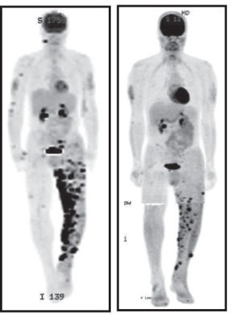
Q17. Dr Yin is pleased with Tim’s progress. So is Tim!
Explain why Tim has a much better PET scan after 15 days of treatment.

.....................................................................................................

.....................................................................................................

.....................................................................................................

Q18. Why isn’t Sally eligible to receive vemurafenib treatment?
Explain your answer.

.....................................................................................................

.....................................................................................................

.....................................................................................................

before treatment after treatment

Sally has a different mutation from Tim’s. Her mutation’s in the KIT gene. She goes into a clinical trial using a KIT- protein inhibitor drug. Luckily, she’s doing well.
Vemurafenib treatment is successful for Tim: there’s 70% tumour regression following treatment.

Consider the microarray that profiled gene expression in normal and cancer cells before treatment.

Q19. What do you think might happen to the expression pattern of gene 1 (cell motility) after vemurafenib treatment?

.............................................................................................................................................................................

.............................................................................................................................................................................

Unfortunately, while melanoma progression slows when using vemurafenib, for most people disease regression only lasts for 5 – 6 months. However, when Tim starts to relapse, Dr Yin places him into a clinical trial that combines two inhibitor drugs.
Cell-signalling pathway
The role of MEK inhibitor

growth factor
cell membrane
RAS

BRAF VEM
Vemurafenib (VEM) blocks the action of the mutated BRAF
protein.
MEK
Blocking this protein stops the cell-signalling cascade and halts cell growth or causes the death of cancer cells.

SECOND INHIBITOR
The second inhibitor drug’s target (protein MEK) is further downstream in the cell-signalling pathway.

Q20. Explain why combined inhibitors, BRAF and MEK, might be more successful than the single BRAF inhibitor.

.....................................................................................................

.....................................................................................................

.....................................................................................................

.....................................................................................................

.....................................................................................................

.....................................................................................................

Personalised medicine targets cancer that has specific genetic mutations. It does this using specific drugs for specific mutations. This has revolutionised melanoma treatment. Doctors now know why drugs such as vemurafenib only work for some patients. If patients don’t have the specific BRAF mutation, the drug won’t work.
Cancer often involves genes (and therefore proteins) that control or manage cell growth. BRAF is a protein in a cell-signalling pathway involved in cell-division. Unsurprisingly melanoma isn’t the only BRAF-driven cancer. Colorectal, ovarian and thyroid tumours may also involve a BRAF mutation.
As vemurafenib is a drug that inhibits mutated BRAF protein it can be used in any cancer that has mutated BRAF, not just melanoma. The drug isn’t restricted to a particular tissue or cancer type, rather it can be used when a particular mutation is present, in this case a mutation in BRAF.
There is controversy over drugs for personalised medicine. They are very expensive to develop and treatment costs can run to more than $100 000 per patient. Certain drugs are subsidised in Australia through the Pharmaceutical Benefits Scheme (PBS, administered by the Australian Department of Health). For a new drug to be approved by the PBS extensive trials and evaluations must be conducted. The benefits of the drug must then be weighed against its risks and cost. This is not an easy process.
Here are three different views on the process, expressed in March 2015.

Pharmaceutical Benefits Advisory Committee submission to Senate Inquiry

“Any change to the approval process would greatly increase the cost to the community and diminish the sustainability of the Pharmaceutical Benefits Scheme without any commensurate gain in health outcomes. In some cases clinical evidence is of such poor quality that it does not allow confident assessment of benefit … and while new drugs are not often dramatically more effective than older drugs, they are routinely dramatically more highly priced”.
Medicines Australia body representing drug manufacturers

“Australians are missing out on too many new and innovative medicines, and wait far too long for those we eventually get
access to through the PBS. These are medicines which improve health outcomes, quality of
life, and the population’s ability to participate as productive members of the workforce”.
A melanoma patient undergoing personalised medicine treatment

“I understand the PBAC has to consider the taxpayer in its
decision making, but new drugs give patients something you can’t put a price on – hope”.

