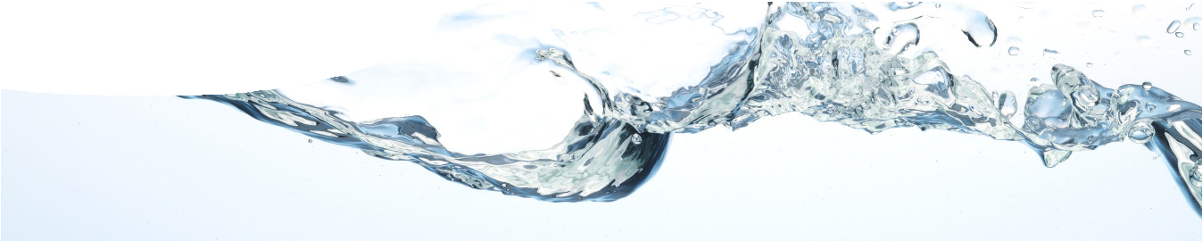How much water is there?
fact sheet
The water cycle
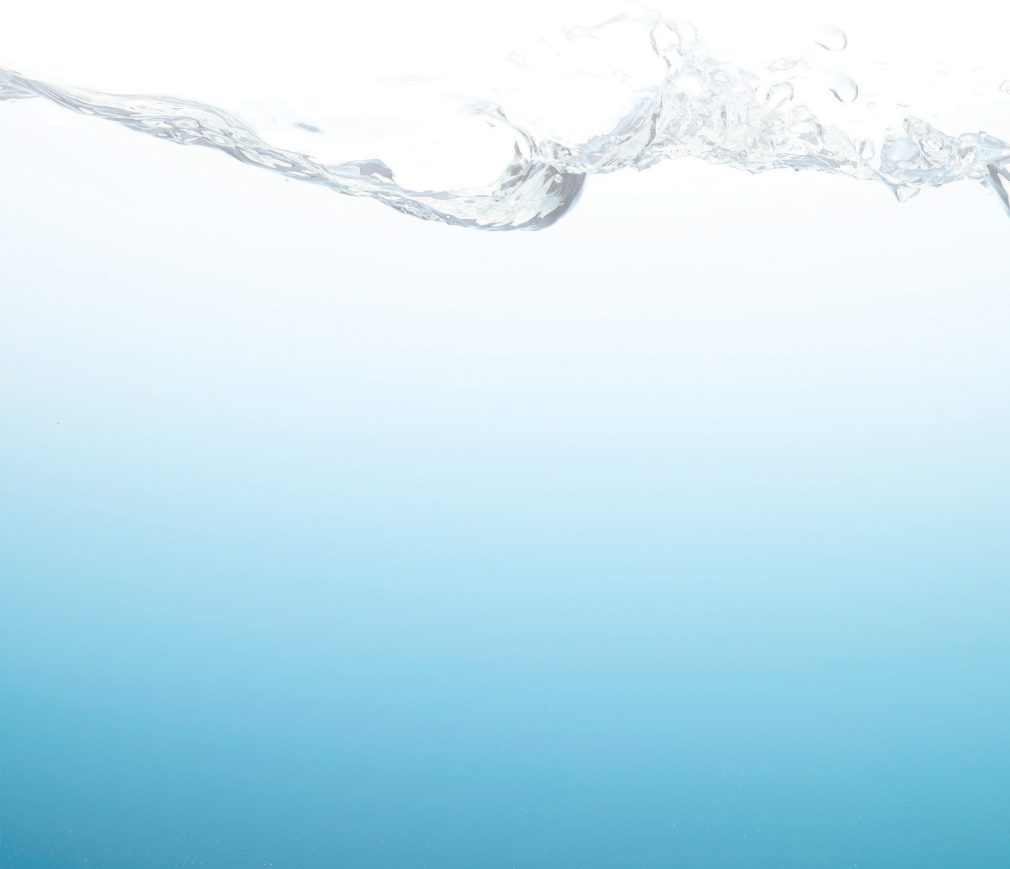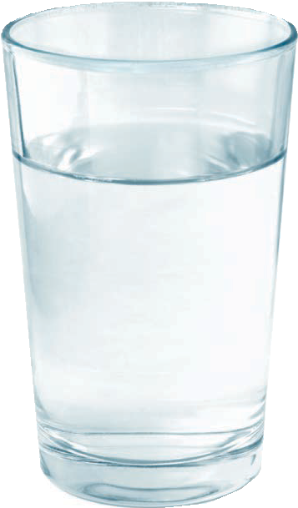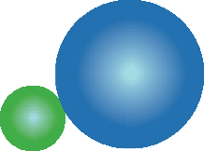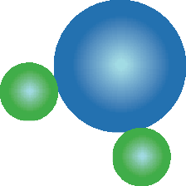After 4.5 billion years you’d think that the world’s water would all be used up! However, there is a special process in place that constantly recycles water — the water cycle. The amount of water on Earth doesn’t change because it can’t escape beyond the Earth’s atmosphere. Dinosaurs or Julius Caesar may have drunk some of the water molecules within your body!

surface water (0.04%)

sea water (97%)

Water covers two-thirds of the Earth’s surface. Only 3% is fresh water — the rest is stored in oceans as salt water. Of the available fresh water, most is found in icecaps, glaciers and underground. Only 0.04% of all water on Earth occurs in surface rivers and lakes.
Water facts
- Water (H2O) is the most important and abundant liquid on Earth.
- It’s the only substance on Earth’s surface that is found in all three states: solid, liquid and gas.
- It’s the best-known solvent, needed by all living things.

Water is a special liquid because of an extra force between its molecules known as a hydrogen bond. Because
of hydrogen bonds water has a higher melting point and boiling point than similar substances. Hydrogen bonding is partly caused by the polar nature
of water molecules, which are slightly positive towards the hydrogen atoms and slightly negative around the oxygen atom. This polarity enables water to dissolve polar compounds and ions easily. Water is sometimes called ‘the universal solvent’.
Some properties of water change when other substances are dissolved in it. For example, dissolved salts can cause the pH of water to be acidic, alkaline, or neutral. This is important as biological organisms can only tolerate a narrow range of pH.
One of the special characteristics of water is that it occurs as a solid, liquid and gas on Earth. It changes state when temperatures change. Energy from the sun can change the state of water from a solid to a liquid or gas in the water cycle.
In Australia water is a precious resource. There is limited groundwater and inland surface water suitable for human use. Water quality needs to be monitored to ensure the protection of Australia’s fragile aquatic ecosystems, flora and fauna, and also that our drinking water supply is sustainable.
Some of water’s unusual physical properties are due to hydrogen bonding:
- high heat of vapourisation,
- strong surface tension,
- high specific heat,
- good solvent properties, and
- at low temperatures the liquid state is denser than the solid state.

hydrogen bonding between water molecules

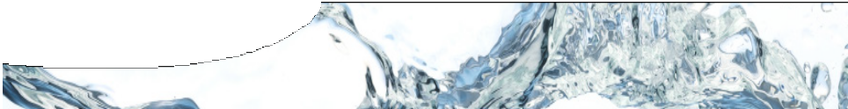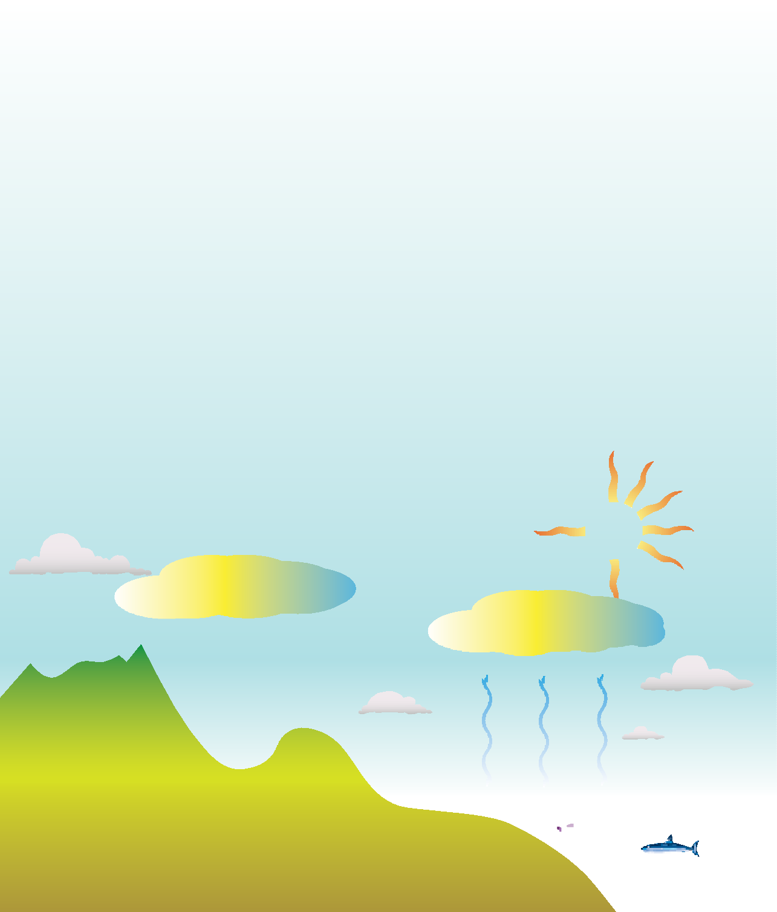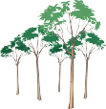What is the water cycle?
fact sheet
The water cycle
Water continually moves around and through the Earth in a cycle powered by solar energy.

DID YOU KNOW?
Glaciers cover about
10 to 11 per cent of all land. If they were all to melt, they would cause sea level to rise about 70 m.

  - Evaporation – Solar energy causes water to move from rivers, lakes, oceans and other water bodies on the Earth’s surface into the atmosphere.
  - Transpiration – Plants have an important role in the movement of water from aqueous state at the Earth’s surface to gaseous state in
the atmosphere. Plants take up water through their roots and release water vapour through pores on the underside of leaves. Temperature, humidity and sunlight intensity affect the rate of transpiration.
  - Condensation – Water vapour forms tiny droplets around nuclei such as dust, pollen or pollutant particles. These water droplets are so small that they float in the air and appear as clouds, mist and fog. They form when warm water vapour meets cooler air and changes state from gas to liquid.

- Precipitation – Water droplets fall to the Earth’s surface as rain, sleet, hail or snow when they become too heavy to remain suspended in air. If the temperature drops low enough
droplets of rain can change into solid forms such as hail and snow.
- Collection – Water from precipitation collects on the Earth’s surface in streams, rivers, lakes, oceans and wetlands.
- Groundwater — Water occurs beneath the ground in spaces in soil and rock. Groundwater is recharged from the surface, and eventually returns water to the surface through springs, seeps and wetlands. The water table marks the depth where soil and rock spaces are completely saturated with water.

cloud formation

snow

surface runoff

precipitation

lake

transpiration
condensing water vapour

evaporation

groundwater

impervious layer

salt water intrusion

ocean

References
Beeton R J S, Buckley K I, Jones G J, Morgan D, Reichelt R E and Trewin D. (2006). Australia State of the Environment 2006. Department of the Environment and Heritage, Canberra.
Bucat R B (Ed.) (1984). Elements of Chemistry: Earth, Air, Fire and Water, Volume 2. Canberra: Australian Academy of Science. Scott W A H (1991). Collins Gem: Chemistry Basic Facts (3rd ed.). Great Britain: HarperCollins Publishing.
United States Geological Survey (n.d.). Water Resources of the United States. Retrieved August 21, 2008 from http://water.usgs.gov/

