The temperature’s rising
fact sheet
The heat is on!
image by James Constable
The CSIRO produced maps (A1F1 – B1) showing summer temperature changes, for each of six Special Report on Emissions Scenarios (SRES). All of them show that temperatures will rise in Australia, and the further in the future, the hotter it gets. For example, in B1 scenario map,
the average temperature in Perth is 1.5 °C hotter in 2070 than it is now.
Each of the SRES models is different, so projections vary. However, models that have fossil fuels as the primary source of energy, such as A1F1, will result in the greatest future temperature increases.
What impact will a warming environment have on you? Well, keeping cool in the future will be more difficult and we may need to change the way we go about sport and physical activities.
Keeping cool
Your body constantly produces heat, mostly through cellular metabolic activity. A lot of this heat is used to maintain core temperature, at about 37 °C. You also absorb heat energy from your environment when it’s warmer than you. In a hot environment (one that is above 37 °C) you gain heat. The only way to lose heat is by evaporation, so your body begins to produce sweat, which evaporates. However, sometimes that’s not enough and heat builds up. So what happens when there’s too much heat in your body?
The main way humans lose heat is through the skin. Sweating is a really good way to
compensate for increasing body temperature in the short term, providing you can replace fluid you lose from your skin, by drinking. Cooling also occurs by pumping blood to the skin surface, making it red.

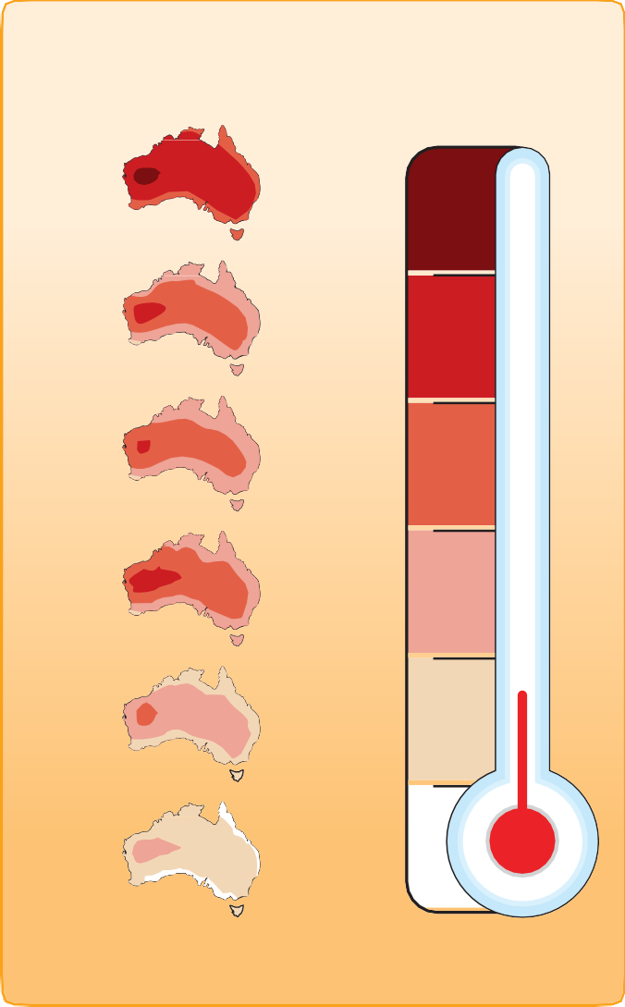
2070
six scenarios
temperature increase since 2010
A1F1
5
4
A1T
3
A1B
2.5
A2
2
B2
1.5
B1
1
predictions for temperature changes (˚C)
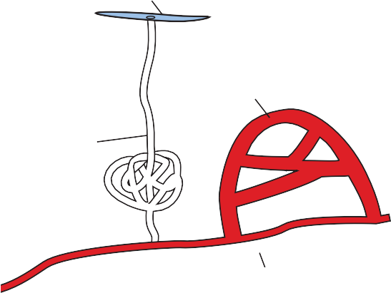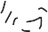pore
blood capillary
sweat gland
fat cell
dermis
epidermis
2mm

cross section of the skin showing sweating and increased blood flow to the skin’s surface
subcultaneous tissue

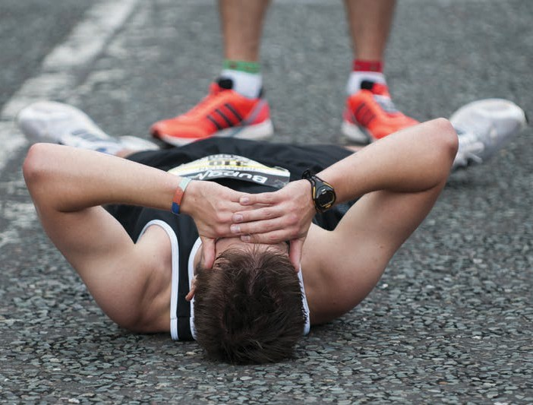
In hot environments sweating may not be enough to maintain a steady body temperature (especially when it’s humid, because high humidity makes sweating less effective). Sweating can lead to dehydration and decreased
blood volume, putting strain on your heart. At very high rates of sweating it may become impossible to replace liquids as fast as they are lost, and when this occurs, sweat production falls too, slowing the rate of dehydration and reducing blood flow to the skin.
When sweating and skin blood flow begin to decrease, body
temperature rises. Blood is diverted away from the skin and sweat glands, to maintain blood pressure to the brain and other vital organs. Heat will build up, eventually resulting in heat stroke, which can be fatal, unless immediate action is taken to cool your body. In hot environments, without adequate fluid replacement, heat stroke can occur in as little as two hours.
Acclimatisation
When you’re exposed to hot conditions over several days, to weeks, your body adapts in a process known as heat acclimatisation. Several changes to your physiology occur. They include: your volume of blood increases; your sweat glands produce more sweat; and your body temperature changes less as your surroundings
get hotter. After several days of heat exposure you feel more comfortable and your chances of heat stroke (hyperthermia) decrease.
People who are acclimatised to heat are more able to comfortably carry out their daily activities when the weather gets hot. Living in Perth, and getting outside for an hour or two each day (taking appropriate measures to prevent sunburn and heat stroke), you’re probably naturally acclimatised. If you spend most of your time indoors, in air-conditioning, you’re probably unacclimatised.
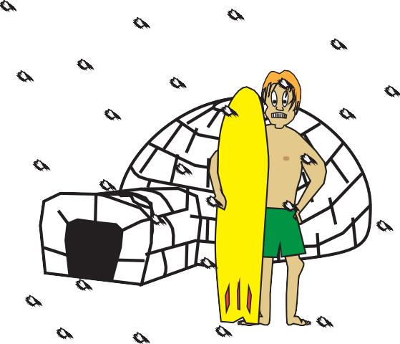Unacclimatised people can become acclimatised. It requires a daily exposure to the heat, of 1-2 hours, for approximately 10 days. However, acclimatisation can be lost if you stay in air-conditioning or move to a cooler
climate.

