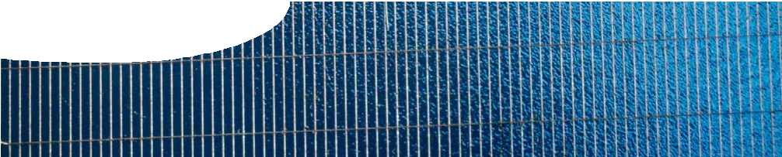
fact sheet
The IDEAL house
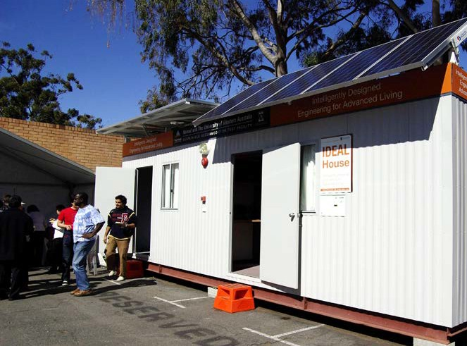
It may not look extraordinary, but this house is set to showcase technologies for state-of–the-art living. All aspects of the household operations — energy use, security, food preparation, audio-visual
entertainment and communications
— will be enhanced by intelligent robotic controls.

The futuristic IDEAL house (Intelligently Designed Engineering for Advanced Living) is being developed by the School of Electrical, Electronic and Computer Engineering at The University of Western Australia. The IDEAL house will be energy self-sufficient through its use of solar and other green technologies, including an array of solar panels on the roof.

Jasmine Henry
One of the major contributors to the IDEAL house project is Dr Jasmine Henry, Senior Lecturer with the School of Electrical, Electronic and Computer Engineering at The University of Western Australia.
Jasmine has been instrumental in the project, and has spent many hours wiring, designing and inspiring.
Jasmine’s recent work on position-sensitive
detectors, with colleague Dr John Livingstone, will comprise part of the IDEAL house’s security system.

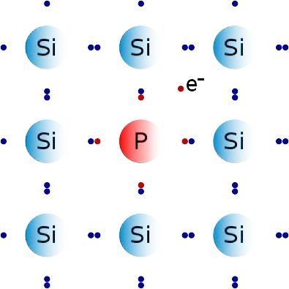
How solar cells work
Solar cells are often made of silicon. Pure silicon is a covalent network substance that is a poor conductor of electricity. To make semi-conductor devices, such
as solar cells, a process known as ‘doping’ alters the electrical conductivity of silicon.

Each silicon atom has four valence electrons which are bonded to four other silicon atoms in a covalent network. When silicon is doped, some atoms are replaced by atoms of another element that has a different number of valence electrons (either three or five).
If atoms such as phosphorus, which has five valence electrons, replace some silicon atoms, locations are created where there is a surplus of electrons. At these locations spare electrons can move more freely and act as negative (n-type) charge carriers.

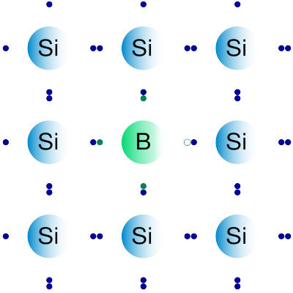Silicon that has been doped with small amounts of phosphorus (above has extra electrons in the structure. Silicon that has been doped with boron (below) has “holes”.
hole
However, if atoms such as boron, which has three valence electrons, replace some silicon atoms, locations are created where
there is a shortage of electrons or a ‘hole’. These locations act as positive (p-type) charge carriers.
Solar cells are made of a thin
p-layer on top of an n-layer (or vice versa). The p-layer is only about
1 µm (10-6 m) thick, so light can easily penetrate to the junction between layers. Metal grids are attached to the upper and lower surfaces to connect the cell to an external circuit.

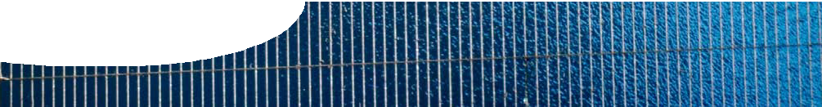
fact sheet
The IDEAL house

Sunlight that enters a solar cell displaces some electrons from silicon bonds, leaving ‘holes’ or positive sites. The junction between the two doped layers separates some holes from

n-type
photons in light

-

electrons because holes flow more
p-type solar cell

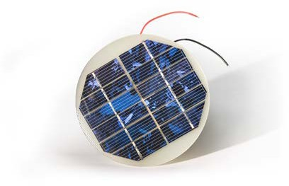
easily in the p-layer and electrons flow more easily in the n-layer. This separation of charges produces a potential difference (an ‘electric push’, measured in volts) across the layers in the solar cell. The easiest way for charges to re-combine is through an external circuit, such as the house electrical system.

Position sensitive detectors
The IDEAL house uses smart
electron -

+ hole

+

sensors and detectors for security. These large, optical sensors use the photovoltaic effect to measure the direction of a light beam that shines onto them. Unlike solar cells that work when the whole surface is exposed to light, position- sensitive detectors (PSDs) work when a spot of light shines on the cell junction.
light
e- e- e- e- e- e-
Polycrystalline silicon photovoltaic cell made from a number of smaller devices. The different crystalline regions can be seen as different reflective areas.

Crystalline solar cell used where the sun’s light is concentrated to 10-50 times greater than normal. These solar cells need good current- collecting abilities, so there are many metal ‘fingers’ used to collect the current. These are the tiny lines on the front surface.

A PSD is made from two layers. One is highly conductive (for example, a metal such as aluminium, tantalum or titanium or heavily doped semiconductor) and one less conductive. The semiconductor layer is less

holes
v

metal layer p-type layer

e- e- e- e- e- e-

lateral voltage
v

conductive. Suppose a junction is formed between a metal layer and silicon p-layer. Electrons and
holes are generated in both layers when a spot of light shines on to this junction. Electrons generated in the silicon layer move to the metal layer. They then spread along this layer since it is so conductive. Holes remaining in the semiconductor layer ‘bunch-up’ momentarily around the site of the light beam in the less conductive silicon p-layer. This separation of charges is parallel to the metal- semiconductor junction and sets up what is known as a lateral voltage.
The photons in sunlight release electrons from the silicon bonds, creating mobile electrons and
holes. The p-n junction causes these to go in opposite directions. The electrons flow through the external load and meet up with holes on their return.

Research at The University of
Western Australia continues to produce high performance solar cells and PSDs. The IDEAL
house project is a multi-disciplinary project that incorporates different aspects of electrical, electronic
and computer technologies. It is set to provide students with the opportunity to contribute
to the future of human habitation on this planet.

Measurement of this lateral voltage can locate a light beam to within 10 µm. This is used to give fast, continuous, accurate information about the position of a light source.
PSDs are used for a variety of applications, including machine tool alignment, medical instruments and robotic vision. In the IDEAL house, PSDs will be used as part of the security system to control central locking of doors and windows, and for security at night.

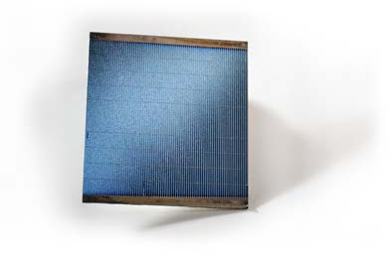
References
Henry, J and Livingstone, J. (2001). Thin-film amorphous silicon position-sensitive detectors. Advanced Materials, 13 (12-13): 1022-1026.
School of Electrical, Electronic and Computer Engineering. (n.d.). The IDEAL House. Retrieved August 8, 2008 from http://idealhouse.ee.uwa.edu.au/ Livingstone, J. (2008). Position sensitive detectors. Retrieved February 7, 2008 from http://www.ee.uwa.edu.au/~johnliv/JL1.html

