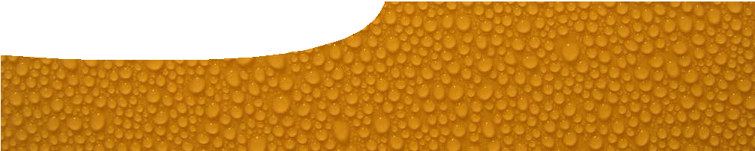
teachers guide
Soft drink science 2
Investigating soft drink

Components

 | NAME | DESCRIPTION | AUDIENCE
 | Investigating soft drink  teachers guide | This guide shows how this resource may be used to explore the separation of substances, and differences between the three states of matter. | teachers
 | What’s in a soft drink?  procedure sheet | Students design and carry out an open investigation to separate a soft drink into its components. This procedure sheet includes a scaffold to help students design, perform and evaluate their investigation. | students
 | Comparing properties  procedure sheet | Students compare properties of sugar, water and carbon dioxide as examples of the three states of matter. | students

Purpose
To Explore components of a soft drink by separating the main ingredients and testing their properties.

Activity summary
Outcomes
Students:
- understand that mixtures can be separated;
- perform a range of physical separation techniques;
- identify some properties of solids, liquids and gases; and
- classify some substances by their state of matter.

ACTIVITY | POSSIBLE STRATEGY
CAUTION: These experiments involve hot liquids.  Students perform the open investigation, What’s in a soft drink? and answer the questions included. Alternatively, this activity can be done as a structured activity, as explained below. | small groups or individuals
Students perform the procedure, Comparing properties, and answer the questions included. | individual or small groups
After completing both activities, students present their findings to the class. Some suggestions for how this could be done are given below. | whole class
Create a word wall in the classroom using key words from activities, eg evaporation, distillation, condenser, solid … More words can added throughout the sequence. | whole class

Technical requirements
The guide and procedure sheets require Adobe Reader (version 5 or later), which is a free download from www.adobe.com. The procedure sheets are also available in Microsoft Word format.

Acknowledgements
Designed and developed by the Centre for Learning Technology, The University of Western Australia.
Production team: Jan Dook, Alwyn Evans, Bob Fitzpatrick, Sally Harban, Dan Hutton, Emma Pointon, Paul Ricketts, Jodie Ween, Michael Wheatley, with thanks to Charmaine White and Wendy Sanderson.

Ask students to draw up a table, similar to the one below, or use pages 3–5 of the procedure sheet, What’s in a soft drink?, to record and analyse their results.
When students have completed all stations, ask what they think might be the ingredients in soft drink.

STATION | What does the drink look like whilst the experiment takes place? | Describe the substance that is separated from the soft drink | Describe what is left behind
evaporation
distillation
nucleation
chromatography
filtration

Open investigation
CAUTION: These experiments involve hot liquids. Check students’ methods before allowing them to start.
Ideally students should try to separate the soft drink using the techniques suggested in the caucus race. They may experience difficulties with chromatography as food colouring is surprisingly dilute in soft
drink. Better results can be achieved if the drink is concentrated first, by heating it to make a thick
syrup. Alternatively students may perform a separate chromatography activity with food colouring.

Liebig condenser
In the open investigation and caucus race students use a test tube and plastic delivery tube to investigate distillation. After they have completed this activity there is an opportunity for teachers to show them a Liebig condenser as an example of equipment used in
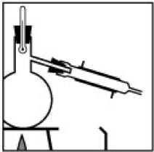
a chemistry laboratory. The Liebig condenser works on the same principle as the test tube and plastic delivery tube, but has the advantage that water is used to cool the evaporated vapour, so it returns to its liquid state more quickly. A Liebig condenser is also illustrated in the learning object, Solutions explorer, in Soft drink science 5: Solutions, later in this sequence.

Student presentation
Students may be given some focus questions after completing either experimental procedure.
- How can you separate a soft drink into its ingredients?
- What is in a soft drink?
- Do the ingredients have different properties?
- How did this help you to separate them?
Students may use a variety of methods to present their answers, such as oral presentation, poster, video, PowerPoint, written report or podcast. There are a number of good and entertaining student presentations on the states of matter on YouTube,
which may be useful to show the class to provide ideas of what they could do.

SPICE resources and copyright
All SPICE resources are available from the Centre for Learning Technology at The University of Western Australia (“UWA”). Selected SPICE resources are available through the websites of Australian State and Territory Education Authorities.
Copyright of SPICE Resources belongs to The University of Western Australia unless otherwise indicated.
Teachers and students at Australian schools are granted permission to reproduce, edit, recompile and include in derivative works the resources subject to conditions detailed at spice.wa.edu.au/usage.
All questions involving copyright and use should be directed to SPICE at UWA.
Web: spice.wa.edu.au Email: spice@uwa.edu.au Phone: (08) 6488 3917
Centre for Learning Technology (M016) The University of Western Australia
35 Stirling Highway
Crawley WA 6009

Associated SPICE resources
Soft drink science 2: Investigating soft drink may be used in conjunction with related SPICE resources.

DESCRIPTION | LEARNING PURPOSE
Soft drink science (overview)
This learning pathway shows how a number of SPICE resources can be combined to assist with teaching the topic of states of matter and solutions.
Soft drink science 1: Soft drink fountain  A teacher demonstration engages students’ interest in the three states of matter, solutions and separating techniques. | Engage
Soft drink science 2: Investigating soft drink  Students separate and investigate the components of soft drink through practical activities. | Explore
Soft drink science 3: States of matter  Students use worksheets and an interactive learning object to construct an explanation of the particle model of matter. | Explain
Soft drink science 4: Making soft drink  Students investigate solutions and use their knowledge to make a soft drink. | Explore
Soft drink science 5: Solutions  Students use worksheets and an interactive learning object to construct an explanation of separation techniques, using the particle model of matter. | Explain
Soft drink science 6: Separation techniques  A video about a forensic food scientist illustrates the importance of different separation techniques. Students perform their own practical investigation that involves separation techniques. | Elaborate

